JENKINS-TASK-01
1.Install Jenkins and run Jenkins on port number 8081.
Installed java
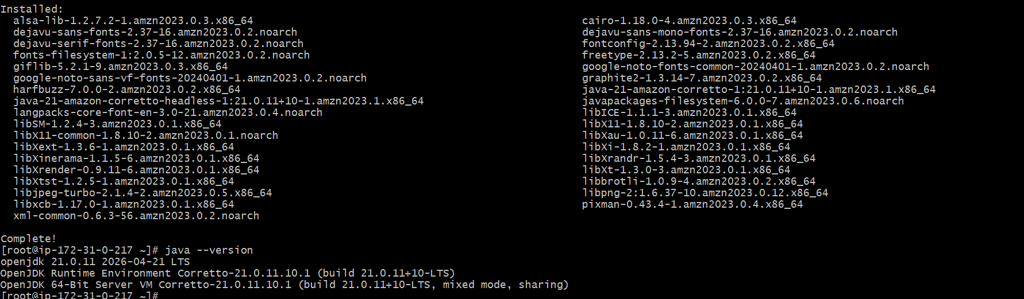
Installed Jenkins
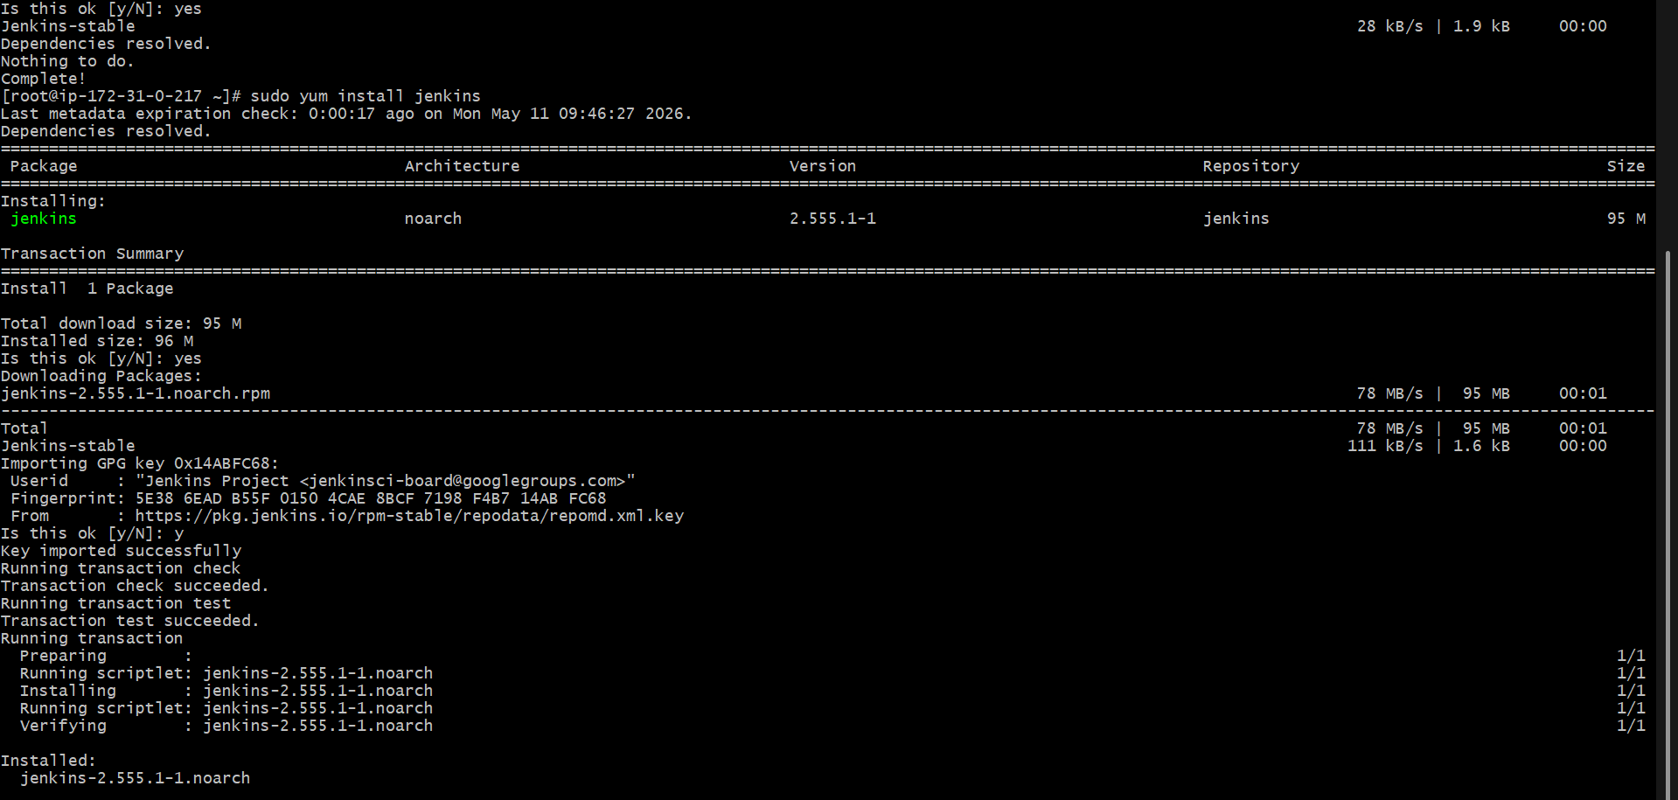
Jenkins is running
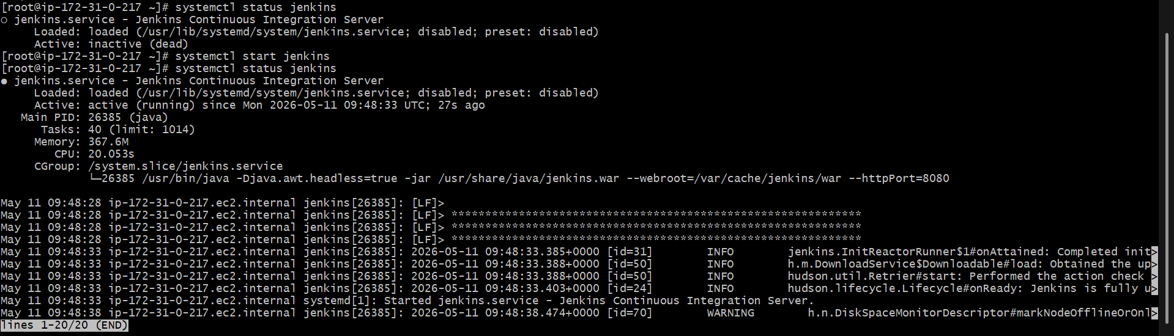
Change the port number from 8080 to 8081 by using the command
sudo vi /usr/lib/systemd/system/jenkins.service
And its working on port number 8081
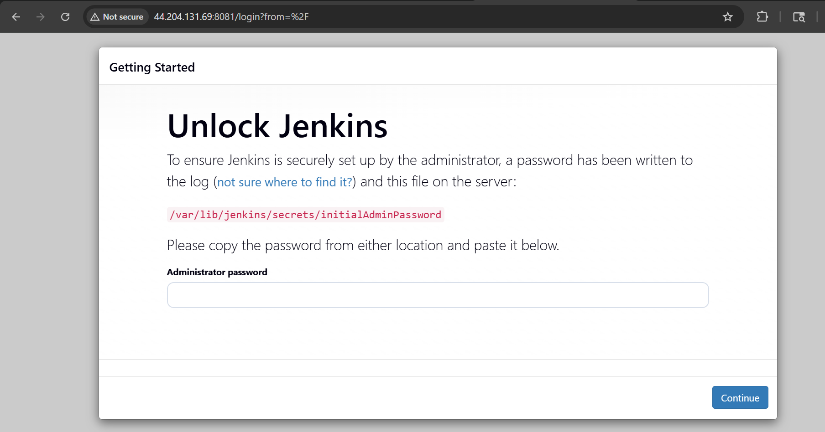
2 Secure Jenkins server
By using initialAdminPassword we can change the username and password

Installed plugins

3. Create users called DevOps, Testing in Jenkins with Limited access.
Created a user Devops and testing
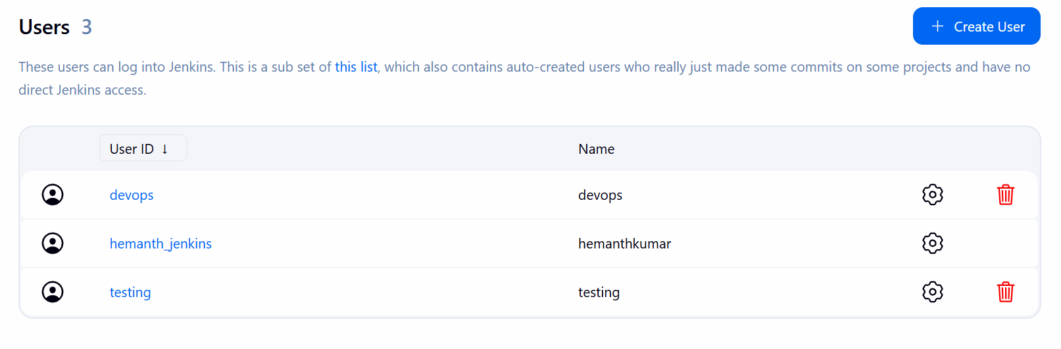

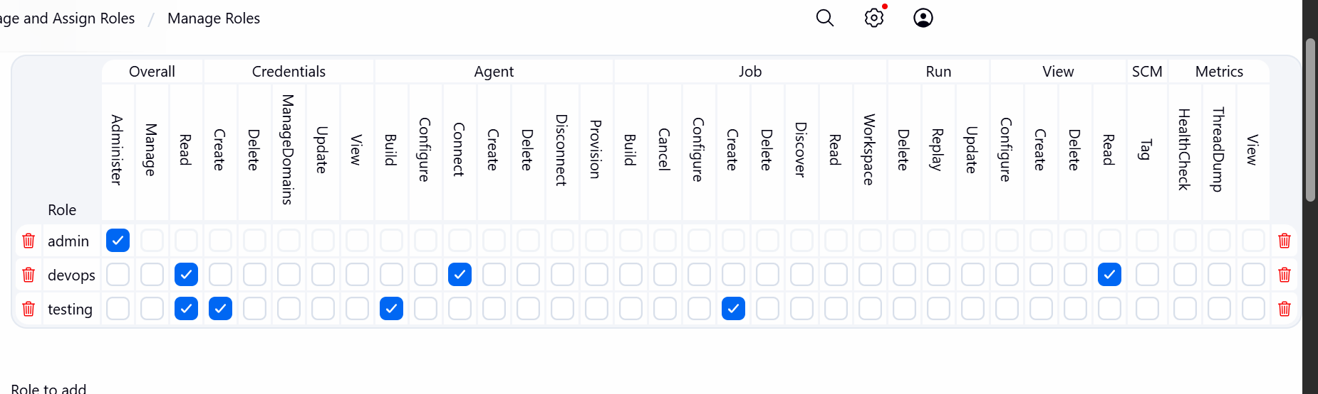

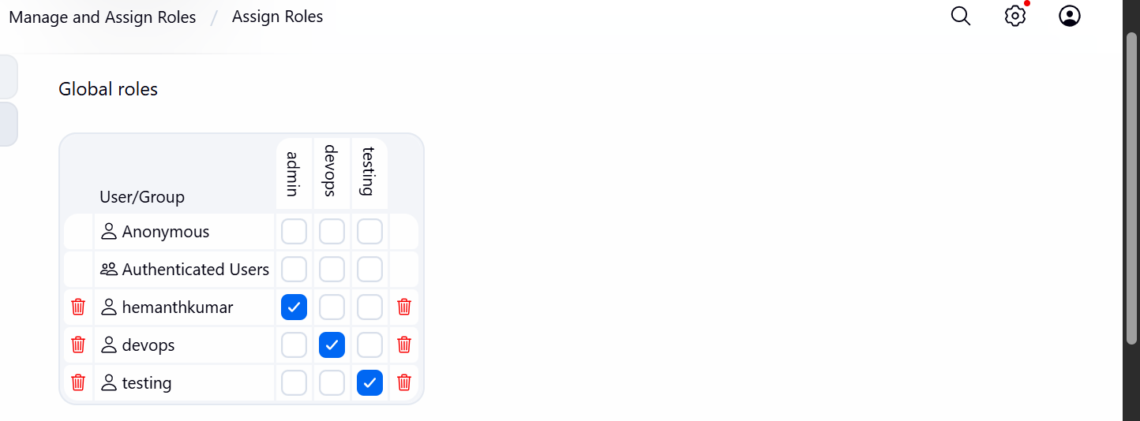
4 Configure labels and restrict the jobs to execute based on label only.
Open Jenkins and open nodes and click on built-in node
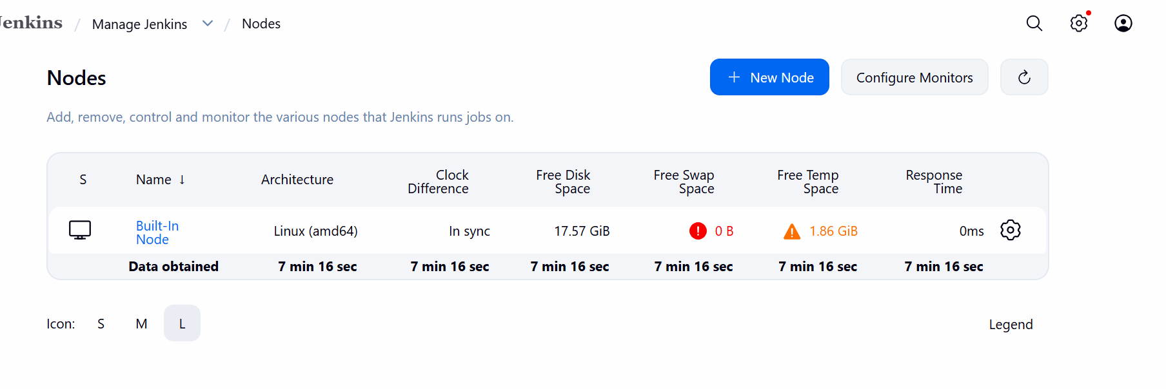
Create a label name as Linux
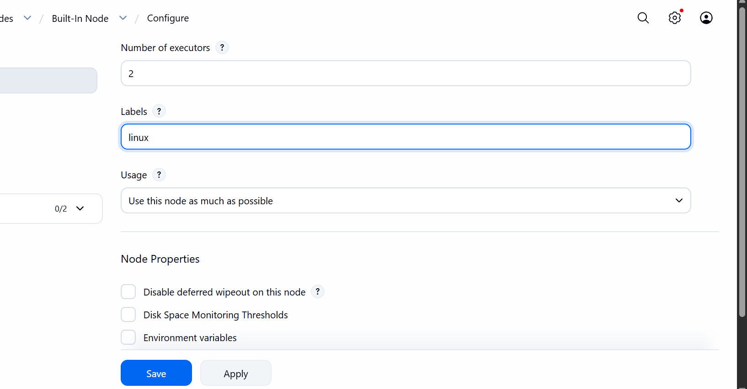
Now create a new job in jenkins
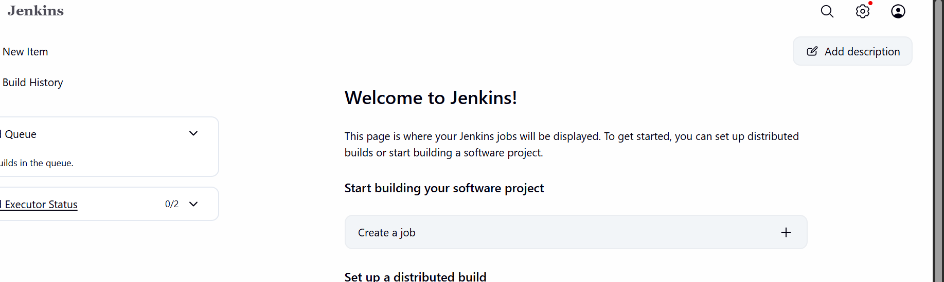
Now give name and choose freestyle project

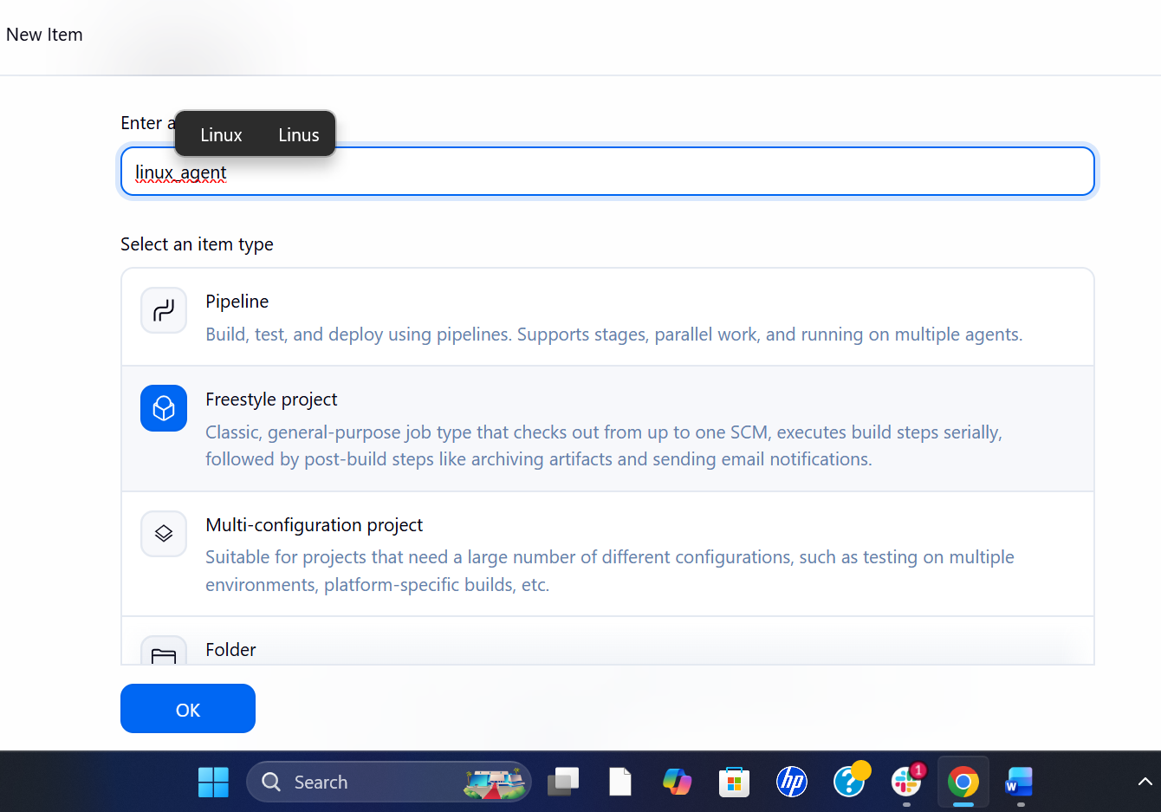

Default we can see Restrict the project and we can add label name and run

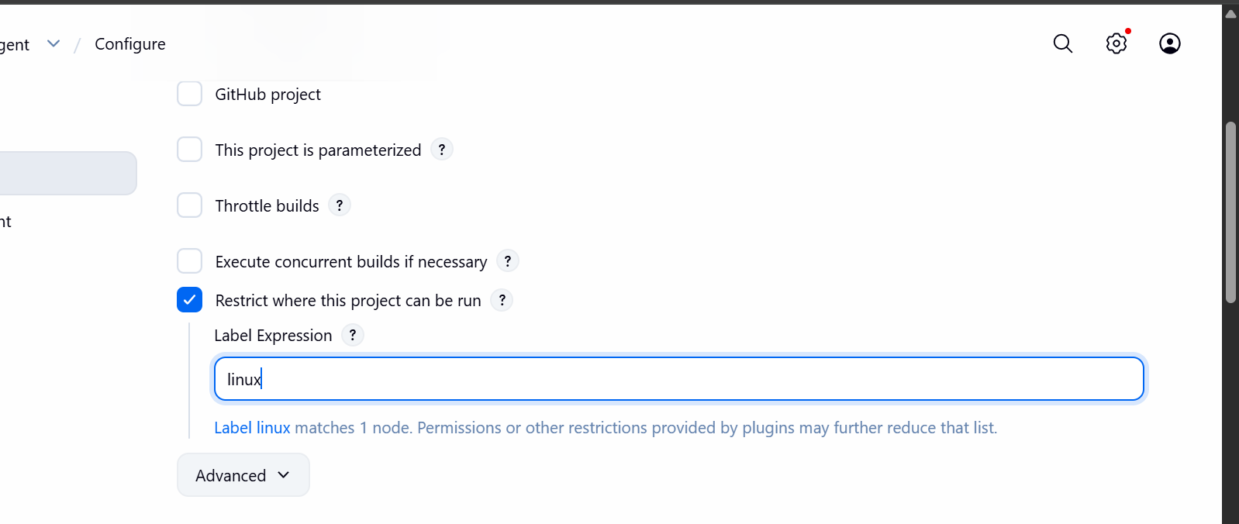
In build steps select execute shell and command
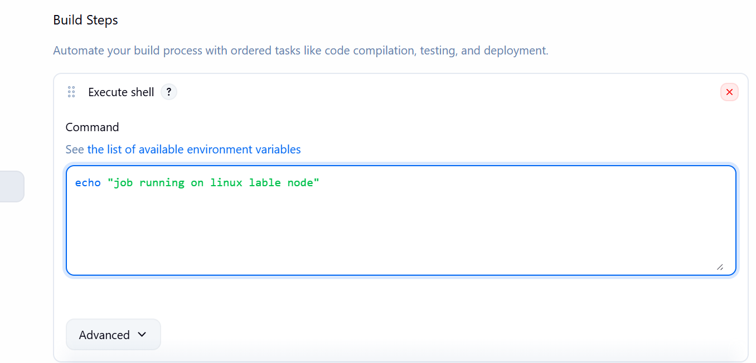
Save and run the build and check the status

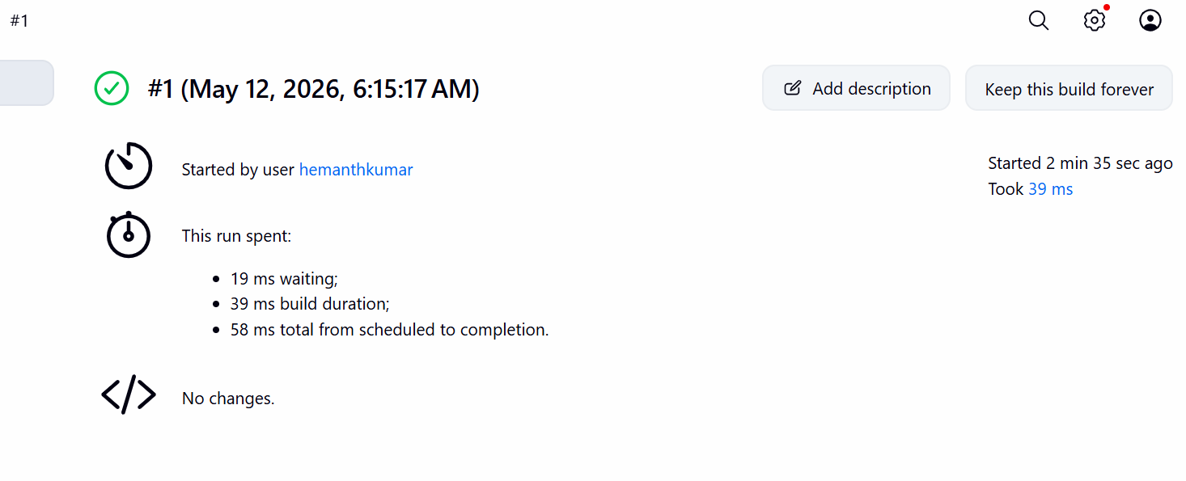
Checked the consol and running successfully
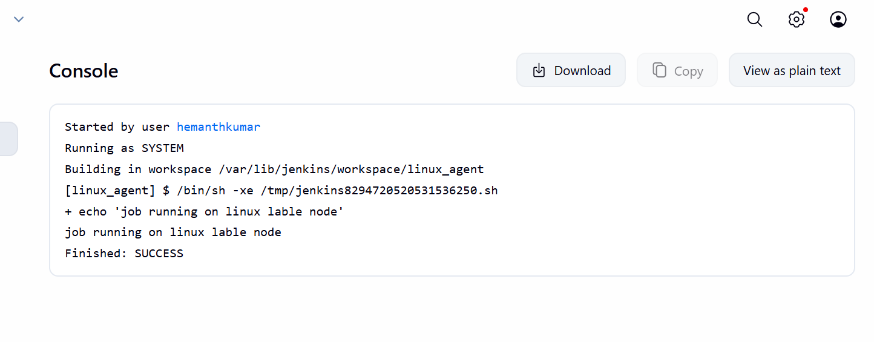
5 Create Three sample jobs using the below URL.
Source Code: https://github.com/betawins/Techie_horizon_Login_app.git
Create a new item in Github-01 in Jenkins
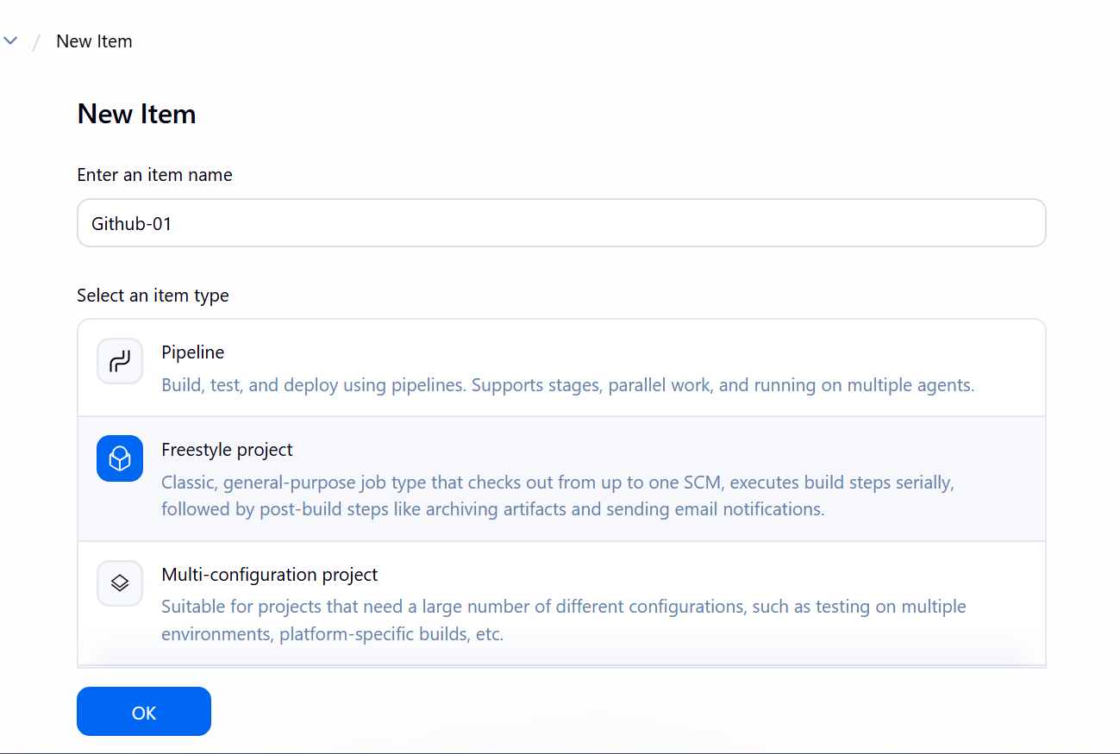
Install git in gitbash
Connected to the instance and install git
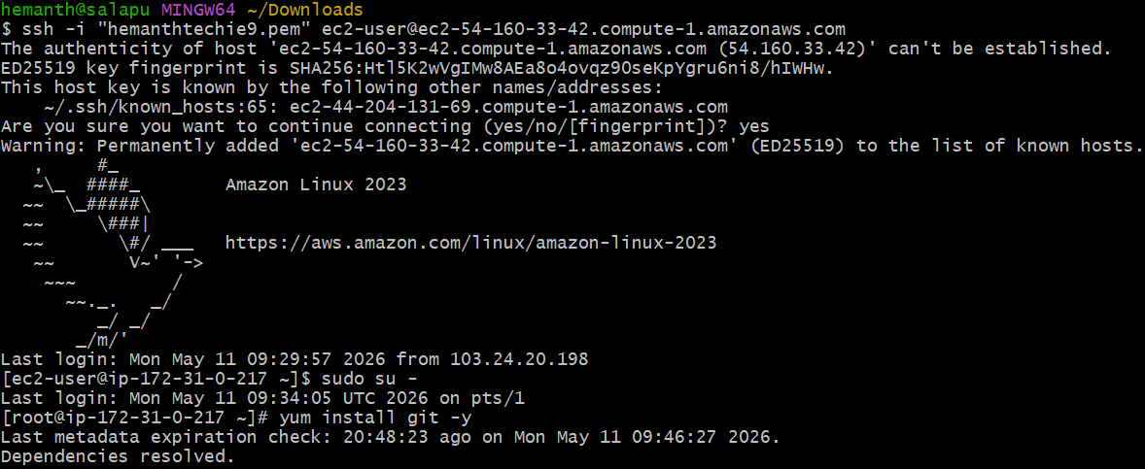
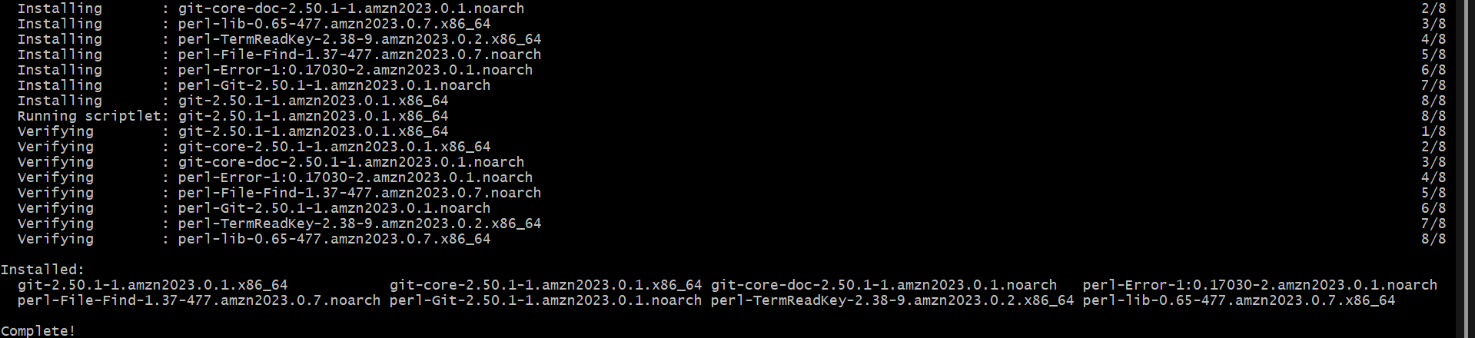
Select source code management and select git and present the url
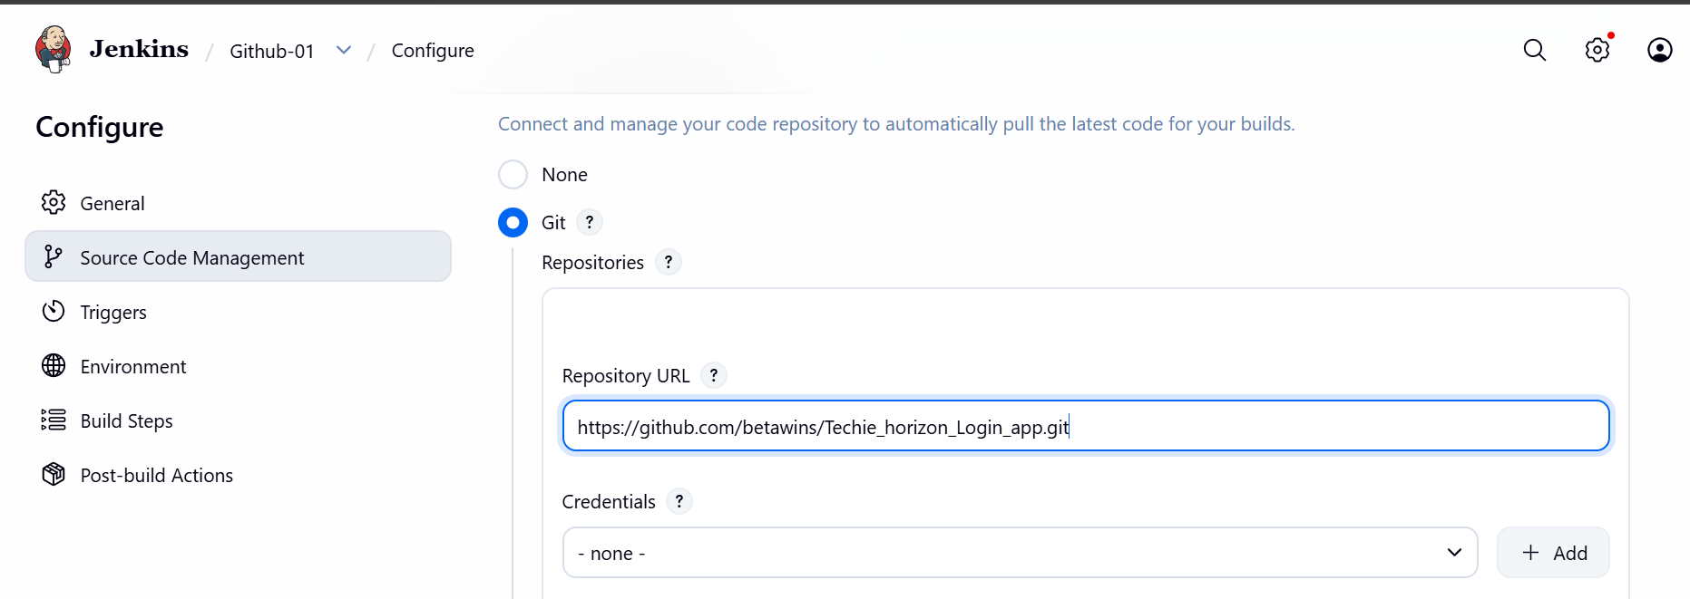
In build step select the execute the shell and write command
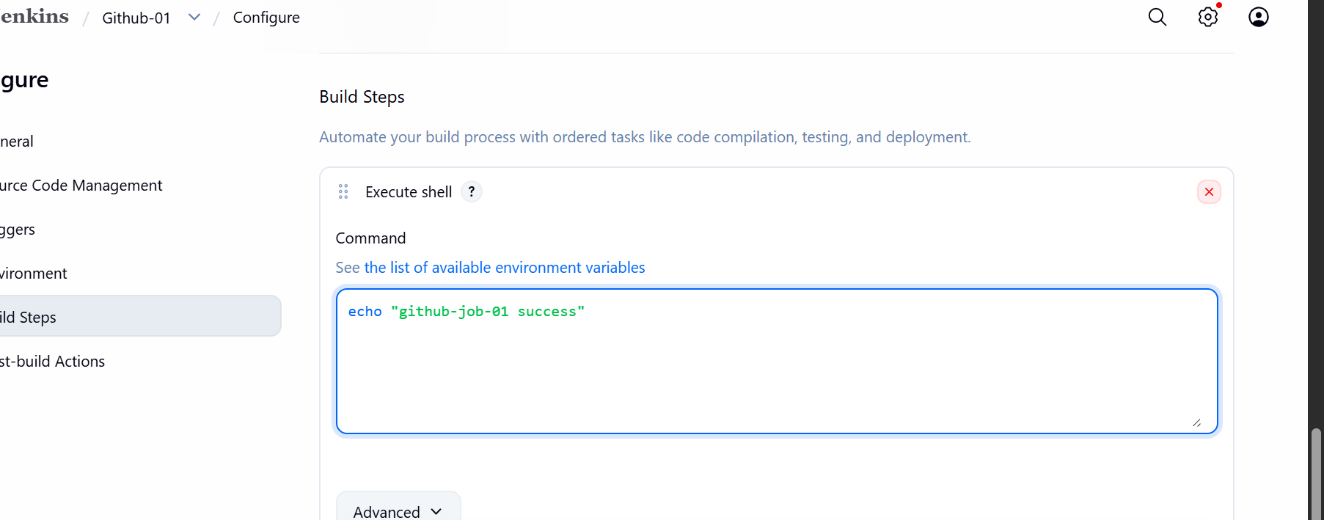
Run the build now
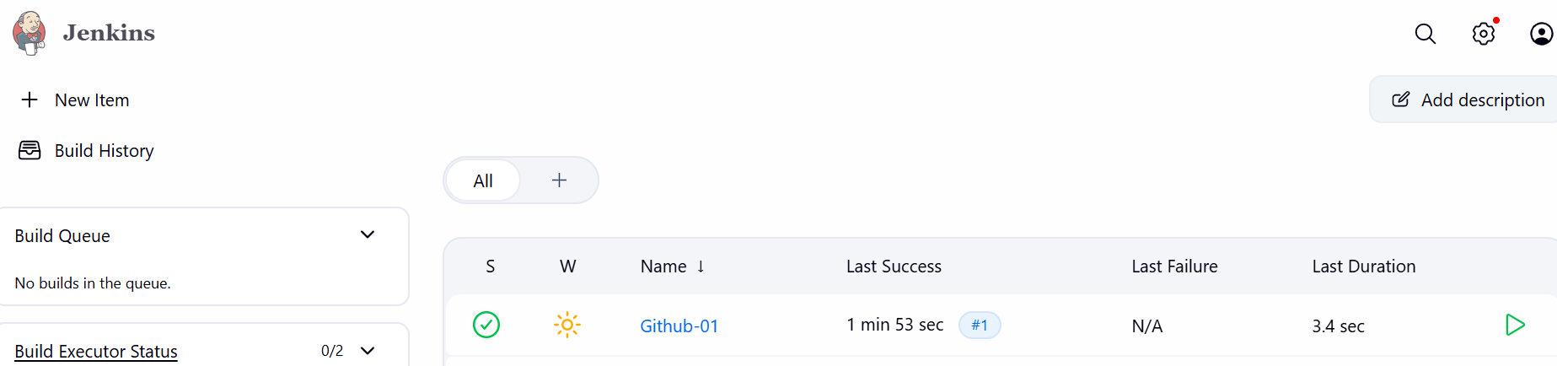
Check the status success 1st job

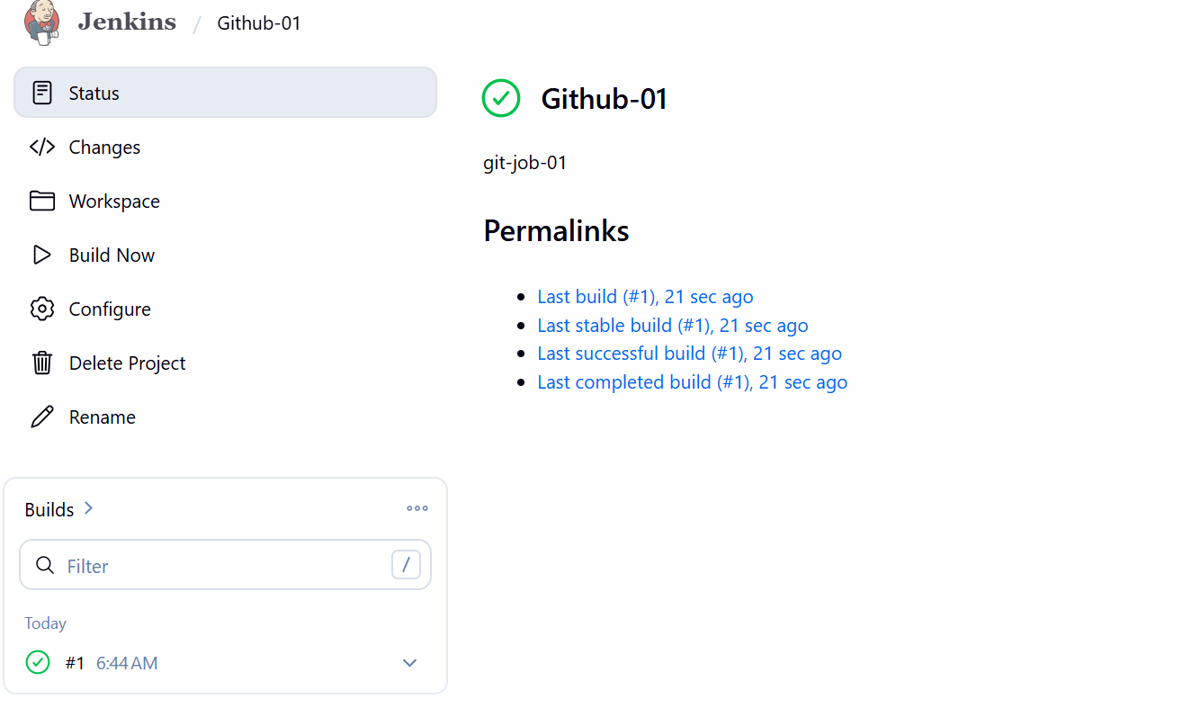
Console output
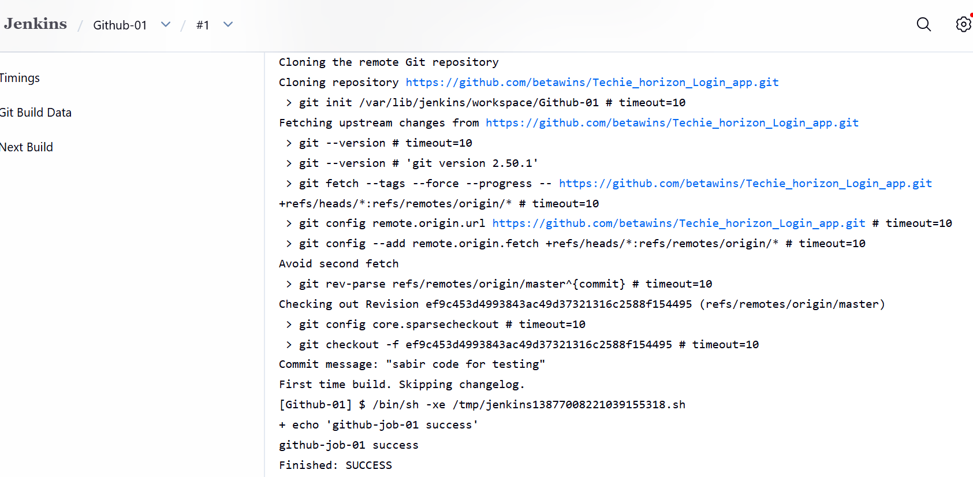
Created 2nd github-02 in new item
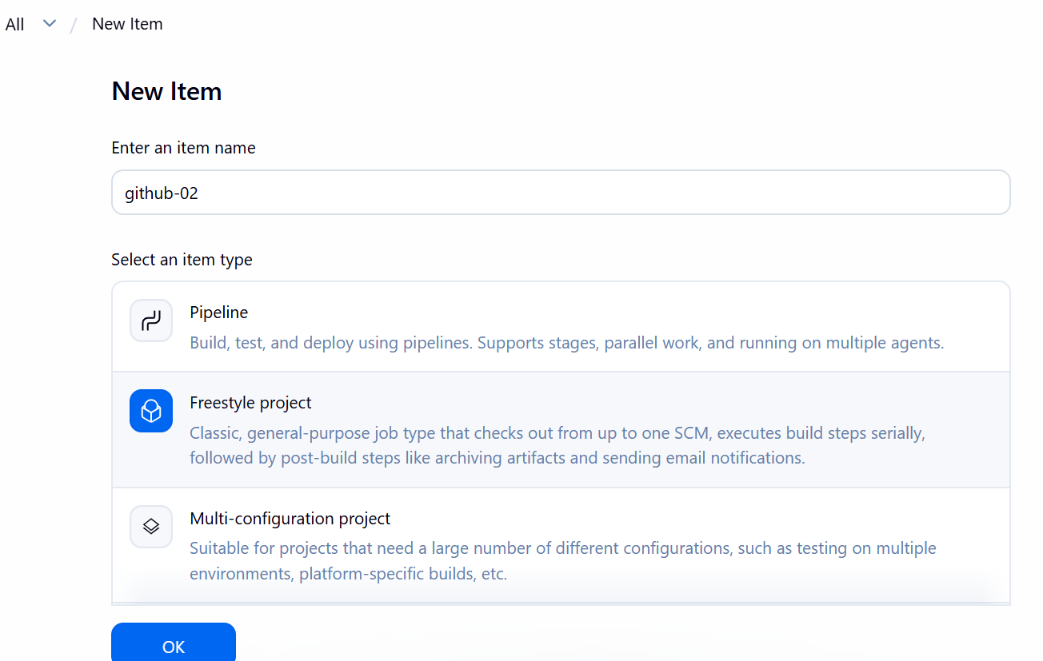

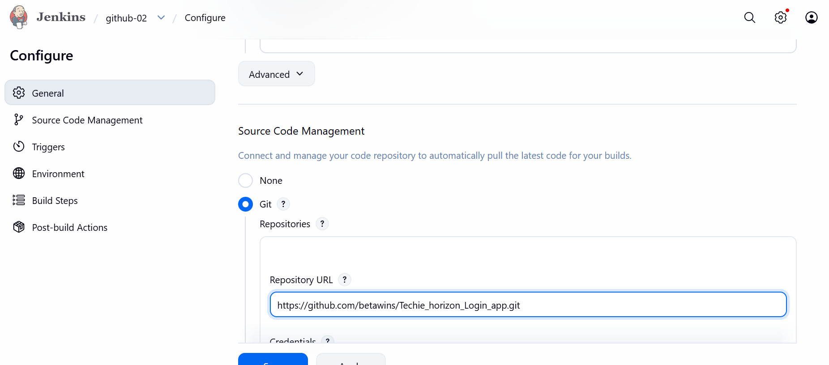

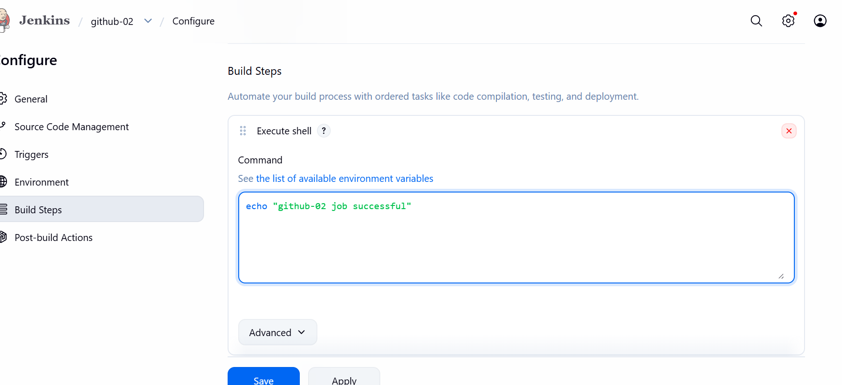
Consol output is success
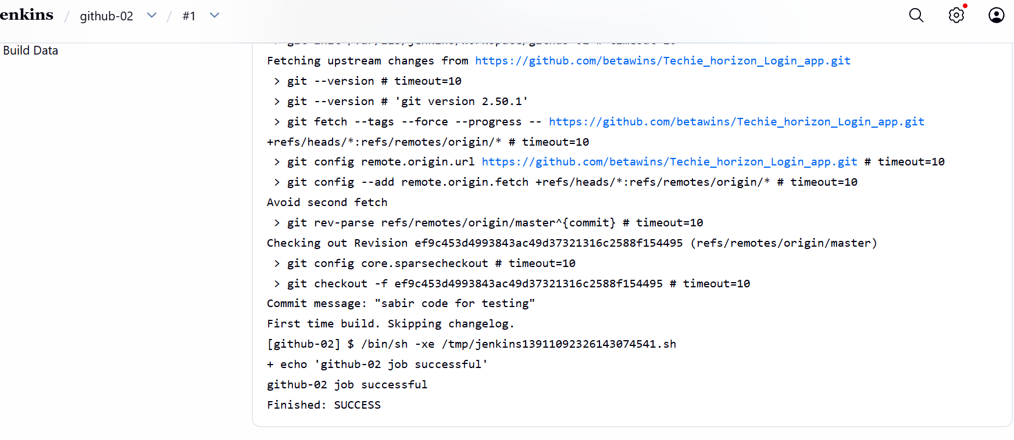
Created a new item in Jenkins as github-03
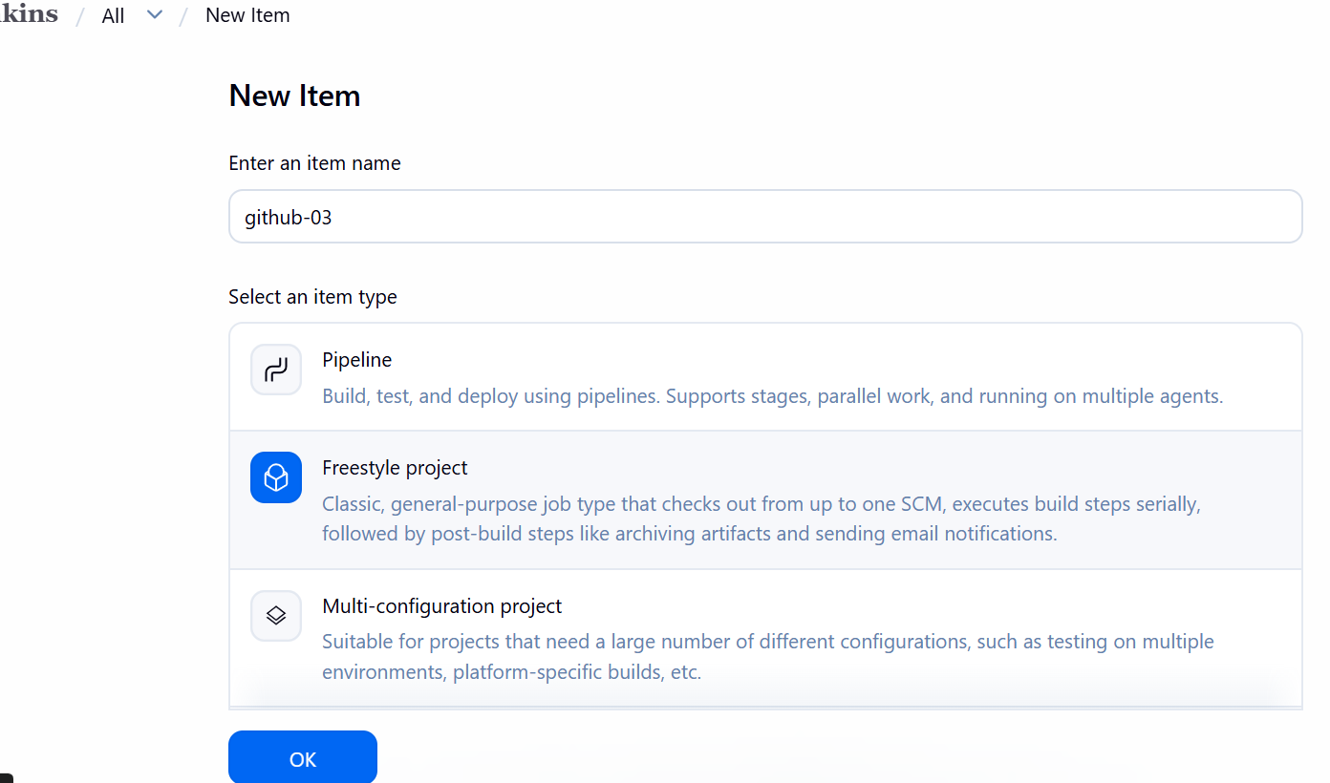

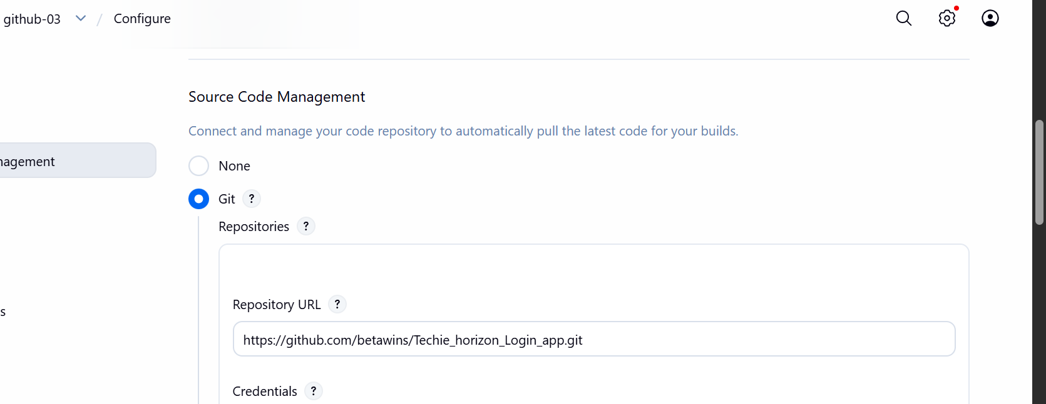

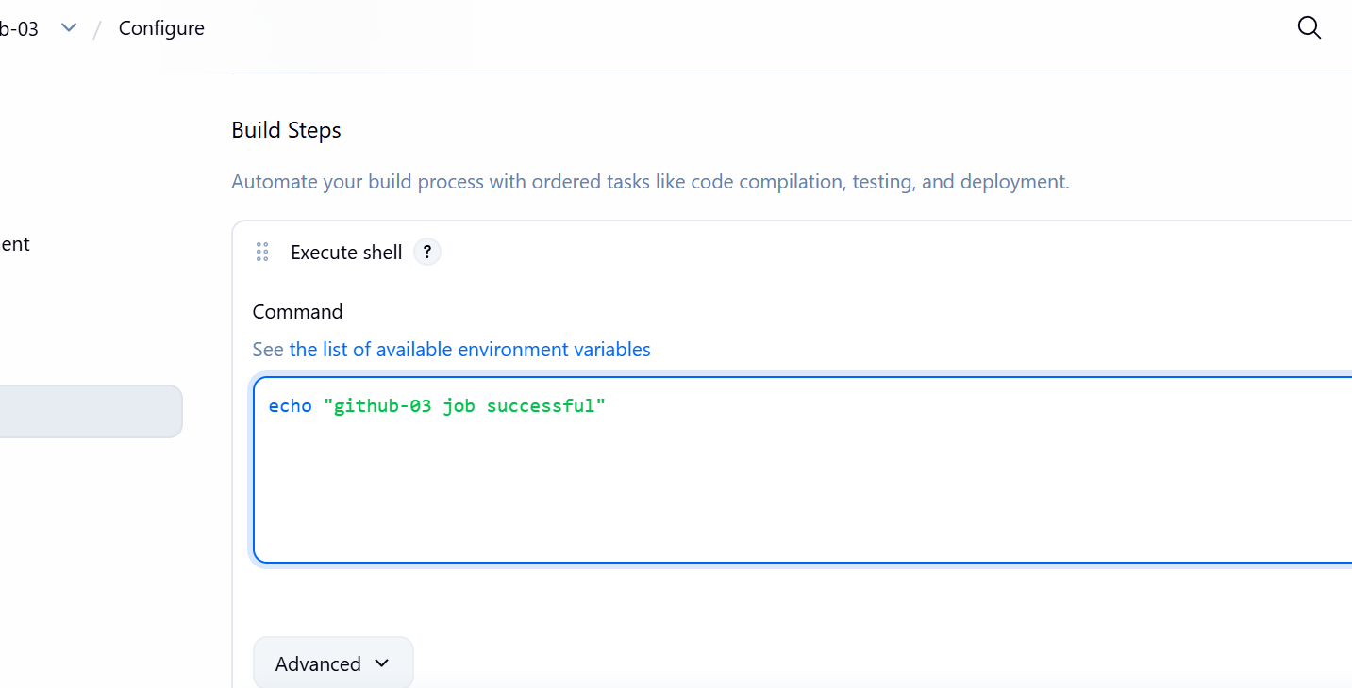
Consol output is success

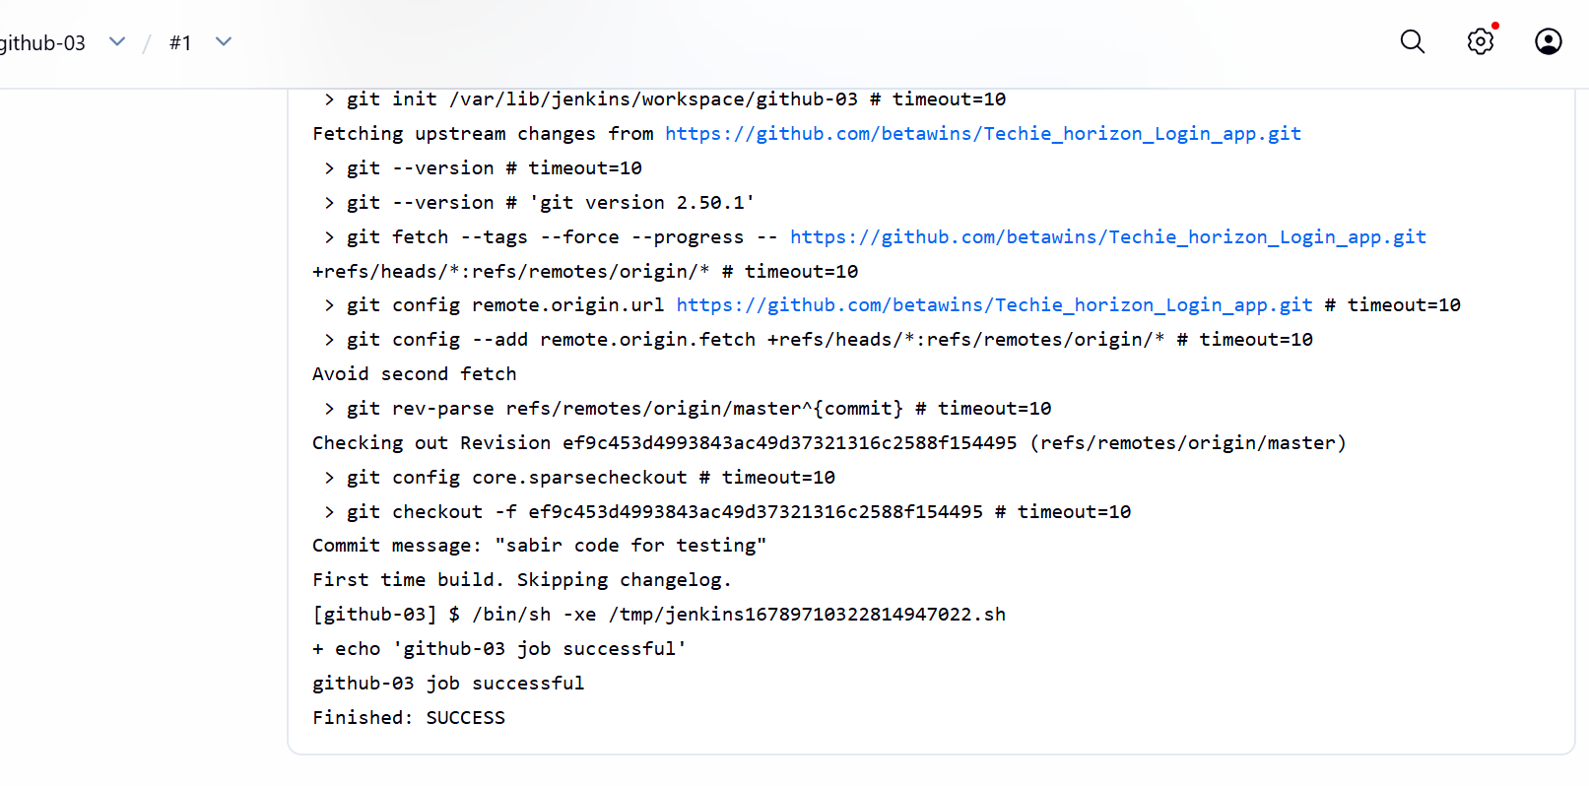
6 Create one Jenkins job using GitHub Private repository.
Open GitHub and click on new repository and given name and in the
configuration change private to public
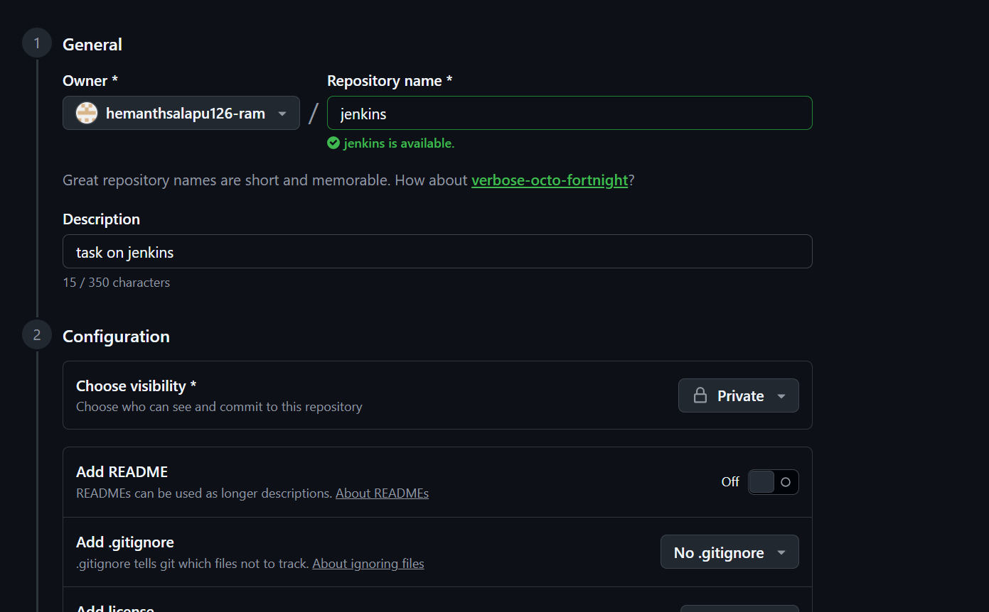
Open settings and generate new token

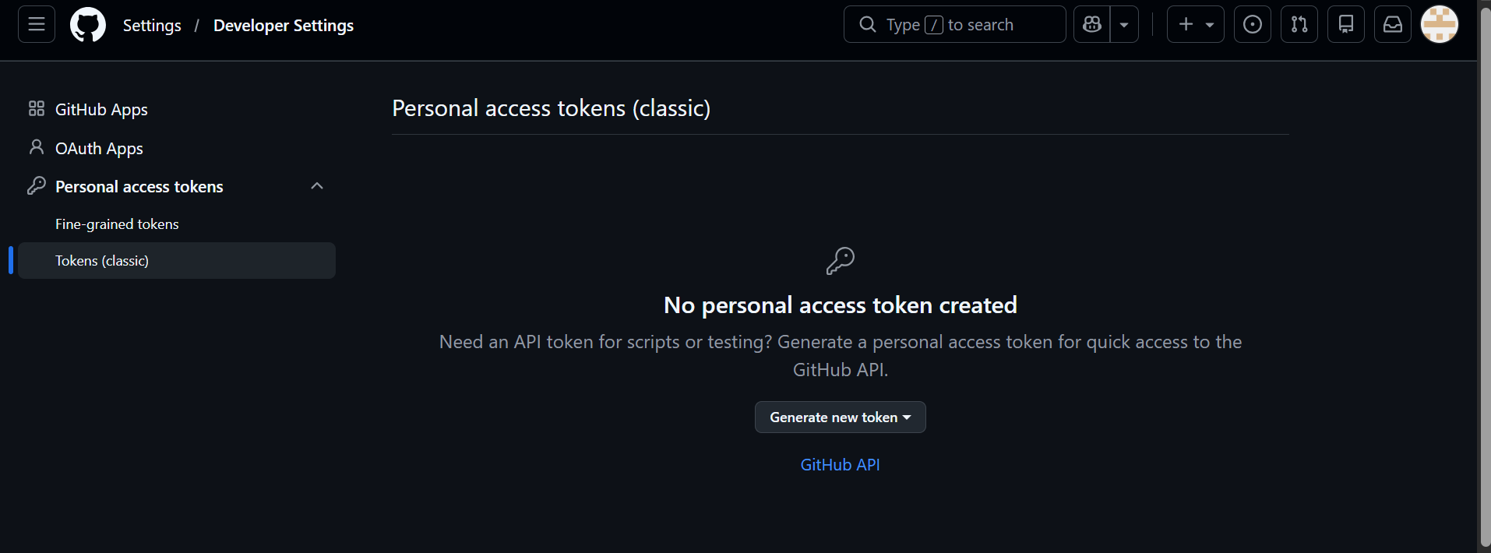
Given name in note and enable repo and generate token and kept safely
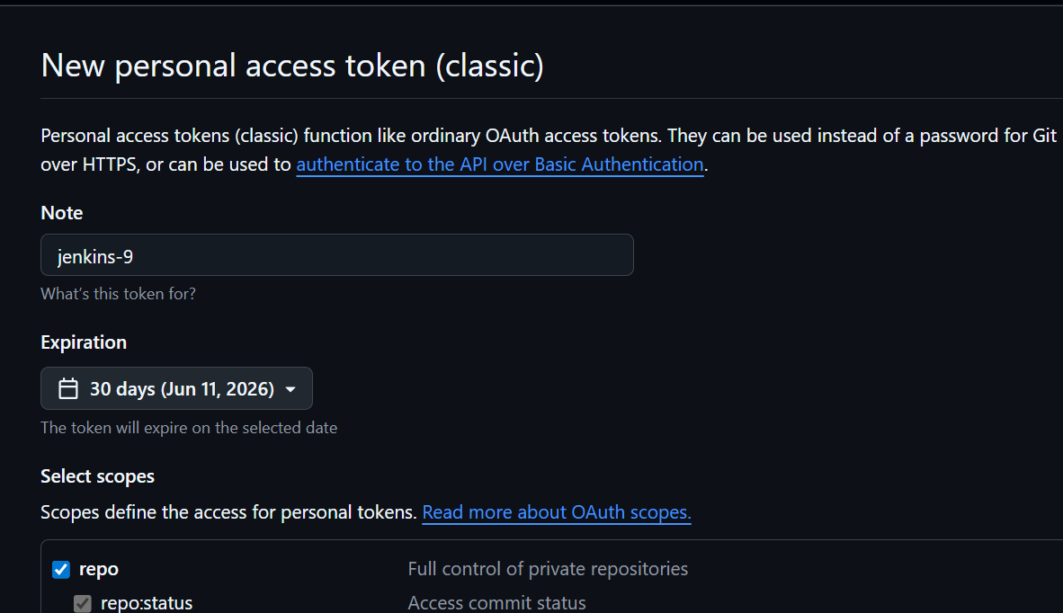

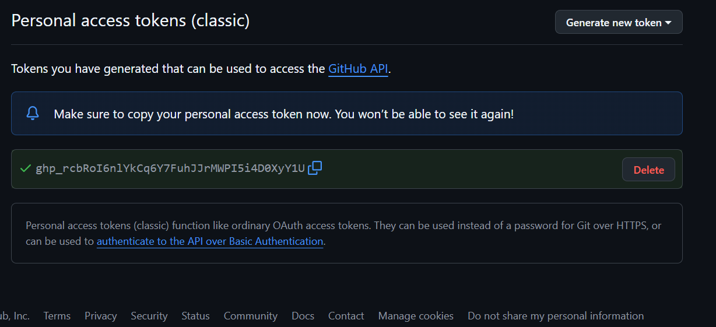
Select Global and Click Add Credentials and select username and password
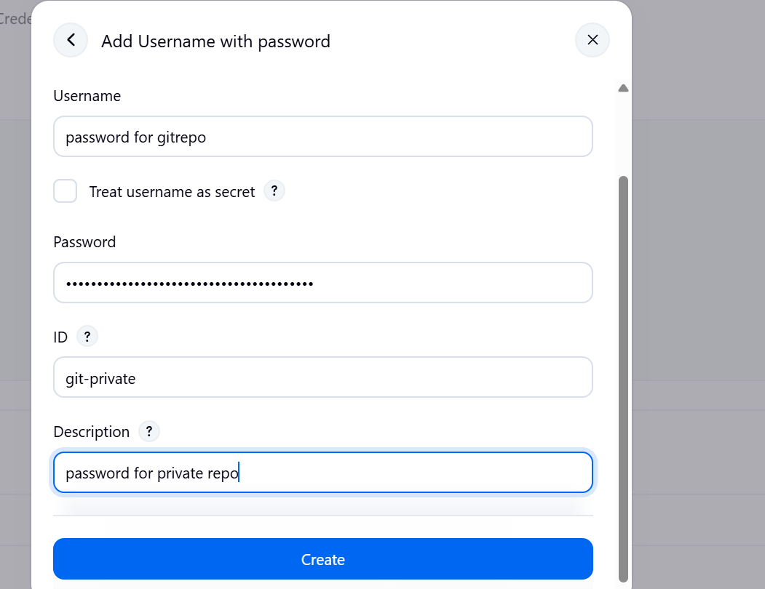
Now created new item as new-private-github

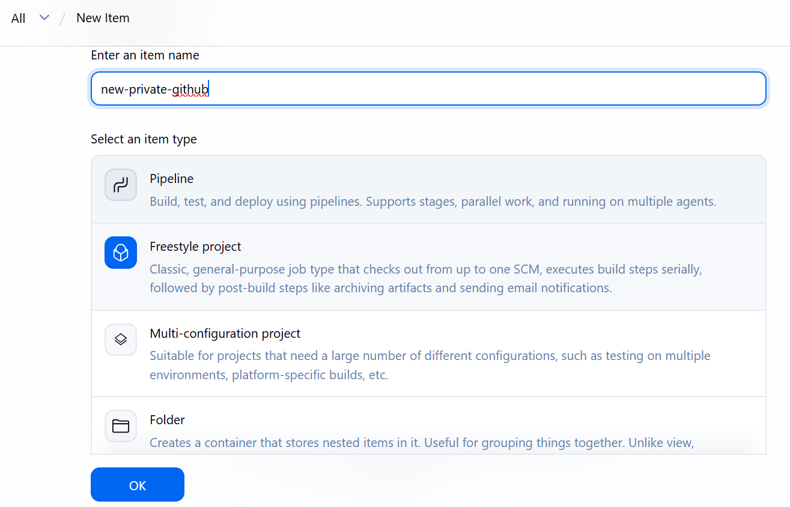
In Source Management change git and added my private git URL and change credentials
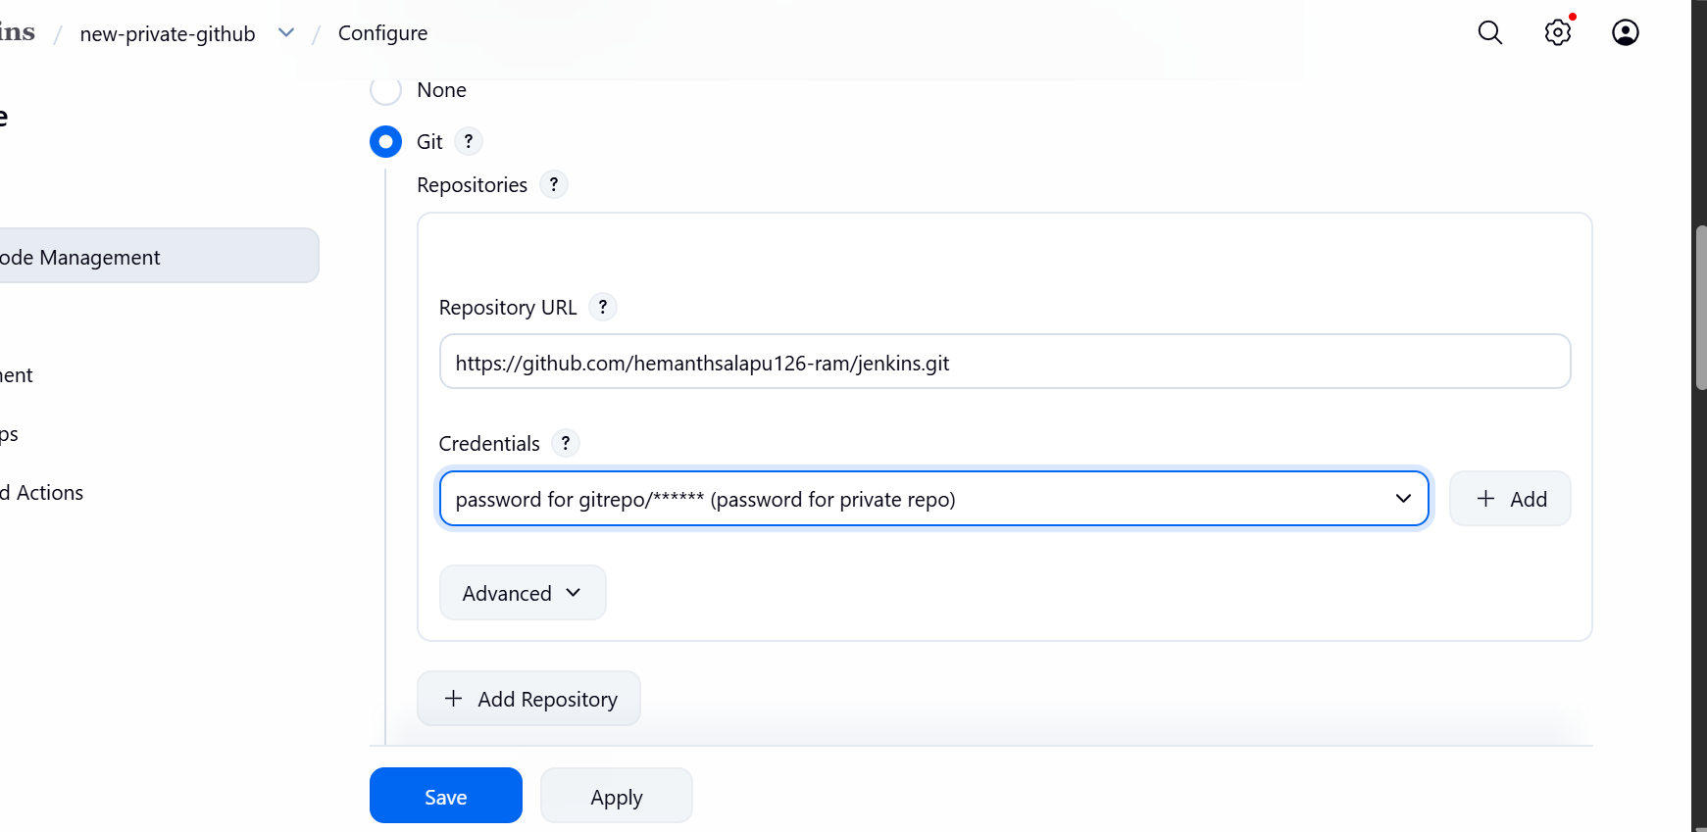
Now Build Steps and Execute Shell and command it and save

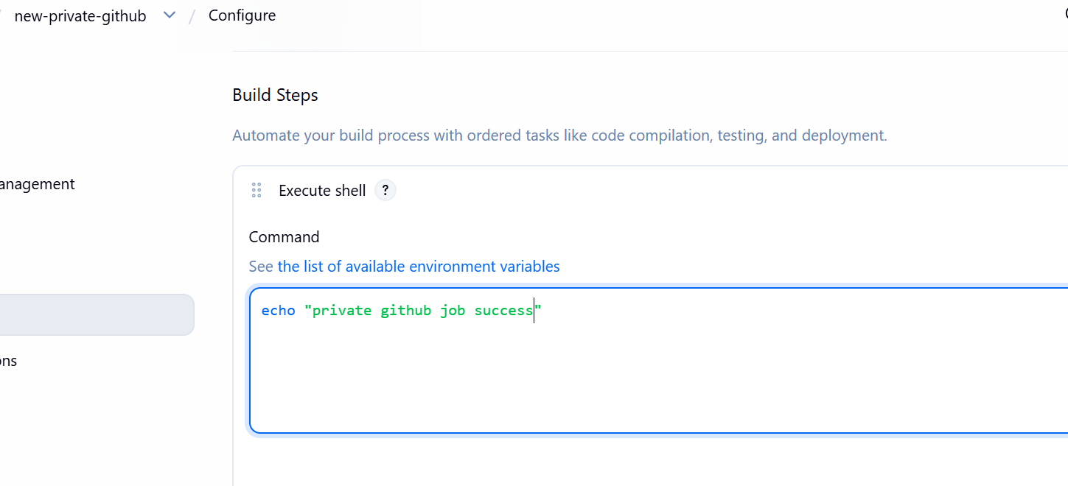
Build now is successful
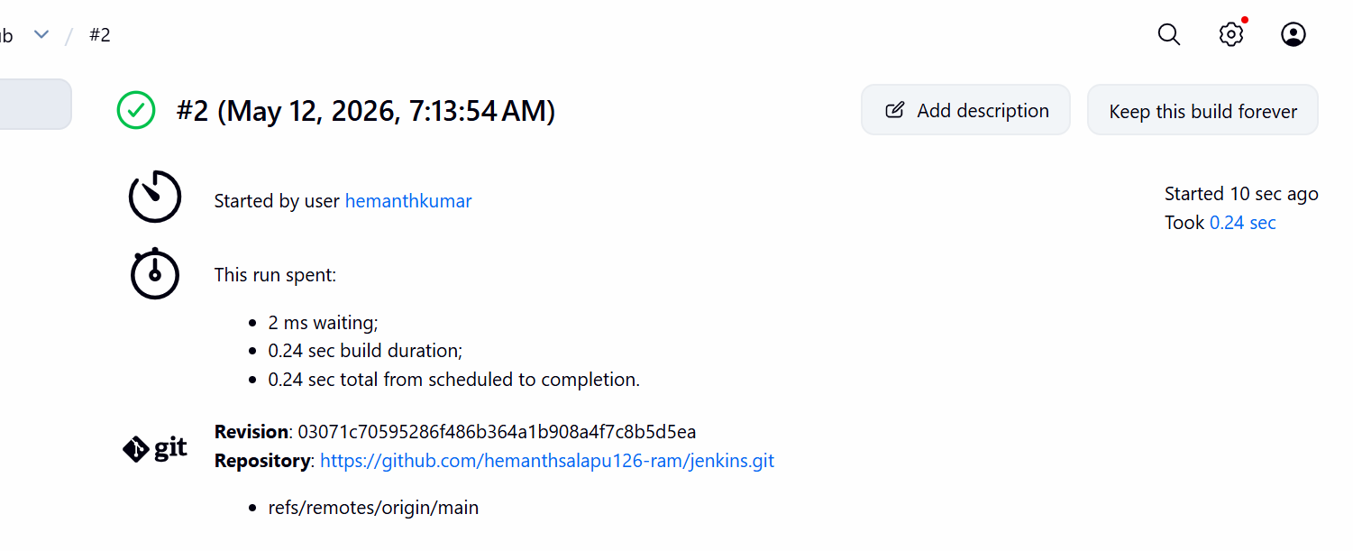
Console output
