NAME: HEMANTH S

REGISTRATION NO.: RA2211003010566

SECTION: CSE – I1

**PROBLEM STATEMENT:**

Subset image of water bodies (15x15). Add noise in the image.  Remove the noise from the given image using gaussian filter, mean filter and median filter.

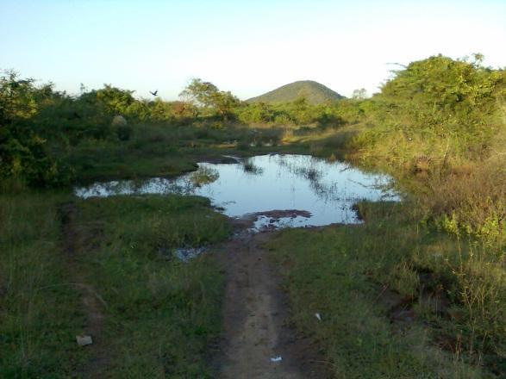

**AIM:**

To process a subset image (15x15 pixels) extracted from an image containing water bodies. The objective includes introducing noise into this subset image. Subsequently, the task involves applying three different filters - Gaussian, mean, and median filters - to remove the added noise from the image. Through this process, we aim to evaluate and compare the effectiveness of these filters in restoring the clarity and quality of the water body subset image, essential for accurate analysis and visual representation in image processing applications.

**ALGORITHM:**

1. Load the original image 'waterbody.jpg'.
2. Display the original image to understand its quality before processing.
3. Add Gaussian noise to the image using a specified standard deviation (gaussianNoiseSigma).
4. Display the noisy image to visualize the effects of added noise.
5. Apply a Gaussian filter to the noisy image to reduce Gaussian noise and smoothen the image.
6. Display the image after Gaussian filtering to observe noise reduction effects.
7. Implement a Mean filter (3x3 kernel) to further denoise the image by averaging pixel values in a neighborhood.
8. Display the image after Mean filtering to compare with the original and Gaussian-filtered images.
9. Use a Median filter (3x3 kernel) to remove noise spikes and improve image quality.
10. Display the image after Median filtering to assess noise reduction capabilities.
11. Present the original noisy image alongside the images filtered using Gaussian, Mean, and Median filters for comparative analysis.

**ARCHITECTURE DIAGRAM / PROBLEM DESIGN:**

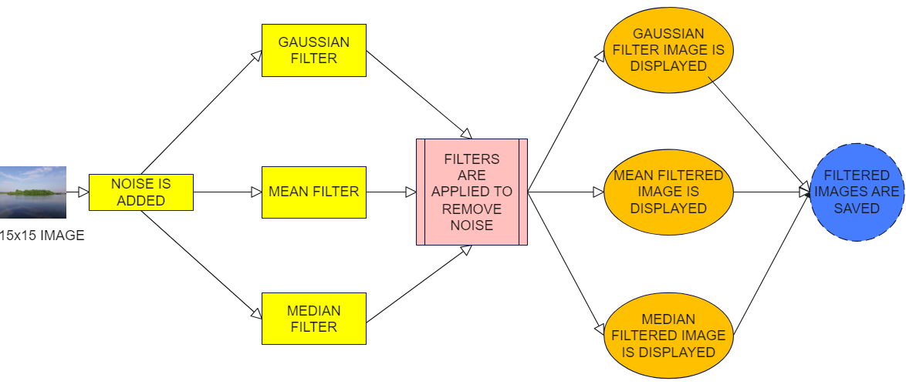

**MATLAB CODE :**

originalImage = imread('waterbody.jpg');

figure;

subplot(2, 2, 1);

imshow(originalImage);

title('Original Image');

gaussianNoiseSigma = 25;

gaussianNoisyImage = imnoise(originalImage, 'gaussian', 0, (gaussianNoiseSigma/255)^2);

subplot(2, 2, 2);

imshow(gaussianNoisyImage);

title('Noisy Image');

gaussianFiltered = imgaussfilt(gaussianNoisyImage, 1);

subplot(2, 2, 3);

imshow(gaussianFiltered);

title('Gaussian Filtered');

meanFiltered = imfilter(gaussianNoisyImage, fspecial('average', [3 3]), 'symmetric');

subplot(2, 2, 4);

imshow(meanFiltered);

title('Mean Filtered');

medianFiltered = medfilt2(gaussianNoisyImage, [3, 3]);

figure;

subplot(1, 2, 1);

imshow(medianFiltered);

title('Median Filtered');

subplot(1, 2, 2);

imshow(gaussianNoisyImage);

title('Noisy Image');

imwrite(gaussianFiltered, 'gaussianFiltered.jpg');

imwrite(meanFiltered, 'meanFiltered.jpg');

imwrite(medianFiltered, 'medianFiltered.jpg');

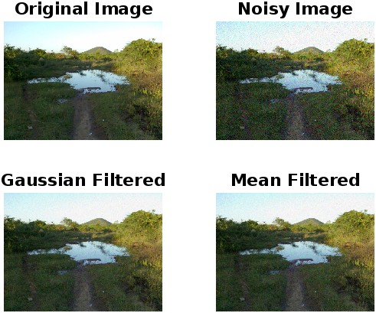**OUTPUT:**

