**CHATBOT DEPLOYMENT WITH IBM CLOUD WATSON ASSISTANT**

**DEVELOPMENT PART 1:**

In IBM Watson Assistant, which is a cloud-based conversational AI platform, entities, intents, and dialogs are key components used to build and train chatbots or virtual assistants. Here's a brief explanation of each:

**Entities:**

* In Watson Assistant, an entity represents a specific piece of information within user input. It is used to extract relevant data from user messages. Entities can be things like dates, numbers, product names, or any other data you want to capture. You define entities to help the assistant understand and process user queries more effectively.
* For example, if you're building a chatbot for a restaurant, you might define an entity named "cuisine" to extract the type of cuisine the user is interested in (e.g., Italian, Chinese, Mexican).

**Intents:**

* An intent is the purpose or goal expressed in a user's message. It represents what the user is trying to achieve or communicate. Intents are essential for routing user requests to the appropriate responses or actions. You define intents to help the assistant recognize and categorize user input accurately.
* For instance, in a virtual assistant for a bank, you might define intents like "Check Account Balance," "Transfer Funds," or "Report Lost Card" to identify the user's intentions.

**Dialogs:**

* Dialogs in Watson Assistant are used to structure the conversation flow between the user and the chatbot. You create dialog nodes to define how the assistant should respond to user input based on detected intents and entities. Dialogs help in creating dynamic and context-aware interactions.
* Within a dialog node, you can define responses, conditions, and actions to take. You can also incorporate variables to store and retrieve information throughout the conversation, enabling personalized interactions.
* The typical workflow in Watson Assistant involves defining entities and intents, building dialog nodes to handle different conversation paths, and training the assistant using historical data or sample conversations. This training helps the assistant understand user input better, recognize intents and entities accurately, and respond appropriately.
* Entities, intents, and dialogs work together to enable natural and context-aware conversations between users and your chatbot or virtual assistant built with IBM Watson Assistant. By correctly defining and configuring these components, you can create effective and intelligent conversational interfaces.
* Now we are going to create the chatbot for that we will do the primary steps now.

**STEP1:**

* Login To The IBM account and click on the Catalog and then search for Watson Assistant and give enter.

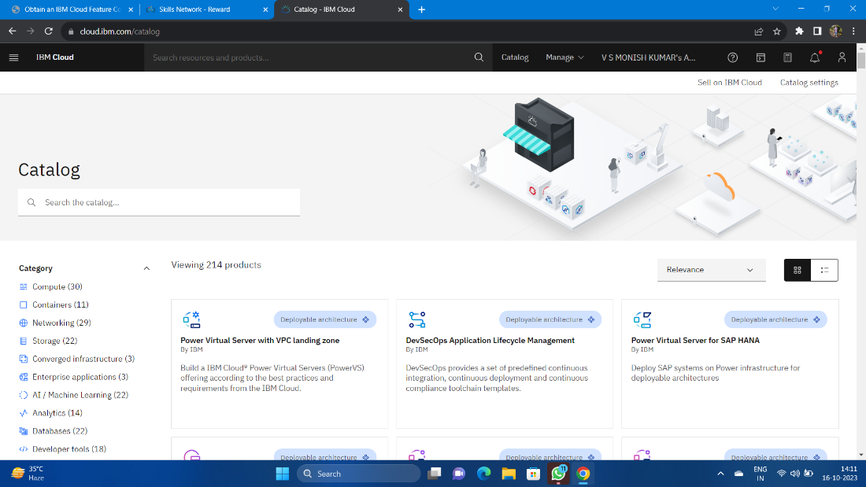

* You will get the Watson Assistant There By default you will have this

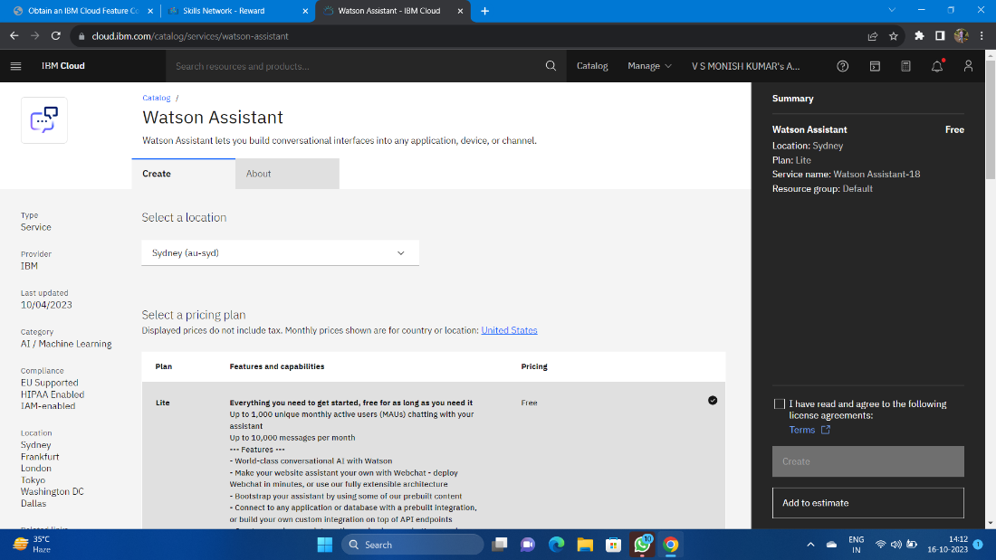

**Step 2:**

* Change the default location and give the location as London(eu-gb) and select the plan as Lite

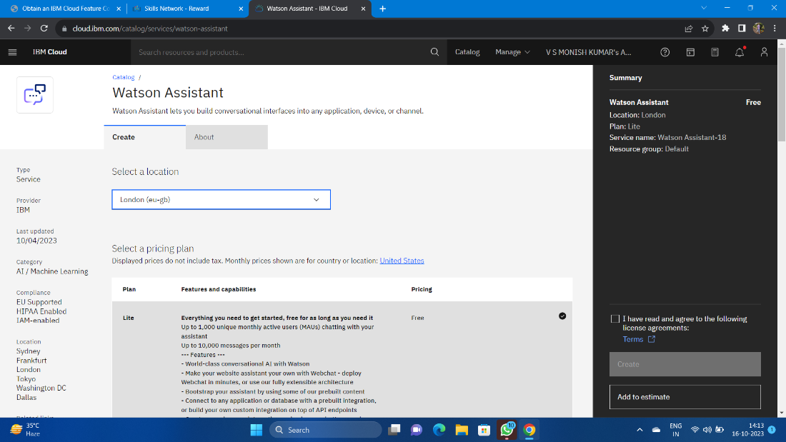

* Give tick mark for I have read and agree to the following license agreement
* Now click on create it will create an instance for you

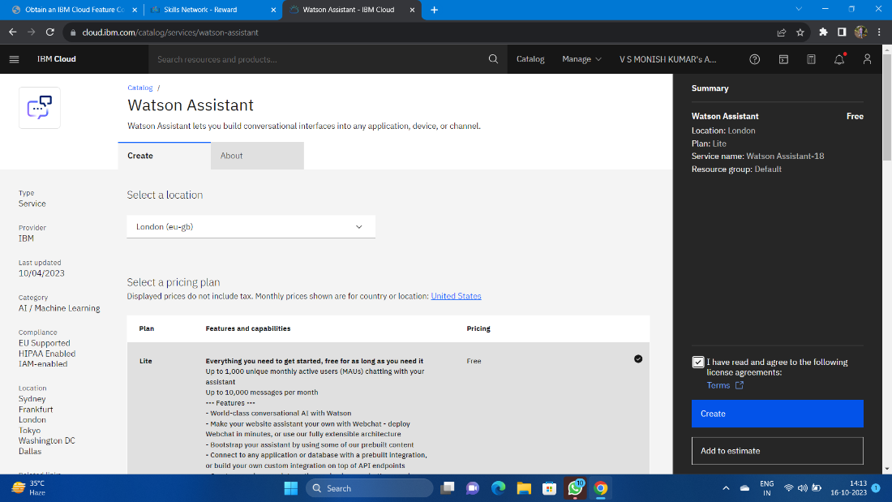

**Step 3:**

* After creating an instance for Watson Assistant you need to launch the Watson Assistant by clicking the launch the assistant

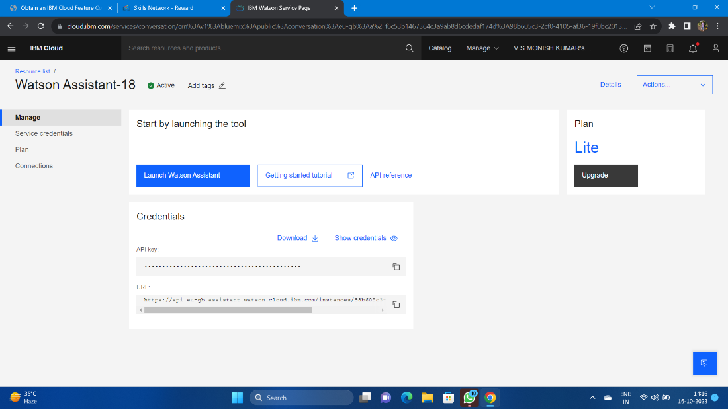

**Step 4:**

* It will give the access to create the assistant give the name for the Assistant and give the description for that assistant it's completely optional click on create and save it.
* Here I have been created NM BOT as my chat bot assistant name .

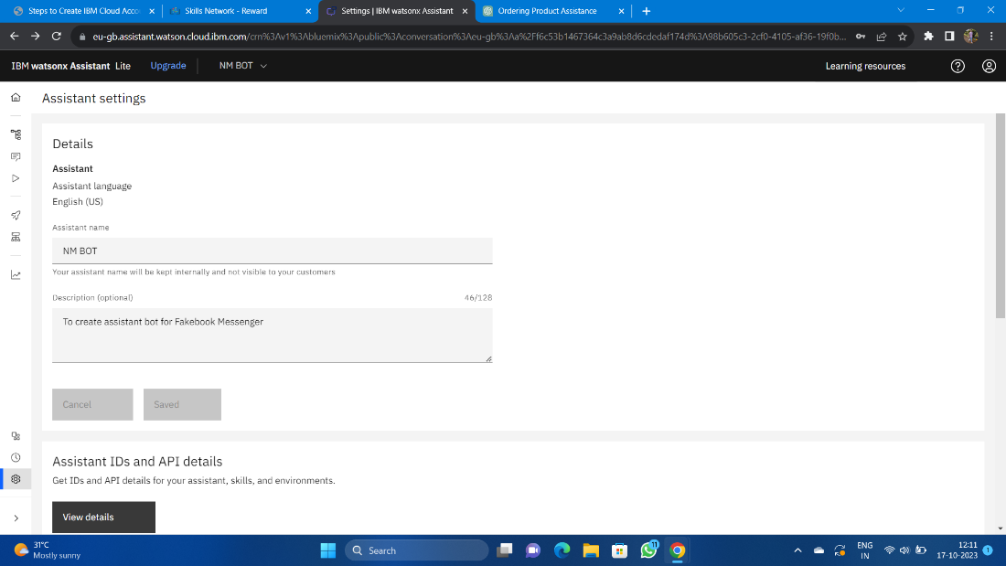

* Now scroll down and then activate the dialog

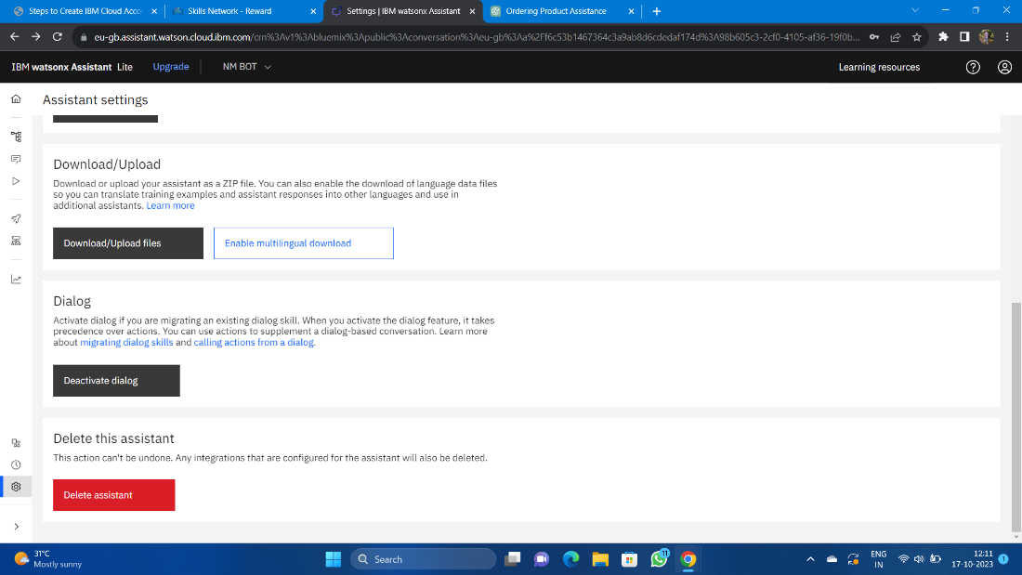

**Step 5:**

* After activating the Dialog, you will get the Intents, Entities, Dialog, and Content catalog like shown below

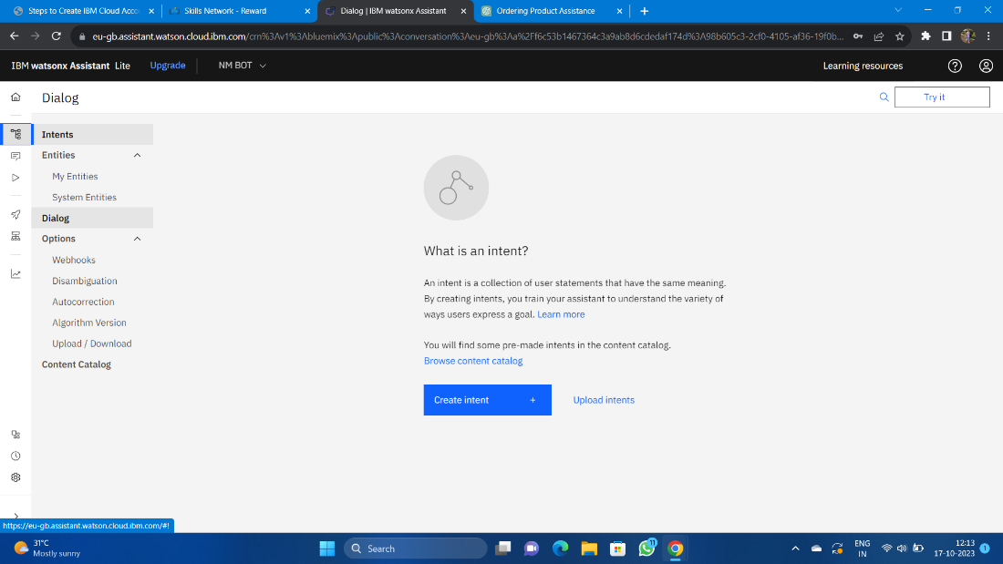

**Step 6:**

* Create the Entities first and one variables for the entities you have been created.
* Here I have been created the Entity with the name Entertainement and added variables as channels and star with some variable value.

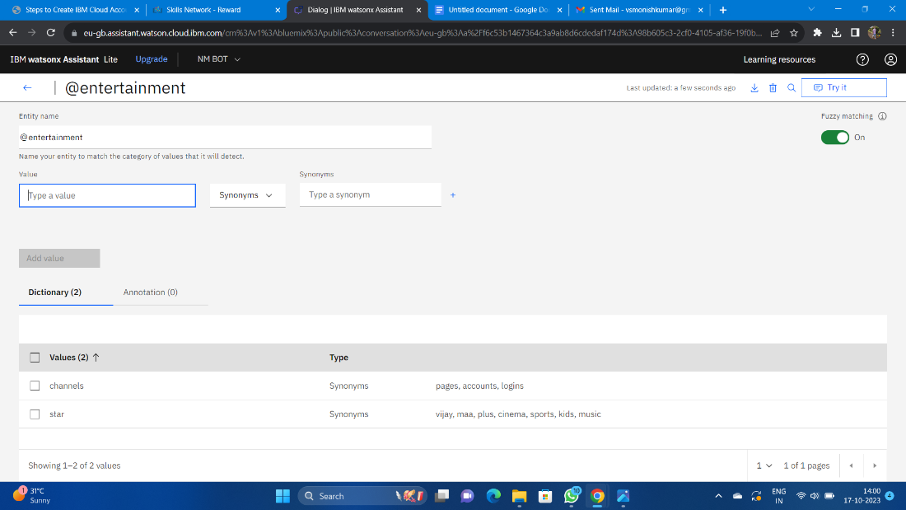

**Step 7:**

* Open the Intents and then create the Intents for Messages, Services, AboutMe give some example queries for them

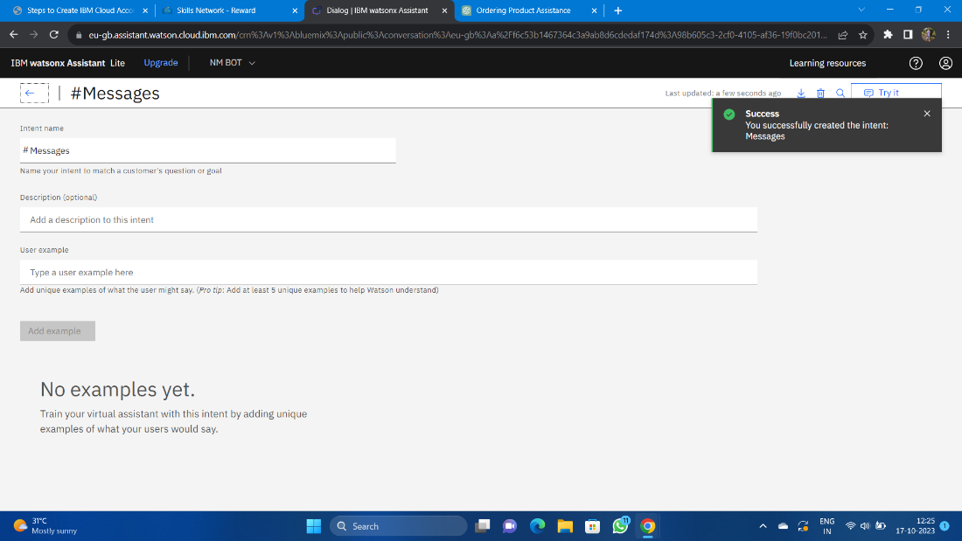

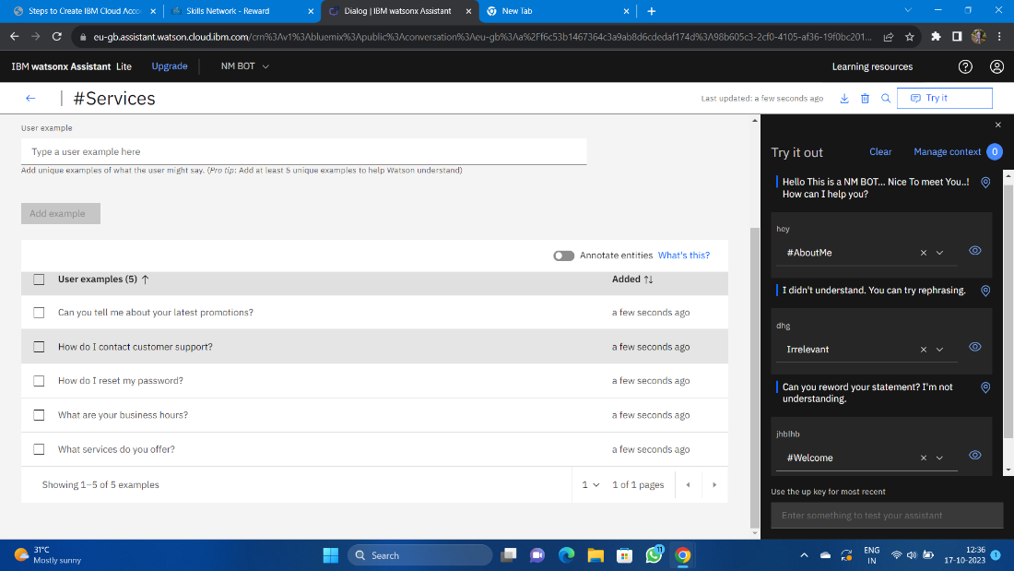

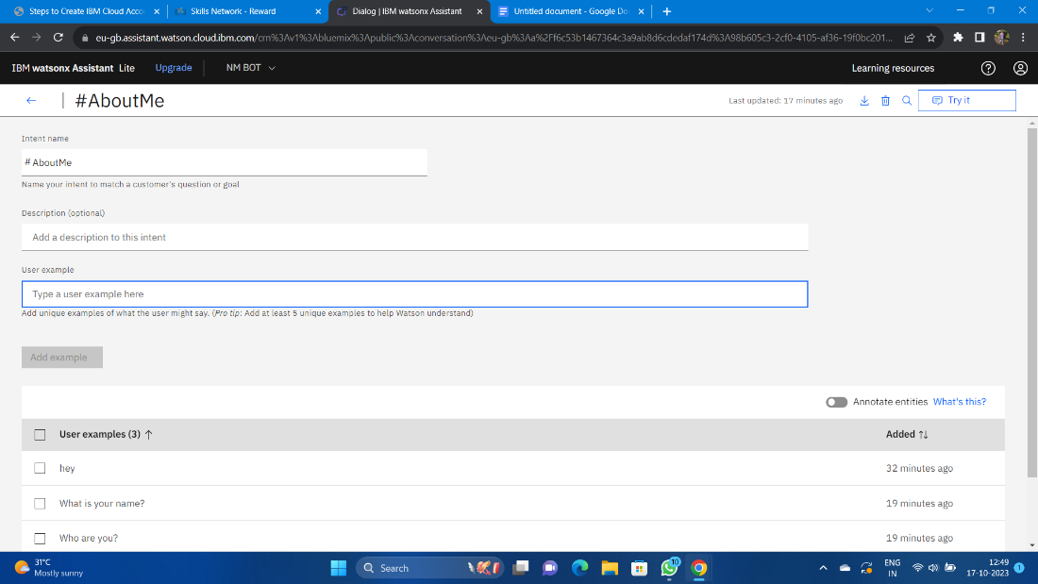

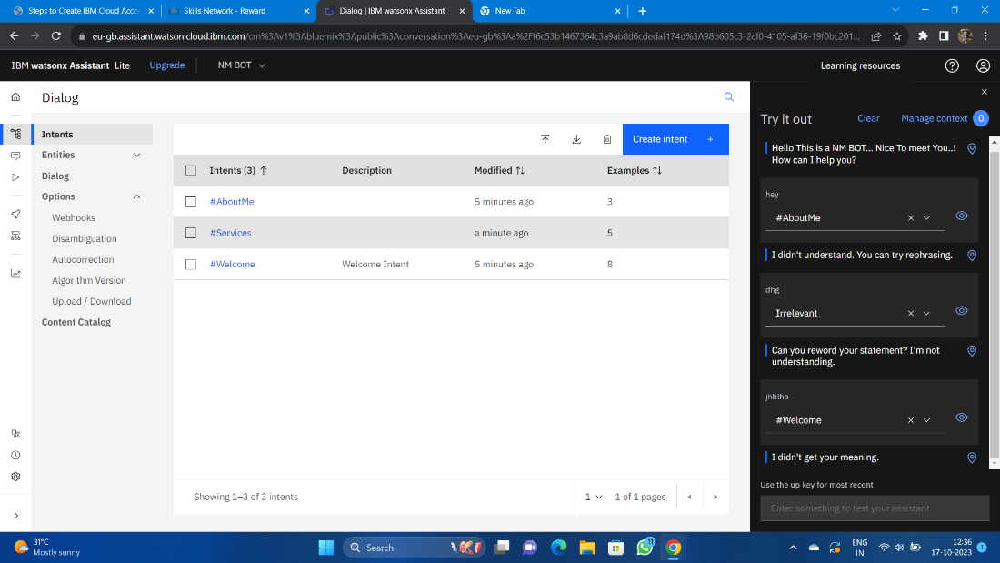

**Step 8:**

* Next open the Dialog and then add nodes for all the Intents you have created where we need to give the responses for the selected queries.
* Whereby default we will have Anything else node.

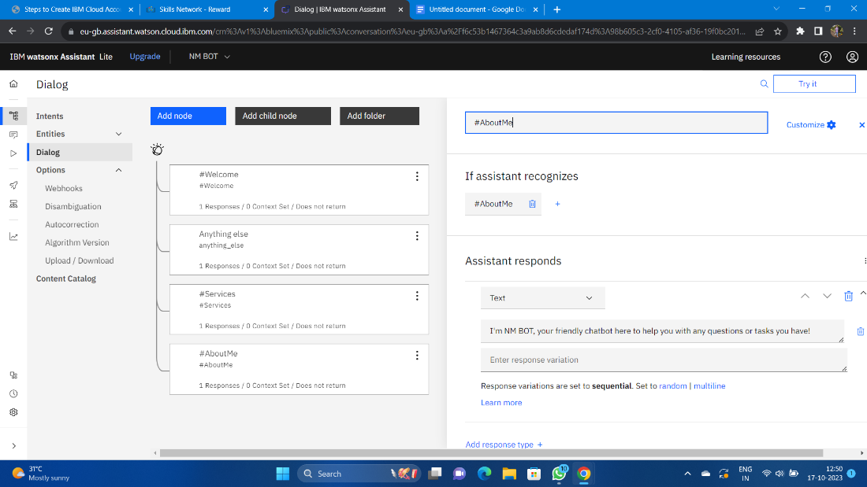

**Step 9:**

* Check the chat bot by clicking the try it before connecting the Facebook Messenger.

