Data Analytics Capstone

Anomaly Detection in Financial Transactions with Application to POS-Based Revenue Leakage in Restaurant Systems

Interim Report - Draft
Hemanth Kumar
Walsh College
QM640: Data Analytics Capstone
Mr Shyam Venkatesh
Fall 2025
06-05-2026

GitHub Repository
GitHub Link:
https://github.com/hemanthsnk/DBA-Anomaly-Detection.git
The GitHub repository contains the data files, Jupyter notebooks, code scripts, and supporting documentation used for this interim report. The repository supports reproducibility by providing access to the datasets, analysis workflow, model outputs, and project documentation.
Repository contents include:
- Dataset files
- Jupyter notebooks
- Code scripts
- Supporting documentation
GitHub Repository Structure screenshot
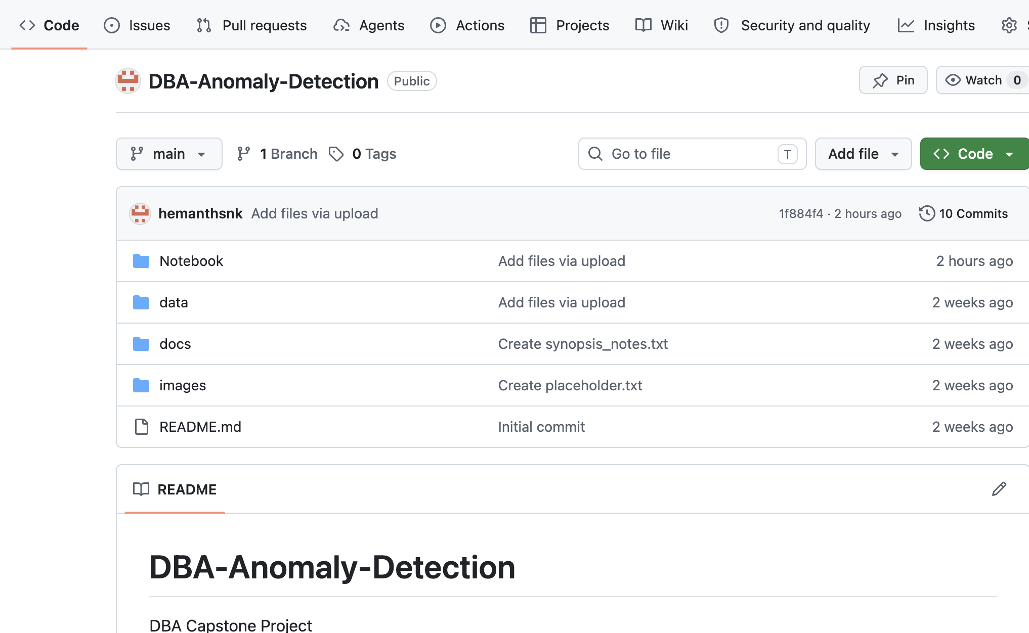
Figure 1. GitHub Repository Structure
Figure 1 shows the GitHub repository created for this project, including the folder structure, data files, notebooks, and supporting documentation.
All results presented in this report can be reproduced using the repository.

1. Introduction

Background and Context
The rapid digitization of financial transactions has significantly transformed how organizations manage financial operations. Businesses today process large volumes of transactions across multiple channels such as credit cards, digital payments, and point of sale systems. While this transformation has improved efficiency and scalability, it has also introduced challenges in monitoring transactions and identifying anomalies.
Fraud detection remains a critical concern in financial systems due to the increasing sophistication of fraudulent behavior. Traditional rule-based systems are effective for known fraud patterns but struggle to detect evolving and subtle anomalies. In addition to financial fraud, operational environments such as restaurant point-of-sale (POS) systems face issues related to revenue leakage due to rounding discrepancies and manual handling of transactions.
This study integrates financial fraud detection with operational anomaly detection by examining both credit card transaction fraud and POS-based revenue leakage. The combined approach provides a practical framework for identifying irregularities in both financial and operational datasets. This is important for financial analysts, fraud detection teams, restaurant operations managers, internal audit teams, and business leaders who need reliable methods to identify risk and reduce financial loss.

Problem Statement
Organizations face challenges in detecting anomalous financial transactions due to severe class imbalance and subtle fraud patterns. Traditional detection systems may either miss fraud cases or generate excessive false alerts. In operational environments such as restaurant POS systems, small rounding discrepancies can accumulate into measurable revenue leakage over time. This project addresses the gap between financial fraud detection and operational anomaly detection by applying both machine learning and rule-based techniques.

Purpose of the Study
The purpose of this study is to detect, classify, and explain anomalous transaction behavior using two datasets. The first objective is to identify fraudulent credit card transactions using supervised and unsupervised machine learning models. The second objective is to detect POS-based revenue leakage using rule-based and machine learning anomaly detection methods. The study also evaluates model performance and interprets findings from a business decision-making perspective.

Interim Project Status
Completed:
- Data collection for credit card and POS datasets
- Data loading and initial inspection
- Data cleaning, including missing value and duplicate checks
- Exploratory data analysis for both datasets
- Baseline modeling using Logistic Regression and Isolation Forest
- Preliminary performance evaluation
In progress:
- Refinement of feature engineering
- Model comparison and interpretation
- Improvement of visual documentation and report formatting
Pending:
- Final model validation
- Additional tuning of anomaly detection thresholds
- Final recommendations and business implementation plan

2. Scope and Objectives

Scope
This study focuses on analyzing financial and POS transaction data to detect anomalies and evaluate business impact. The scope is limited to offline analysis using available datasets and does not include real-time system deployment. The study uses a credit card fraud dataset to evaluate financial transaction anomaly detection and a POS dataset to examine revenue leakage patterns across stores.

Objectives
The objectives of this study are:
- To detect fraudulent transactions using machine learning techniques
- To evaluate model performance under highly imbalanced data conditions
- To identify revenue leakage patterns in POS systems
- To compare rule-based and machine learning anomaly detection approaches
- To interpret preliminary findings from both technical and business perspectives

Research Questions
RQ1: How effectively can anomaly detection techniques identify fraudulent financial transactions?
RQ2: What transaction-level features contribute most to anomaly detection?
RQ3: How can anomaly detection techniques detect revenue leakage patterns in POS systems?
RQ4: What is the impact of detected anomalies on business performance?

3. Literature Survey

Literature Review Approach
The literature review focused on studies related to credit card fraud detection, anomaly detection, imbalanced classification, machine learning models, and operational fraud monitoring. Sources were selected based on their relevance to the research questions and their contribution to model selection, data interpretation, and business applicability. The review includes peer-reviewed journal articles, survey papers, and applied fraud detection studies.

Summary of Key Literature
Table 1. Literature Relevance Matrix
Author | Domain or Context | Dataset or Setting | Method(s) | Key Findings | Relevance
Bhattacharyya et al. (2011) | Credit card fraud | Financial transactions | Data mining models | Fraud detection requires careful handling of rare events | Supports RQ1 and model selection
Bolton and Hand (2002) | Statistical fraud detection | Financial fraud | Statistical anomaly detection | Rare events can be detected through deviations from normal behavior | Supports RQ1
Chandola et al. (2009) | General anomaly detection | Multiple domains | Survey of anomaly methods | Anomaly detection is effective for unusual pattern identification | Supports RQ1 and RQ3
Ngai et al. (2011) | Financial fraud detection | Fraud systems | Data mining review | Classification and outlier detection are common fraud tools | Supports RQ1 and RQ2
Phua et al. (2010) | Fraud detection | Multiple fraud datasets | Survey and hybrid models | Hybrid approaches improve fraud detection | Supports hybrid method
Dal Pozzolo et al. (2015) | Credit card fraud | Imbalanced fraud data | Machine learning | Imbalanced data requires careful evaluation metrics | Supports RQ1
Jurgovsky et al. (2018) | Credit card fraud | Sequential transactions | Sequence classification | Transaction behavior over time helps fraud detection | Supports time-based analysis
Sahin and Duman (2011) | Credit card fraud | Financial transactions | Decision trees and support vector machines | Machine learning models can detect fraud but vary in performance | Supports modeling comparison
West and Bhattacharya (2016) | Intelligent fraud detection | Financial systems | Review of fraud practices | Practical systems need interpretability and business fit | Supports RQ4
Whitrow et al. (2009) | Credit card fraud | Transaction aggregation | Aggregation methods | Aggregated transaction features can improve detection | Supports feature engineering
The literature supports the use of both supervised and unsupervised models, which guided the modeling approach in this study.
Fraud detection has been widely studied as a rare-event classification problem. Bhattacharyya et al. (2011) demonstrated the usefulness of machine learning techniques in identifying fraudulent credit card transactions, while Bolton and Hand (2002) emphasized the importance of statistical fraud detection and deviations from normal behavior. These studies are relevant to RQ1 because they show that fraud detection requires techniques designed for unusual and infrequent events.
Research on anomaly detection provides a strong foundation for this project. Chandola et al. (2009) categorized anomaly detection approaches into statistical, proximity-based, and machine learning techniques. Ngai et al. (2011) and Phua et al. (2010) further highlighted the role of data mining and hybrid approaches in fraud detection. These studies support the decision to use both Logistic Regression and Isolation Forest in this project.
The literature also shows that highly imbalanced datasets require careful evaluation. Dal Pozzolo et al. (2015) discussed challenges in modeling credit card fraud under realistic imbalance conditions, while Jurgovsky et al. (2018) demonstrated the value of transaction behavior over time. These findings support the use of precision, recall, and F1-score instead of accuracy alone.
A gap remains in applying anomaly detection to operational business problems such as POS revenue leakage. Most existing fraud detection studies focus on banking and credit card systems. This study extends anomaly detection into operational transaction monitoring by identifying store-level rounding discrepancies and potential revenue leakage patterns.

Research Gap
Existing studies primarily focus on financial fraud detection and do not adequately address operational anomalies such as POS-based revenue leakage. In addition, many studies emphasize model performance but provide limited business interpretation. This study addresses these gaps by combining financial fraud detection with POS anomaly detection, applying both rule-based and machine learning methods, and interpreting results from a business decision-making perspective.

4. Data Description

Data Source(s) and Access
Two datasets are used in this study. The first dataset is a publicly available anonymized financial transaction dataset widely used in academic research for credit card fraud detection. The dataset contains European cardholder transactions over a two-day period and includes anonymized principal component analysis (PCA) features, transaction amount, time, and fraud label.
The second dataset is a synthetic POS dataset created to reflect realistic restaurant transaction behavior. The dataset simulates store-level transactions, rounding discrepancies, and potential revenue leakage patterns. No personally identifiable or proprietary business data is included.
Both datasets and supporting code are available in the GitHub repository listed at the beginning of this report.

Dataset Overview
Table 2. Dataset Overview
Dataset | Records | Variables | Unit of Analysis | Target Variable | Purpose
Credit Card Fraud Dataset | 284,807 original records; 283,726 after duplicate removal | 31 | Transaction | Class | Fraud detection
POS Dataset | 20,000 | 6 | Transaction | Anomaly_Flag or ML_Anomaly | Revenue leakage detection

Credit Card Dataset
The credit card dataset contains anonymized transaction data with features V1–V28, Amount, Time, and Class. Fraudulent transactions represent a very small proportion of the dataset. The Class variable is binary, where 1 represents a fraudulent transaction and 0 represents a non-fraudulent transaction.
Table 3. Sample Credit Card Dataset
Time | V1 | V2 | V3 | Amount | Class
0.0 | -1.3598 | -0.0728 | 2.5363 | 149.62 | 0
0.0 | 1.1919 | 0.2662 | 0.1665 | 2.69 | 0
1.0 | -1.3584 | -1.3402 | 1.7732 | 378.66 | 0
1.0 | -0.9663 | -0.1852 | 1.7930 | 123.50 | 0
2.0 | -1.1582 | 0.8777 | 1.5487 | 69.99 | 0

Table 4. Credit Card Dataset Summary
Metric | Value
Original records | 284,807
Records after duplicate removal | 283,726
Variables | 31
Missing values | 0
Duplicate records removed | 1,081
Fraud percentage | 0.1667%
Median transaction amount | 22.00
Maximum transaction amount | 25,691.16
The dataset contains 284,807 transaction records with 31 numerical variables, including 30 input features and one binary target variable. There are no missing values, which eliminates the need for imputation. Features V1–V28 are anonymized using PCA, meaning they lack direct business interpretation but are effective for modeling. The dataset is mostly model-ready, with preprocessing required mainly for duplicate removal and scaling of Time and Amount variables.

POS Dataset
The POS dataset contains 20,000 transactions including Amount, Rounded_Value, Difference, Store_ID, and Timestamp. The Difference variable represents the discrepancy between actual transaction amount and rounded transaction value and is used as the primary anomaly indicator.
Table 5. Sample POS Transaction Dataset
Transaction_ID | Store_ID | Timestamp | Amount | Rounded_Value | Difference
1 | S7 | 2026-01-01 00:00:00 | 187.79 | 188.00 | 0.21
2 | S4 | 2026-01-01 00:01:00 | 185.00 | 185.00 | 0.00
3 | S8 | 2026-01-01 00:02:00 | 19.58 | 20.00 | 0.42
4 | S5 | 2026-01-01 00:03:00 | 42.89 | 43.00 | 0.11
5 | S7 | 2026-01-01 00:04:00 | 36.51 | 37.00 | 0.49

Table 6. Summary Statistics of POS Transaction Dataset
Statistic | Transaction_ID | Amount | Rounded_Value | Difference
Count | 20,000 | 20,000 | 20,000 | 20,000
Mean | 10,000.50 | 104.93 | 105.03 | 0.099
Std Dev | 5,773.65 | 54.83 | 54.83 | 0.352
Min | 1 | 10.00 | 10.00 | -0.50
25% | 5,000.75 | 57.74 | 58.00 | -0.18
50% | 10,000.50 | 105.09 | 105.00 | 0.10
75% | 15,000.25 | 152.42 | 152.00 | 0.35
Max | 20,000 | 200.00 | 200.00 | 0.99
The POS dataset contains 20,000 transaction records across multiple stores with no missing values. It consists of six variables, including transaction details, store identifier, and financial attributes. The Difference variable ranges from -0.50 to 0.99 with an average of approximately 0.099, indicating both under-rounding and over-rounding behavior. The Store_ID and Timestamp variables enable store-level and time-based analysis.

Data Dictionary
Table 7. Data Dictionary
Variable | Dataset | Definition | Type | Missing Value Handling | Notes
Time | Credit Card | Time elapsed between transactions | Numeric | None required | Scaled before modeling
V1–V28 | Credit Card | PCA-transformed anonymized features | Numeric | None required | Used for modeling
Amount | Credit Card | Transaction value | Numeric | None required | Scaled before modeling
Class | Credit Card | Fraud label | Binary | None required | 1 = fraud; 0 = non-fraud
Transaction_ID | POS | Unique transaction identifier | Integer | None required | Identifier only
Store_ID | POS | Store identifier | Categorical | None required | Used for store-level analysis
Timestamp | POS | Transaction date and time | Datetime | None required | Used for time-based analysis
Rounded_Value | POS | Rounded transaction value | Numeric | None required | Used for difference calculation
Difference | POS | Rounded value minus actual amount | Numeric | None required | Main POS anomaly indicator
Anomaly_Flag | POS | Rule-based anomaly indicator | Binary | Created variable | 1 = anomaly; 0 = normal
ML_Anomaly | POS | Isolation Forest anomaly indicator | Binary | Created variable | 1 = anomaly; 0 = normal

GitHub Data Availability Statement
The raw and processed datasets are available in the GitHub repository under the data folder. The Jupyter notebook containing Python code and outputs is available under the notebooks or docs folder. The repository includes all files required to reproduce the analysis and review the interim project progress.

5. Analysis

5.1 Data Cleaning
Data cleaning was performed to confirm missing values, duplicate records, and model readiness. The credit card dataset contained no missing values but included 1,081 duplicate records, which were removed before exploratory data analysis and modeling. The POS dataset contained no missing values and no duplicate records.
Table 8. Data Cleaning Log
Issue | Dataset | Variables Affected | Detection Method | Treatment Applied | Rationale
Missing values | Credit Card | All variables | isnull().sum() | No treatment required | No missing values found
Duplicates | Credit Card | All variables | duplicated().sum() | Removed 1,081 duplicate rows | Avoid duplicated records biasing analysis
Missing values | POS | All variables | isnull().sum() | No treatment required | No missing values found
Duplicates | POS | All variables | duplicated().sum() | No treatment required | No duplicates found
Scale differences | Credit Card | Time, Amount | Data inspection | StandardScaler applied | Required for Logistic Regression
Derived anomaly label | POS | Difference | Business threshold | Created Anomaly_Flag | Supports POS anomaly detection
The data cleaning process confirmed that both datasets were suitable for analysis. The credit card dataset was reduced from 284,807 records to 283,726 records after duplicate removal. The POS dataset remained at 20,000 records after validation. These steps ensure that the analysis and modeling are not biased by missing or duplicated observations.

5.2 Credit Card Exploratory Data Analysis
The credit card dataset shows extreme class imbalance, with fraud representing only 0.1667% of transactions. This means that a model could achieve high accuracy by predicting most transactions as non-fraudulent. Therefore, accuracy alone is not sufficient for evaluating model performance.
Fraud vs Non-Fraud Transaction Distribution
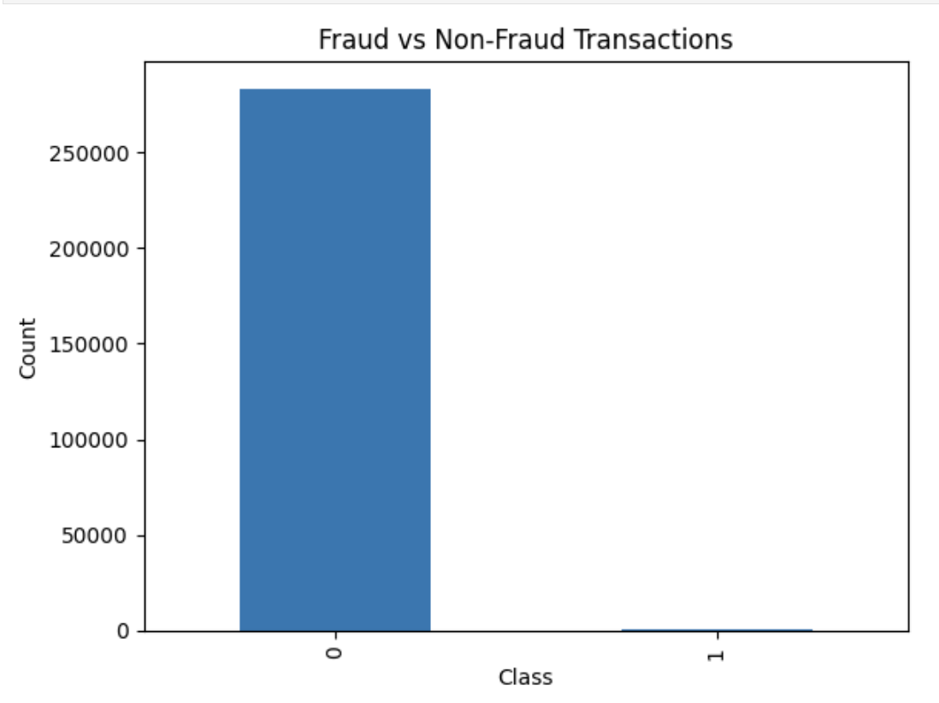
Figure 2. Fraud vs Non-Fraud Transaction Distribution
Figure 2 shows that the non-fraud class is significantly larger than the fraud class. This finding supports the use of precision, recall, and F1-score for model evaluation.
Fraud Percentage Output
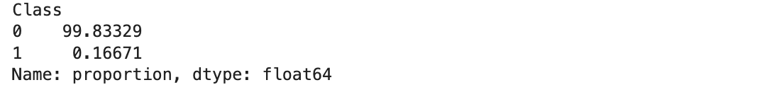
Figure 3. Percentage Distribution of Fraudulent and Non-Fraudulent Transactions
Figure 3 confirms that fraudulent transactions represent only 0.1667% of the dataset, while non-fraudulent transactions account for 99.8333%. This directly supports RQ1 because it shows that specialized anomaly detection methods are needed for highly imbalanced data.

Transaction Amount Distribution
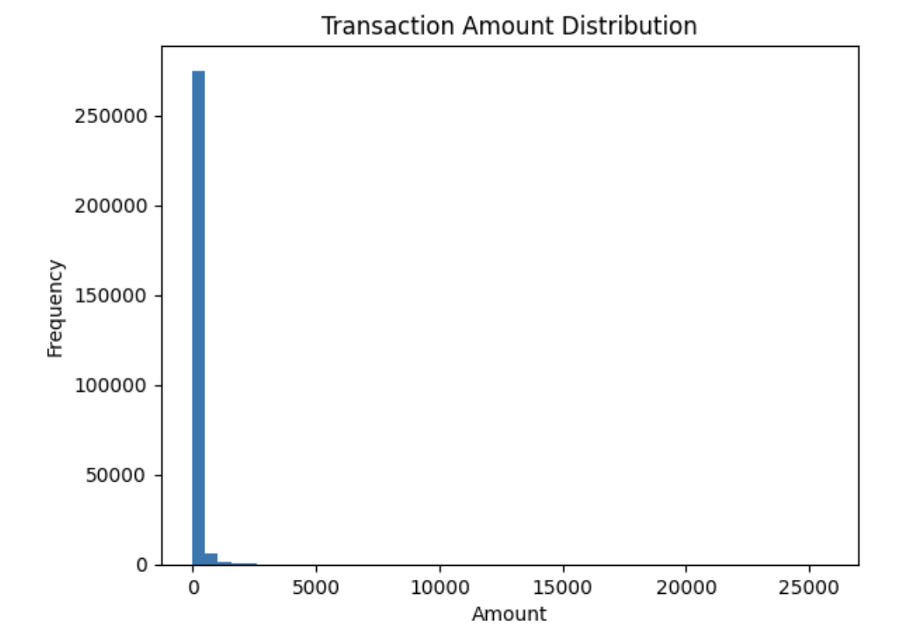
Figure 4. Distribution of Transaction Amounts
Figure 4 shows that transaction amounts are highly right-skewed. Most transactions are low-value, while a small number of transactions have extremely high amounts. This suggests that transaction amount may provide useful information but is not sufficient by itself.
Fraud Transaction Amount Distribution
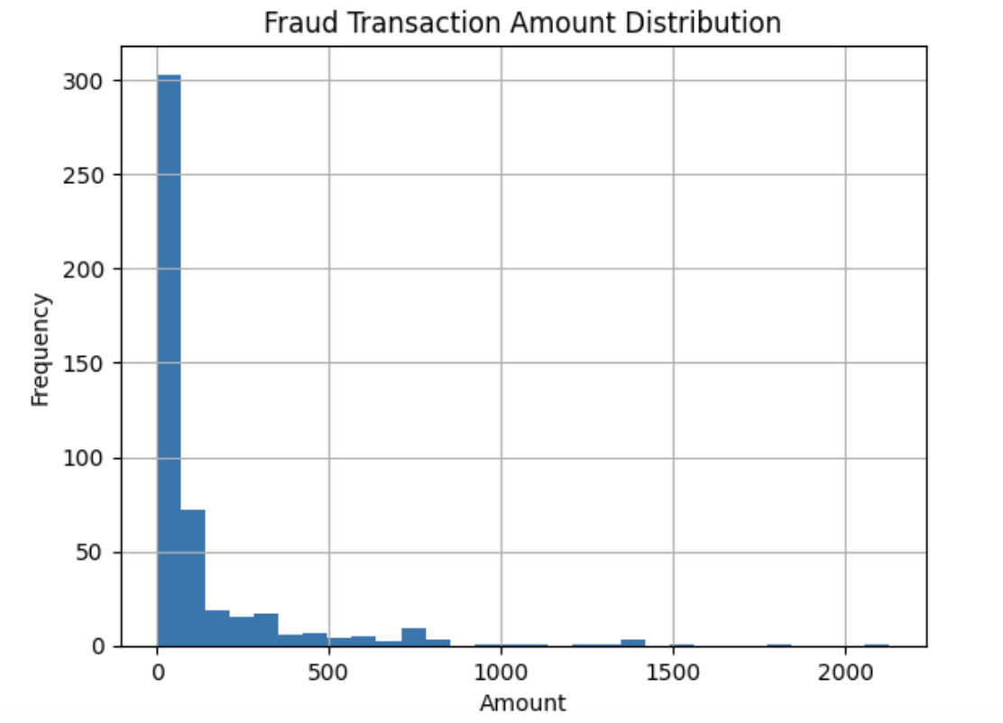

Figure 5. Distribution of Fraudulent Transaction Amounts
Figure 5 shows that fraudulent transactions also occur across a range of values and are not limited to high-value transactions. This supports RQ2 because it shows that fraud detection requires multi-feature analysis rather than simple amount-based thresholds.
Transaction Time Distribution
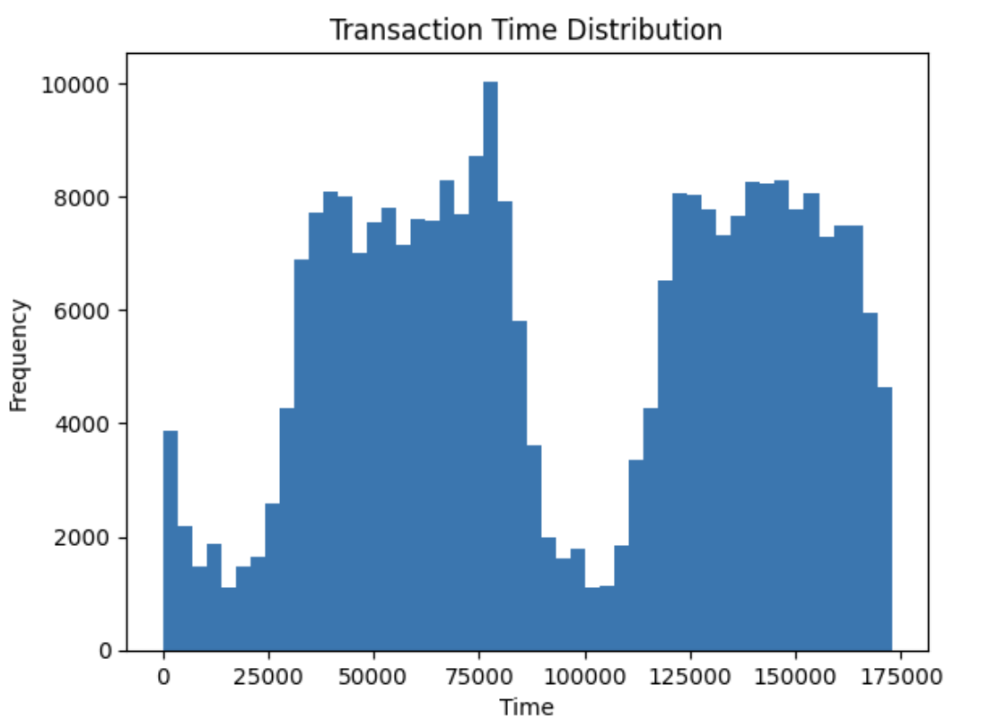
Figure 6. Distribution of Transactions Over Time
Figure 6 shows that transaction activity varies over time and appears to follow a non-uniform pattern. This suggests that time-based features may contribute to anomaly detection.
Fraud Transactions Over Time
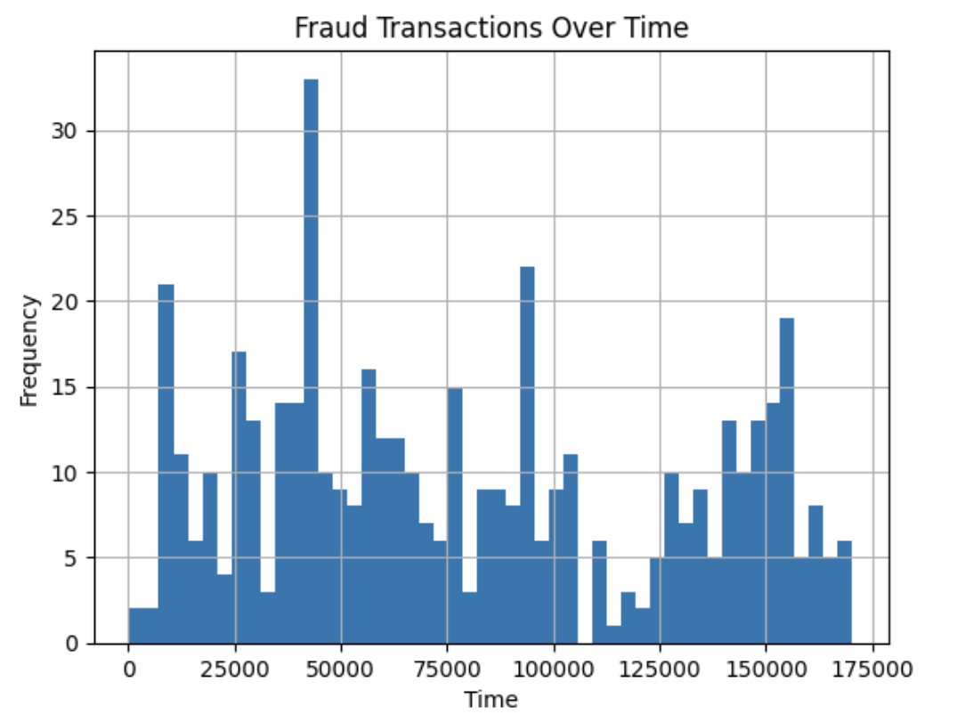
Figure 7. Distribution of Fraudulent Transactions Over Time
Figure 7 shows that fraudulent transactions are scattered across time and do not follow one clear time-based pattern. This reinforces the importance of combining time with other transaction features.
Correlation Matrix
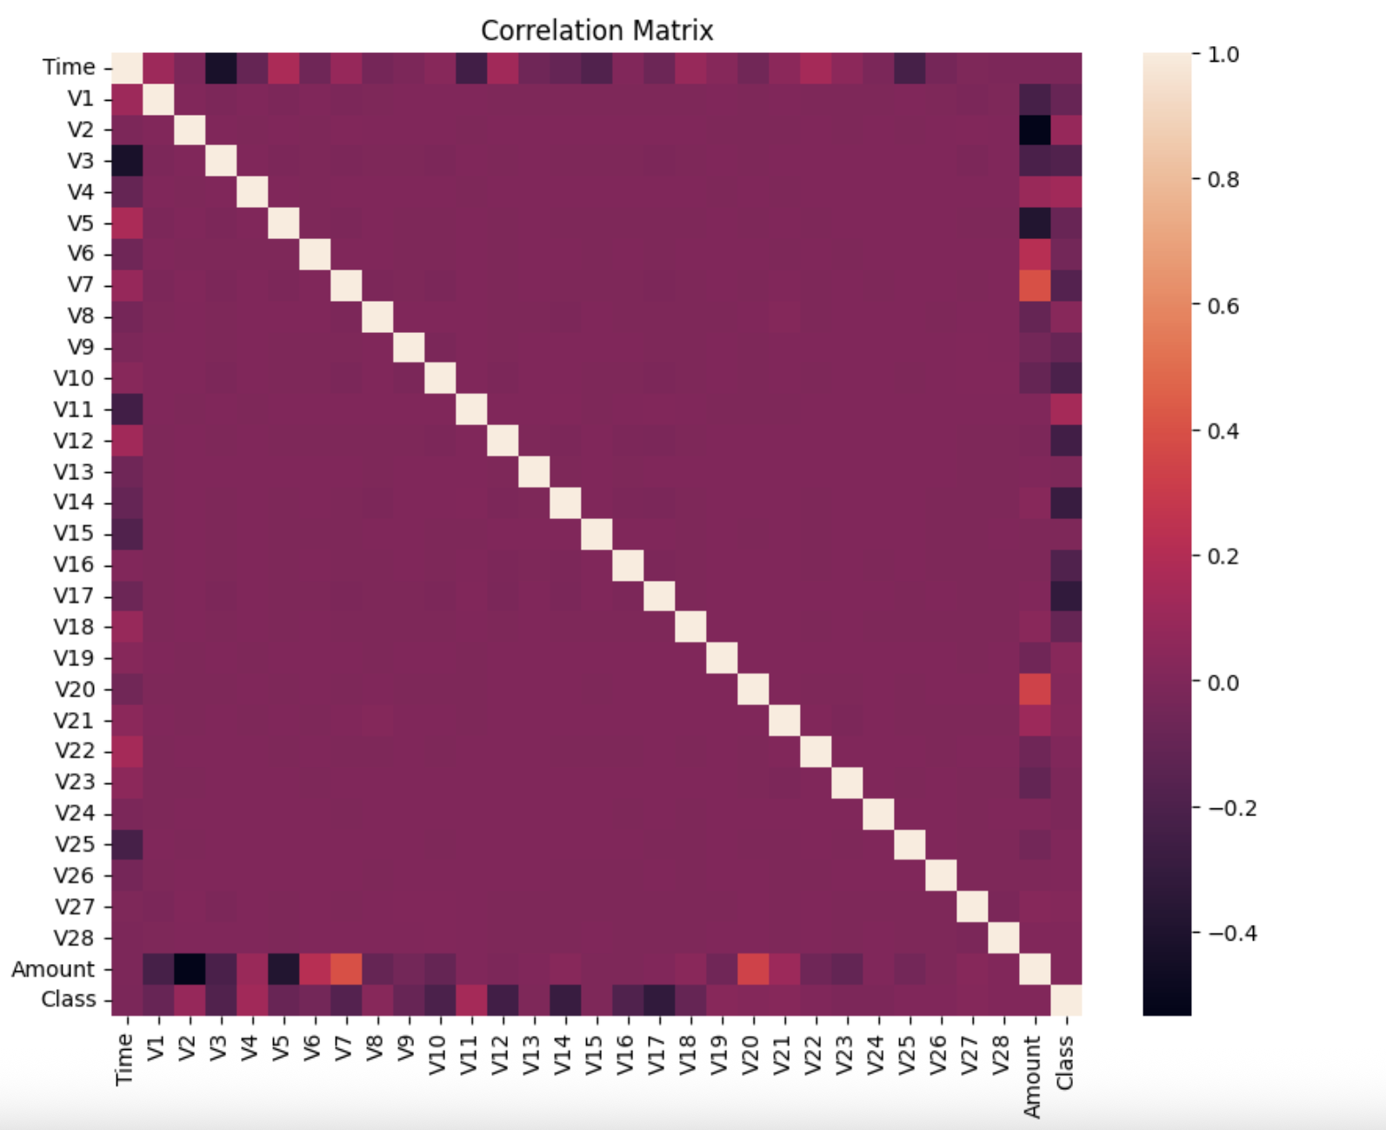
Figure 8. Correlation Matrix of Transaction Features
Figure 8 shows that most PCA-transformed variables have low correlation with each other. No single feature shows a dominant relationship with the Class variable. This supports the use of machine learning models that can capture multi-dimensional patterns.

5.3 POS Exploratory Data Analysis
The POS dataset provides operational insight into revenue leakage patterns. Store-level analysis shows that most stores have average differences close to zero, while stores S3 and S7 show higher positive differences.

Average Difference by Store
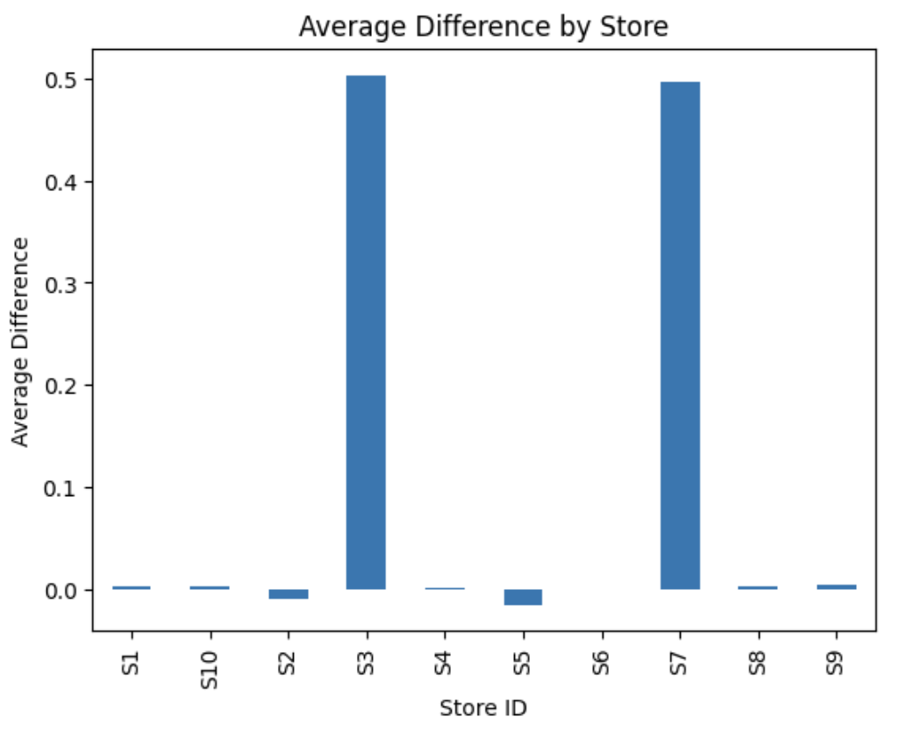
Figure 9. Average Difference in Transaction Values by Store
Figure 9 shows that stores S3 and S7 have significantly higher average differences compared to the other stores. This suggests that these stores may have systematic rounding behavior.
Total Difference by Store
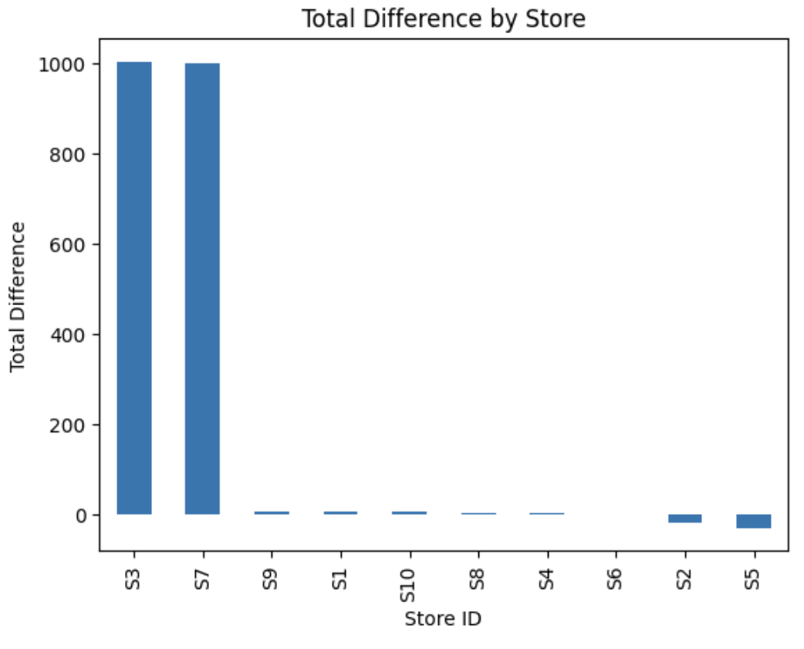
Figure 10. Total Accumulated Difference by Store
Figure 10 shows that stores S3 and S7 contribute the largest total differences. This indicates that small per-transaction discrepancies can accumulate into meaningful financial impact.

Distribution of Transaction Differences
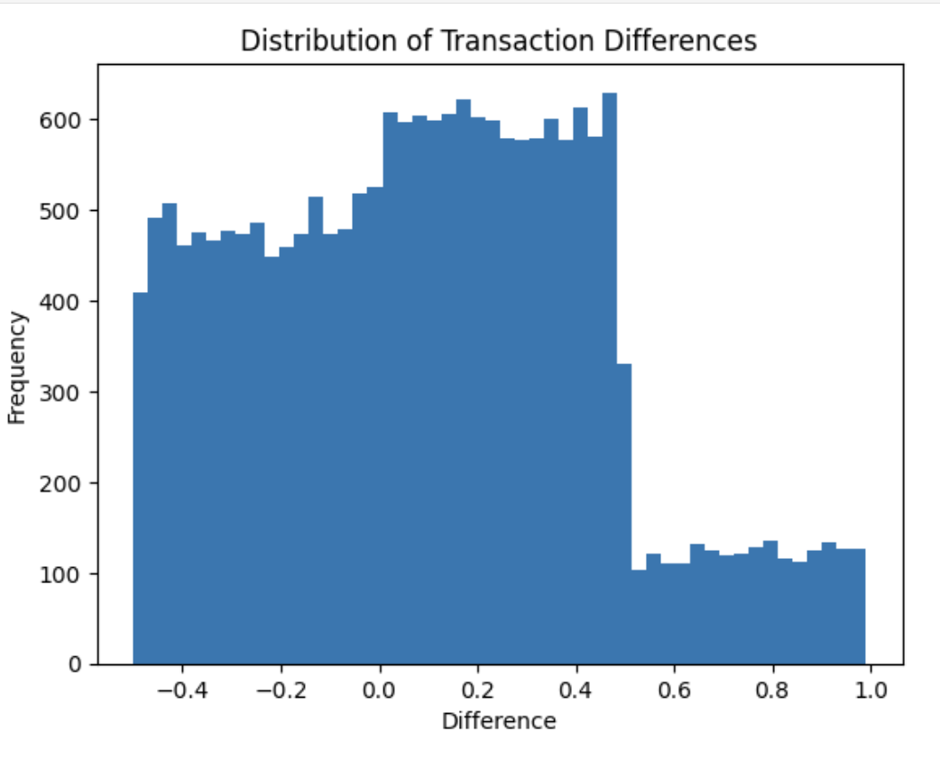
Figure 11. Distribution of Transaction Differences
Figure 11 shows that the Difference variable includes both positive and negative values but appears biased toward positive differences. This suggests that over-rounding occurs more frequently than under-rounding.
Anomalies by Store
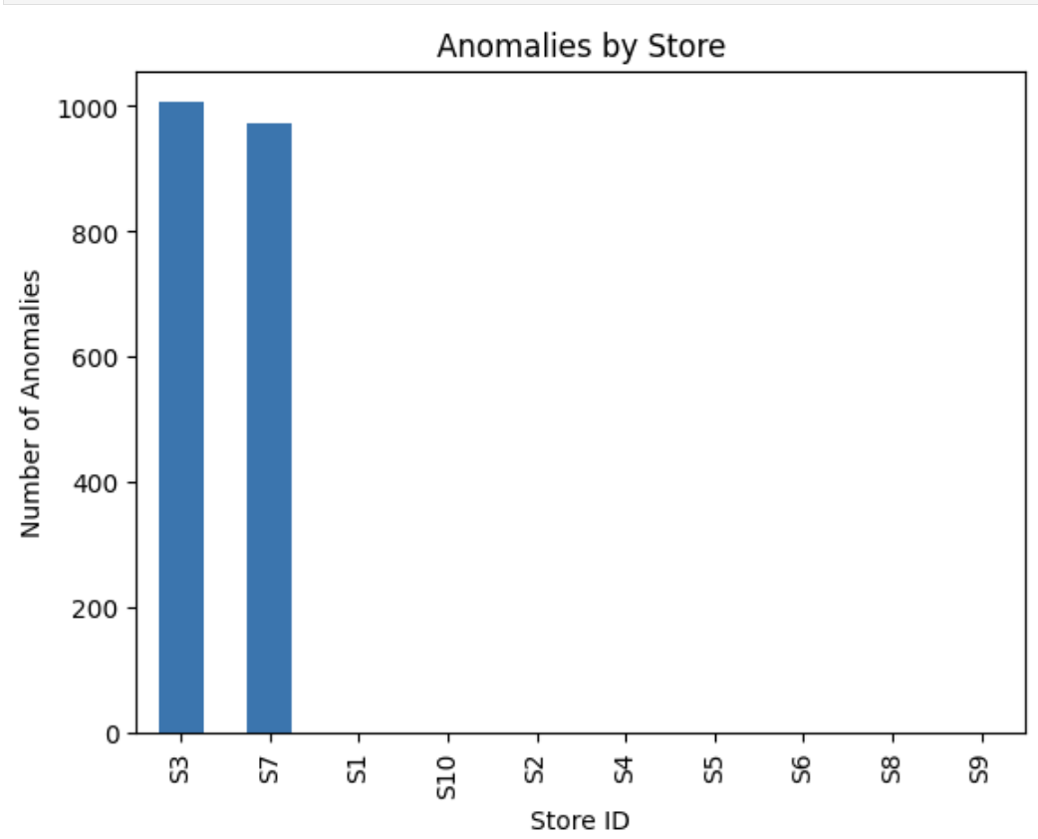
Figure 12. Distribution of Anomalous Transactions by Store
Figure 12 shows that rule-based anomalies are concentrated in S3 and S7. This indicates that the anomaly pattern is localized rather than system-wide.
These findings support the hypothesis that anomaly detection can identify localized operational issues.

5.4 EDA Insight Summary
Table 9. EDA Insight Summary
Figure or Table | What It Shows | Key Insight | RQ Link | Decision or Next Step
Figure 2 | Fraud vs non-fraud count | Severe class imbalance | RQ1 | Use precision, recall, F1-score
Figure 3 | Fraud percentage | Fraud is only 0.1667% | RQ1 | Avoid relying on accuracy
Figure 4 | Amount distribution | Right-skewed amounts | RQ2 | Scale Amount
Figure 5 | Fraud amount distribution | Fraud occurs across amounts | RQ2 | Use multi-feature models
Figure 6 | Transaction time distribution | Transactions vary over time | RQ2 | Consider time feature
Figure 7 | Fraud over time | Fraud is irregular | RQ2 | Use anomaly methods
Figure 8 | Correlation matrix | No single strong predictor | RQ2 | Use machine learning
Figure 9 | Average difference by store | S3 and S7 stand out | RQ3 | Investigate store-level leakage
Figure 10 | Total difference by store | Leakage concentrated in S3 and S7 | RQ3, RQ4 | Quantify impact
Figure 11 | Difference distribution | Positive bias exists | RQ3 | Apply anomaly threshold
Figure 12 | Anomalies by store | Anomalies localized | RQ3, RQ4 | Targeted controls

6. Modelling

6.1 Choice of Models with Justification
Four modeling approaches were used in this interim stage. Logistic Regression and Isolation Forest were applied to the credit card dataset, while a rule-based anomaly model and Isolation Forest were applied to the POS dataset.
Logistic Regression was selected as a baseline supervised classification model because it is interpretable and useful for comparing fraud and non-fraud classes. Class weighting was applied to address severe class imbalance.
Isolation Forest was selected because it is designed for anomaly detection and is appropriate when fraudulent or irregular behavior represents a small proportion of observations.
For the POS dataset, a rule-based anomaly model was used because the Difference variable directly captures the discrepancy between actual and rounded transaction values. This model is transparent and easy to interpret. Isolation Forest was also applied to the POS dataset to identify broader anomaly patterns beyond the threshold-based rule.

6.2 Features Included and Feature Engineering
Table 10. Feature Set and Usage
Feature | Dataset | Original or Engineered | Type | Reason for Inclusion | Used In
Time | Credit Card | Original | Numeric | Captures transaction timing | Logistic Regression, Isolation Forest
Amount | Credit Card | Original | Numeric | Captures transaction value | Logistic Regression, Isolation Forest
V1–V28 | Credit Card | Original PCA features | Numeric | Main anonymized transaction features | Logistic Regression, Isolation Forest
Class | Credit Card | Original | Binary | Target variable | Model evaluation
Difference | POS | Engineered | Numeric | Captures discrepancy | Rule-based model, Isolation Forest
Amount | POS | Original | Numeric | Captures transaction value | POS Isolation Forest
Store_ID | POS | Original | Categorical | Used for grouped interpretation | POS EDA and results
Anomaly_Flag | POS | Engineered | Binary | Rule-based anomaly output | POS preliminary results
ML_Anomaly | POS | Engineered | Binary | ML anomaly output | POS preliminary results
Feature engineering was limited and targeted. For the credit card dataset, Time and Amount were scaled before Logistic Regression. For the POS dataset, the Difference variable was used to create Anomaly_Flag based on a threshold greater than 0.5. The ML_Anomaly variable was created using Isolation Forest.

6.3 Evaluation Metrics
Table 11. Evaluation Metrics and Formulae
Metric | Formula | Interpretation | Used For
Accuracy | (TP + TN) / (TP + TN + FP + FN) | Overall correctness | Classification
Precision | TP / (TP + FP) | Proportion of predicted fraud cases that are correct | Fraud detection
Recall | TP / (TP + FN) | Proportion of actual fraud cases detected | Fraud detection
F1-score | 2 × (Precision × Recall) / (Precision + Recall) | Balance between precision and recall | Imbalanced classification
Anomaly Count | Sum of anomaly flags | Number of flagged transactions | POS anomaly detection
Store-Level Anomaly Count | Sum of anomalies by Store_ID | Identifies stores with anomaly concentration | POS analysis
Because the credit card dataset is highly imbalanced, precision, recall, and F1-score are more informative than accuracy. For POS anomaly detection, performance is evaluated based on anomaly concentration, interpretability, and consistency between rule-based and machine learning outputs.

6.4 Credit Card Model Results
The credit card dataset was split into 70% training and 30% testing using stratified sampling. The training dataset contained 198,608 records, and the testing dataset contained 85,118 records. Stratified sampling preserved the fraud/non-fraud distribution in both datasets.
Table 12. Logistic Regression Performance
Metric | Value
True Negatives | 82,719
False Positives | 2,257
False Negatives | 16
True Positives | 126
Fraud Precision | 0.05
Fraud Recall | 0.89
Fraud F1-score | 0.10
Accuracy | 0.97
The Logistic Regression model achieved a fraud recall of 0.89, meaning it successfully detected 89% of actual fraud cases. However, fraud precision was only 0.05, indicating a large number of false positives. This model is useful when the primary goal is to detect as much fraud as possible, but it may create operational burden due to excessive false alerts.
Table 13. Isolation Forest Performance for Credit Card Dataset
Metric | Value
True Negatives | 84,851
False Positives | 125
False Negatives | 102
True Positives | 40
Fraud Precision | 0.24
Fraud Recall | 0.28
Fraud F1-score | 0.26
Accuracy | 1.00
The Isolation Forest model achieved lower recall than Logistic Regression but improved fraud precision from 0.05 to 0.24. It reduced false positives from 2,257 to 125. This result shows that Isolation Forest is more conservative and produces fewer false alerts, but it misses more fraud cases.
This trade-off highlights the importance of selecting models based on business priorities.

6.5 POS Model Results
For the POS dataset, two approaches were used: a rule-based anomaly model and an Isolation Forest model. The rule-based model flagged transactions where Difference was greater than 0.5. This identified 1,978 anomalies, representing approximately 9.89% of the dataset.
Table 14. Store-Level Rule-Based Anomaly Counts
Store_ID | Anomaly Count
S3 | 1,006
S7 | 972
S1 | 0
S10 | 0
S2 | 0
S4 | 0
S5 | 0
S6 | 0
S8 | 0
S9 | 0
The rule-based model identified all anomalies in stores S3 and S7, indicating localized operational issues rather than system-wide behavior.
Table 15. POS Isolation Forest Store-Level Anomaly Counts
Store_ID | ML Anomaly Count
S3 | 616
S7 | 612
S10 | 106
S8 | 104
S4 | 100
S9 | 100
S2 | 97
S5 | 95
S6 | 86
S1 | 83
The POS Isolation Forest model identified 1,999 anomalies. It confirmed S3 and S7 as the strongest anomaly locations while also detecting smaller numbers of anomalies across other stores. This shows that the machine learning approach captures both clear and subtle anomaly patterns.

7. Preliminary Results

7.1 Preliminary Findings by Research Question
Table 16. Preliminary Findings by Research Question
Research Question | Preliminary Finding | Evidence | Status
RQ1 | Fraud can be detected, but model trade-offs exist | Logistic Regression recall = 0.89; Isolation Forest precision = 0.24 | In progress
RQ2 | No single feature fully explains fraud | Correlation matrix and EDA | In progress
RQ3 | POS anomalies can be detected and localized | S3 and S7 dominate anomaly patterns | Completed preliminarily
RQ4 | Detected anomalies show business impact | Total difference concentrated in specific stores | In progress

7.2 Preliminary Model Performance Comparison
Table 17. Preliminary Model Performance Comparison
Dataset | Model | Feature Set | Validation Approach | Precision | Recall | Key Takeaway
Credit Card | Logistic Regression | Time, Amount, V1–V28 | 70/30 train-test split | 0.05 | 0.89 | Detects most fraud but creates many false positives
Credit Card | Isolation Forest | Time, Amount, V1–V28 | 70/30 train-test split | 0.24 | 0.28 | Reduces false positives but misses more fraud
POS | Rule-based model | Difference | Threshold > 0.5 | Not applicable | Not applicable | Identifies 1,978 anomalies concentrated in S3 and S7
POS | Isolation Forest | Amount, Difference | Full dataset anomaly scoring | Not applicable | Not applicable | Identifies 1,999 anomalies, with highest counts in S3 and S7

7.3 Preliminary Results Interpretation
The preliminary results show that anomaly detection techniques are effective in identifying irregular patterns across both datasets. For the credit card dataset, Logistic Regression achieved high recall of 0.89, meaning it detected most fraudulent transactions. However, the model had low precision of 0.05, indicating many false positives. Isolation Forest showed the opposite pattern: lower recall of 0.28 but higher precision of 0.24, meaning it produced fewer false alarms.
For the POS dataset, the rule-based model identified 1,978 anomalous transactions using a Difference threshold greater than 0.5. These anomalies were concentrated in stores S3 and S7. The POS Isolation Forest model identified 1,999 anomalies and also highlighted S3 and S7 as the strongest anomaly locations, while detecting smaller irregularities across other stores.
Overall, the results suggest that a hybrid approach is most useful. Logistic Regression is helpful when the goal is maximum fraud detection, Isolation Forest is useful when reducing false positives is important, and POS rule-based logic provides clear interpretability for operational monitoring.
These findings demonstrate the practical applicability of anomaly detection in both financial and operational contexts.
Additional code snippets and store-level anomaly outputs are provided in the Appendix.

7.4 Interim Limitations and Risks
Current limitations include:
- The POS dataset is synthetic, although designed to reflect realistic transaction behavior.
- The credit card dataset uses anonymized PCA features, which limits direct business interpretation.
- Initial models were evaluated at a preliminary level and require further tuning.
- The POS rule-based threshold may need adjustment based on business tolerance.
- Model performance may change after additional feature engineering.

7.5 Next Steps for Final Report
Next steps include:
- Perform additional model tuning for Logistic Regression and Isolation Forest.
- Explore threshold adjustment for POS anomaly detection.
- Compare additional models if time allows.
- Add final model evaluation and visual summaries.
- Develop final business recommendations for fraud monitoring and POS leakage control.
- Strengthen GitHub documentation and reproducibility.

8. Recommendations
The preliminary findings suggest that organizations should use a hybrid anomaly detection approach that combines rule-based logic with machine learning models. For financial fraud detection, models should be selected based on business tolerance for false positives and missed fraud cases. Logistic Regression may be suitable when maximizing fraud detection is the priority, while Isolation Forest may be more appropriate when reducing false alerts is important.
For POS revenue leakage, store-level monitoring should be prioritized. Stores S3 and S7 should be reviewed first because they show the strongest anomaly patterns. Restaurant operators and internal audit teams can use the results to identify operational process issues, improve controls, and reduce cumulative losses from repeated small discrepancies.
The primary end users of this study include fraud analysts, financial controllers, restaurant operations managers, internal audit teams, and senior management.

9. References and Bibliography
Bhattacharyya, S., Jha, S., Tharakunnel, K., & Westland, J. C. (2011). Data mining for credit card fraud detection. Decision Support Systems, 50(3), 602–613.
Bolton, R. J., & Hand, D. J. (2002). Statistical fraud detection: A review. Statistical Science, 17(3), 235–255.
Chandola, V., Banerjee, A., & Kumar, V. (2009). Anomaly detection: A survey. ACM Computing Surveys, 41(3), 1–58.
Ngai, E. W. T., Hu, Y., Wong, Y. H., Chen, Y., & Sun, X. (2011). The application of data mining techniques in financial fraud detection. Decision Support Systems, 50(3), 559–569.
Phua, C., Lee, V., Smith, K., & Gayler, R. (2010). A comprehensive survey of data mining-based fraud detection research. arXiv preprint arXiv:1009.6119.
West, J., & Bhattacharya, M. (2016). Intelligent financial fraud detection: A comprehensive review. Expert Systems with Applications, 57, 47–66.
Whitrow, C., Hand, D. J., Juszczak, P., Weston, D., & Adams, N. M. (2009). Transaction aggregation as a strategy for credit card fraud detection. Data Mining and Knowledge Discovery, 18(1), 30–55.
Dal Pozzolo, A., Boracchi, G., Caelen, O., Alippi, C., & Bontempi, G. (2015). Credit card fraud detection: A realistic modeling and a novel learning strategy. IEEE Transactions on Neural Networks and Learning Systems, 29(8), 3784–3797.
Jurgovsky, J., Granitzer, M., Ziegler, K., Calabretto, S., Portier, P. E., He-Guelton, L., & Caelen, O. (2018). Sequence classification for credit card fraud detection. Expert Systems with Applications, 100, 234–245.
Sahin, Y., & Duman, E. (2011). Detecting credit card fraud by decision trees and support vector machines. International Journal of Advanced Research in Artificial Intelligence, 1(6), 55–59

10. Appendix

Appendix A: Dataset Source Information
Credit Card Dataset:
The dataset used for this study is a publicly available anonymized financial transaction dataset widely used in academic research for fraud detection. The dataset contains transactions made by European cardholders over a two-day period and includes anonymized features obtained through principal component analysis (PCA), along with transaction amount and time variables.
Due to data privacy and licensing considerations, direct redistribution of the dataset is restricted. However, it is commonly available through academic research repositories and can be accessed upon request or through publicly available research platforms.
POS Dataset:
The POS dataset used in this study is a synthetic dataset generated based on real-world transaction patterns. The dataset simulates restaurant transaction behavior, including rounding discrepancies and store-level variations. This approach ensures data privacy while maintaining realistic characteristics for analysis.

Appendix B: GitHub Repository and Code Availability
The GitHub repository includes the datasets, Jupyter notebooks, code scripts, and supporting documentation. The repository link is included at the beginning of this report.

Appendix C: Key Code Snippets
Credit Card Logistic Regression:
lr_model = LogisticRegression(class_weight='balanced', max_iter=1000)
lr_model.fit(X_train, y_train)
y_pred = lr_model.predict(X_test)
Credit Card Isolation Forest:
iso_model = IsolationForest(contamination=0.002, random_state=42)
iso_model.fit(X_train)
POS Rule-Based Model:
pos_df['Anomaly_Flag'] = pos_df['Difference'].apply(lambda x: 1 if x > 0.5 else 0)
POS Isolation Forest Model:
pos_iso = IsolationForest(contamination=0.1, random_state=42)
pos_iso.fit(pos_features)

Appendix D: Additional Outputs
Table D1. Store-Level Rule-Based Anomaly Counts
Store_ID | Anomaly Count
S3 | 1,006
S7 | 972
S1 | 0
S10 | 0
S2 | 0
S4 | 0
S5 | 0
S6 | 0
S8 | 0
S9 | 0
Table D2. POS Isolation Forest Store-Level Anomaly Counts
Store_ID | ML Anomaly Count
S3 | 616
S7 | 612
S10 | 106
S8 | 104
S4 | 100
S9 | 100
S2 | 97
S5 | 95
S6 | 86
S1 | 83

