import pandas as pd

import matplotlib.pyplot as plt

# Read the dataset

df = pd.read_csv("HadCRUT.5.0.1.0.analysis.ensemble_series.global.monthly.csv")

# Define a function to create a line plot

def create_line_plot(dataframe):

plt.figure(figsize=(12, 6))

for i in range(1, 6):

plt.plot(dataframe['Time'], dataframe[f'Realization {i}'], label=f'Realization {i}')

plt.xlabel('Time')

plt.ylabel('Temperature')

plt.title('Line Plot of Temperature Realizations')

plt.legend()

plt.xticks([])

plt.grid(True, axis='y')

plt.show()

create_line_plot(df)

# Define a function to create a scatter plot

def create_scatter_plot(dataframe):

plt.figure(figsize=(10, 6))

plt.scatter(dataframe['Realization 1'], dataframe['Realization 2'], c='b', label='Realization 1 vs Realization 2')

plt.scatter(dataframe['Realization 1'], dataframe['Realization 3'], c='r', label='Realization 1 vs Realization 3')

plt.xlabel('Realization 1')

plt.ylabel('Realizations 2 and 3')

plt.title('Scatter Plot of Temperature Realizations')

plt.legend()

plt.xticks([])

plt.grid(True, axis='y')

plt.show()

create_scatter_plot(df)

# Define a function to create a histogram

def create_histogram(dataframe):

plt.figure(figsize=(10, 6))

plt.hist(dataframe['Realization 1'], bins=30, color='b', alpha=0.7, label='Realization 1')

plt.hist(dataframe['Realization 2'], bins=30, color='r', alpha=0.7, label='Realization 2')

plt.xlabel('Temperature')

plt.ylabel('Frequency')

plt.title('Histogram of Temperature Realizations')

plt.legend()

plt.xticks([])

plt.grid(True, axis='y')

plt.show()

create_histogram(df)

**Visual Analysis of Temperature Realizations**

**Visualization 1: Line Plot of Temperature Realization**

The line plot displays temperature realizations over time. Each line on the graph represents one of the first five realizations (Realization 1 to Realization 5). During the 1st time temperatures were low ranging at negative 1.0 to 0, after some time the temperatures started increasing and with time the temperatures hit above 1.0

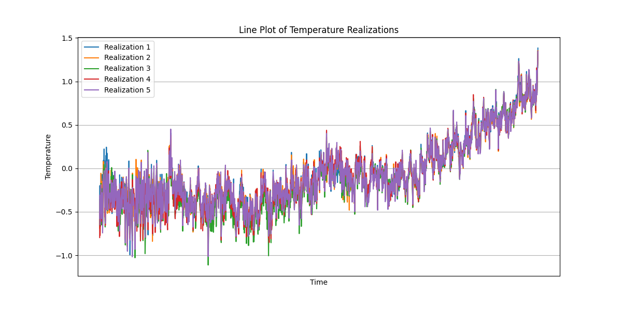

**Visualization 2: Scatter Plot of Temperature Realization**

The scatter plot compares two different temperature realizations: Realization 1 and Realization 2, and Realization 1 and Realization 3. The data points are represented as dots on the graph. At temperatures between negative 0.5 and 0 the realization 1 vs 2 have more points, these continues to decrease as the temperature rises above 1.0

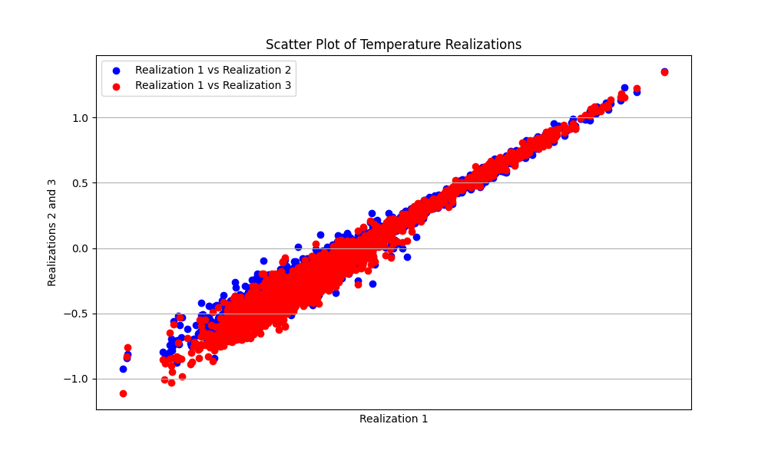

**Visualization 3: Histogram of Temperature Realizations**

The histogram visualizes the frequency distribution of temperature values for two different realizations: Realization 1 (in blue) and Realization 2 (in red). The temperature realization 1 has more counts than the Realization 2, mostly at the mid temperatures.

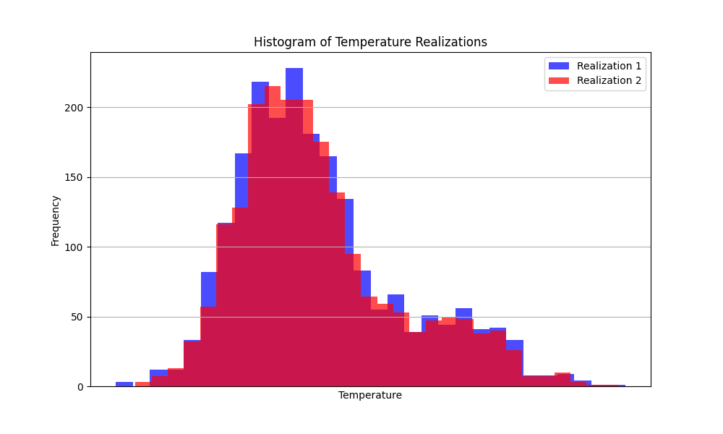

# References

<https://www.metoffice.gov.uk/hadobs/hadcrut5/data/current/download.html>