Create Fabric Workspace
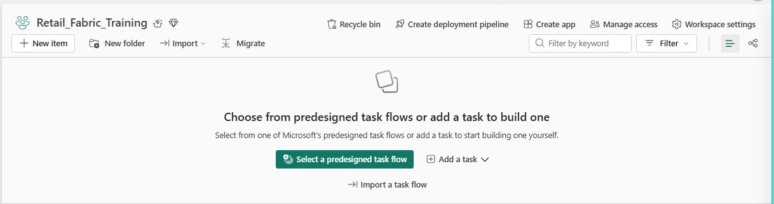

Create Lakehouse
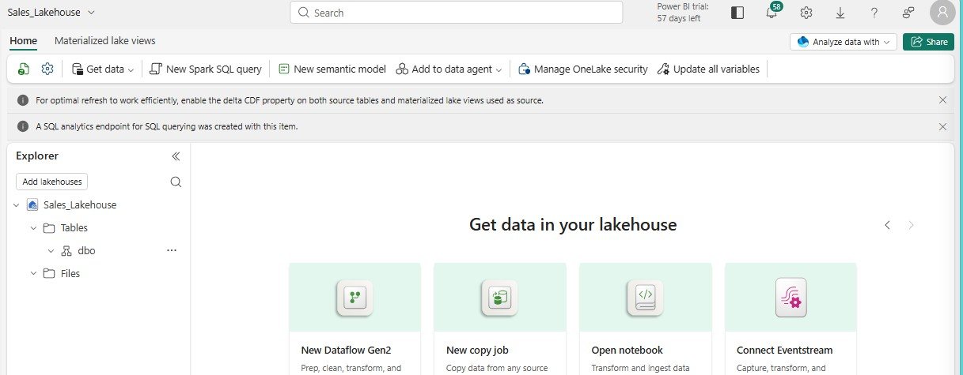
Q1. What is a Lakehouse?
A Lakehouse combines the flexibility of a data lake with the structured data management and analytics capabilities of a data warehouse.
Q2. Purpose of Files
Files stores raw data such as CSV, JSON,Exel, etc. Q3. Purpose of Tables
Tables contain structured data that can be queried and analyzed. Q4. What is SQL analytics endpoint?
It allows you to query Lakehouse tables using SQL.

Copy CSV to Lakehouse
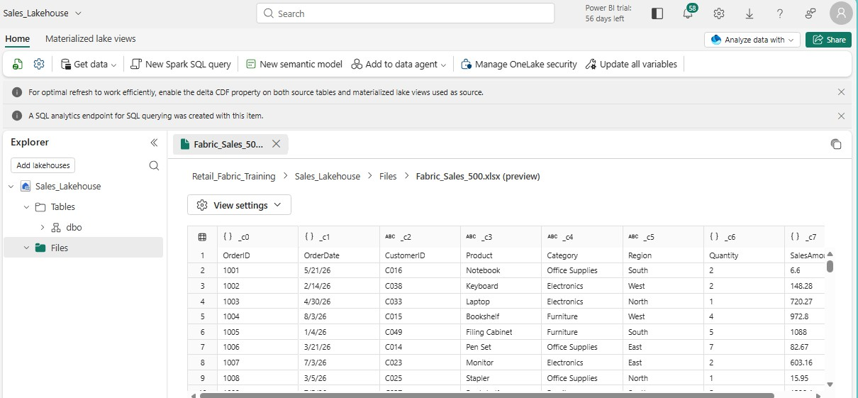
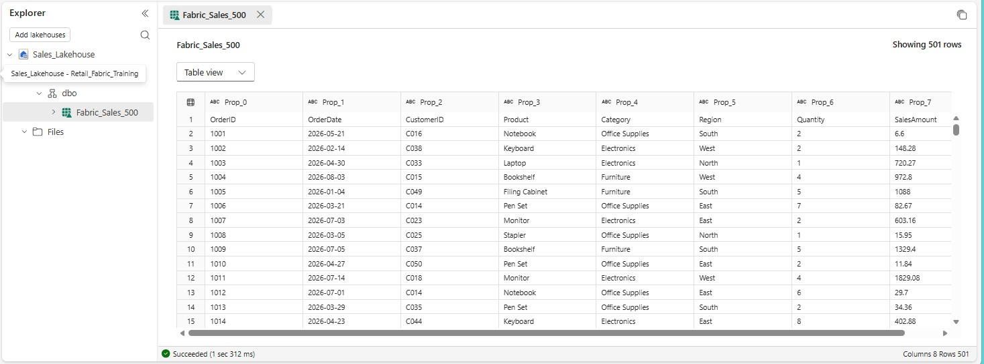

Validate the Lakehouse Sales table
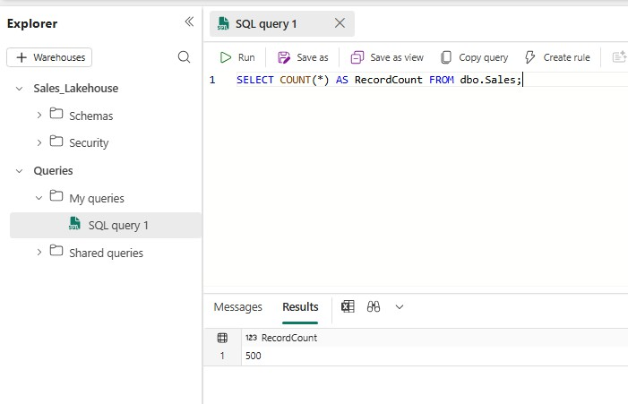
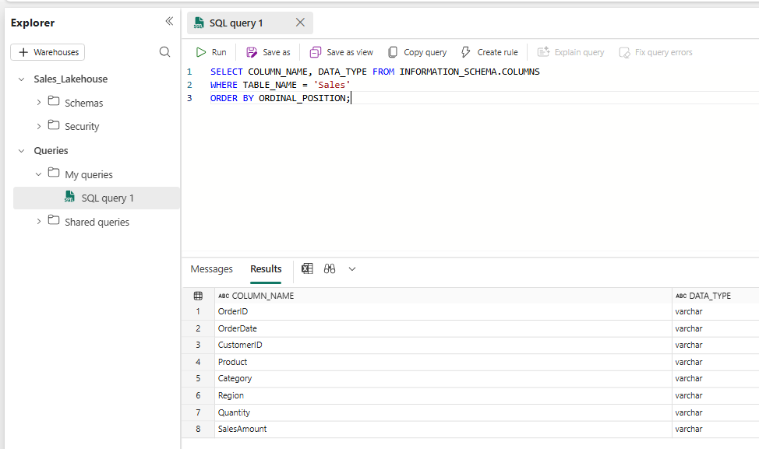

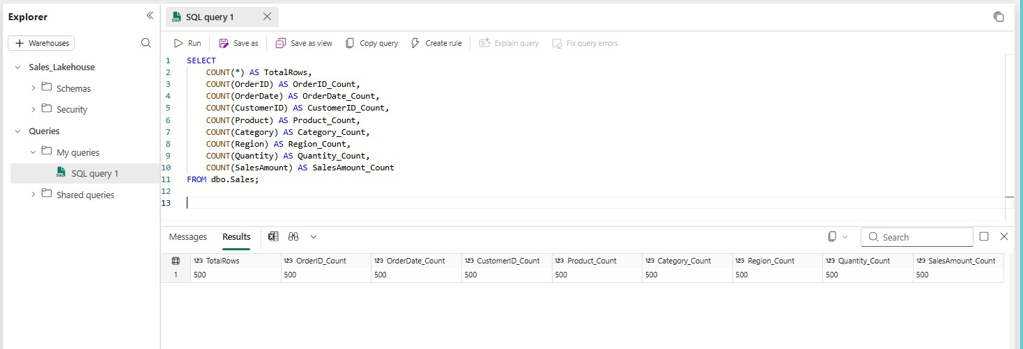

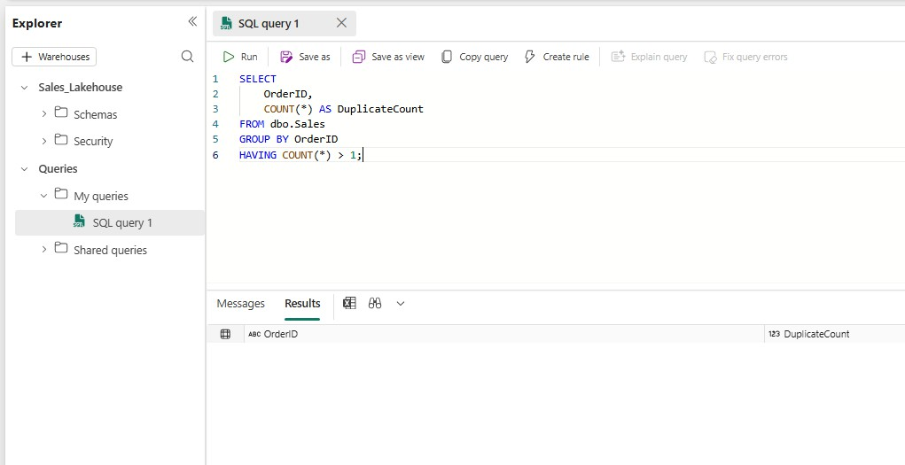
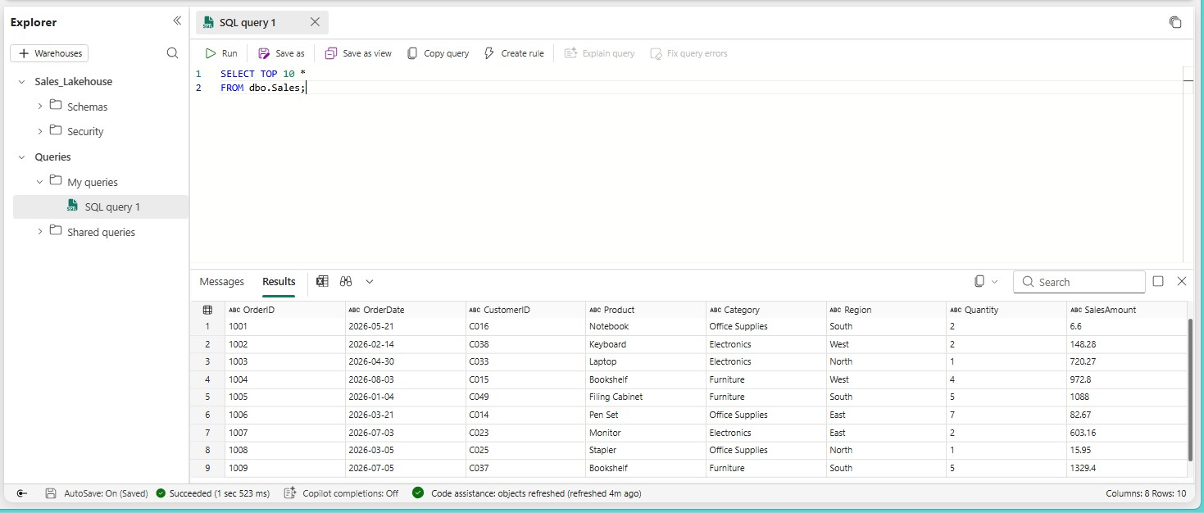

Q1. How many records are present?
There are 500 records in the Sales table. Q2. What is the data type of OrderID?
The data type of OrderID is VARCHAR. Q3. What is the data type of Quantity?
The data type of Quantity is VARCHAR. Q4. What is the data type of SalesAmount?
The data type of SalesAmount is VARCHAR. Q5. Are there any null values?
No, there are no null values in the Sales table. Q6. Are there duplicate OrderID values?
No, there are no duplicate OrderID values.

Create the Warehouse
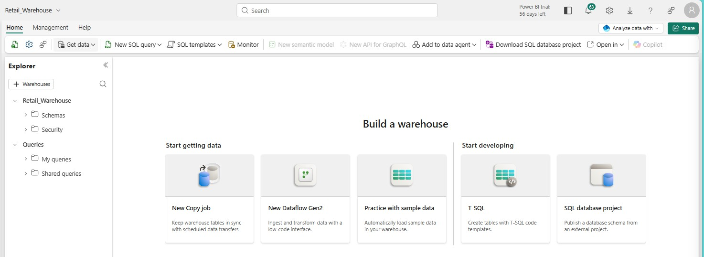

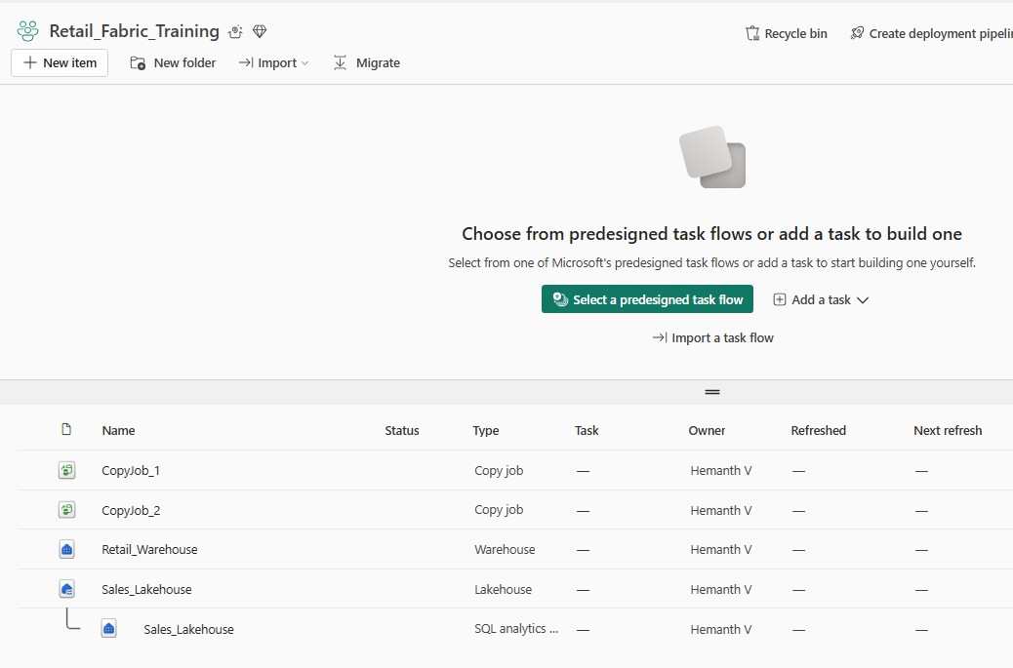
Q1. What is a Warehouse?
A Warehouse is a structured data storage system designed for storing, managing, and analyzing large amounts of data using SQL.
Q2. How is a Warehouse different from a Lakehouse?
A Warehouse is mainly designed for structured data and SQL analytics, while a Lakehouse can handle both structured and unstructured data.
Q3. What type of workloads are commonly performed in a Warehouse?
Warehouses are commonly used for SQL queries, reporting, dashboards, business intelligence, and data analysis.

Copy Sales from Lakehouse to Warehouse
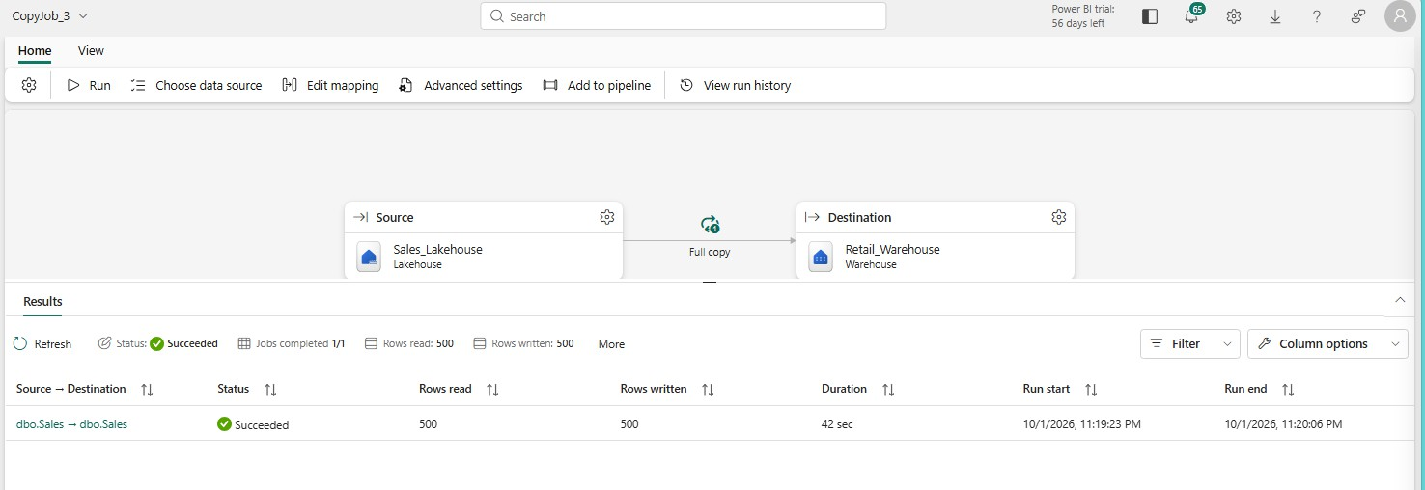

Run SQL queries in the warehouse
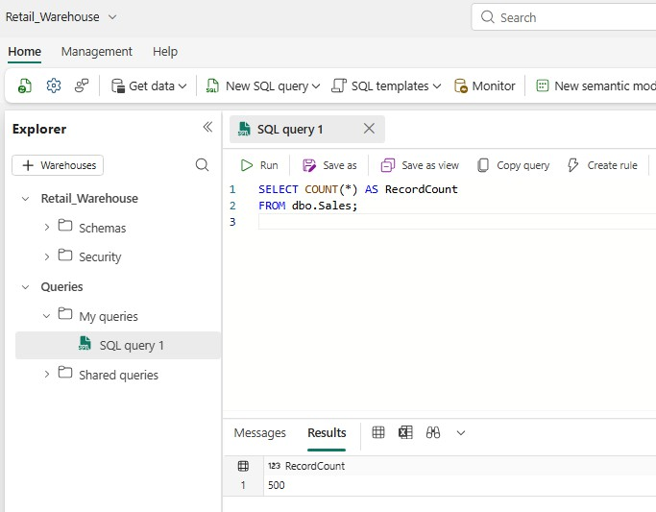

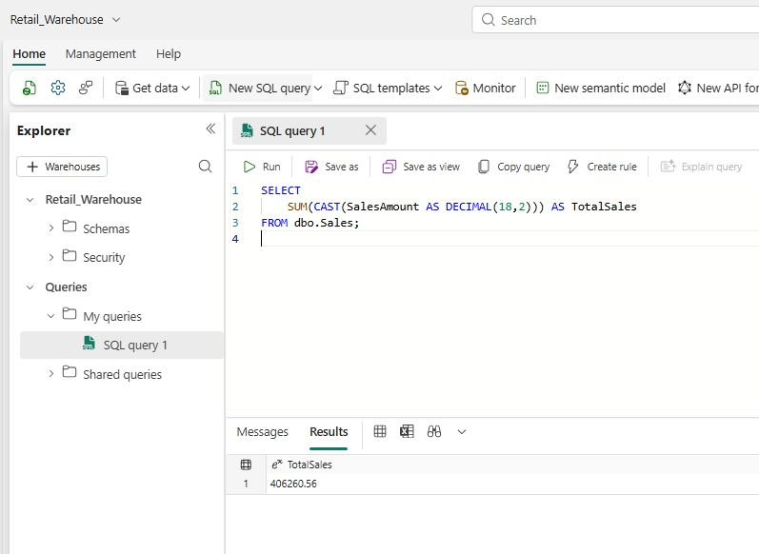
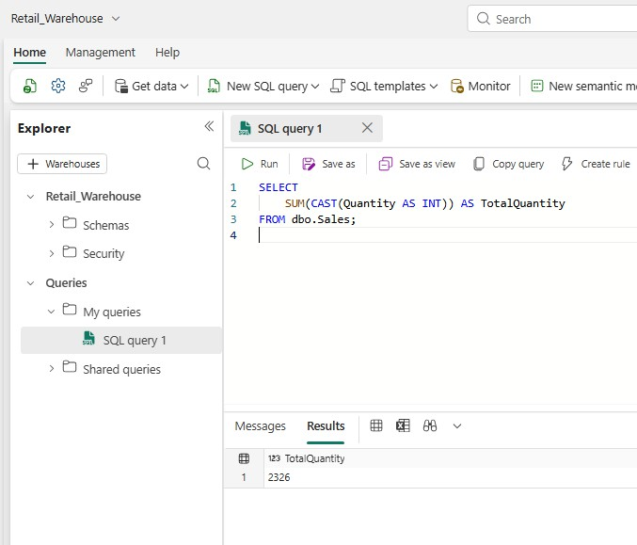

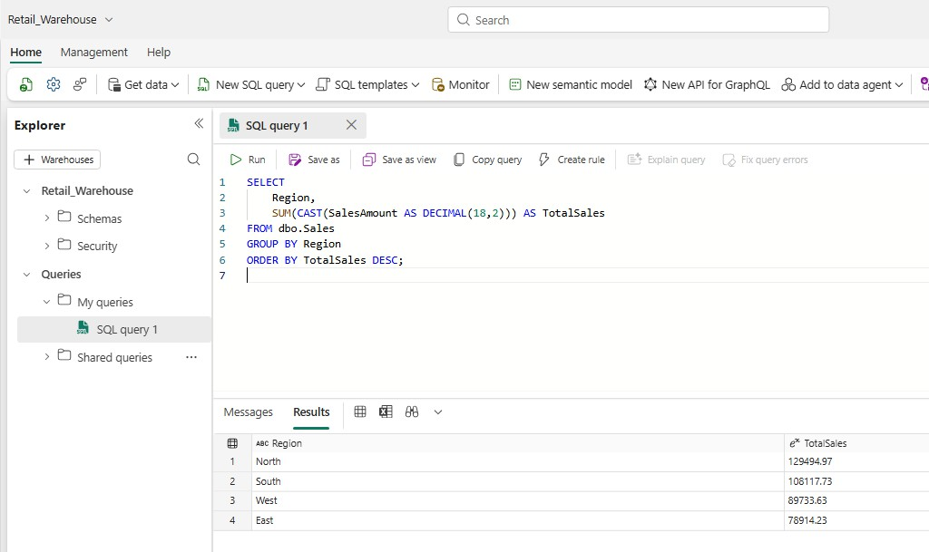

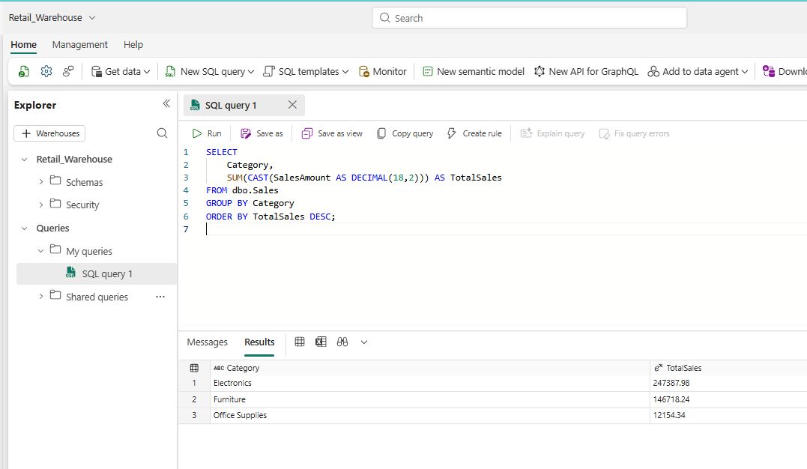

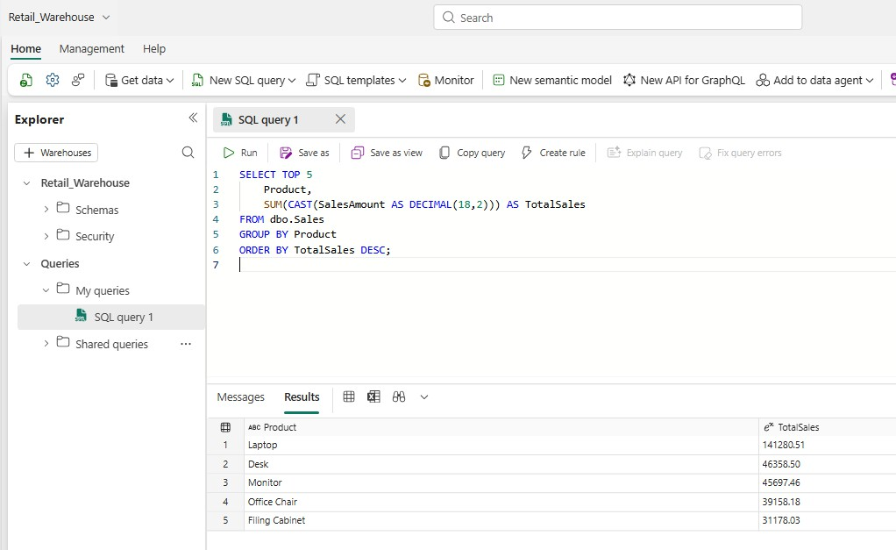
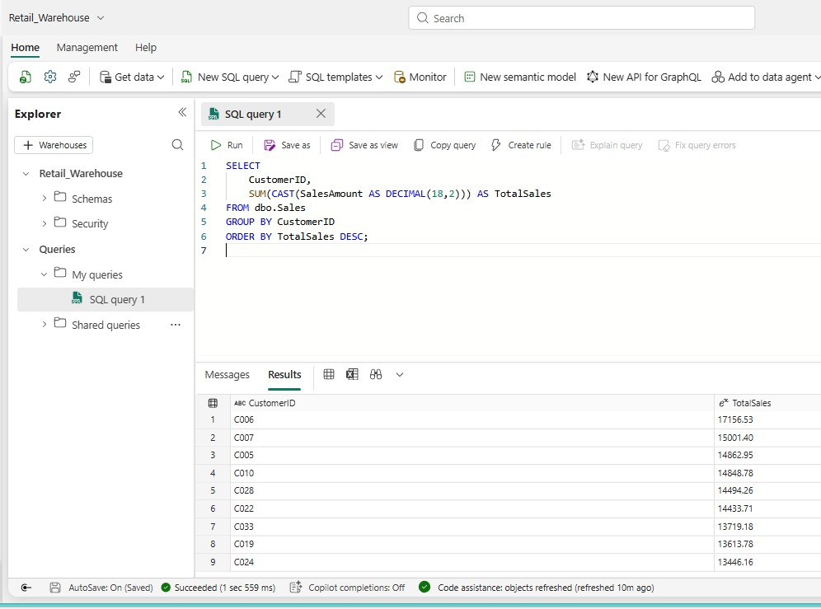

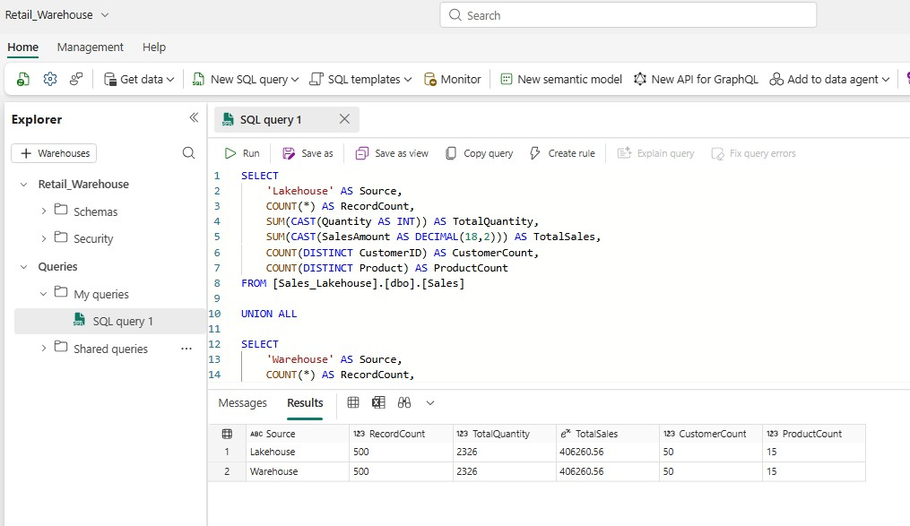
Compare Lakehouse and Warehouse

Q1. Are the record counts equal?
Yes, the record counts are equal in both the Lakehouse and Warehouse. Q2. Is the total sales amount equal?
Yes, the total sales amount is the same in both. Q3. Is the total quantity equal?
Yes, the total quantity is the same in both.
Q4. If the results are different, what could be the reason?
Differences could happen because of missing records, incorrect data types, duplicate records, or errors during data transfer.
Q5. How would you troubleshoot the difference?
I would compare the record counts, check for duplicates and NULL values, verify the data types, and check the copy activity for any errors.

