Aspect-Based Sentiment Analysis on Student Review Dataset Using Computational Approaches

Amith S Bhoomkar
Department of Information Science and Engineering JSS Science and Technology University
Mysuru, Karnataka, India
Email: amithbhoomkar2003@gmail.com

Prathibha R J
Associate Professor
Department of Information Science and Engineering JSS Science and Technology University
Mysuru, Karnataka, India Email: rjprathibha@sjce.ac.in

Hemanth V
Department of Information Science and Engineering JSS Science and Technology University
Mysuru, Karnataka, India Email: hemanthv@outlook.in

Abstract—The feedback provided by the students in the course evaluation, university level surveys, and website reviews includes important information regarding different aspects of the educational process. The conventional Sentiment Analysis typically entails the assignment of sentiments labels to the entire review without considering any of the aspects such as teaching quality, learning materials, course content, etc. On the other hand, Aspect Based Sentiment Analysis (ABSA) helps in identifying the aspects of the review and assigning sentiments to them individually.
In this study, we have developed an ABSA model for analysing the information obtained from student reviews utilizing the power of machine learning and transformer models. In this study, we have compared different machine learning algorithms including Logistic Regression, SVM, Random Forest, and BiLSTM along with Deep Learning model, fine-tuned DistilBERT classifier incorporating the context, aspect term and category in the classification of the sentiment on aspect level. The experimental evaluation conducted at different split ratios shows that Transformer models are more effective than others in sentiment classification on aspect level. The fine-tuned DistilBERT model achieves an accuracy of 90.5 percent in the sentiment classification of aspects of the reviews.
Index Terms—Aspect-Based Sentiment Analysis, Student Re-view Analysis, Sentiment Classification, DistilBERT, BiLSTM, Machine Learning, Deep Learning, Educational Data Mining, Natural Language Processing.

Introduction
The introduction of digital technology into the context of higher education entailed considerable changes in terms of students’ learning experience communication. The course evaluation systems, online surveys, learning management
systems, discussion forums, and institutional review systems are widely used by educational institutions. They provide a lot of information regarding numerous issues concerning teaching effectiveness, course content, laboratory work, testing procedure, curriculum, and the overall learning experience. This information, being unstructured texts, serves as an invaluable resource for NLP researchers and educational data mining.
The feedback is used for the purpose of evaluating the educational quality and making decisions. There exists a traditional approach to analyzing students’ feedback which implies its manual analysis by educational administrators. It is extremely time-consuming and takes a lot of effort due to the large volume of data. Sentiment analysis can be viewed as an efficient solution to this problem. However, traditional sentiment classification analyses the whole document, review or sentence according to some pre-defined categories, such as positive, negative, or neutral. In spite of their effectiveness in terms of determining the overall sentiment of the users, they are of analyzing multi-aspect educational reviews.
For example, in the case of student feedback, it could be possible that the reviewer might be satisfied with the teaching methodology of his/her teacher but unsatisfied with the lab facilities or the difficulty level of the examination. In such a scenario, the labeling of only one sentiment label to the entire review will result in losing the context information. This makes the sentiment analysis less useful for practical purposes. Hence, the use of sentiment analysis in such fields becomes impractical and less efficient when a particular sentiment

analysis is required.
Aspect-based Sentiment Analysis (ABSA) solves the prob-lem of sentiment analysis. Sentiment analysis here is performed not on the basis of the whole document but on the basis of the aspect of the review. ABSA aims at determining the aspect as well as the sentiment correlated with the particular aspect. The aspect-based sentiment analysis allows analyzing the user opinions in detail. With respect to education field, the ABSA technique could prove helpful in finding strengths and weaknesses of educational institutes.
Developments in machine learning and deep learning have resulted in major improvements in the performance of sentiment analysis tools. Machine learning techniques including Logistic Regression, SVM, and Random Forest have proven to be efficient when combined with feature extraction techniques such as TF-IDF. These methods have been based on statistical analysis of texts and do not account for context and semantics of natural languages.
To address this issue, deep learning methods have been ex-tensively employed in sentiment analysis. BiLSTM architecture has the capability of learning the context by analyzing words that appear before and after each other. Transformer architecture is considered to be the most effective architectural framework for a range of NLP tasks. Deep learning methods including BERT and DistilBERT make use of self-attention technique to create contextual word representations, thus making it possible to detect more complex linguistic patterns.
The present study focuses on assessing the implementation of Aspect-Based Sentiment Analysis on student reviews through the application of an annotated structured data set. It employs the comparative analysis of three sentiment classification models: classical machine learning algorithms, deep learning models, and transformer-based language models. As the base-line classical machine learning algorithms, Logistic Regression, Support Vector Machine, and Random Forest are applied. In addition to that, the Bidirectional Long Short-Term Memory model is used as the basis of deep learning approach. Finally, the fine-tuned DistilBERT algorithm is employed to test the potential of contextual transformer representation in aspect-level sentiment classification.
In order to enhance the accuracy of sentiment classification, the aspect terms and categories are included into the review text as rich input representations. All these models are evaluated based on different train-test splits in terms of such performance metrics as accuracy, precision, recall, and F1-score. Simultane-ously, the validation of domain-specific inputs is used as one of the steps in order to ensure that sentiment classification is
applicable only to education-related inputs.
The findings from the present study will help to contribute to the existing literature on the analysis of educational texts through comparative assessment of the performance of machine learning, deep learning, and transformers for ABSA. The ability of the context-based model to obtain rich sentiment analysis data from student reviews will help to improve the quality of teaching with the support of empirical evidence. The key contributions of the present research include:
- Classical Machine Learning Models
- Deep Learning using BiLSTM
- Transformer-Based DistilBERT

Motivation

The student feedback has become the leading indicator that defines the efficacy of teaching, curricula, learning materials and other physical resources of the institution. In the modern educational institutions, there is plenty of feedback that is collected using surveys, questionnaires,learning management systems, and online review platforms. Despite the fact that there is plenty of information that may provide important insights, it is quite challenging to process numerous texts of feedback.
The classic methods of feedback analysis imply manual analysis, which is time-consuming and subjective. The growing amount of educational data implies another approach. There should be more detailed insight about the problems that bother the students.
The classical models of sentiment analysis do not give precise information about the opinion of the students, as they apply sentiment labeling to the whole review. It should be noted that an educational review contains a few opinions about different issues, presented within one sentence. For example, the student can like the teaching technique of his/her instructor, but at the same time, he/she can think that there is not enough equipment for labs.
Aspect Based Sentiment Analysis (ABSA) is the correct methodology for solving this issue because it is used to detect sentiment about aspects. Thus, sentiments toward teaching, course, labs, and exams will be analyzed independently. It will provide colleges and universities with valuable information that can be used to improve their academic strategy. The purpose of this research is to develop an automatic system of ABSA using machine learning, deep learning, and transformers.

Literature Review
In 2002, Pang et al. (2002) [1] proposed the use of machine learning techniques in sentiment analysis via the use of classification algorithms for movie reviews. The work has demonstrated that sentiment classification can be achieved via text classification and this opens up opportunities for opinion mining research. However, in this study, only the document level sentiments were considered while aspect-level sentiments were not taken into account.
In 2012, Liu (2012) [2] provided the framework for research in sentiment analysis and opinion mining with the introduction of concepts like entities, aspects, opinion holders and sentiment orientation. Liu identified the importance of aspect-level analysis to mine opinions from the unstructured text. For this reason, this paper is regarded as the milestone paper in the area of ABSA.
The research in Aspect-Based Sentiment Analysis has been driven by the organization of SemEval-2014 Task 4 by Pontiki et al. (2014) [3]. This study has provided benchmark datasets and metrics for ABSA research.
The authors of the paper by Altrabsheh et al. (2014) [4] conducted sentiment analysis in educational student feedback to analyze the learning experience in real time. The findings showed that sentiment analysis can be useful for measuring students’ satisfaction; however, the research worked on a course-grained level rather than aspect level.
Sentence compression was used as a pre-processing tech-nique for aspect-based sentiment analysis in the study by Che et al. (2015) [5], to reduce noise before the application of classical feature-based classifiers. This research may be considered an example of the machine learning era, during which models heavily relied on feature engineering before deep neural representation learning emerged.
In their study, Tang et al. (2016) [6] suggested the attention-based LSTM network for solving the problem of aspect-level sentiment classification. The authors could benefit from using aspect information in the network and obtain better results compared to classical recurrent neural networks. However, this model copes poorly with distant dependencies.
Ruder et al. (2016) [7] suggested H-LSTM (Hierarchical LSTM), which uses review-level Bi-LSTM over sentence-level Bi-LSTMs in order to consider both intra- and inter-sentence relations. This solution helped to deal with the distant dependency problem, which was present in the earlier attention-LSTM models, but still it was only tested on generic domains of product reviews.
The authors of the work, Schouten and Frasincar (2016) [8], reviewed the state-of-the-art of the aspect-level sentiment analysis in their paper. They discussed the rule-based, machine learning, and deep learning approaches and pointed out that the aspect extraction and context interpretation problems require further investigation.
In 2017, Wang et al. (2017) [9] suggested coupled multi-layer attention networks to perform joint co-extraction of aspects and opinion terms. Their work is an improvement of the previous pipeline-based works where these two tasks were performed separately.
Majumder et al. (2018) [10] suggested a memory network using multi-hop attention method (IARM), where sentence representations specific to an aspect are compared to each other, which helped in generating a better representation, laying the groundwork for transformer-based auxiliary sentence models to come in the future.
Devlin et al. (2019) [11] introduced Bidirectional Encoder Representations from Transformers (BERT), where there was a huge breakthrough in NLP by employing contextual language models and self-attention. Fine-tuning BERT proved to be highly effective in several sentiment analysis benchmarks.
Sanh et al. (2019) [12] designed a lightweight DistilBERT based on BERT via knowledge distillation methods. This model preserved almost all linguistic capabilities of BERT and made it more useful for applications in limited resource environments because of computational efficiency and speed of inference.
Sun et al. (2019) [13] redefined the problem of Aspect-Based Sentiment Analysis as sentence-pair classification with additional auxiliary sentences carrying aspect information. Such an approach enabled transformer models to effectively model interactions between the context and target aspects.
Xu et al. (2019) [14] explored the area of domain adaptive fine-tuning of BERT in the tasks of ABSA and review comprehension. The authors demonstrated that domain pre-training provides significantly better prediction performance compared to finetuning language models for general language.
Zhou et al. (2019) [15] conducted an overview of deep learning approaches to aspect-based sentiment analysis in IEEE Access, providing an extensive list of CNN-, RNN-, attention-and memory-network-based methods right before the advent of transformers for this problem.
Kastrati et al. (2020) [16] used LSTM and CNN models together with several word-embedding approaches for classi-fication of more than 100,000 student reviews and classroom feedback remarks, which can be considered one of the first

examples of large-scale applications of deep-learning methods to ABSA in the field of education.
Kastrati et al. (2021) [17] carried out a systematic mapping study, published in Applied Sciences, concerning sentiment analysis of student feedback in NLP and deep-learning setting, summarizing the current state of the art in the field and explicitly pointing out the lack of aspect-level studies rather than document-level ones.
Karl and Scherp (2022) [18] proved the superiority of larger transformer architectures like RoBERTa to standard BERT variants in the task of sentiment classification, especially in unseen-data settings, providing motivation for using RoBERTa
In their research, Jazuli et al. (2023) [19] used an Indo-BERT model, which they fine-tuned on 10,000 reviews provided by students at a private Indonesian university to perform both aspect extraction and sentiment classification tasks with an F1-score of 0.897 and 0.882 for each task correspondingly. The proposed method was compared against the results that could be achieved through the application of Naive Bayes, K-NN, and Decision Tree baselines. Though this paper is the closest one to the current study, the authors do not perform the explicit validation of aspects or the domain before applying the sentiment prediction algorithm.
The article by Perikos and Diamantopoulos (2024) [20], published in Big Data and Cognitive Computing, presents the use of BERT, RoBERTa, DistilBERT, and XLNet, which were fine-tuned on the MAMS, SemEval, and Naver datasets, and explains transformer predictions using five methods: LIME,
In their work titled “Enhancing RoBERTa-based aspect-level sentiment analysis” in Informatica, Chauhan et al. (2025)
[21] presented an improved ABSA system that used state-of-the-art transformer architecture and was compared with other transformer systems on several benchmark data sets, characterizing the research directions in the field right before the current work.
Recently, Zhong et al. (2026) [22] presented a multi-granularity feature fusion network for ABSA based on hi-erarchical layers. Contextual and external knowledge features along with constituent and dependency syntactic features were fused using graph convolutional network. Their system showed superior performance over state-of-the-art ABSA approaches on the SemEval-2014 and Twitter data sets, suggesting that combining features of multiple linguistic granularities still helps improve sentiment classification at the aspect level. However, similar to previous works, this work too is confined to product review and social media domains, and does not perform domain-specific aspect validation before sentiment classification.
Missaoui et al. (2026) [23] addressed the problem of ABSA within the SemEval-2026 Task 3 challenge, shifting from polarity categories to a dimensional approach and predicting continuous valence and arousal ratings of aspects by fine-tuning transformer encoders, including RoBERTa-large. This paper is one of many examples of how the field of ABSA research is moving towards more precise and continuous representation of sentiments on an aspect level. Yet, unlike most ABSA papers that follow it, their work has been evaluated not within the scope of a specific domain, but rather on general-purpose review and multilingual benchmark datasets without the validation of aspects or domains before calculating sentiment scores.

Problem Statement
Educational institutions produce huge volumes of unstructured texts as opinions and reviews of different aspects of learning process. However, although this unstructured data might include lots of information about some particular aspect of the institution, different opinions concerning the same aspect of an educational environment make automated sentiment analysis almost impossible in such cases.
As a general rule, sentiment analysis algorithms are designed in such a way that they determine the polarity of the sentiment in a review without taking into account the object of the opinion. As a result, important information about different aspects like the effectiveness of teaching, the quality of curriculum, the availability of infrastructure facilities, etc. might be overlooked.
For our current research, our purpose is to create an Aspect-based Sentiment Analysis method, which will be able to analyze sentiment with respect to individual aspect terms in student reviews. Thus, our objective is to build a classification framework that will help to establish whether the sentiment toward a specific aspect term is positive, negative, or neutral.
The proposed system should be capable of using information about the context, features connected with aspects, and domain-specific knowledge, but at the same time be able to generalize on new data. Additionally, the created system should provide dependable results for the educational domain.

Research Objectives
- Construct an ABSA dataset from ASQE-DPT annota-tions.
- Develop feature representations incorporating aspect and category information.
- Train and compare ML, BiLSTM, and DistilBERT models.

- Evaluate performance across multiple train-test configu-rations.
- Develop an interactive educational feedback prediction system.

Research Gap
Version 1: It is evident from the most recent literature that there has been considerable progress in the domain of Aspect-Based Sentiment Analysis (ABSA), owing to advancements made via machine learning [1], deep learning [6], and transformer-based systems [11]–[14]. Fundamental works on ABSA [2], [3] established the problem formulation, along with benchmarking datasets that continue to contribute to research on ABSA. The evolution of this research field has been thoroughly reviewed [8], starting from its lexicon- and feature-based approach to the more advanced deep contextualized model. Recent literature suggests [22], [23] that ABSA is moving beyond simple polarity classification .
Nevertheless, one should take into account that the over-whelming majority of research works, spanning almost two decades from 2002 to 2026, concentrated on a commercial or social environment, including product reviews, restaurant feedbacks, and social media communications [1], [3], [6], [13], [14], [22]. On the other hand, an extremely small number of studies explored the field of educational sentiment analysis
[4] and, even smaller, conducted research in the field of ABSA for students’ feedback analysis. Even more shocking is the fact that there is no work comparing classical machine learning algorithms, BiLSTM-based models, and transformers for educational ABSA tasks in the same experiment. Moreover, from the literature surveyed [3], [6], [11], [13], [14], [22], [23], the validation of the correctness of aspects’ classification and relevance of the chosen domain is performed rarely in ABSA pipelines.
These shortcomings have been covered in this research with the introduction of an educational ABSA system that (a) critically examines machine learning, BiLSTM, and transformer algorithms on equal footing using the dataset of students’ reviews and (b) incorporates the validation process of aspects and domain before sentiment analysis takes place. Such a dual method improves the validity of the resulting predictions.

Proposed Work
The suggested ABSA approach would make use of a well-designed pipeline to extract sentiment scores of aspects from the reviews provided by students. The pipeline is expected to
contain five main stages: dataset creation, data preprocessing, features extraction, modeling, and evaluation. The major goal of this work would be the comparison of the performance of traditional, deep, and transformer learning models under similar conditions.
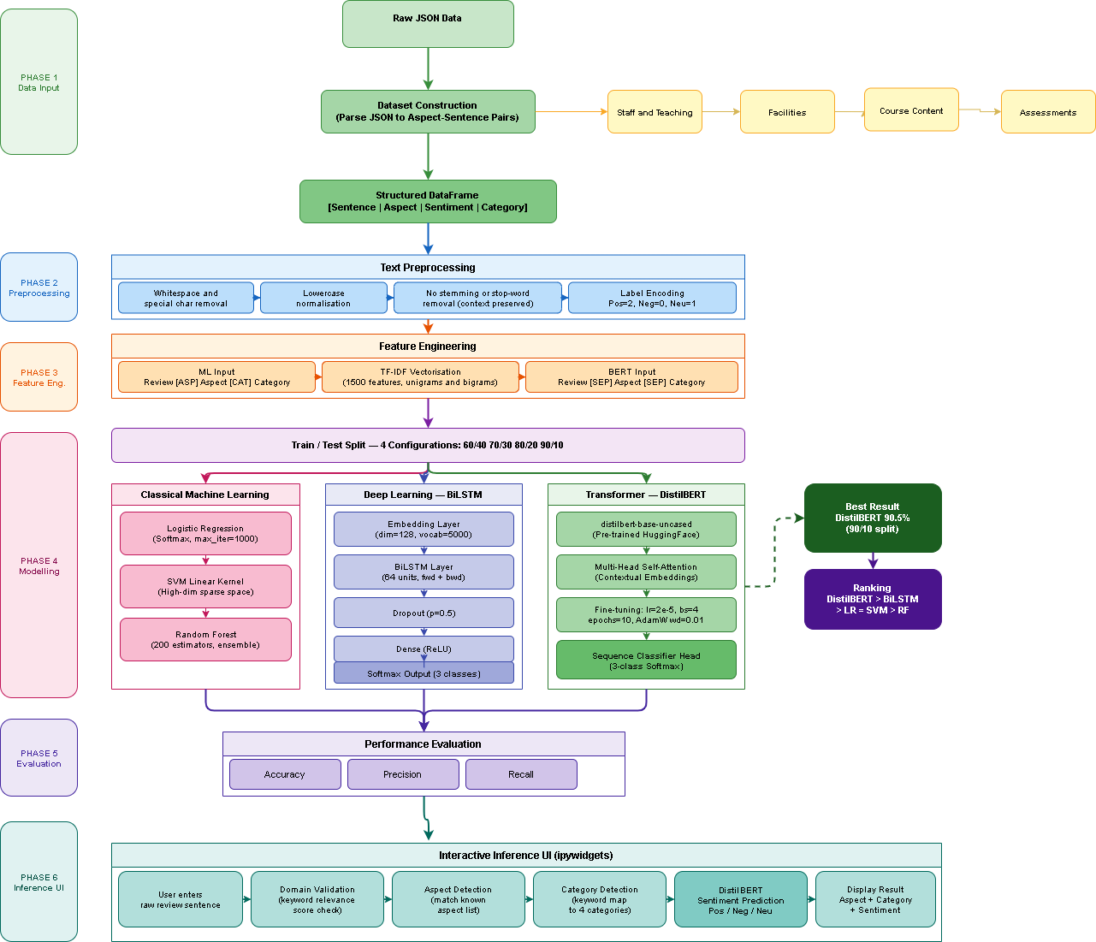

Fig. 1. Overall System Architecture for Aspect-Based Sentiment Analysis on Student Reviews.

Dataset Construction
The dataset that is going to be used for this research is ASQE-DPT (Aspect Sentiment Quadruple Extraction – Dependency Parse Tree), and the collection of such a dataset is conducted using the JSON format. The uniqueness of this sentiment dataset is that while other datasets only provide polarity per sentence, this specific dataset provides annotations that include aspects terms, opinions, sentiment polarity, and aspects categories.
This dataset has many components within the data file, depending on each review within the dataset. The components of the data are: token ID, surface form, sentiment related, aspect type, aspect category, and pairs. While each review was being created, there was a process involved that helped in recreating the real sentence using the token. Aspect tokens and opinion tokens were identified using the relationship within the annotation in the pairs.
For each of the aspects that were identified, there was creation of a record, which had the following four entries:
    - Complete review sentence
    - Aspect term
    - Sentiment polarity

    - Aspect category
Hence, the constructed data set is made up of aspect-sentence pairs rather than entire reviews which facilitates the process of sentiment
Educational reviews may be generally divided into four types of aspects:
    - Staff and Teaching
    - Facilities
    - Course Content
    - Assessments
As can be seen from the above-mentioned types, there are major dimensions that serve as criteria for evaluation of education by students.

Data Preprocessing
t is not surprising that plain text collections are usually faced with various problems such as problems with spacing, unconventional capitalization, punctuation, and domain-specific abbreviations. As a result, text pre-processing was performed prior to constructing the sentiment classification model.
At first, all text sentences were restored from tokens and redundancy of whitespace and special symbols was removed.
Contrary to the classical approaches of sentiment analysis, stemming and stop-words removal were not applied in this study since these two text preprocessing steps could harm the useful data required for the task of aspect-based sentiment analysis. The phrases like “not good” and “not satisfied” are examples of the information that can be lost because of excessive preprocessing.
Label Encoding technique was used in order to perform numerical encoding of the sentiment tags. Particularly, there are three sentiment classes in this research:
- Positive
- Negative
- Neutral

Feature Engineering
Feature extraction is an essential process for aspect-based sentiment analysis since besides the text itself, sentiment analysis is dependent on the aspects and their corresponding categories.
In machine learning approaches, a combination of all of the three elements, i.e., the text, the aspect term, and the aspect category is done in order to obtain the composite representation.
Different tags are assigned to mark the differences between each of the components. Input representation can be stated as:

Input = Review+[ASP ]+Aspect+[CAT ]+Category (1) For instance, the following sentence:
“The faculty explains concepts clearly but laboratory equipment is outdated.”
is transformed into:
“The faculty explains concepts clearly but laboratory equipment is outdated [ASP] Faculty [CAT] Staff-Teaching”
This way, the classifier is able to take advantage of both contextual and aspect-specific features.
In transformer-based learning, the input is formed by the sentence pair representation:

Review [SEP ] Aspect [SEP ] Category (2)

with the specific separator token enabling DistilBERT to learn the relationships between the review, aspect, and category using self-attention.

Classical Machine Learning Models
The baselines were implemented using TF-IDF (Term Frequency-Inverse Document Frequency) feature extraction algorithm. The key idea of TF-IDF algorithm is to represent texts as numerical sparse vectors, where discriminative words would be emphasized, while the most frequent ones would be de-emphasized. Vocabulary consists of 1500 words, which are both unigrams and bigrams, so the semantics of the words and their combinations are kept.
There were three classification algorithms chosen for the comparison purposes:
    - Logistic Regression: Multinomial regression with the softmax optimization; the maximum number of iterations is limited to 1000. Logistic regression is an efficient linear algorithm suitable for text classification problems.
    - Support Vector Machine (SVM): Linear kernel SVM was chosen as an efficient algorithm in high-dimensional sparse spaces generated with the help of the TF-IDF vectorization.
    - Random Forest: An ensemble of several decision trees was used to study non-linear decision boundaries.

All these algorithms can be considered as baselines to be compared with other approaches.

BiLSTM Architecture
In order to model context sequence dependencies, a BiLSTM neural network was implemented with TensorFlow/Keras as:
    - Embedding layer that maps words to the dense vector representation of the size 128;
    - Bidirectional LSTM layer with 64 neurons in each forward and backward directions to obtain context information based on preceding and succeeding words;
    - Dropout layer with dropout rate 0.5 to avoid overfitting by switching off neurons during the training process;
    - Dense layer with ReLU activation function to map features to another feature space;
    - Softmax layer that predicts one of the three sentiments.
The network was trained with Adam optimizer and sparse categorical cross-entropy cost function for 10 epochs and batch size 16.

DistilBERT Transformer Model
The model architecture used in this experiment is the distilbert-base-uncased model that is publicly ac-cessible on the Hugging Face platform. The DistilBERT model is a lightweight version of the BERT model where it retains almost all features of the language understanding model, but with less computation.
As compared to TF-IDF and BiLSTM models, the Distil-BERT model utilizes multi-headed self-attention mechanism for generating contextual embeddings for the words in a sentence and thus is able to understand the relation between the words even if they are distant from each other in the sentence. The neural network is trained on the educational review dataset for three-way sentiment classification task. The major hyperparameters involved in the training procedure are:
    - Learning rate: 2 × 10⁻⁵
    - Batch size: 4
    - Epochs: 10
    - Weight decay: 0.01
    - Optimizer: AdamW
The sentence representation is as shown below:

Review [SEP ] Aspect [SEP ] Category (3) This above-mentioned representation enables the transformer
to focus on the context about the reviews, aspects and categories.

Evaluation of Performance

All the models were trained in four distinct train test split ratio settings: 60:40, 70:30, 80:20 and 90:10. In order to evaluate the performance of these models, accuracy, precision, recall and F1 scores have been taken into account. Moreover, a classification report is also prepared in all the models to evaluate their predictions class wise.
Other than this, there exists an educational domain validation technique based on rules prior to the process of inference. This technique ensures that the sentence being analyzed is relevant to the field of education which includes teaching, infrastructure, curriculum and assessments.

Experimental Setup

Experiments have been carried out using train test ratios of 60:40, 70:30, 80:20, and 90:10. Performance metrics such as Accuracy, Precision, Recall, and F1-Score have been employed in the evaluation process.

Results and Discussion

Comparison of Performance Between Various Models

Table I represents the accuracy of the five models for the four cases of train test ratios (60:40, 70:30, 80:20, and 90:10). This table clearly shows the efficiency of traditional machine learning, deep learning, and transformers in carrying out Aspect

TABLE I
Accuracy Comparison of Different Models

Model | 60/40 | 70/30 | 80/20 | 90/10 | Best (%)
Logistic Regression | 0.422 | 0.471 | 0.739 | 0.667 | 73.9
SVM (Linear) | 0.422 | 0.471 | 0.739 | 0.667 | 73.9
Random Forest | 0.333 | 0.382 | 0.565 | 0.500 | 56.5
BiLSTM | 0.652 | 0.704 | 0.739 | 0.782 | 78.2
DistilBERT | 0.785 | 0.832 | 0.891 | 0.905 | 90.5

TABLE II
Performance Evaluation Across Different Models

Model | Precision | Recall | F1-Score
Logistic Regression | 0.6100 | 0.6100 | 0.6100
Random Forest | 0.6120 | 0.6110 | 0.6115
LSTM | 0.8270 | 0.8240 | 0.8250
BiLSTM | 0.8120 | 0.8100 | 0.8110
CNN-LSTM | 0.8070 | 0.8050 | 0.8060

It is possible to observe a clear hierarchy between the algorithms’ performances from the experiment’s findings, such that DistilBERT algorithm is the most efficient one when compared with BiLSTM and the classical machine learning algorithms. Logistic Regression and SVM have the same efficiency in the classical machine learning algorithms, and Random Forest Classifier is the most inaccurate algorithm in this set. BiLSTM captures better the context than classical algorithms, but DistilBERT was able to reach excellent 90.5% accuracy:

DistilBERT > BiLSTM > Classical Models (4) DistilBERT reached the best accuracy of 90.5%.
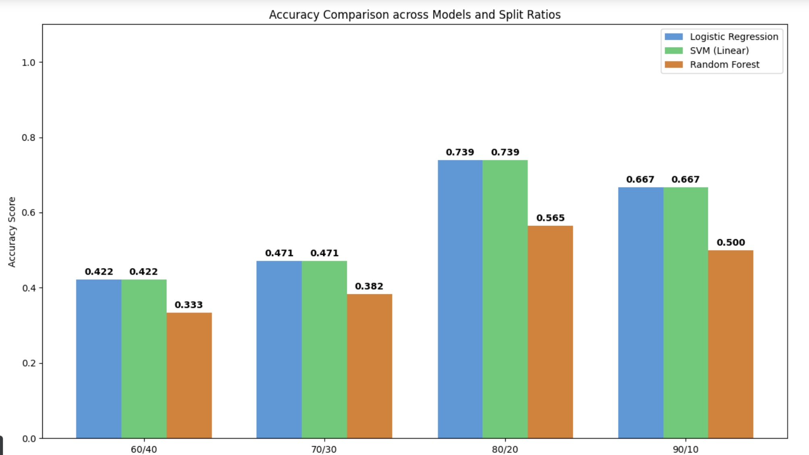
Fig. 2. Classification Performance across Models.
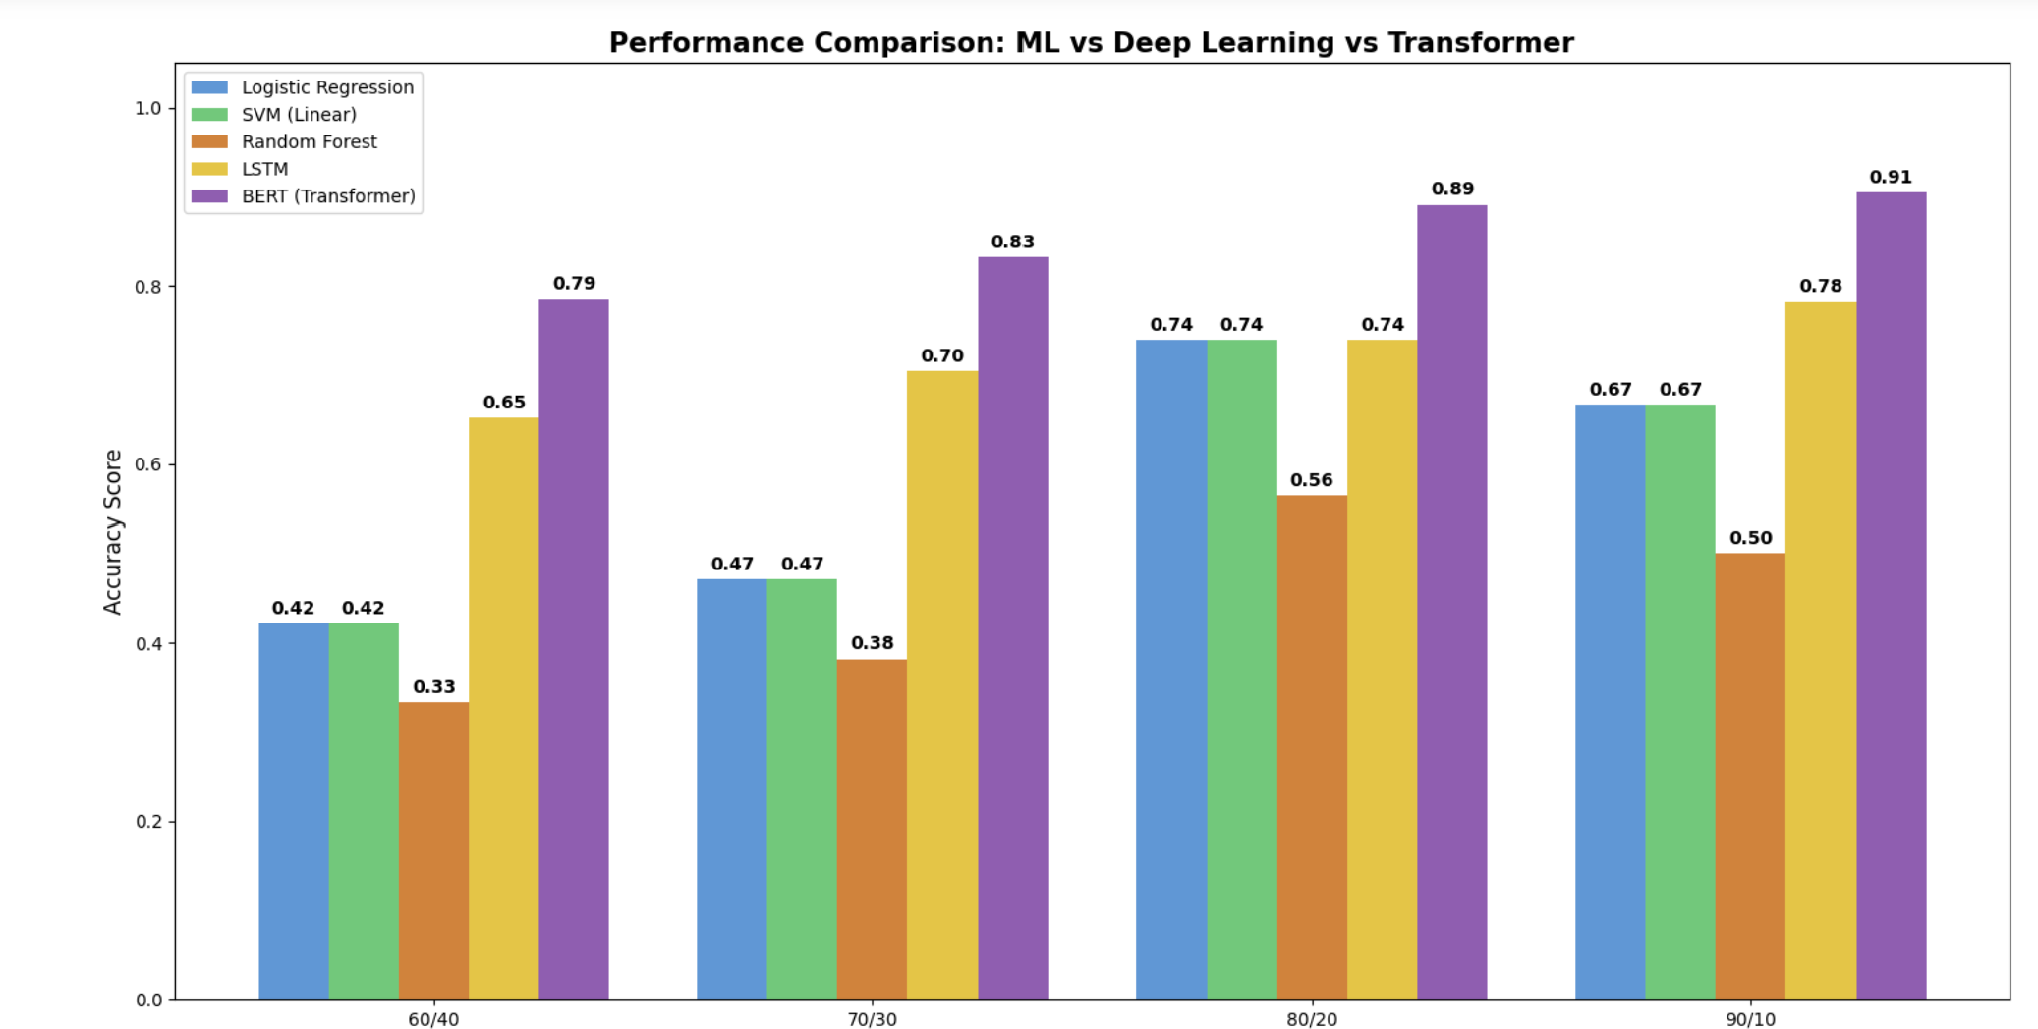

Fig. 3. Accuracy Trends over Different Train-Test Splits.

Conclusion
The research provided a comprehensive approach towards con-ducting ABSA by analyzing various types of machine learning algorithms, deep learning architecture, and transformer-based methods. The methodology followed by the authors involved data preprocessing, data structuring, feature engineering, and classification approaches used to conduct sentiment analysis on the aspect level. Unlike the traditional approach that considers one overall sentiment rating for the entire review, the proposed methodology helped detect individual sentiment scores on specific aspects such as staff and teaching, facilities, course material, and evaluation.
In order to establish which model is the most effective one, a comparison between logistic regression, support vector machine, random forest, BiLSTM, and fine-tuned DistilBERT models was done using different train-test splits. From the results of the study, it can be concluded that transformer models performed far much better than both machine learning and deep learning models due to their ability to capture contextual relationship through the attention mechanism. Overall, DistilBERT model performed the best, with the accuracy rate of 90.5incorporation of aspects and categories in the input representation also improved the classifier’s performance.
Conclusion In conclusion, the developed methodology can be considered an effective, scalable, and reliable approach to tackling the problem of huge amounts of feedback. Results obtained in this paper can help educational institutions to figure out their strengths and weaknesses in various aspects of education.

Future Work
There are a number of positive aspects in the framework. However, there are also a few improvements which might be performed in the future. For example, the framework should support a full pipeline for Aspect-Based Sentiment Analysis including automatic extraction of aspect terms from unannotated reviews of students. Moreover, the proposed framework can be applied in the analysis of multilingual and code-mixed reviews of students based on language models like Multilingual BERT and IndicBERT. Another improvement could be using Explainable Artificial Intelligence approaches such as SHAP, LIME, and attention mechanisms for better transparency and interpretability. Moreover, there is an option to do multi-label and hierarchical sentiment analysis to detect reviews with multiple aspects. The last one is to integrate the proposed model into app or RESTful API.

References
- B. Pang, L. Lee, and S. Vaithyanathan, “Thumbs up? Sentiment classification using machine learning techniques,” in Proc. Conference on Empirical Methods in Natural Language Processing (EMNLP), 2002,
pp. 79–86.
- B. Liu, Sentiment Analysis and Opinion Mining. San Rafael, CA, USA: Morgan & Claypool Publishers, 2012.
- M. Pontiki, D. Galanis, J. Pavlopoulos, H. Papageorgiou, I. Androutsopou-los, and S. Manandhar, “SemEval-2014 Task 4: Aspect based sentiment analysis,” in Proc. 8th International Workshop on Semantic Evaluation (SemEval 2014), 2014, pp. 27–35.
- N. Altrabsheh, M. Cocea, and S. Fallahkhair, “Sentiment analysis: towards a tool for analysing real-time students feedback,” in Proc. IEEE 26th International Conference on Tools with Artificial Intelligence (ICTAI), 2014, pp. 419–423.
- W. Che, Y. Zhao, H. Guo, Z. Su, and T. Liu, “Sentence compression for aspect-based sentiment analysis,” IEEE/ACM Transactions on Audio, Speech, and Language Processing, vol. 23, no. 12, pp. 2111–2124, 2015.
- D. Tang, B. Qin, X. Feng, and T. Liu, “Effective LSTMs for target-dependent sentiment classification,” in Proc. 26th International Confer-ence on Computational Linguistics (COLING), 2016, pp. 3298–3307.
- S. Ruder, P. Ghaffari, and J. G. Breslin, “A hierarchical model of reviews for aspect-based sentiment analysis,” in Proc. 2016 Conference on Empirical Methods in Natural Language Processing (EMNLP), 2016,
pp. 999–1005.
- K. Schouten and F. Frasincar, “Survey on aspect-level sentiment analysis,” IEEE Transactions on Knowledge and Data Engineering, vol. 28, no. 3,
pp. 813–830, 2016.
- W. Wang, S. J. Pan, D. Dahlmeier, and X. Xiao, “Coupled multi-layer attentions for co-extraction of aspect and opinion terms,” in Proc. 31st AAAI Conference on Artificial Intelligence (AAAI), 2017, pp. 3316–3322.
- N. Majumder, S. Poria, A. Gelbukh, M. S. Akhtar, E. Cambria, and A. Ekbal, “IARM: Inter-aspect relation modeling with memory networks in aspect-based sentiment analysis,” in Proc. 2018 Conference on Empirical Methods in Natural Language Processing (EMNLP), 2018, pp. 3402–3411.
- J. Devlin, M.-W. Chang, K. Lee, and K. Toutanova, “BERT: Pre-training of deep bidirectional transformers for language understanding,” in Proc. 2019 Conference of the North American Chapter of the Association for Computational Linguistics (NAACL-HLT), 2019, pp. 4171–4186.
- V. Sanh, L. Debut, J. Chaumond, and T. Wolf, “DistilBERT, a distilled version of BERT: smaller, faster, cheaper and lighter,” arXiv preprint arXiv:1910.01108, 2019.
- C. Sun, L. Huang, and X. Qiu, “Utilizing BERT for aspect-based sentiment analysis via constructing auxiliary sentence,” in Proc. 2019 Conference of the North American Chapter of the Association for Computational Linguistics (NAACL-HLT), 2019, pp. 380–385.
- H. Xu, B. Liu, L. Shu, and P. S. Yu, “BERT post-training for review reading comprehension and aspect-based sentiment analysis,” in Proc. 2019 Conference of the North American Chapter of the Association for Computational Linguistics (NAACL-HLT), 2019, pp. 2324–2335.
- J. Zhou, J. X. Huang, Q. Chen, Q. V. Hu, T. Wang, and L. He, “Deep learning for aspect-level sentiment classification: survey, vision, and challenges,” IEEE Access, vol. 7, pp. 78454–78483, 2019.
- Z. Kastrati, A. S. Imran, and A. Kurti, “Weakly supervised framework for aspect-based sentiment analysis on students’ reviews of MOOCs,” IEEE Access, vol. 8, pp. 106799–106810, 2020.
- Z. Kastrati, F. Dalipi, A. S. Imran, K. Pireva Nuci, and M. A. Wani, “Sentiment analysis of students’ feedback with NLP and deep learning: a systematic mapping study,” Applied Sciences, vol. 11, no. 9, p. 3986, 2021.
- F. Karl and A. Scherp, “Transformers are short text classifiers: a study of inductive short text classifiers on benchmarks and real-world datasets,”
in Proc. International Conference on Machine Learning and Data Engineering (iCMLDE), 2022, pp. 43–50.
- A. Jazuli, W. Widowati, and R. Kusumaningrum, “Aspect-based sentiment analysis on student reviews using the Indo-BERT base model,” E3S Web of Conferences, vol. 448, p. 02004, 2023, doi: 10.1051/e3sconf/202344802004.
- I. Perikos and A. Diamantopoulos, “Explainable aspect-based sentiment analysis using transformer models,” Big Data and Cognitive Computing, vol. 8, no. 11, p. 141, 2024, doi: 10.3390/bdcc8110141.
- A. Chauhan, A. Sharma, and R. Mohana, “An enhanced aspect-based sentiment analysis model based on RoBERTa for text sentiment analysis,” Informatica, vol. 49, no. 14, 2025, doi: 10.31449/inf.v49i14.5423.
- X. Zhong, H. Di, X. Zhao, C. Bai, and Z. Zhong, “Multi-granularity features fusion with hierarchical networks for aspect-based sentiment analysis,” Electronic Research Archive, vol. 34, no. 5, pp. 2897–2925, 2026, doi: 10.3934/era.2026132.
- Y. Missaoui, S. Kebede, M. Marreddy, and A. Mehler, “DualAxis AI at SemEval-2026 Task 3: Dimensional aspect-based sentiment analysis,” in Proc. 20th International Workshop on Semantic Evaluation (SemEval-2026), 2026.

