Below is the image of the design we can take for the widget pitch stair case.
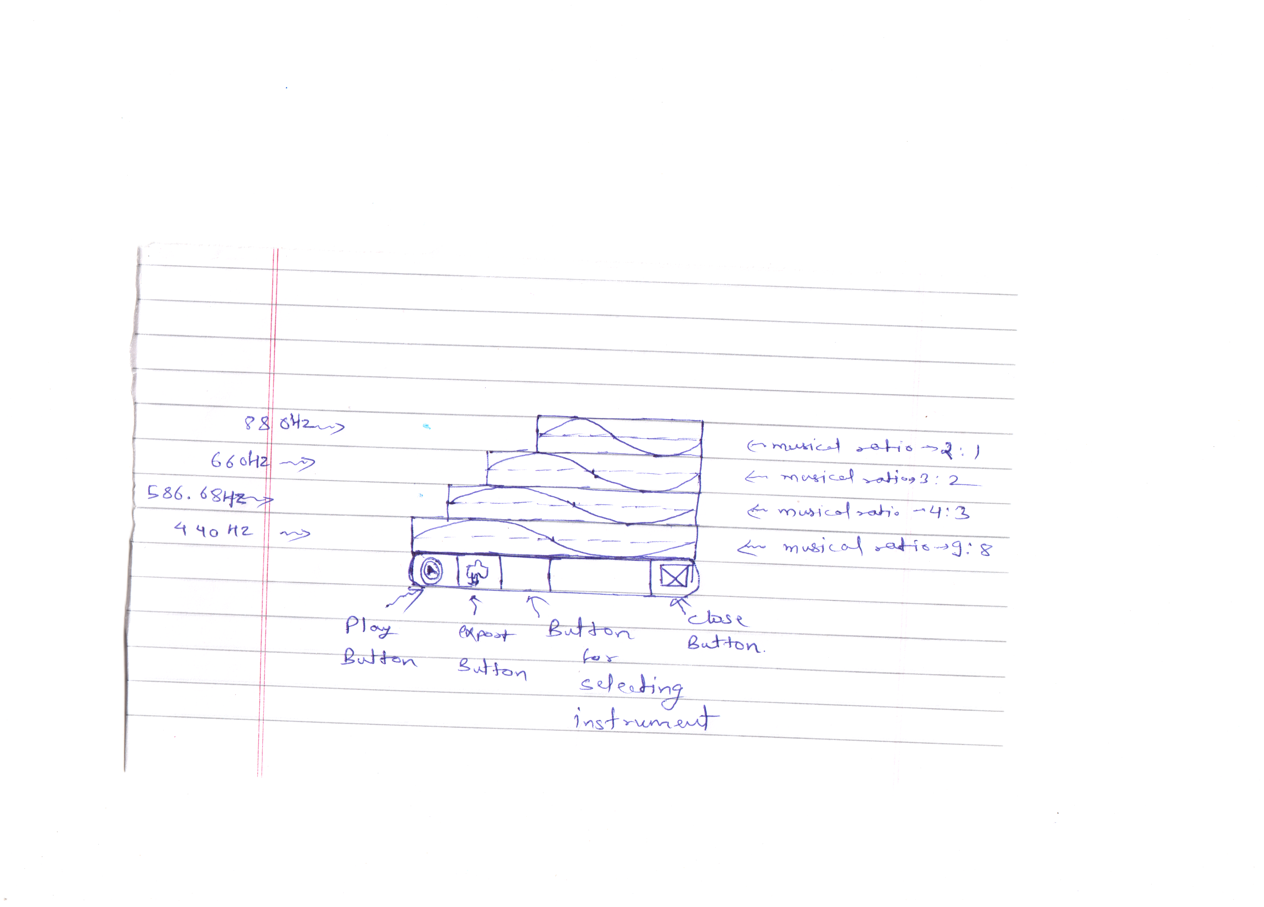
It consist of play, export, close and button for choosing the instrument to be played.
So key concept is as the height of the stair increases the frequency increases hence the pitch of the sound increases.

For example in the design image
First stair corresponds to 440 Hz having musical ratio 9:8(Pythagorean whole tone )
Second stair have musical ratio 4:3 ( Perfect Fourth ) and hence corresponds to frequency
equal to (4/3)*440 = 586.67 Hz
Third stair have musical ratio 3:2 ( Perfect Fifth ) and hence corresponds to frequency equal
to (3/2)*440 = 660 Hz
Fourth stair have musical ration 2:1 ( Octave ) and hence corresponds to frequency equal to
(2)*440 = 880 Hz

An another feature, the frequency distribution is described by the sine wave in the stair, we see that wavlength of the sine wave is decreasing as the height of the stair increase this shows that the frequency is increasing as the height is increasing.

