For the Tempo widget as we have the widget almost ready as shown in the image below : ->

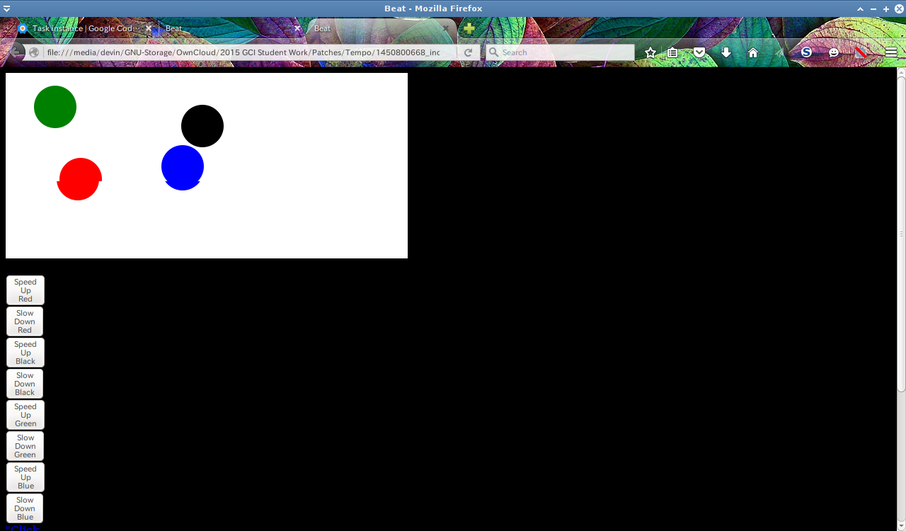
We can see we have buttons to speed up , speed slow of the balls.
If needed we can add more features to this widget only.

So the main task will be how we export it to Music Blocks code.
This can be done by creating a new block “Tempo Block” having argument the Tempo value.

