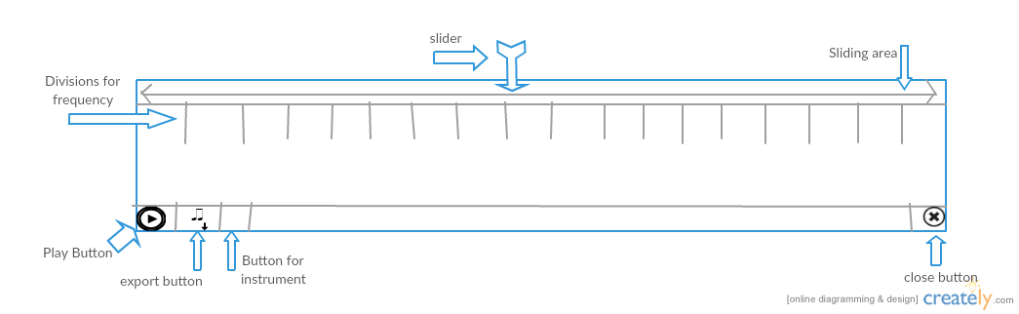
The design for the widget pitch slider is shown below.
As can be seen in the image it consist of play, export, button for choosing instrument and close
button. We have a slider to slide through the sliding area having frequency division ( pitch division).

For division we can either show the absolute frequency of the sound or we can show the notes like (
C, D etc. ) . Or we can show notes and absolute frequency both at the same time.

