**COMPANY CHANGES**

1. ENQUIRY NO AUTO: PREFIX/NO/SUFIX LIKE ASSET

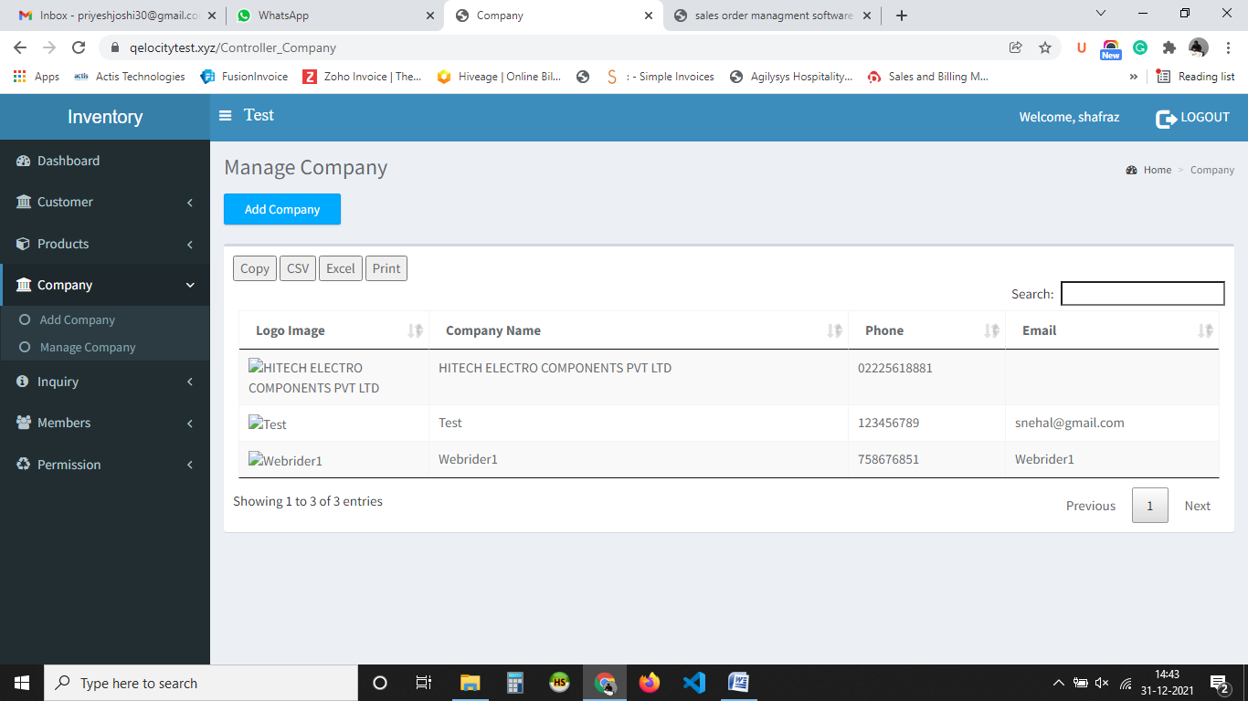

2. Cannot edit delete

3. Cannot login in the new company with [admin@admin.com](mailto:admin@admin.com) and admin

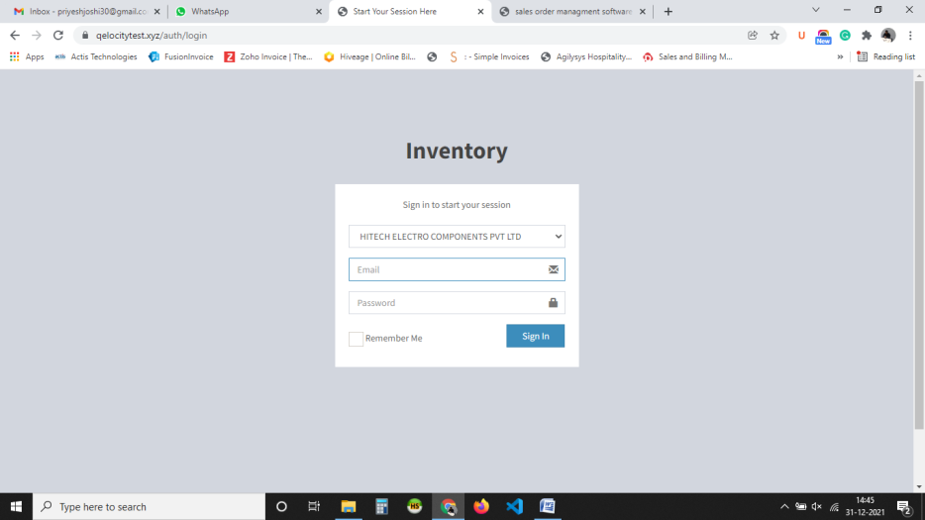

4. Make a id like Superadmin 12345 to login into any company

**Customer:**

1. Attachment cannot be downloaded it is taking first document only

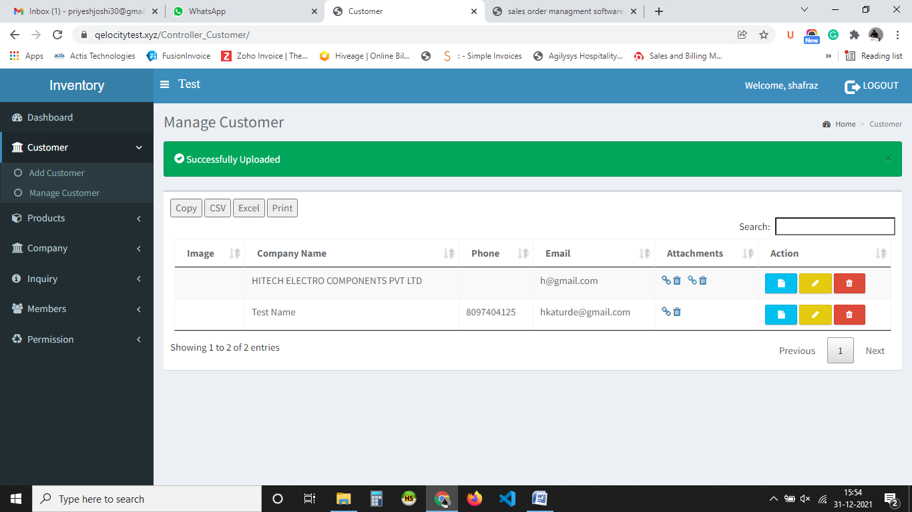

**User Premission**

Remove Invoice&LR

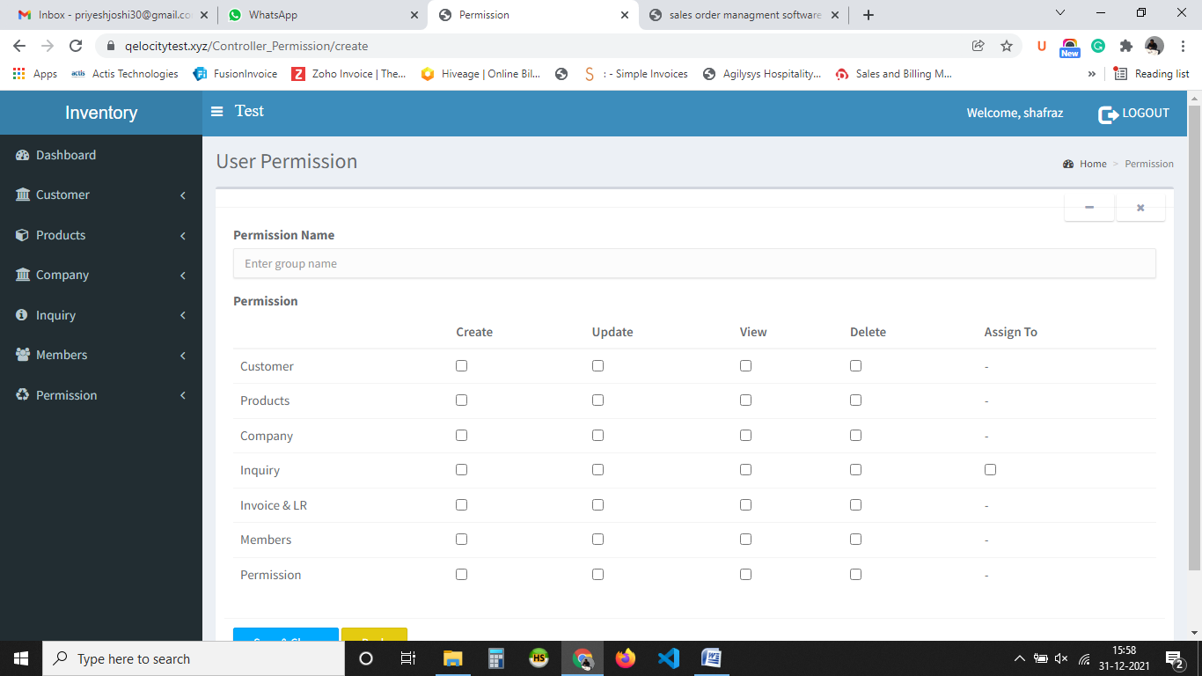

Cannot edit delete

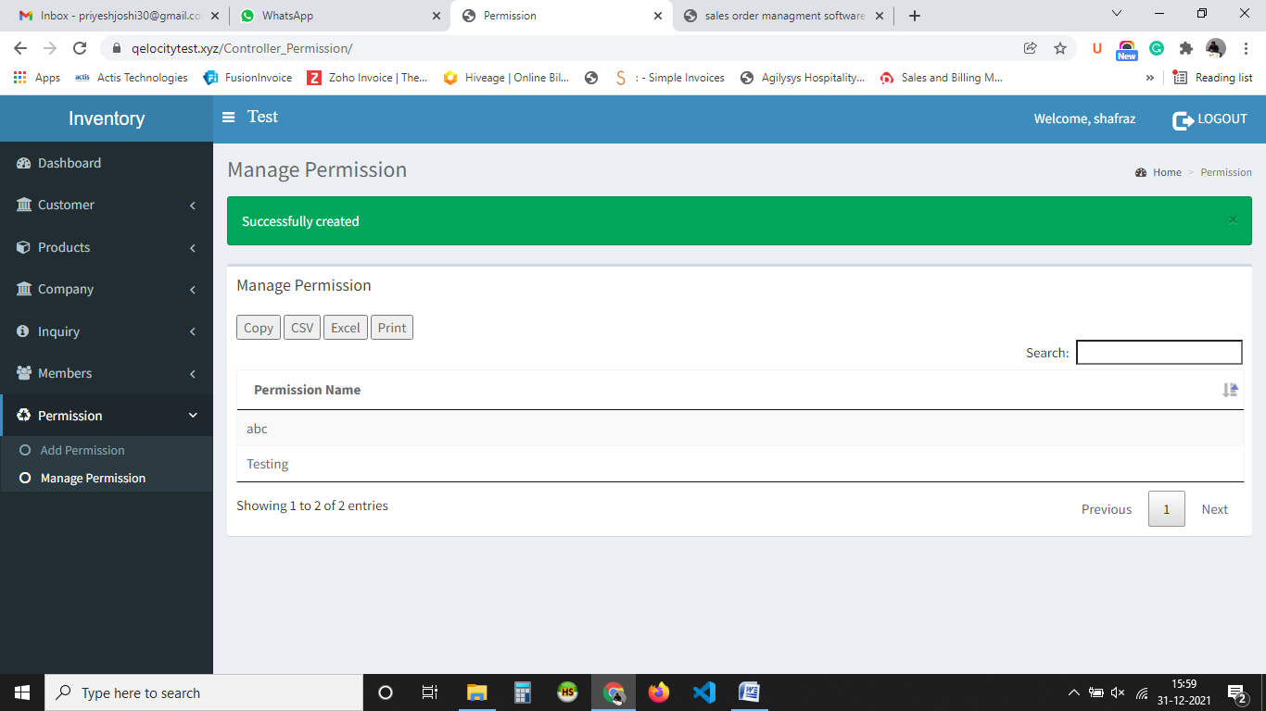

**Members:**

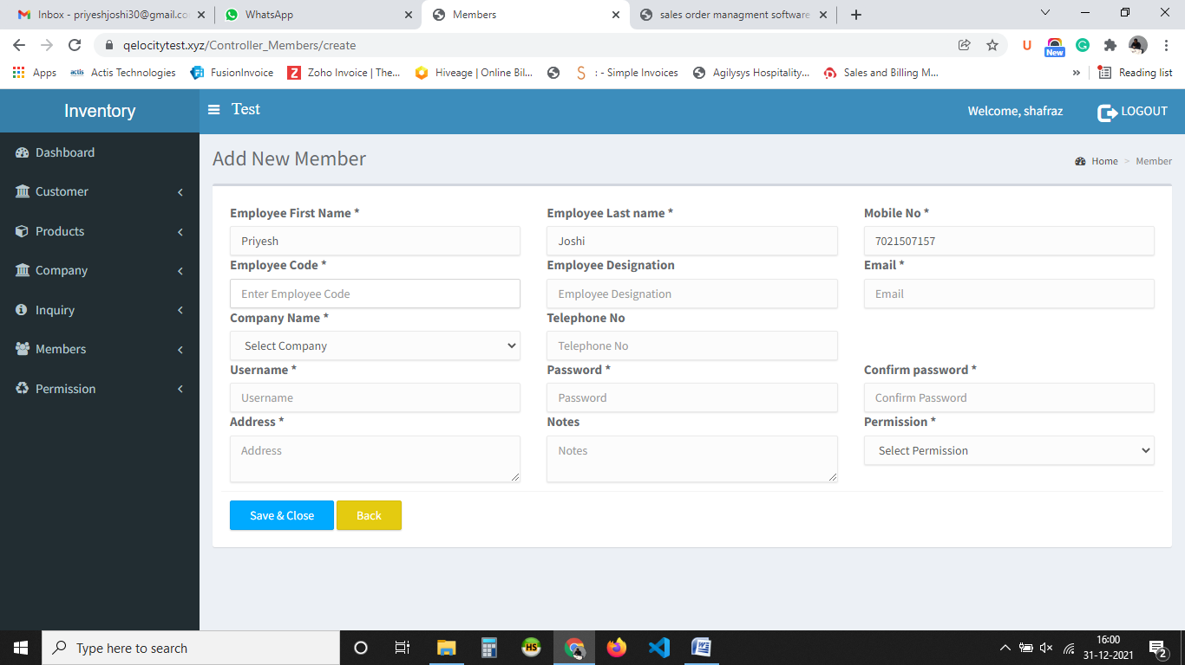

Make non compulsory: last name, employee code, address, remove company name as members would be company specific on add edit both pages

Remove password length like 5 or 8 characters

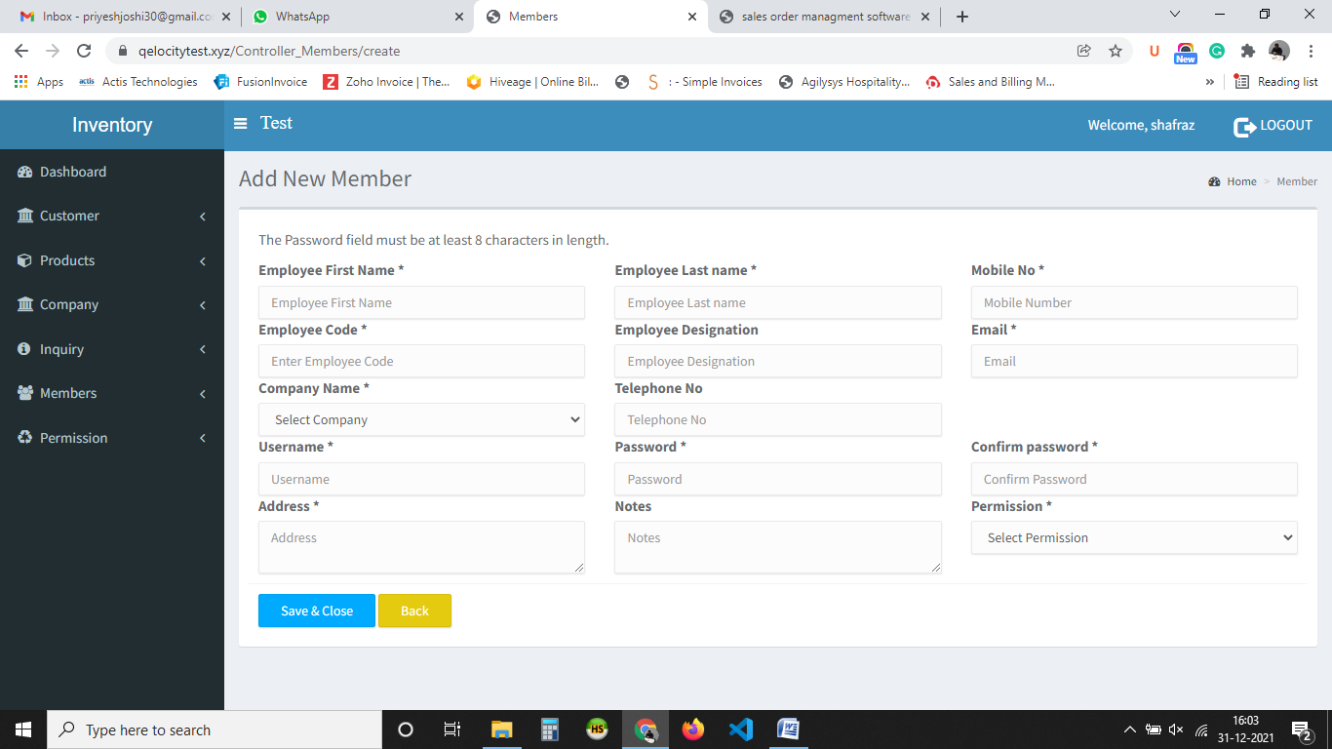

**Product:**

1. Create Product Type
2. In product give product type dropdown
3. On listing show product type and name not code

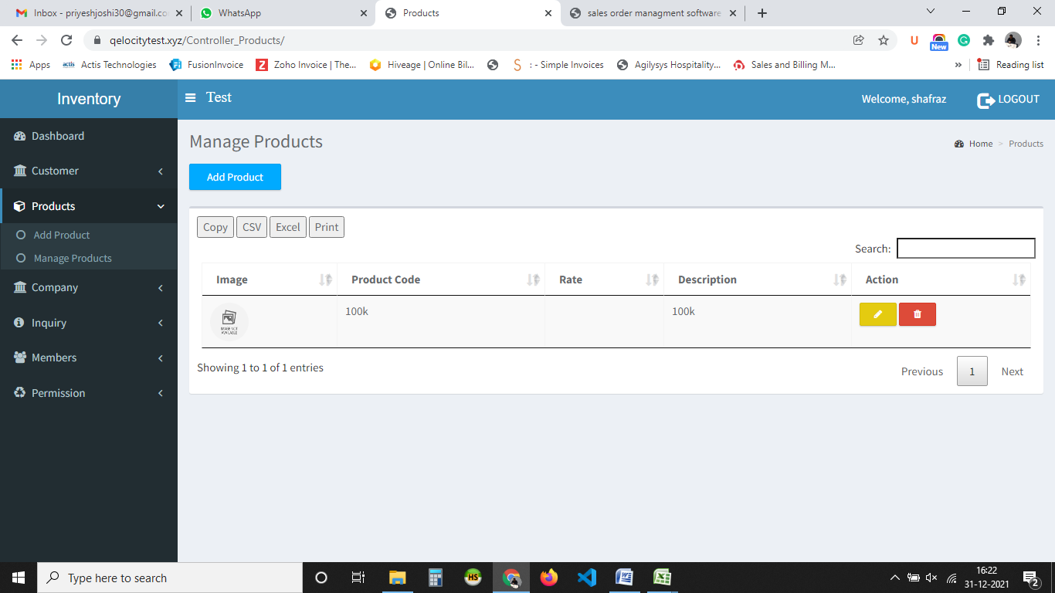

Note: Check Search it doesn’t work on any pages listing

Inquiry:

1. Enquiry no to be auto generated from company prefix and suffix

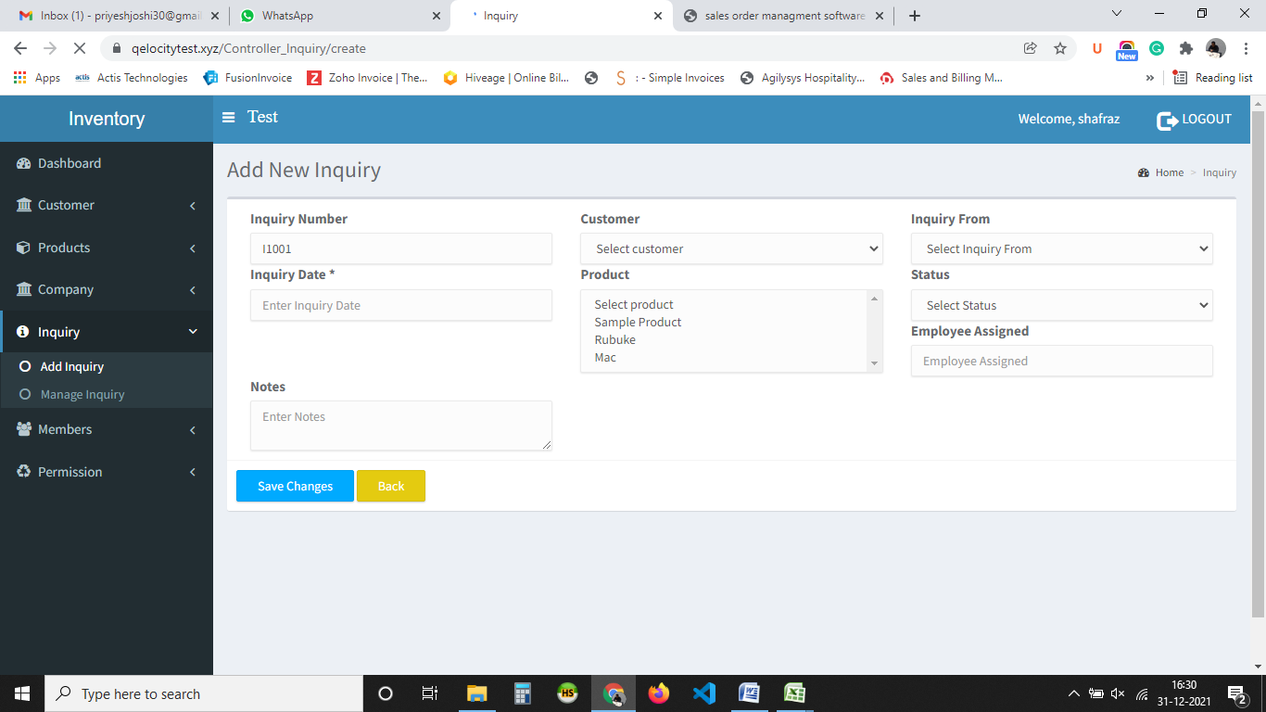

1. Make Inquiry From Master single box add edit delete option
2. Inquiry Date use calendar
3. Assigned link to employee its not linked
4. 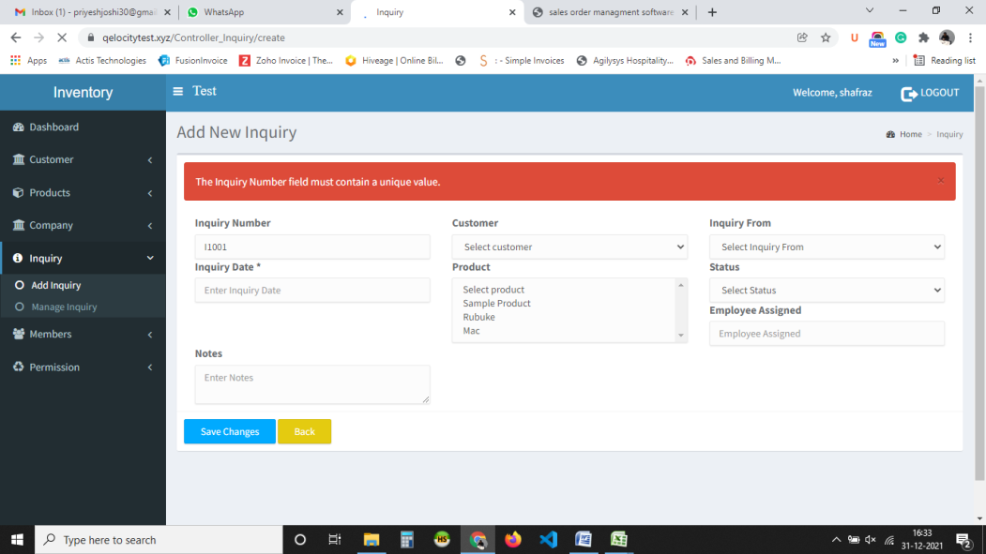
5. Inquiry form doesn’t work
6. Refer documents of software for more.
7. We need to add status to inquiry and approval.