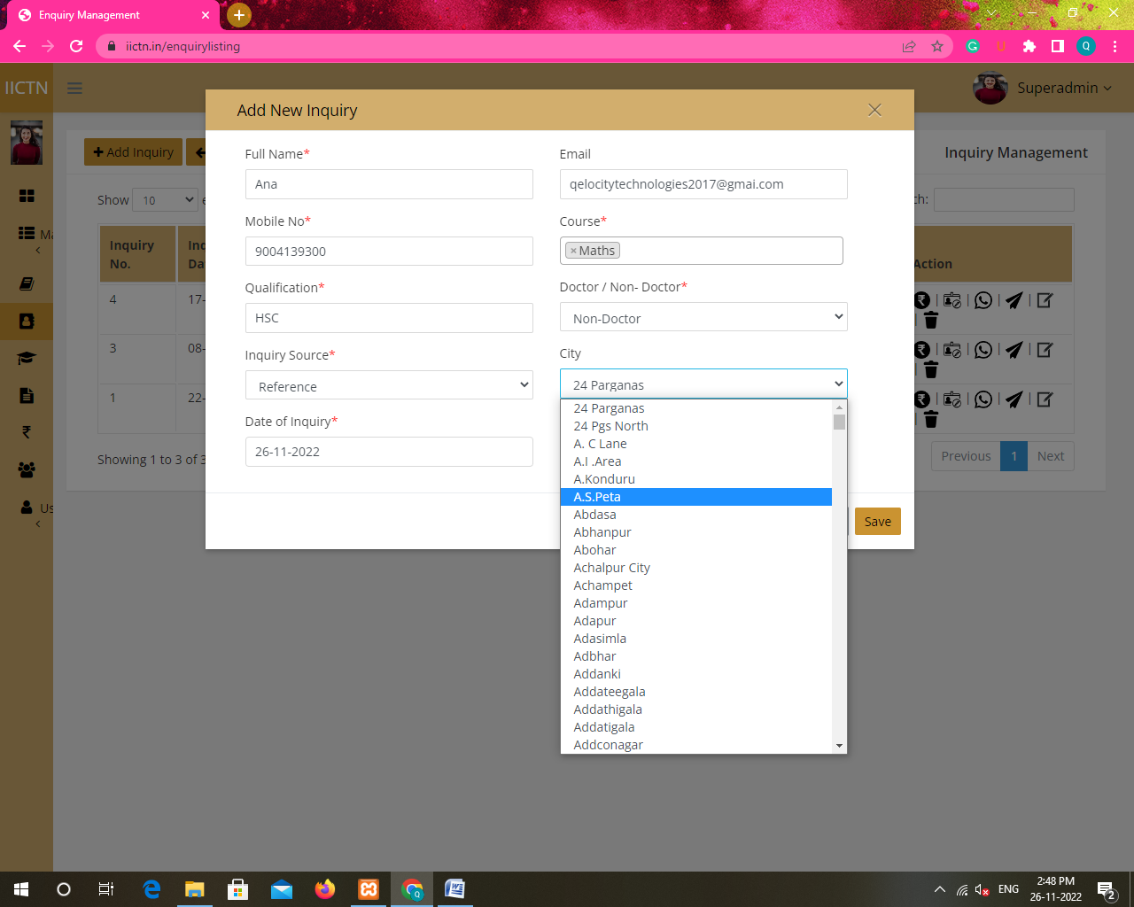

Add search option for states in Add New Inquiry

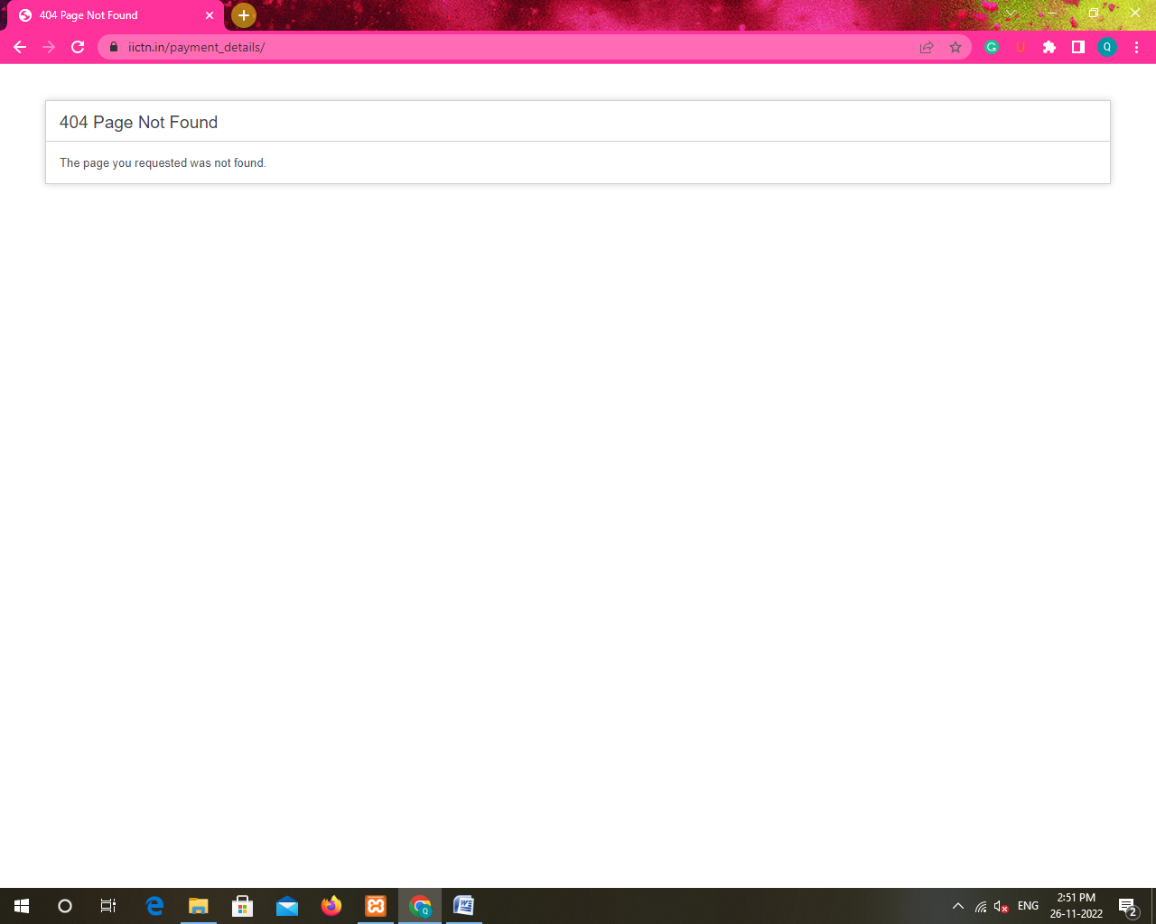

This error occurs when payment details, follow up, edit inquiry icon is clicked in inquiry/leads

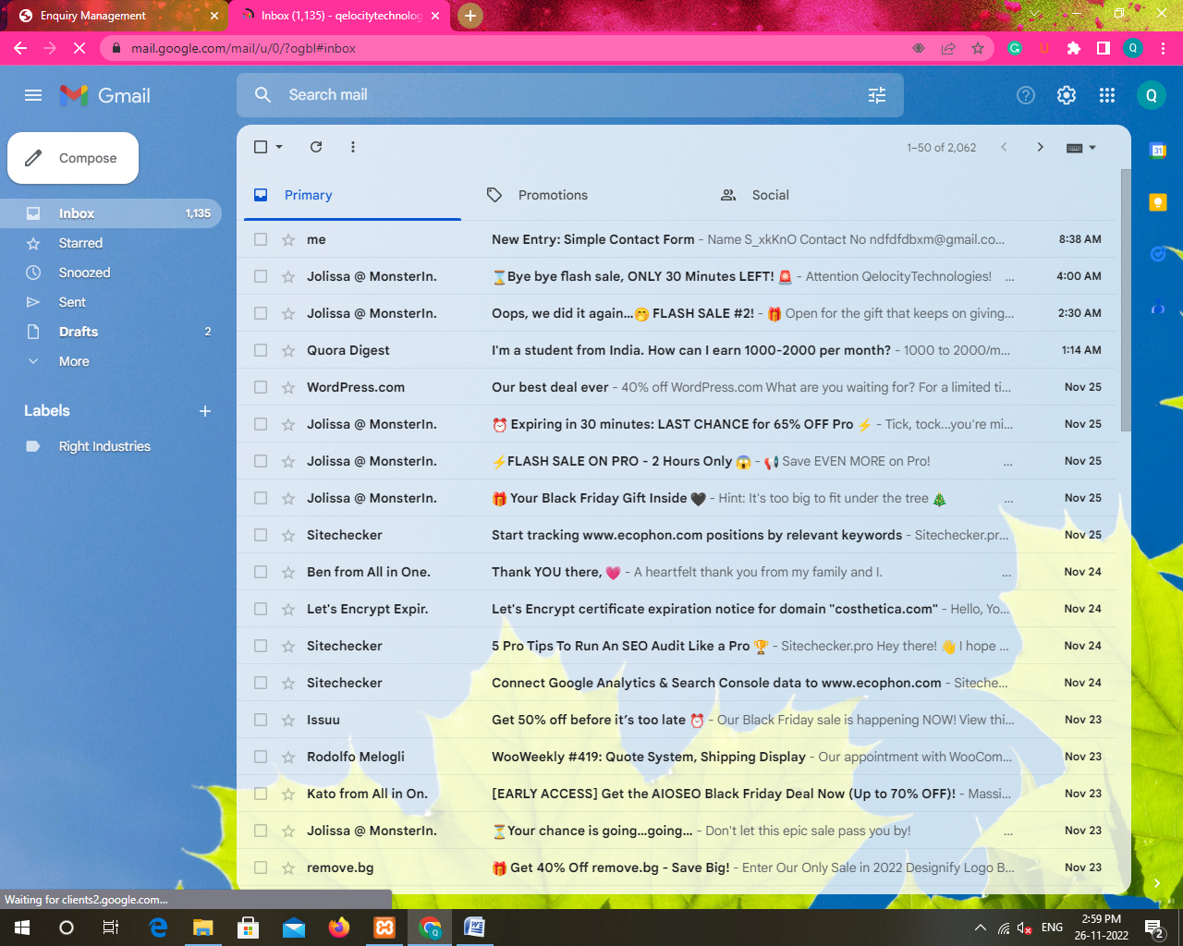

Brochure mail did not arrive even when not sent

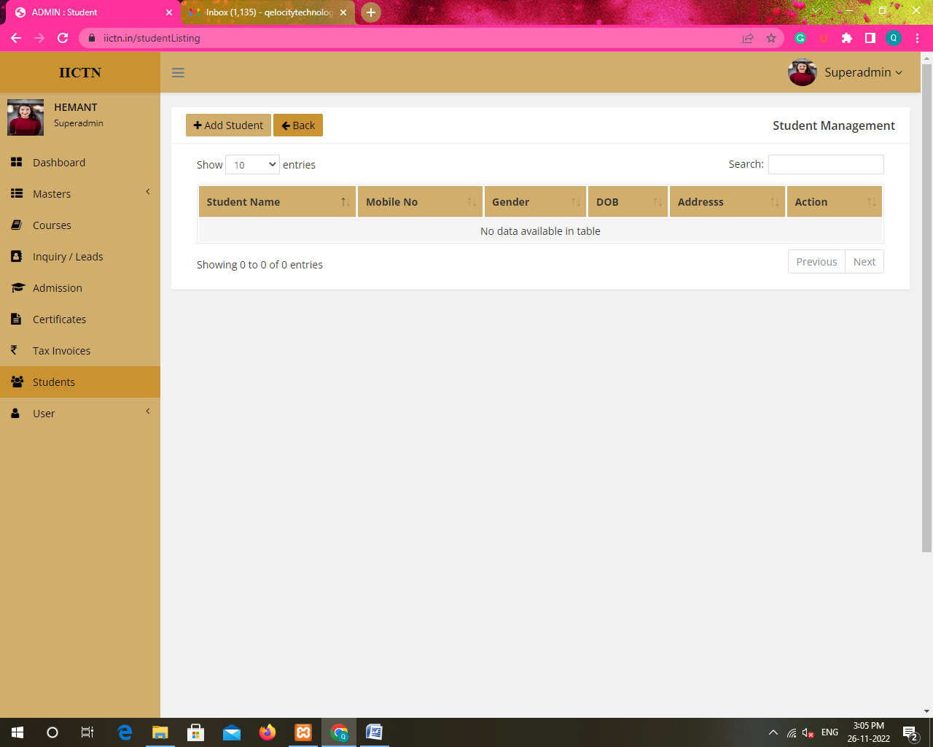

Student disappeared after editing and student details change automatically

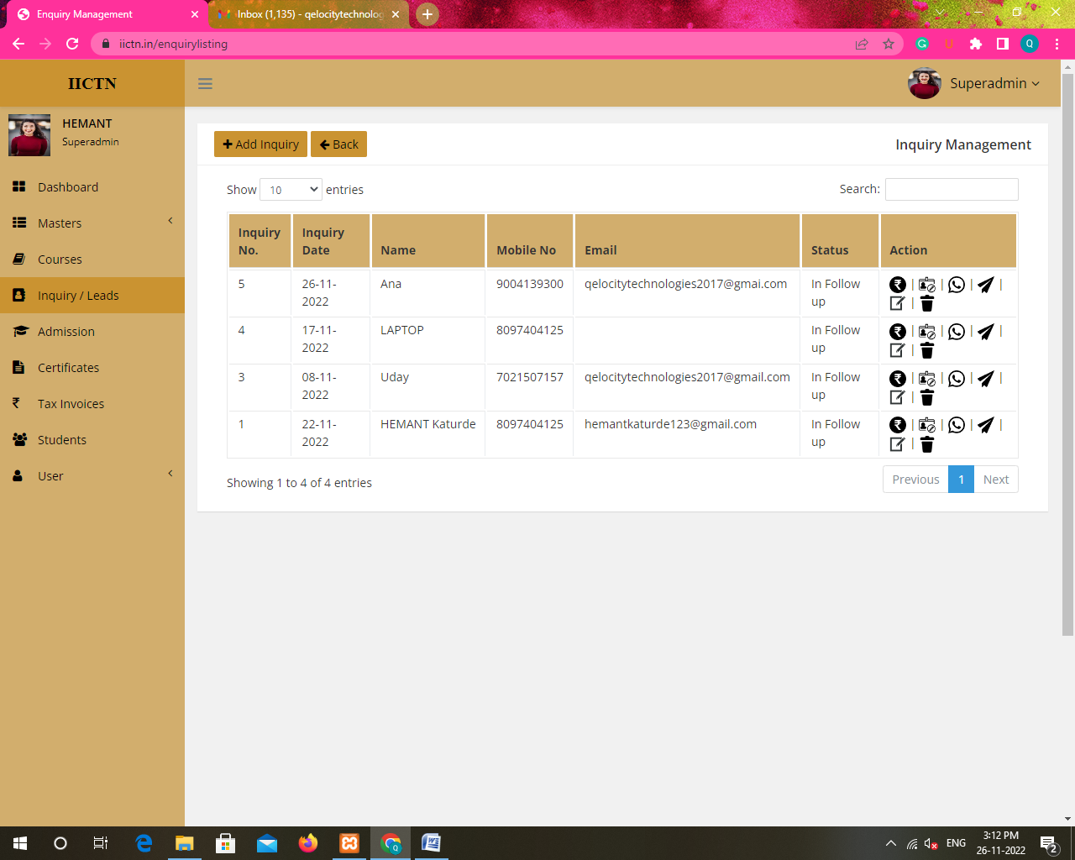

User is not deleting