Below is the screenshot for the rearc assigned activity to ingest the data files in
BRONZE->SILVER->GOLD.

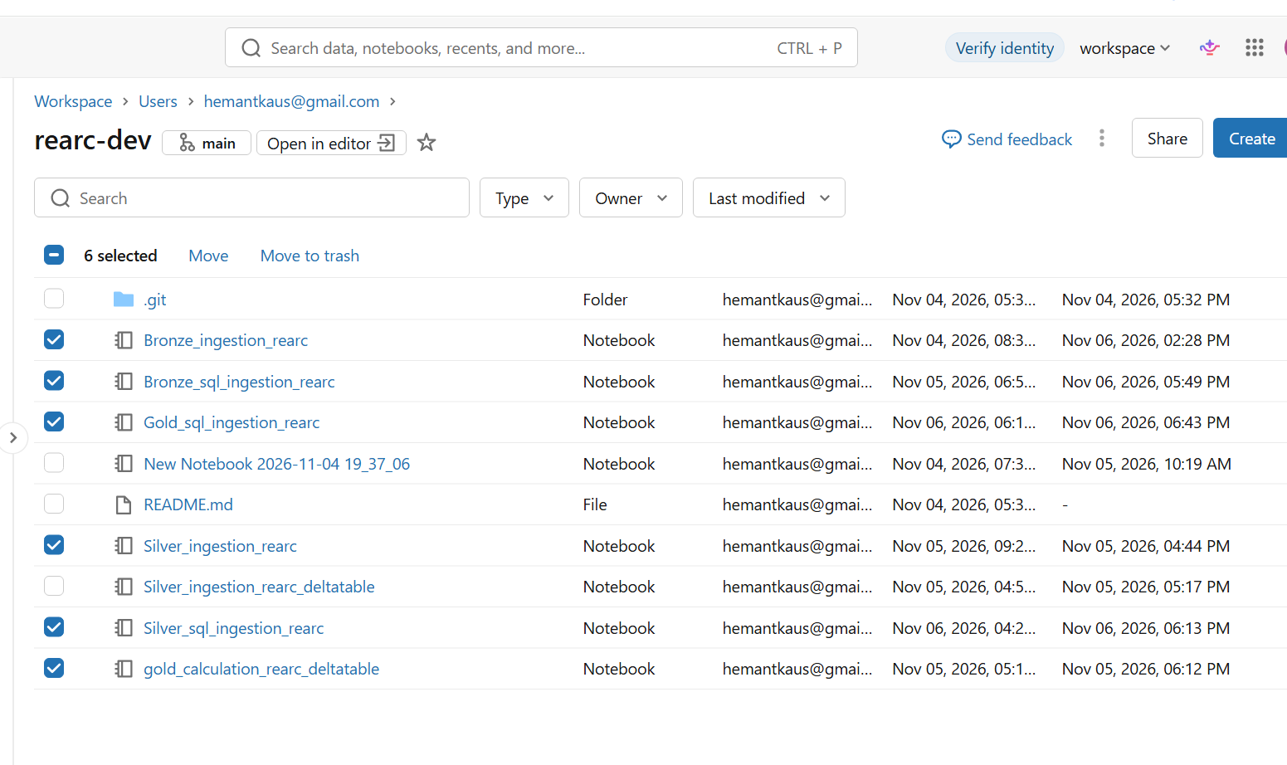

I have created 2 kind of tables in each schema(bronze,silver and gold)
%sql_pr% with the SQL style notebook and other are from PYSPARK style notebook


