AWS Assignment Day-2

Task 1:

Create a vpc not by wizard this time but manually, having 2 public subnets and 2 private subnets and 2 protected subnets.

setup should be highly available

Create 1 IGW and 2 NGW in each availability zone and make the appropriate routes in route tables

Main route will remain intact, instead make 4 route tables

public_route_table
private_route_table_1
private_route_table_2
protected_route_table

Solution:

1) Created vpc namely ninja and assigned ipv4 address range (10.0.0.0/16) to it.
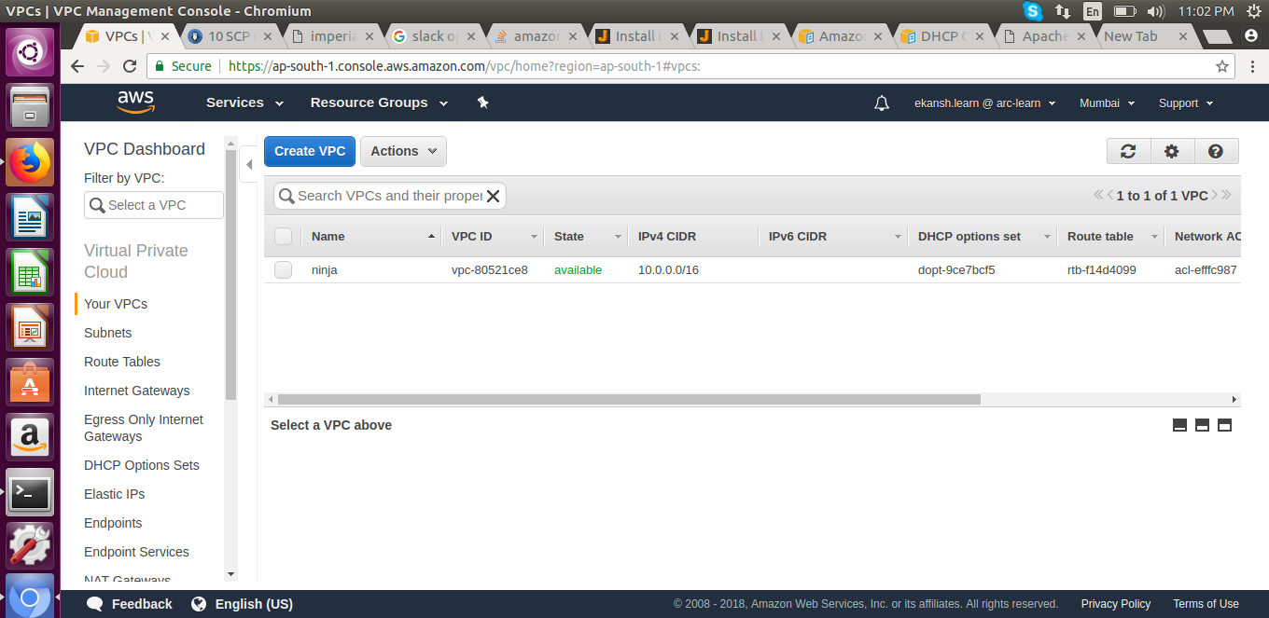
2) Create 2 private subnets namely ‘pri1’ and ‘pri2’, 2 public subnets namely ‘pub1’ and ‘pub2’ into it this vpc and set their ipv4 range individually which belongs to vpc ip.
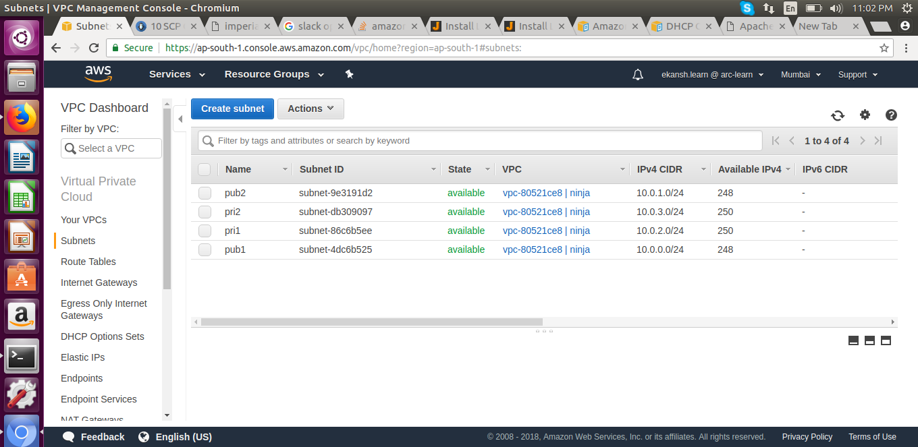
3) Created a internet gateway namely ‘ninja_ig’ to connect vpc to the internet and attached this gateway to vpv from actions tab.
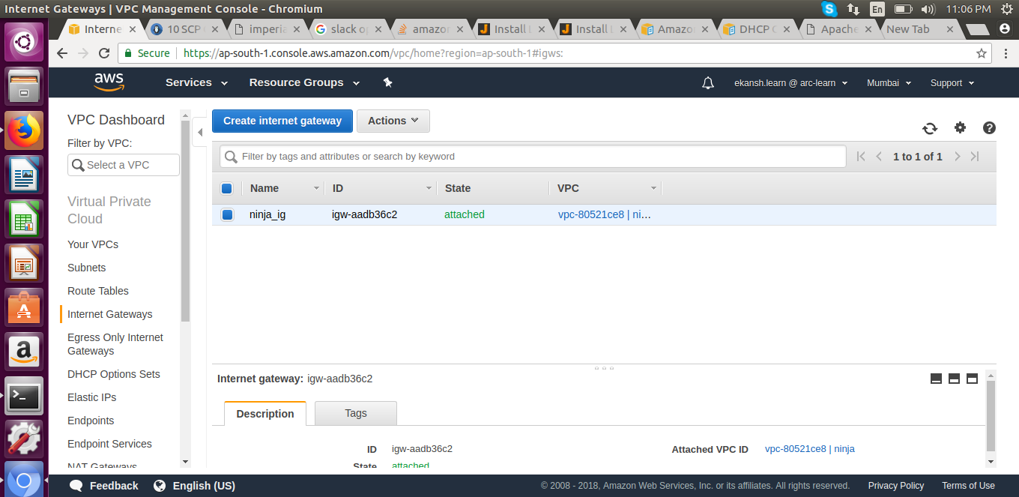
4) Created 2 NAT gateway respectively in public subnets (pub1 and pub2) and assigned an elastic ip to NAT.

* NAT is created to get the responses from private subnets i.e. to run the internet in them. In this case the request from private subnet will first hit the the NAT, and then NAT will return the response keeping them private.
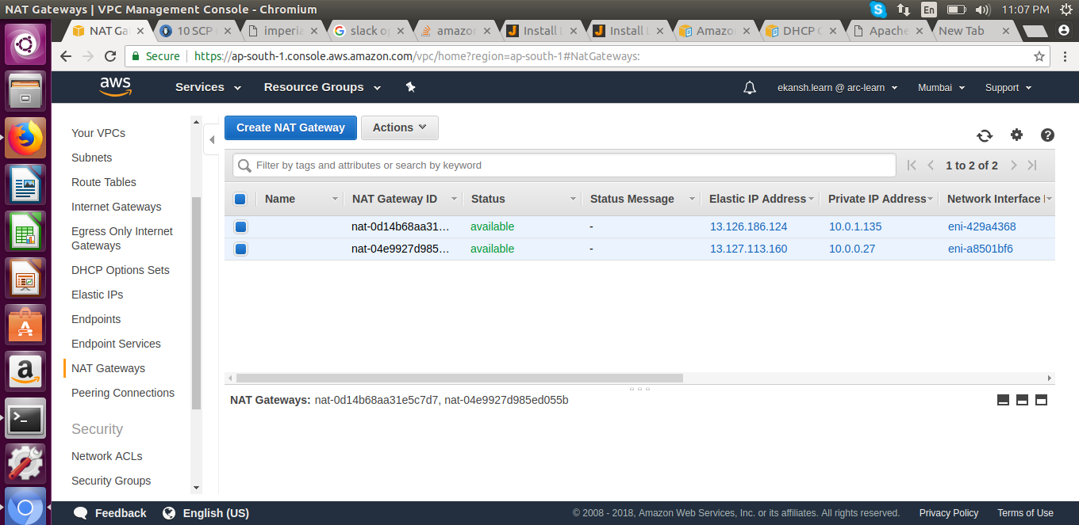
5) Created route table namely
pub_rt to be used by public subnets
pri1_rt to be used by private subnet 1
pri2_rt to be used by private subnet 2
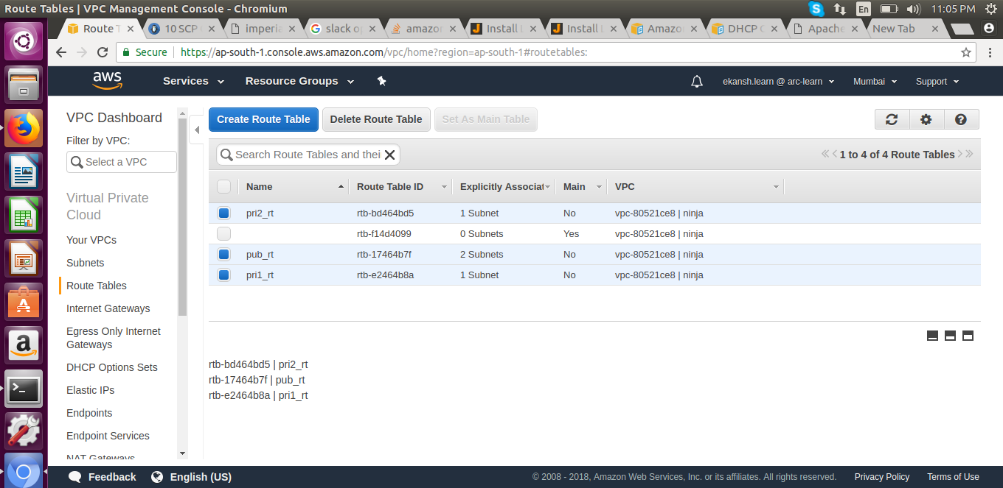
6) Associate subnets to their route table respectively.

7) Added internet gateway to public subnet route table
with destination as : 0.0.0.0/0
target as: igw-aadb36c2
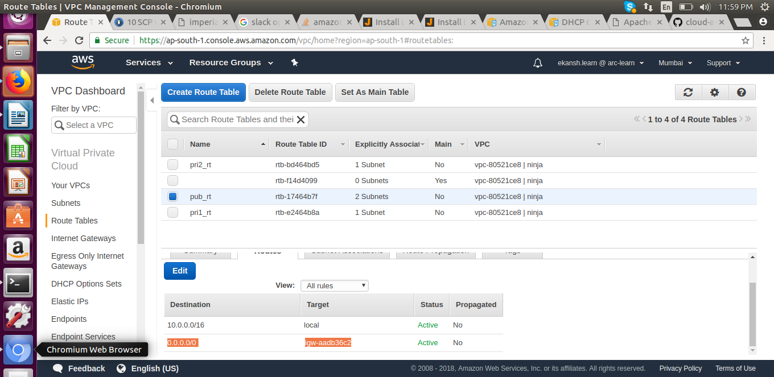
8) Added NAT to private subnets table respectively.
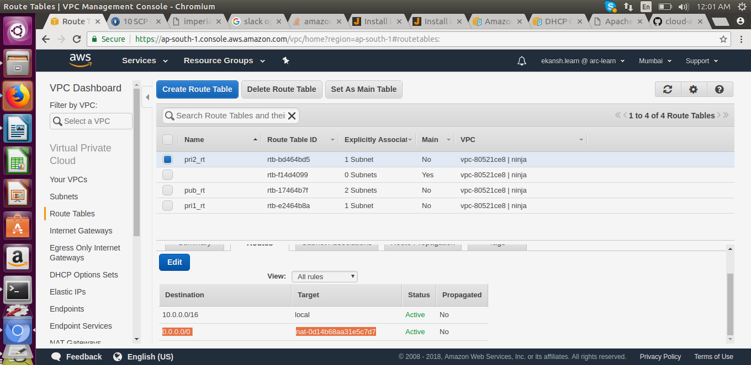
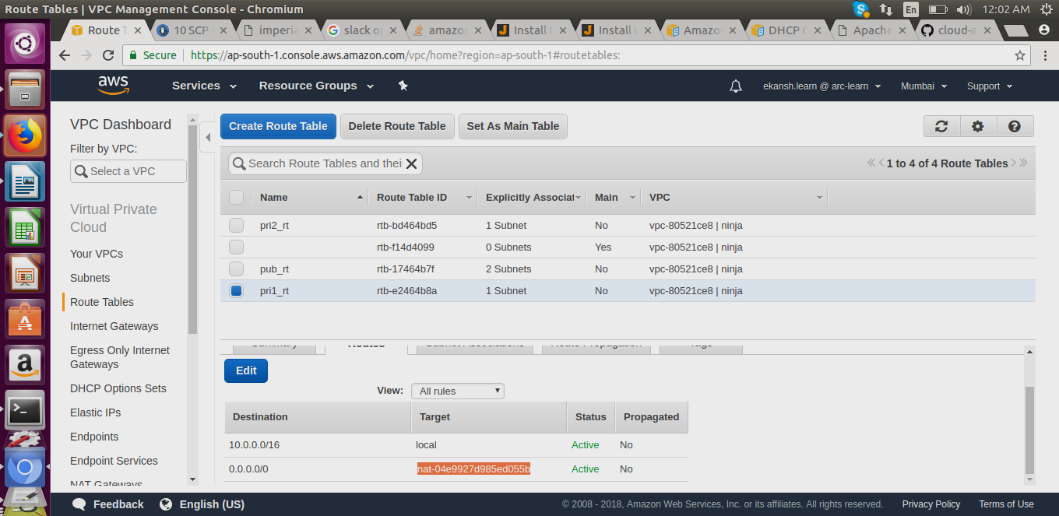

________________________________________________________________________________
Task 2:

Make LAMP setup with 2 instances in each private subnets.
Server-1 should serve a webpage that would say "Hi! i am server 1"
Server-2 should serve a webpage that would say "Hi! i am server 2"

Solution:

1) Created three ec2 instances of that VPC (AMI Ubuntu) namely:
pub1_ubuntu (for public subnet pub1 ) as a medium to take entry into private subnets in that VPC
pri1_ubuntu (for private subnet1 pri1) to serve as server1
pri2_ubuntu (for private subnet pri2) to serve as server2
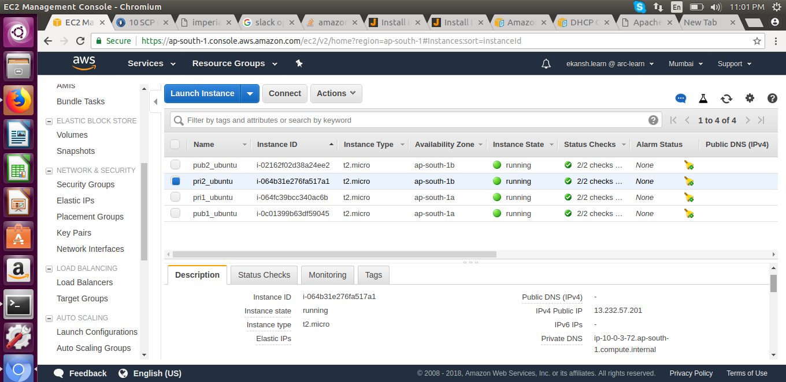

2) Created a key file namely “ninjakey.pem” and assigned to each instance and downlloaded it into local to create establishment with these remotes instances.

3) Added a security group namely to each instance which allows SSH, HTTP, HTTPS, TCP

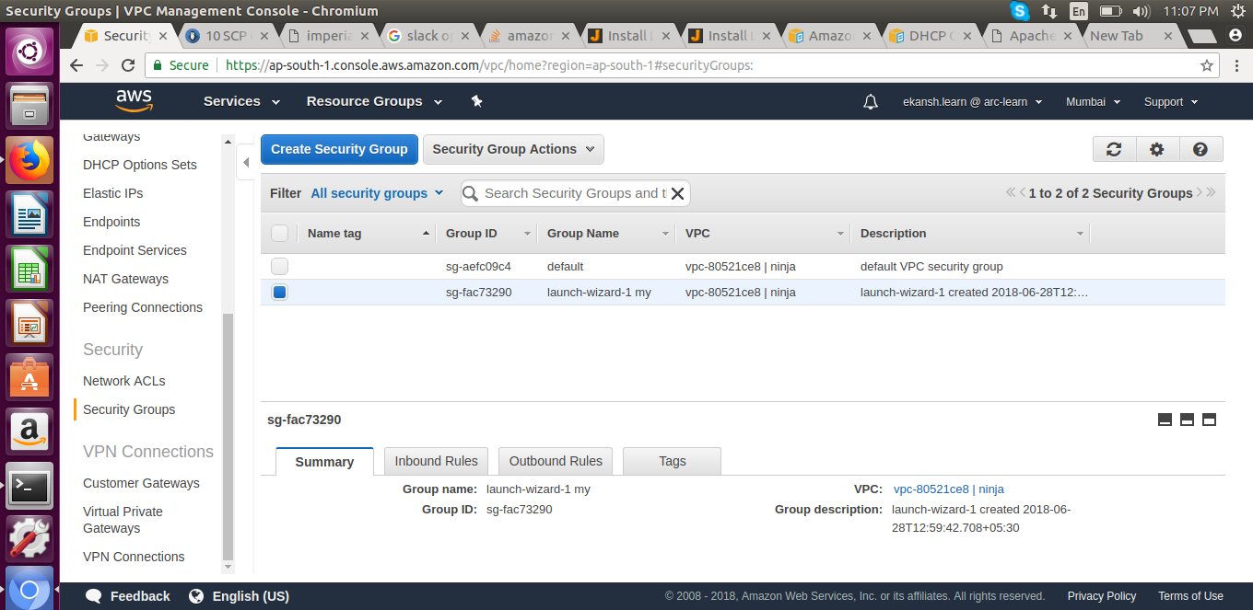
4) Access the remote public instance using ssh -i "ninjakey.pem" ubuntu@13.232.124.245

5) Copy ninjakey.pem to this public remote instance using scp to be used for further connecting to private instances using this public instance.

6) Enter into private instance through this public instance using ssh -i "ninjakey.pem" ubuntu@10.0.2.40

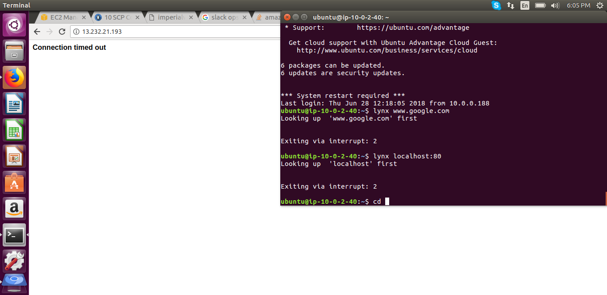
7) setup lamp into it using commands
sudo apt-get update & sudo apt-get upgrade
sudo apt-get install apache2 php libapache2-mod-php mysql-server libapache2-mod-auth-mysql php-mysq

8) opened and re-saved /var/www/html/index.html
Changed its content to say “Hi! I’m Server 1”.

9) Step 6,7,8 are made repeat for private instance 2 respectively and changed file contnets to say “Hi! I’m server 2”.

Task3:

Launch a public load balancer that would forward the requests to these 2 LAMP instances

Solution:

1) created a load balancer of type application type namely load-balancer1 on public subnet in vpc

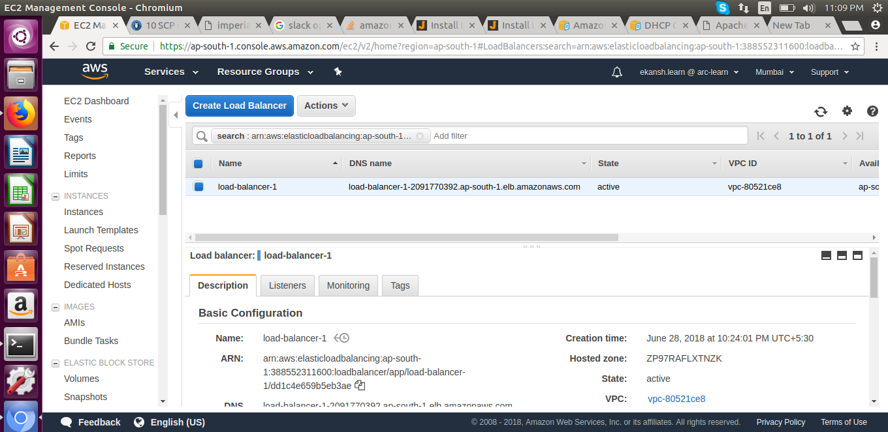
2) set the target to this load balancer as pri1_ubuntu and pri2_ubuntu.

3) Copy the dns of this load balancer to display the desired result as

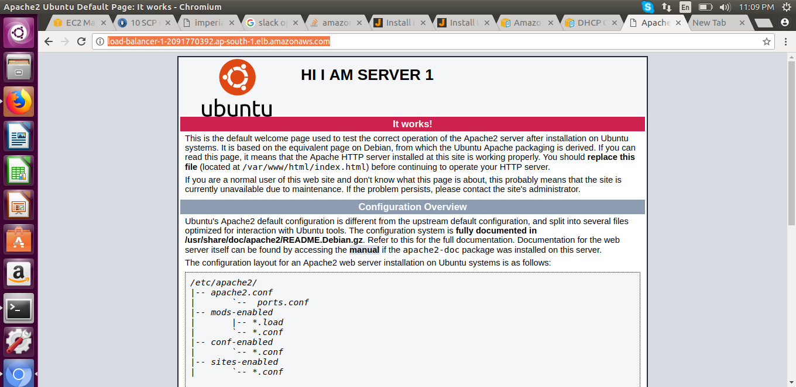
l phpmyadmin

* If the server 1 (pri1_ubuntu instance is made low) then the load automatically hits the server 2
* Also, its hits the load one by one on both the server respectively.

