Day 3 Assignment

**Assignment1:**

* Create account on each
  1. [Github](https://github.com/) [https://github.com/](https://github.com/kamal24111991/)hemantkhokharvce
  2. [Gitlab](https://about.gitlab.com/) https://gitlab.com/hemantkhokhar
  3. [Bitbucket https://bitbucket.org/](https://bitbucket.org/)hemantkhokharvce
* Try to find out key features and major differences between all

**Similarities:**

* Pull request
* Code review
* Issue tracking
* Two factor authentications
* Advanced permission management
* Hosted static web pages
* Feature rich API
* Fork / Clone Repositories
* Snippets
* 3rd party integrations

**Key feature & difference**

**Authentication Levels:**

With GitLab you can set and modify people’s permissions according to their role. In GitHub, you can decide if someone gets a read or write access to a repository.

**Build in CI:**

One of the big differences between GitLab and GitHub is the built-in Continuous Integration/Delivery of GitLab. CI is a huge time saver for many development teams and a great way of QA (nobody likes pull requests that break your application).

GitLab offers their very own CI for free. No need to use an external CI service. And if you are already used to an external CI, you can obviously integrate with Jenkins, Codeship and others.

Bit bucket CircleCI automatically creates your build environment using inference logic with the flexibility to customize as needed.

**Difference :**

GitHub Enterprise is way more expensive than Bitbucket Server, offering similar functionality

GitHub, who is famous for open source friendliness and hosts the largest amount (19.4M+) of open source projects is not open source.

Bitbucket is not open source but upon buying the self-hosted version the full source code is provided with product customization option

**Importing repository**

GitHub supports:

- The import of Git, SVN, HG, TFS.

GitLab supports:

-The import of Git.

-Easy import from other services GitHub, Bitbucket, Google Code, Fogbugz.

Coding supports:

- The import of Git, SVN, HG.

Bitbucket supports:

- The import of Git, CodePlex, Google Code, HG, SourceForge, SVN.

Assignment2:

* Check for organization and repository level permission for team and users over repositories and branches.

There are few type of organization and repository level permission for team and members.

Repository creation

Repository deletion

Repository visibility change

Repository forking

Repository permissions (Admin , Read & Write)

I have created an organization( https://github.com/hemant1234567)

**Assignment3**:

* Create a test repo in your github account, write some demo commits.
* Add this test repo as submodule inside your git repo.
* Clone git repo with submodule.

**Solution:**

git submodule add https://github.com/hemantkhokharvce/ninja.git

clone git repo with sub module use:

$ git clone –recursive https://github.com/hemantkhokharvce/ninja.git

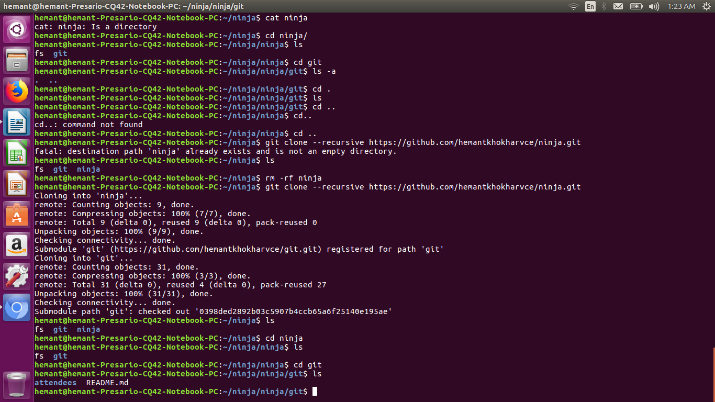

**Assignment4:**

* Configure & setup gitolite server to host private git server.
* Add user based permissions over your repositories and branches.
* Create repository inside gitolite server, and clone, add, commit, push into that.

**Solution :** pending