Date: 22/05/2018

**Assignment: 2**

**Task1:**

make 5 partitions in your pendrive as: first 3 primary partitions(10MB each) then an extended one (think yourself about it's size) last 2 partitions should be logical (50MB each) format them with ext4 filesystem mount the partitions on directory /mount1, /mount2, /mount3, /mount4, /mount5 validate the same by making files in the the above directories and then un-mount the same and then check if you still see the content in the directories

**Solution:**

//The actions (commands) have been performed on ubuntu

1. lsblk : to check the current partition of the system
2. fdisk /dev/sdb :enter into sdb harddisk (pen drive)
3. Create 5 Partition
   1. Using ‘n’ for new partition
   2. 3 primary partition (sdb1, sd2, sd3) of 10 MB each
   3. 1 extended partition (sdb4) having remaining size of hard disk
   4. 2 logical partition (sdb5, sdb6) in extended partition of 50MB each
4. Save changes using ‘w’
5. To overwrite the older partition changes without reboot used ‘partprobe’ command
6. Format the partition as per mentioned “ext4” format
   1. mkfs -t ext4 /dev/sdb1
   2. mkfs -t ext4 /dev/sdb2
   3. mkfs -t ext4 /dev/sdb3
   4. mkfs -t ext4 /dev/sdb5
   5. mkfs -t ext4 /dev/sdb6
7. Make directory in mnt directory using (cd /mnt)
   1. mkdir /mount1
   2. mkdir /mount2
   3. mkdir /mount3
   4. mkdir /mount4
   5. mkdir /mount5
8. Mount the partition on directory using:
   1. mount -o rw /dev/sdb1 /mount1
   2. mount -o rw /dev/sdb2 /mount2
   3. mount -o rw /dev/sdb3 /mount3
   4. mount -o rw /dev/sdb5 /mount4
   5. mount -o rw /dev/sdb6 /mount5
9. move into directory using cd /mount1 and create a new file onto using touch test
10. unmount the partition using umount -f /dev/sdb1 /mount1

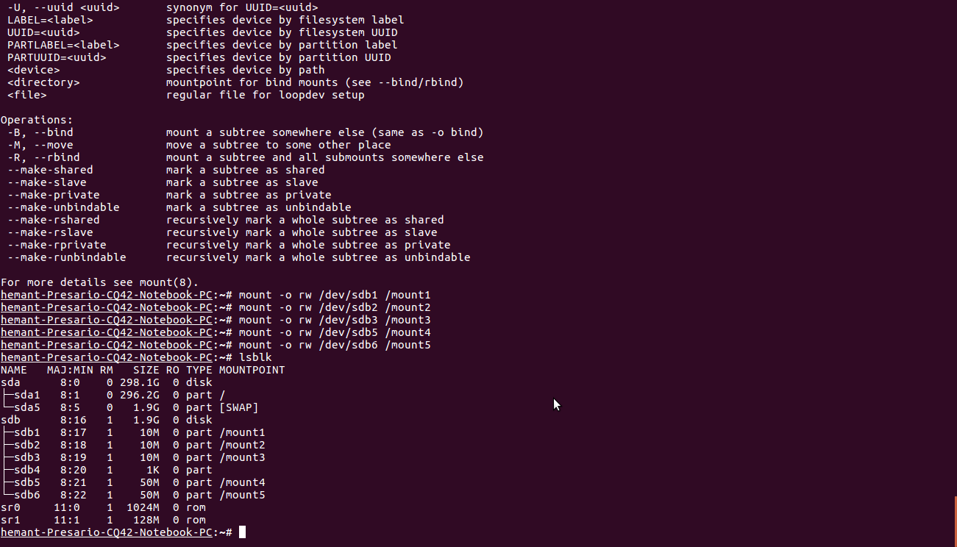

**Task 2:** delete all the partitions that you created above and make a single partition of the size that pendrive is of: make it an lvm partition make a physical volume create a volume group of same size as that of physical volume make an lvm of size 1GB extend the size to 1.5GB reduce the size to 500MB

**Solution:**

1. delete all partition at once using

<https://www.cyberciti.biz/faq/linux-remove-all-partitions-data-empty-disk/>

1. or delete partition one by one using command fdisk using ‘d’ option
2. created new partition
3. changes partition type using t and then 8e (for LVM type)
4. Trying to create physical volume using pvcreate /dev/sdb1
   1. Getting an error “unable to locate package pvcreate”
   2. Tried apt get install pvcreate (but didn’t work)
   3. Tried installing lvm2 package for ubuntu (not able to run pvcreate)

// Working on this part. Will update you once I found any solution for this.

**Task 3:** Write a Script for

|  |
| --- |
|  |

Print "Enter any single digit or double digit number"

* Read input from the user

* If number is of single digit then print "Its a single digit number"

* If number is of double digit then print "Its a double digit number"

* If number is of greater than double digit then print "Invalid choice"

**Solution:**

// This task have been performed in Python

#! /bin/python

var= input("Enter one digit or two digit no: ")

if ( len(str(var)) ==1 ):

print ("Its a single digit number")

elif (len(str(var)) ==2):

print ("Its a two digit number")

else:

print ("Invalid choice")