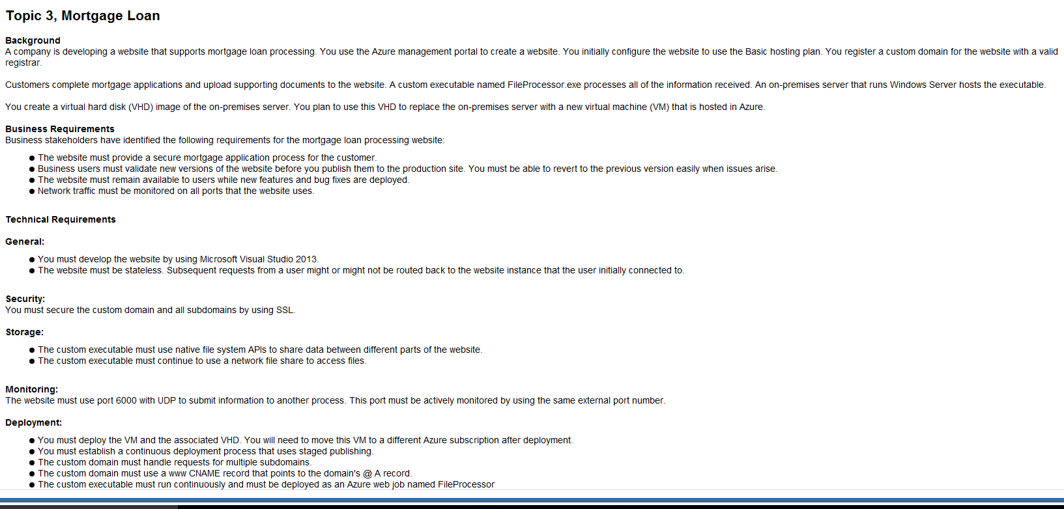

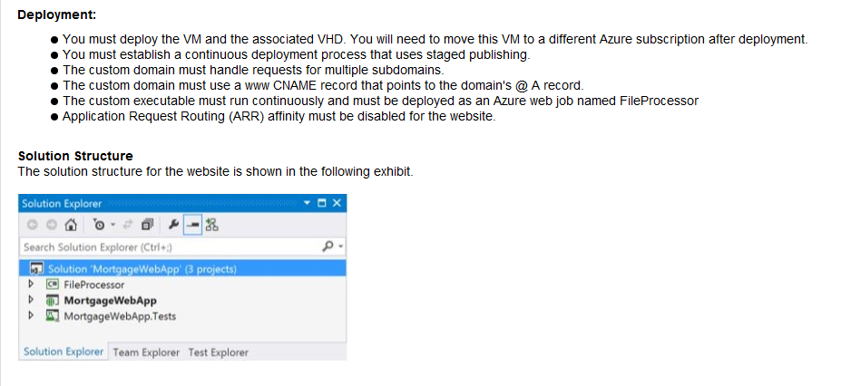

1)
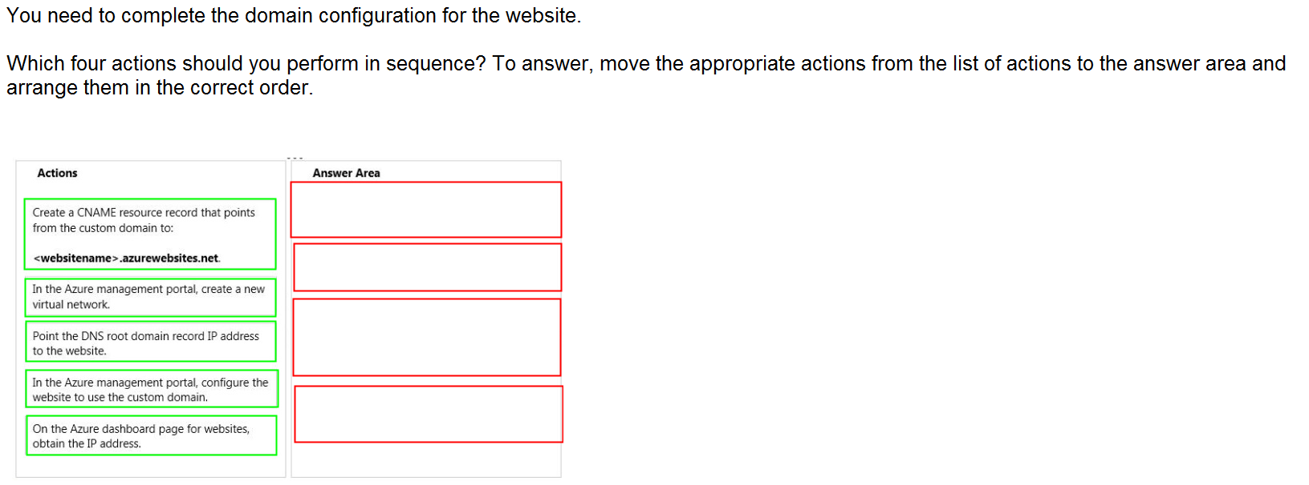
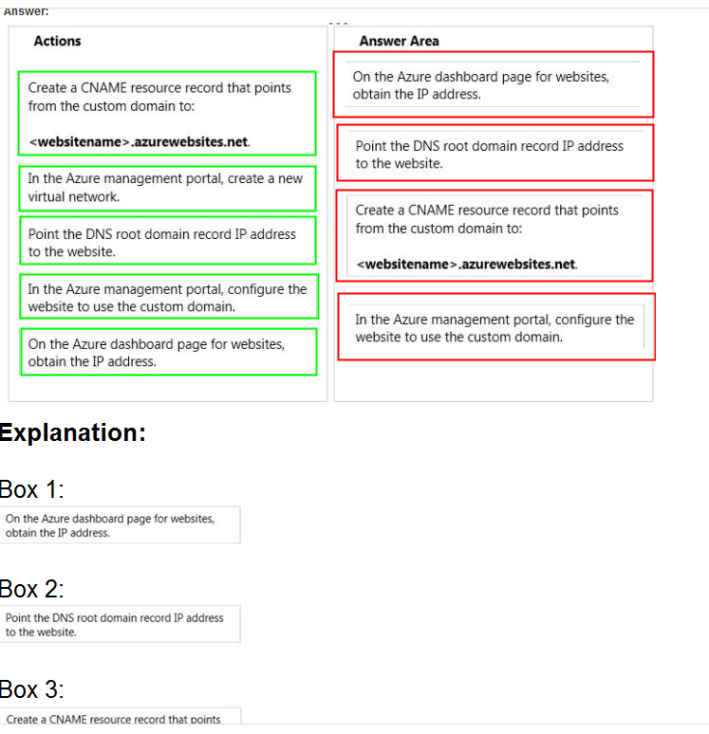

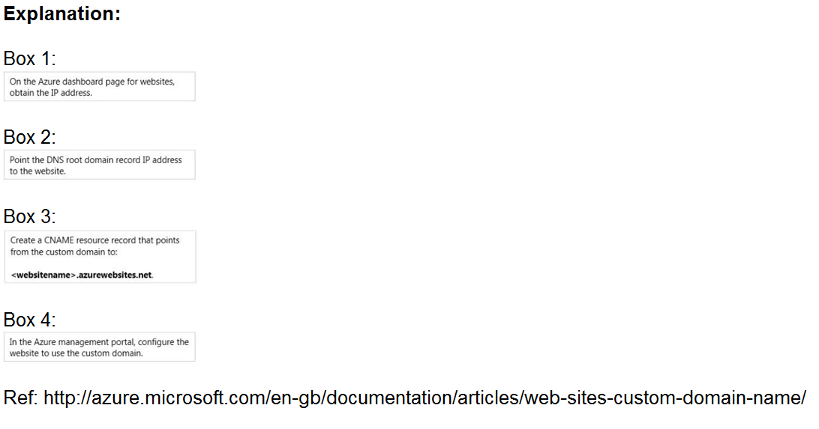

2)

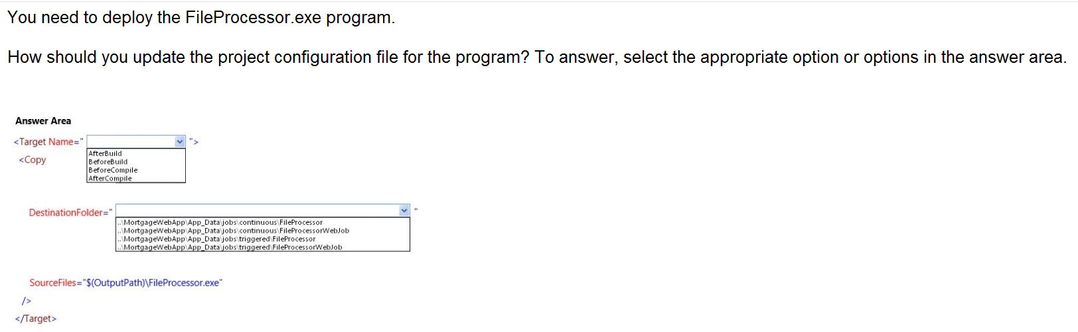

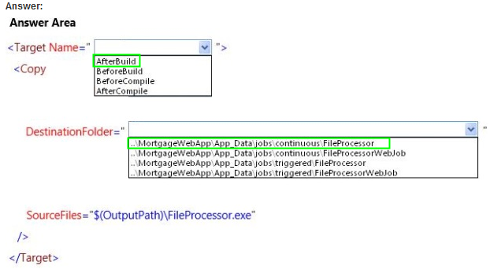
When Visual Studio deploys a WebJobs-enabled Console Application project, it performs two tasks:
- Copies runtime files to the appropriate folder in the web app (App_Data/jobs/continuous for continuous WebJobs, App_Data/jobs/triggered for scheduled and on-demand WebJobs).
- Sets up Azure Scheduler jobs for WebJobs that are scheduled to run at particular times. (This is not needed for continuous WebJobs.)
+
A WebJobs-enabled project has the following items added to it:
- The Microsoft.Web.WebJobs.Publish NuGet package.
- A webjob-publish-settings.json file that contains deployment and scheduler settings.

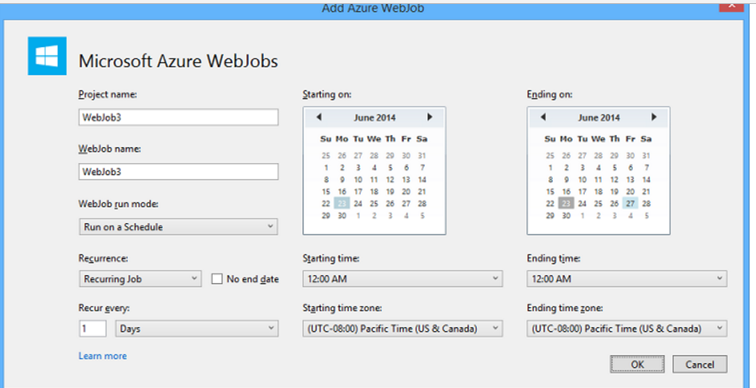

3)
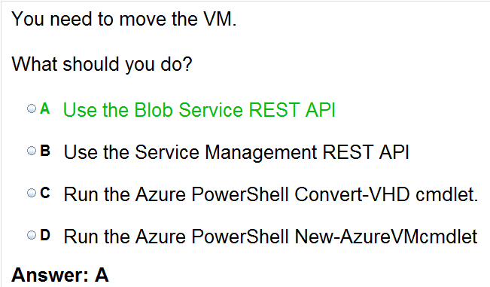

4)
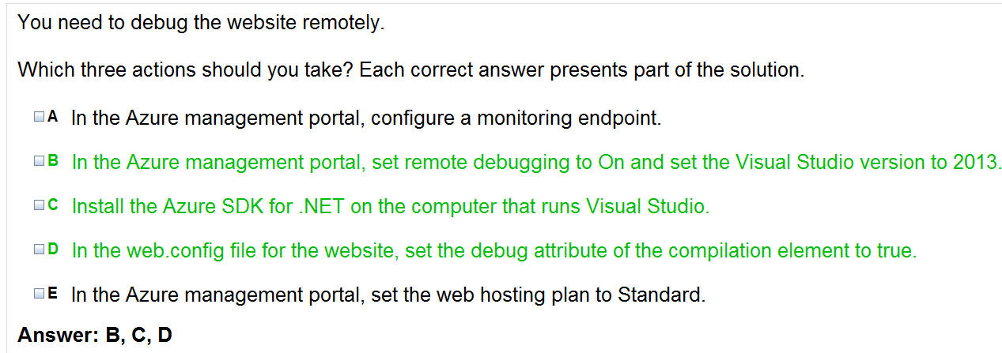

5)

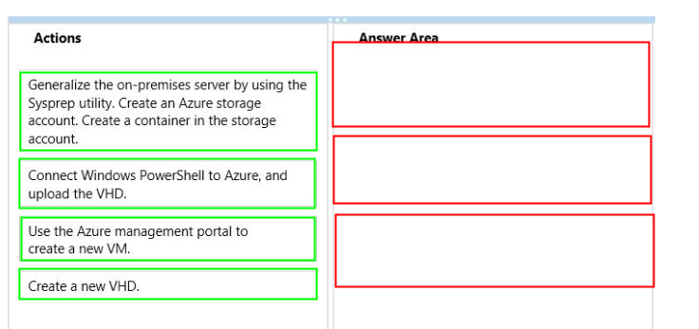

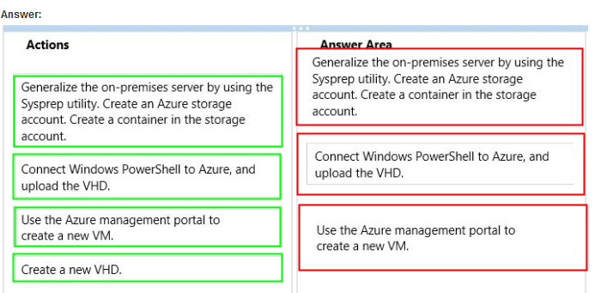

6)
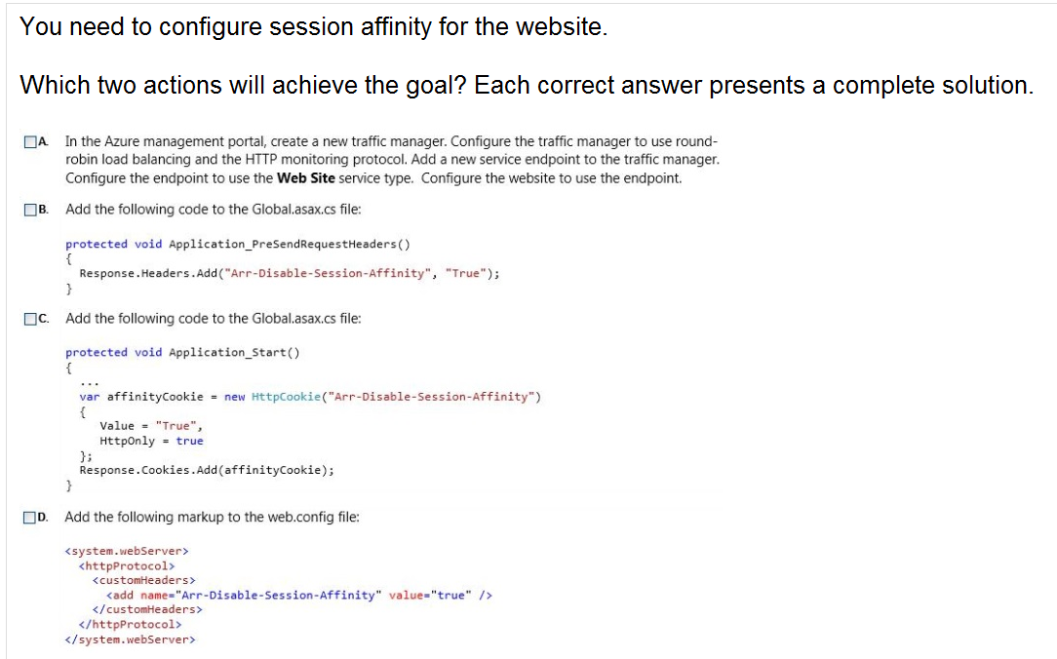

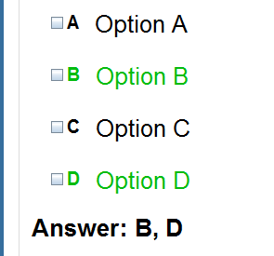

7)
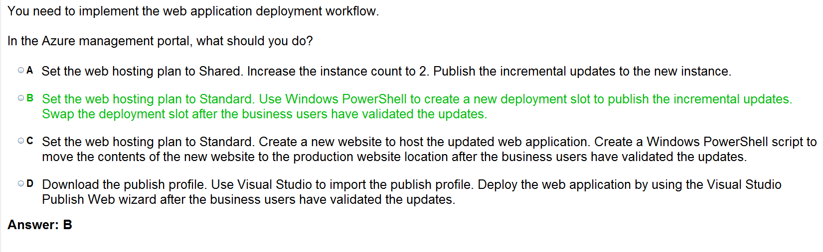
8)
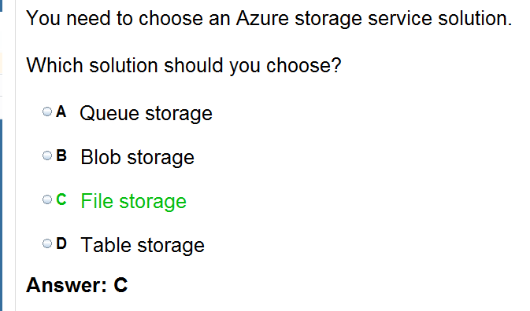

9)


