Project Report

on

**ONLINE TEST PORTAL**



Maharaja Agrasen Institute of Technology, PSP Area,

Sector – 22, Rohini, New Delhi – 110085

**Submitted by:**

Hemant Pandey

18614802712

MAHARAJA AGRASEN INSTITUTE OF TECHNOLOGY

**(Guru Gobind Singh Indraprastha University)**

**SUMMER INTERNSHIP REPORT**

Undertaken at



**“techSync Counsulting Pvt. Ltd.”**

**(www.techsync.in)**

**IN**

**“Devolpment of Web Application (Online Test Portal)”**

**Submitted by:**

**Hemant Pandey**

**18614802712**

**C5**

**PROJECT**

**ONLINE TEST PORTAL**

SUBMITTED IN PARTIAL FULFILLMENT OF THE DEGREE

OF

BACHELOR OF TECHNOLOGY

IN

“COMPUTER SCIENCE ENGINEERING”

**MAHARAJA AGRASEN INSTITUTE OF TECHNOLOGY, GGSIPU**

Summer Internship after 3rd Year

Year-2015

Under the guidance of:

Mr. Vipin Chehal

(Mentor)

techSync Consultancy pvt Ltd.

**CERTIFICATE**

This is to certify that this project report entitled **“*Online Test Portal”*** comprehends the authentic work of in-house training accomplished by

|  |  |  |
| --- | --- | --- |
| Name | | Enrollment No |
| 1. | *Hemant Pandey* | 18614802712 |

This training partially fulfils their Bachelor of Technology course and requirement after third year at Maharaja Agrasen Institute Of Technology, an institution affiliated to Guru Gobind Singh Indraprastha University, Delhi.

**Vipin Chahal Pratibha Dubey**

(Project Manager) (CEO)

**ACKNOWLEDGEMENT**

The successful completion of this project is indeed practically incomplete without mentioning of all those encouraging people who genuinely supported and encouraged me throughout the project.

I hereby take this opportunity to thank all those people whose knowledge and experience helped me bring this report in its present form. It would have been a tough task for me to complete report without their help.

I express my sincere thanks and gratitude to My mentor **Mr. Vipin Chehal (Software Developer, techSync)** and **Bhavya Bhatia(ECE, MAIT)** for helping me to complete the project the opportunity to pursue my training at the institute.

Finally I would like to express my deep appreciation to my family and friends who have been a constant source of inspiration. I am internally grateful to them for always encouraging me wherever and whenever I needed them.

**Hemant Pandey**

18614802812

C456

**CONTENTS**

|  |  |  |
| --- | --- | --- |
| **S. NO** | **Topic** | **Page Number** |
| *1.* | *ABSTRACT* | **7** |
| *2.* | *CERTIFICATE* | **8** |
| *3.* | *INSTITUTE PROFILE* | **9** |
| *4*. | *INTRODUCTION* | **10** |
| *5.* | *SYSTEM REQUIREMENTS* | **11** |
| 6. | *DFD’S* | **12** |
| 7. | *ENVIRONMENT SETUP* | **15** |
| *8.* | *RELATED THEORY* | **16** |
| *9.* | *SCREENSHOTS* | **22** |
| *10.* | *CONCLUSION* | **27** |
| *11.* | *BIBLIOGRAPHY* | **28** |
|  |  |  |

**ABSTRACT**

This project aims to implement a “Online Test Portal” . This parses a subset of HTML,CSS,PHP and Javascript language code. It possesses a subset of functionalities provided by Web Expression. The parsing would result in actions on the given input.

“*techSync Test Portal”* is a multi-purpose website that allows students preparing for different entrance examinations to take different tests and provides them scores on the basis of correct answers. There is no negative marking.

The website provide facilities for registration, logging in, changing details, uploading profile pic, taking online tests and getting an instant score card.

For the ease of the user, this website include the contact page for reffering o the developers and giving feedback regarding the functioning/.

**DECLARATION**

This is to declare that this project report entitled **“*techSync Test Portal”*** comprehends the authentic work of in-house training accomplished by

|  |  |  |
| --- | --- | --- |
| Name | | Roll No |
| 1. | Hemant Pandey | 18614802812 |

This training partially fulfils their Bachelor of Technology course and requirement after third year at Maharaja Agrasen Institute Of Technology, an institution affiliated to Guru Gobind Singh Indraprastha University, Delhi.

**INSTITUTE PROFILE**

**ABOUT techSync**



## OVERVIEW

**TechSync** is a consulting-oriented software development company, intending to fill in the market need for a professional, customer-focused customize software development and maintenance company. The company emphasizes service and support to differentiate itself from more price-oriented computer companies. We are on the brink of penetrating a lucrative market in a rapidly growing industry. The current trend towards an increase in the number of entrepreneurs and competition amongst existing companies presents an opportunity for techSync

to penetrate this market.we believe that to prosper, we need to be flexible and responsive, to delight clients by providing them with what they want, when they want it, and before the competition can offer it. The company intends to achieve this through a solutions approach that is customer-centric, and in which the customer's business objectives enjoy top priority.  
Once the needs and processes are understood and described, leading edge products and best-of-industry skills will be applied to design and develop a fitting solution to enable the client's business in the most cost effective way. Our marketing strategy will be based mainly on ensuring that clients know what need the service(s) is able to fulfill, and making the right service and information available to the right target client. We intend to implement a market penetration strategy that will ensure that our services are well known and respected in our respective industry. Our strategy will convey a sense of quality and satisfaction in every picture, every promotion, and every publication. Our promotional strategy will involve traditional advertising, Internet marketing, personal selling, public relations, and direct marketing, details of which are provided in the marketing section of It is important to recognize that make our intangible resources, such as our ability to relate to this plan.

Customers regarding their needs and wants, management style, corporate culture and commitment. These elements will differentiate us from our competitors and contribute towards the development of a sustainable competitive advantage. In a nutshell, we don't intend to just market and sell our product and services, but to provide customized services and products that will enable our clients to optimize their output and, assist in the attainment of their goals and objectives. However, for us to attain the above stated we shall need funding from outside investors.  
TechSync an upcoming and promising software company, which has successfully delivered many projects in given time frame believes in optimized solution in terms of quality, cost effective enduring solutions and time all three blended together. Company's main asset are happy and satisfied client .

Our Strengths

* Optimization
* Process implementation
* Cross functional team to meet the BCP(Business continuity plan)
* Project control
* Continuous interaction with client
* Dedicated learning and development cell to adapt new tools and technologies(DLDC)
* Process control
* Developed and QAed together by independent teams to reduce turnaround time

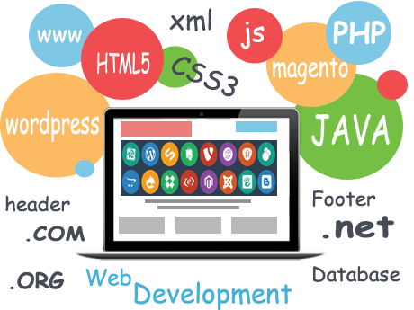

Contact us

**Development & Technology Centre**

5th Floor, Assotech One,

C-20/1A/1, Phase 2,

Sector 62, Noida,

Uttar Pradesh 201309.

**Registered & Sales Office**

107A/1, Mayur Vihar Phase 1,

New Delhi- 110091.

**US Contact Number**

+1 (770) 828-8101

For Sales [*sales@techsync.in*](https://techsync.in/contact.php)   
  
For support [*support@techsync.in*](https://techsync.in/contact.php)   
  
For General Enquiry [*info@techsync.in*](https://techsync.in/contact.php)

**INTRODUCTION**

The Online Examination System will permit to take and give online examination and maintaining master information and generating various reports of test. The main users of this project are Student or Member and System Administrator. From an end-user perspective, the e Examination System Project consists of enhanced Member modules for registration, giving examination, manage profile**.**

Member and Examination Module - An enhanced interface for student to registration, edit profile, login, select examination, and give examination, view results, view answers Following modules pages are available for members.

Administration and Question Bank Module - Administration module- used to enter and edit examination details, question banks, maintain the members and view the reports

Online examination is getting popular on web these days. This feature is particularly useful for those websites which deal in education/ recruitment/ employee screening process. Now-a- days institutes are organizing exams online. In this module a user can give online exam of a particular subject and get the results instantly through which the user can know his/her potential and how much more effort he/she needs to put in to get better marks.

The task of instantly producing questions from resources for academic exercise and evaluation. Our approach is to over generate questions. We use personally written rules to perform a series of general purpose syntactic changes (e.g., subject-auxiliary inversion) to turn declarative phrases into questions. The top-ranked concerns could be strained and improved by teachers, or given directly to students for exercise

**SYSTEM REQUIREMENTS**

**HARDWARE:**

* + **HARDWARE REQUIRED**
    - 1. INTEL Pentium-II or above
      2. 256 MB RAM, 1 GB hard disk

* + - **DEPLOYED**

1.) CORE 2 DUO processor 1.67GHz

2.) 1 GB RAM, 160 GB hard disk

* + **SOFTWARE REQUIRED**

**Environment** PHP

**OS** Any OS.

*To run on server, domain and hosting should be purchased as per the requirements*

**DATA FLOW DIAGRAM**

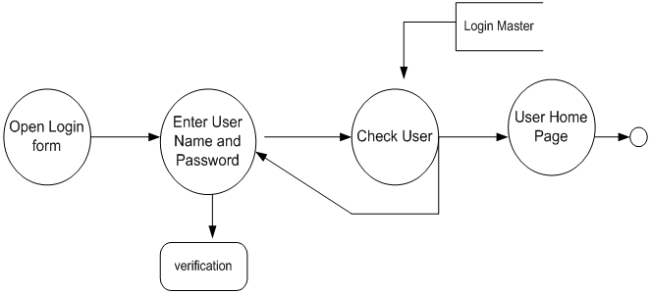

**ENVIRONMENT SETUP**

**HTML**

When you write a normal document using a word processor like Microsoft Word/Office, your text is saved in a file with a special format. It is not simply saved as the string of words you typed since the document needs to preserve things like the font you chose, the size of the text, which words are in bold, which italics, and so on. The special format includes not only your words, but all these extra information so that the next time Word opens your document, it can display the document with the exact appearance you created earlier.

In the same way, web pages are simply strings of words put in a special format that web browsers are able to display. While the format of Word documents is simply called "Word format" (or "doc format"), loosely speaking, one might say that web pages are formatted using "HTML"

"HTML" stands for "Hypertext Markup Language". Basically, it's just a means for formatting your document. There's nothing esoteric or fancy about it, just as there's nothing special about the Word format or any other document forma.

**CSS**

Cascading Style Sheets, or CSS, allow you to specify things like the font you want on your page, the size of your text, whether the page is to have 2 columns, whether your text is to be in bold or italics, and so on. In other words, it is the part that lets you control the appearance of your web page.

You may be used to the Microsoft Word "doc" format, where everything from the text you type to the appearance of the document is specified in a single file, transparent to you. On the web, the raw information is specified in HTML and most of the appearance is determined by the CSS.

If you use a web editor like those I mentioned above, you won't have to bother with which parts goes into the HTML portion and which parts goes into the CSS portion. Everything will be taken care of by the editor. It gives you the advantage of reusability and gives your website a stable and symmetric luk,

**Javascript and PHP**

Since the HTML/CSS combination is analogous to the data found in a Word document, it is good only for displaying information.

If you want your web pages to do different things depending on the situation, you will need a programming language. For example, some websites want to provide a membership facility where people can log into the site, and access certain information. Other sites provide a feedback form so that visitors can contact them. All these things require facilities that a simple document format cannot do.

JavaScript, PHP and Perl are three of the most commonly-used programming languages on the Internet. They are used by websites to carry out more complicated operations.

Programs written in JavaScript run in the web browser itself, so if your website has a JavaScript program, the program will be automatically fetched by your visitor's browser and executed on his/her computer. PHP and Perl programs, on the other hand, run on the computer where your website is located, that is, on your web host's computer. After the PHP or Perl program does what it needs to do, it sends the result to the visitor's web browser, which merely displays the results.

Apart from the above difference, from the point of view of a non-programmer, there's not much point asking what the difference is between the languages, say, between PHP and Perl. It would be like asking what the difference is between English and German, or some other human language. They're just different languages that you can use to write web-based programs. Each computer language has its own strengths and weaknesses.

Learning a programming language is vastly different from creating a website whether with a web editor or directly in HTML.

For the most part, it is not necessary to learn JavaScript, PHP or Perl to create your website. In fact, even if you want your site to do complicated things, you can often find pre-written programs to do the job for you without your having to daggling programming.

PHP is a programming language. It is often used for server side programming, but has uses in general programming too. JavaScript is a programming language. It is the only language that has a decent level of native support for running in a browser. It has a wide variety of server side implementations (including Node and ASP). It is one of the languages you can use with the Windows Scripting Host. etc.

With client side programming you can manipulate things in the browser without going back to the server. e.g. you can add elements to the document to display a message. You also have access to APIs provided by the browser, such as the alert() method which will display a message box that isn't an intrinsic part of the document. With server side programming, you can modify the document you are sending to the client, but only at load time, and you don't have access to things like the alert() method. (Although you can generate program code (usually in JS) that will run client side and will have access to those methods).

**Microsoft Expression Web**

Microsoft Expression Web, code-named Quartz, is an HTML editor and general web design software product by Microsoft. It is available free of charge from Microsoft and is component of the discontinued Expression Studio.

Expression Web can design and develop web pages using XML, CSS 2.1, ASP.NET or ASP.NET AJAX, XHTML, XSLT, PHP and JavaScript. Expression Web 4 requires .NET Framework 4.0 and Silverlight 4.0 to install and run. Expression Web uses its own standards-based rendering engine which is different from Internet Explorer's Trident engine.

**What is MySQL?**

MySQL is a database system used on the web

MySQL is a database system that runs on a server

MySQL is ideal for both small and large applications

MySQL is very fast, reliable, and easy to use

MySQL supports standard SQL

MySQL compiles on a number of platforms

MySQL is free to download and use

MySQL is developed, distributed, and supported by Oracle Corporation

MySQL is named after co-founder Monty Widenius's daughter: My

The data in MySQL is stored in tables. A table is a collection of related data, and it consists of columns and rows.

Databases are useful when storing information categorically. A company may have a database with the following tables:

**PHP + MYSQL**

MySQL works very well in combination of various programming languages like PERL, C, C++, JAVA and PHP. Out of these languages, PHP is the most popular one because of its web application development capabilities.

PHP provides various functions to access MySQL database and to manipulate data records inside MySQL database. You would require to call PHP functions in the same way you call any other PHP function.



**ARCHITECTURE**

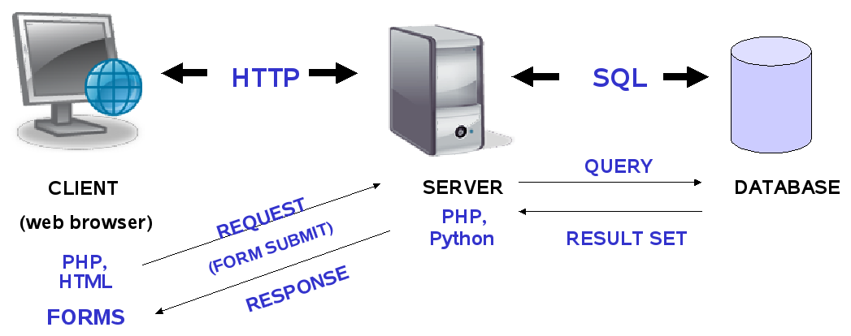

**(PROJECT PLANNING-GAANT CHART)**

Week-1

Week- 2,3

Week-4

Week-5

Week-6

Project Planning

Requirement Modelling

Throwaway Prototyping

Software Design

Implementing Desing

Adding Functionality

Connecting Design

And functionality

Completion

And delivery

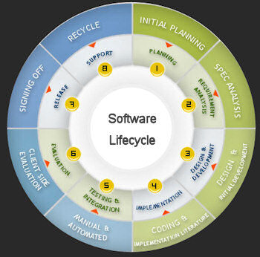

**INSTRUCTIONS TO USE**

1. Create an account by clicking on **Register Now** or Login with existing user name and password.
2. After Registraton, Go back to the homepage and login with your existing username and password.
3. The profile view will appear with diiferent options. You can select the option as per your need.
4. Click Take Test to take online tests and select the specified test you want to take from different categories of test.
5. Each test consists of 10 question each having 5 marks which makes the maxmum score to be 50.
6. Each question has a timer of 60 seeconds and Submit button must be clicked before the time runs out. Try to make a guess if you don’t know the answer since there is no negative marking for wrong answers.
7. Results will be provided to you in form of scorecard with the correct answers of each question.
8. Your test record history will be stored in the user profile from where you can check previous scores.
9. If you are the admin, you can make changes to the database by <http://127.0.0.1/techsync_exam%20portal/admin> and giving the username and password for the administrator account.
10. Your password has been secured in our database and encrypted to prevent any security threats.

**SCREENSHOTS**





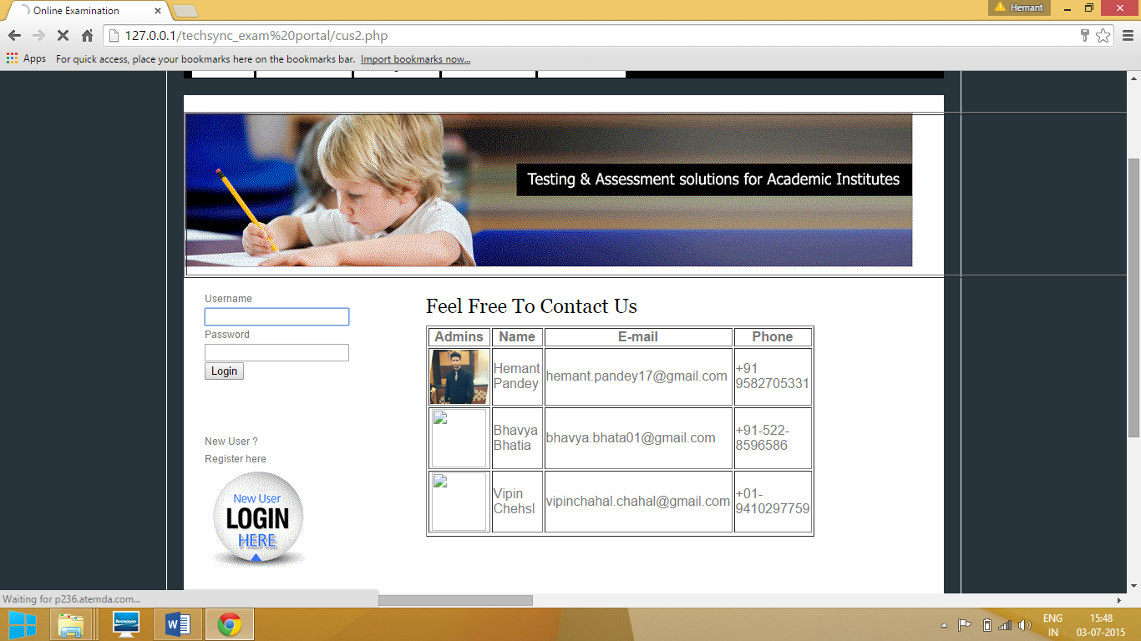

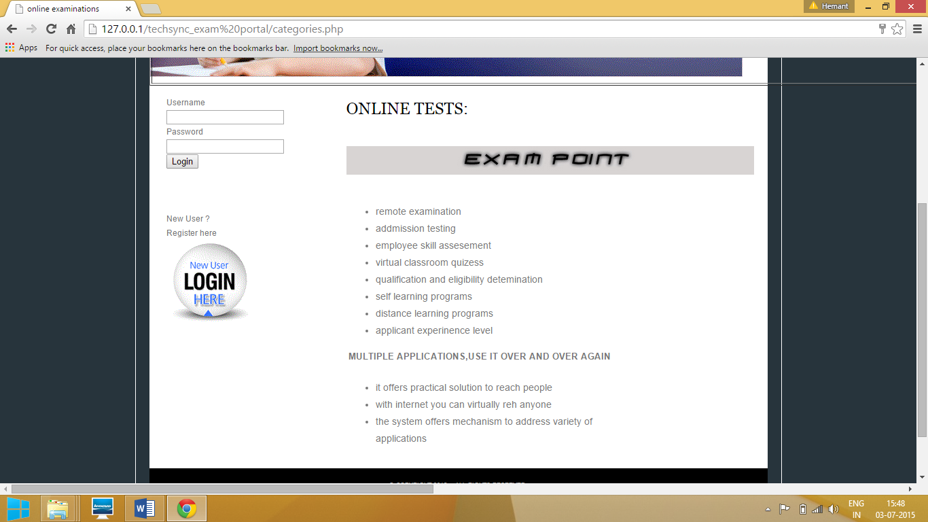

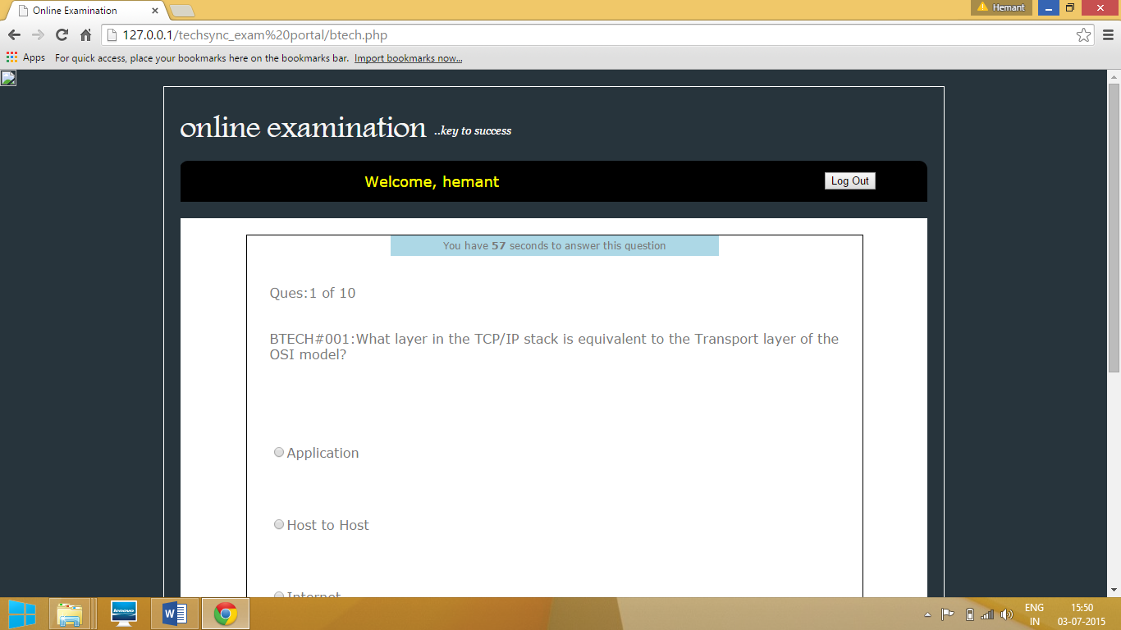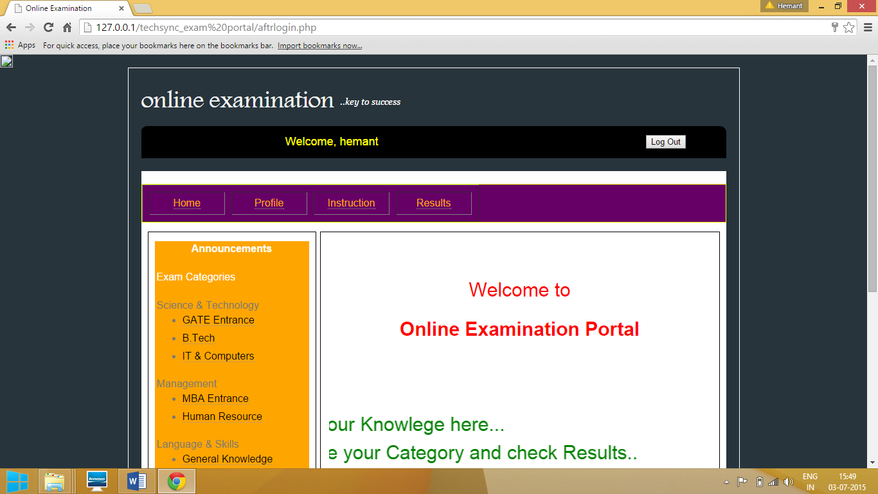

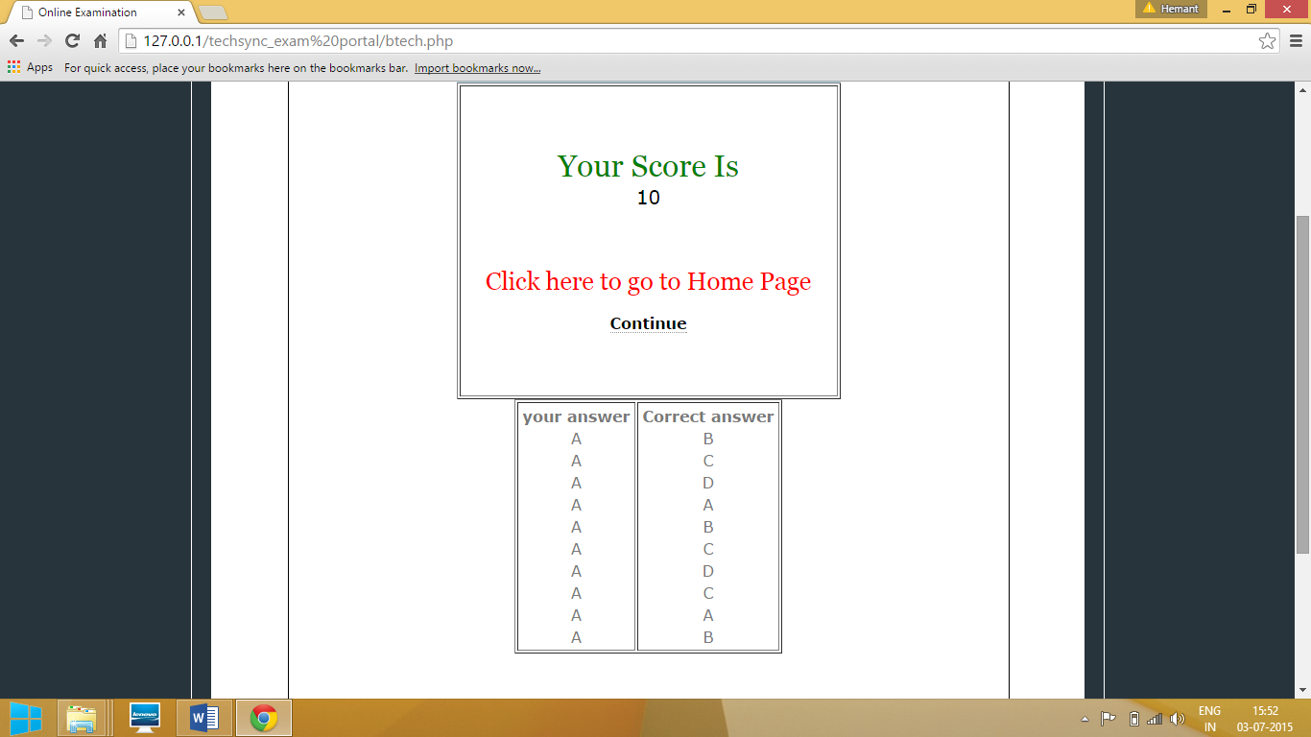

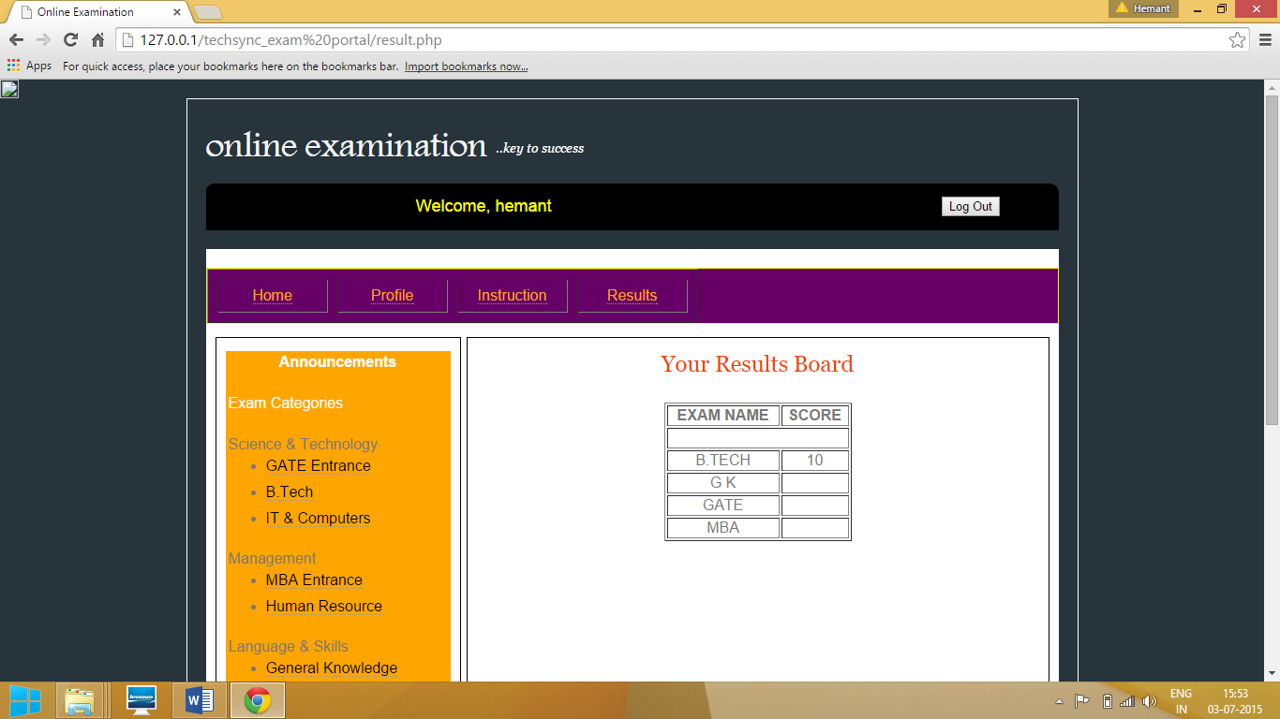

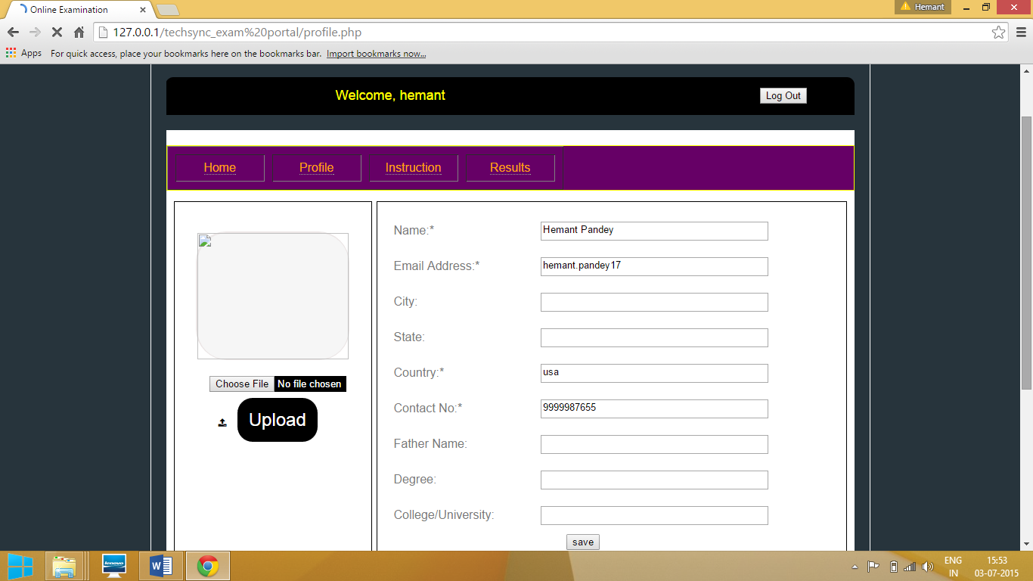

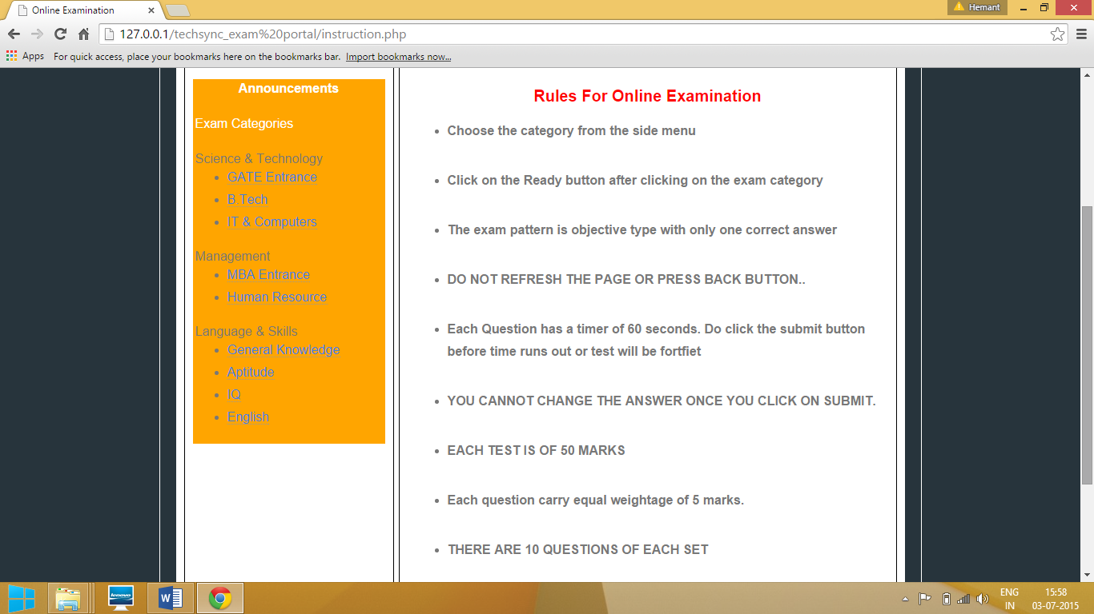

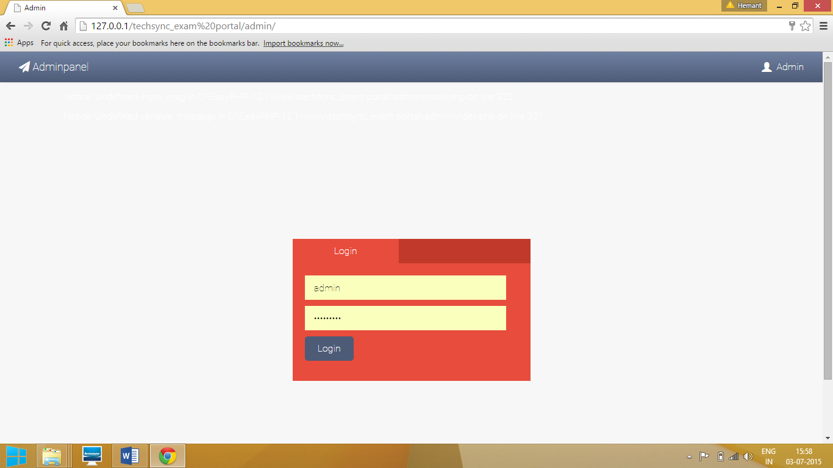

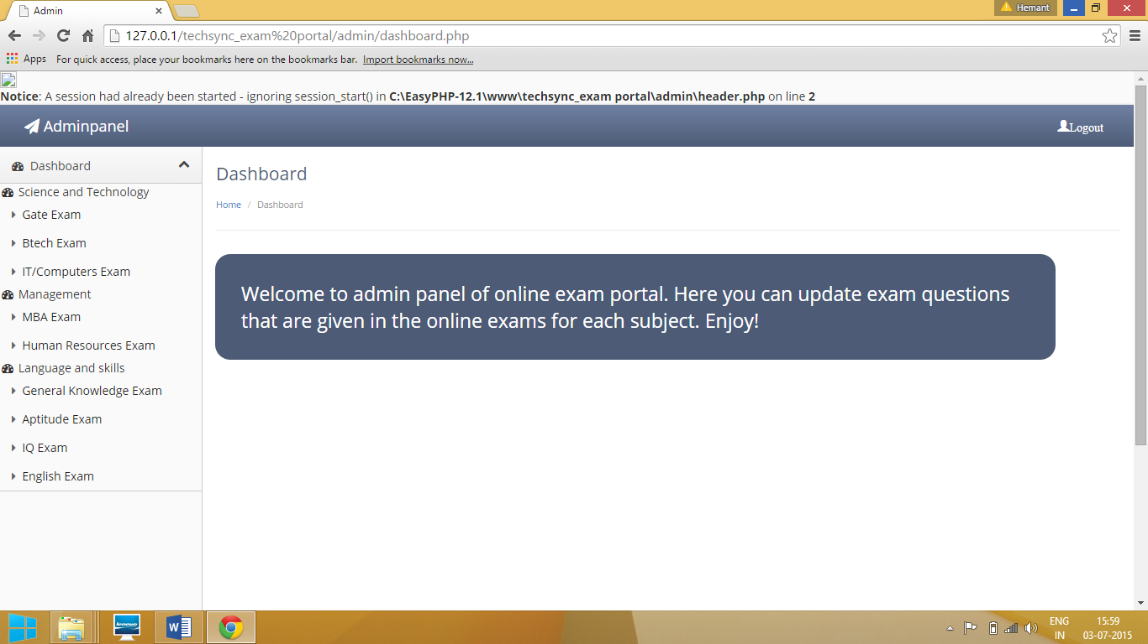

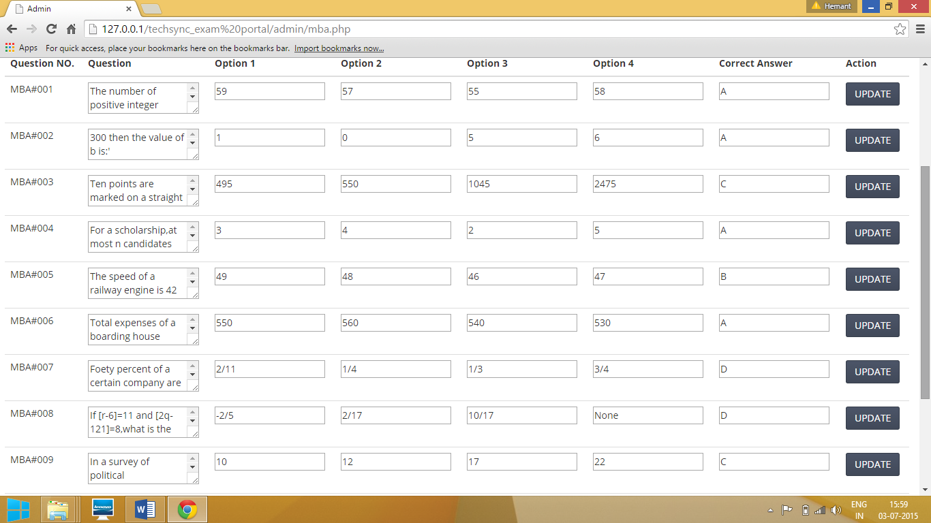

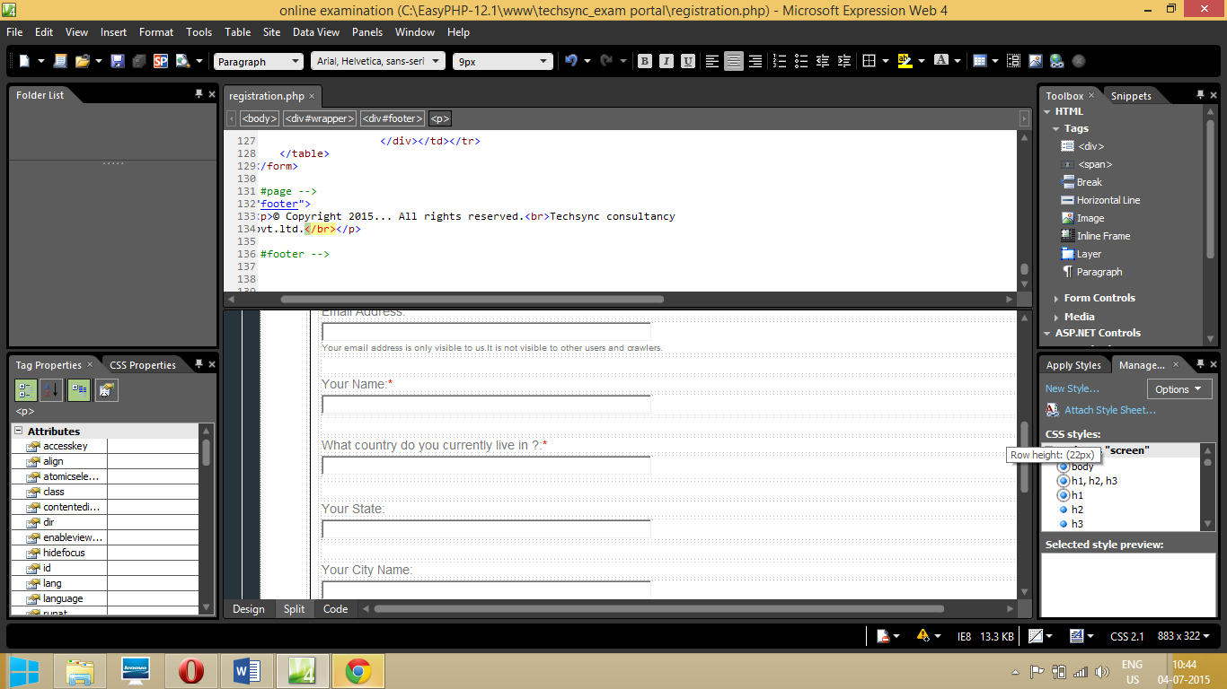

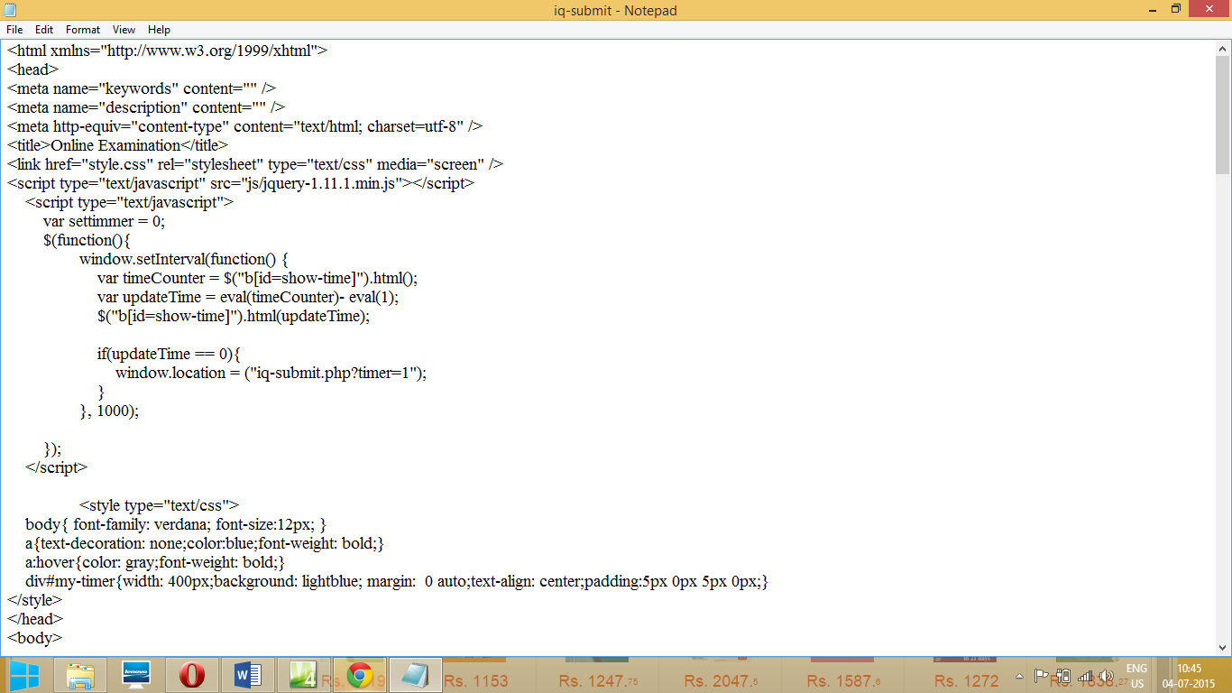

**CONCLUSION**

* The buses were searches as per the choice
* The user form was filled and submitted.
* The information was stored in database.
* The tickets were booked and the message was printed

It provides us the facility to plan our vacations just sitting at home. More emphasis has been put on the designing part rather than the backhand or data management part. Only Bus booking service has been covered in the website.

Information regarding taxi, car, hotel services has been included. The main purpose of the project is to develop a simple tourism website using HTML, CSS, JAVASCRIPT, PHP and MYSQL.

**References**

**>** PHP manual, Internet and some previous project files.

> Web Expression Manual

* + www.google.com
  + www.w3schools.com
  + [www.stackoverflow.com](http://www.stackoverflow.com)