Developer’s Setup Guide

WIKI Application

**Revision**: 0.0.1

**1. Introduction**

1.1 What is WIKI

WIKI application is intended to be used internally at Smartek and which is futuristic, robust, reliable and highly available. WIKI to help user to perform all operations that are possible with confluence.

### 1.2 Knowledge required

Experience in Javascript, CSS and SQL is must. Basics of NodeJs are good to start with the application development.

**2. Setting up for Development on Windows**

This provides detailed setup information for developers.

2.1  Development tools required

* Eclipse with NodeJs Support
* NodeJs command promt
* MySQL server
* Phpmyadmin or MySQL workbench to access MySQL database

### 2.2 Get the code

* Create project directory (ex. wiki) in your preferred drive
* Go to <https://github.com/hemantpurkar/wiki>
* Copy the clone url i.e. <https://github.com/hemantpurkar/wiki.git>
* Select Right click -> Git Clone on your project directory name(ex. wiki)

And paste the clone url into URL textbox.

* After selecting your directory and Loading putty key, click on OK button.
* Whole project will be copied to your project directory.

### 2.3 Installation and configuration

* On node command prompt go to your project directory like

c:\> cd wiki

* Execute below command to install all the required packages

c:\> wiki > npm install

* Change the paths and urls in /*config/config.js* with required environment variable at top.
* Change email server configuration (if required) into */lib/email.js*
* Create a database “node_test” into your database server using any one of the tools like phpmyadmin or mysql workbench.
* Get the ‘.sql’ file from /sql/ directory present in downloaded project directory
* Import this .sql file into newly created database.

### 2.4 Getting started with development

* Create new Node project into Eclipse IDE
* Import your project directory (ex. wiki) into that project
* Project directory to contain below structure:

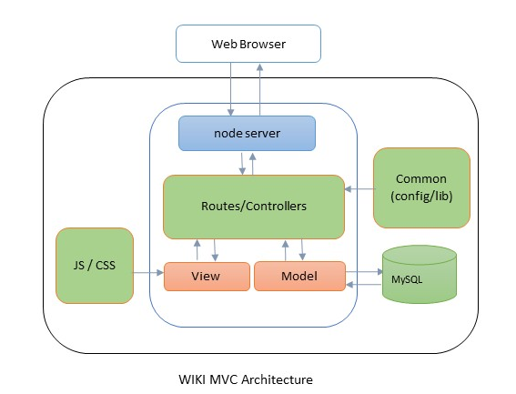

### 2.4 Running the application

* On node command prompt go to your project directory like

c:\> cd wiki

* Start node server using command :
* node app.js
* On browser enter below URL:
* <http://localhost:3000/>