**CRED -**

**ABOUT –**

**CRED is India’s first application that rewards its users for paying their credit card bills on time. It was founded by Kunal Shah ( former founder of Freecharge ) in April, 2018. Kunal Shah started CRED with a vision to create an exclusive community for India’s most trustworthy and creditworthy individuals. It helps us to manage and pay all our credit cards in one place. It also reminds us about payments, offers on our credit card, and also monitors our spending’s. If we are a regular credit card user and pay bills through any other app, you can use CRED to earn great rewards.**

**Business Model of CRED -**

Cred is a credit card payment platform which lets cardholders pay their credit card bill through the app and get a bouquet of benefits via Cred coins. The virtual coins can be redeemed across coffee shops, movie theatres, e-commerce shopping and curated experience workshops, among others.

**People who already pay their credit card bills using payment apps or directly from their bank. With CRED, they get more benefits for performing the same activity of paying their credit card bills through the app. As more people use CRED to earn benefits, they share it across more of their friends and family.**

Though some people find it clumsy, the CRED app has a beautiful UI and UX design. Users sign up on the app and can see all the available offers on paying their credit card bills. As you continue to pay bills, you accumulate CRED coins which you can redeem for the rewards.

**CRED Ecosystem -**

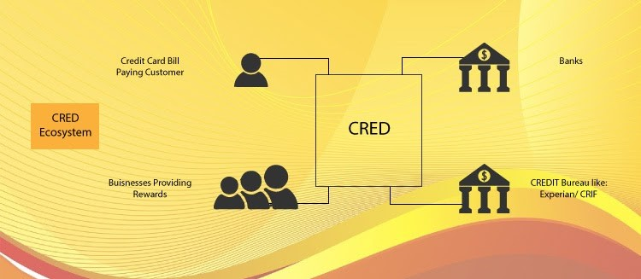

**Revenue Model of CRED –**

Currently there is no revenue model of CRED. Currently, CRED is focused on expanding its user base and not focuses on making any profit. They expect to earn money from a credit-line business model in the future.

The only way that they makes money by charging a **fee** from businesses to list products and offers on the app. There are offers from fashion retailers, to spas, to Amazon gift cards, and much more. These offers give their users a variety of rewards to pick from. And in turn, it draws more user attention. Every time a user picks an offer by redeeming the CRED coins from the app, the business pays fees to CRED for sending the business to them. This is the main source of revenue for CRED at present.

As you continue to pay bills and use the app, CRED collects your financial data to offer you better offers in the future. This is their second source of revenue.

**Growth of CRED –**

**In 2019 their valuation was $450 million and in 2020 it was almost touch $800 million. The reason behind too much valuation is their startup concept and future plans which helps them to raised funds from the different-different investors in the year 2018-19 & 20. And we can say that they will become a member of unicorn startup club in future or in this year.**

**Marketing Analytics in CRED –**

**As we know that currently CRED focused on expanding its user base, so for this marketing analytics helps them to bring and retain the customers.**

While offering its services, the company (CRED) collects a lot of information about an individual. The information includes but is not restricted to:

* Credit Card Information (including the number and brands of credit cards a user holds)
* Data relating to monthly spends on the cards.
* Repayment profile.
* Credit Score and related information.
* Spend Patterns (the website acknowledges the fact that the CRED platform uses algorithms to access user spending habits by reading emails from banks and credit card issues.)

**On the basis of the collected data they decide their target customers for providing offers for this they use a useful marketing analytics technique which is: Customer Segmentation & Targeting in which they segmenting their customers on the basis of their spending score (monthly spend) and their credit card value. After segmenting they give offers on the bill pay of those customer those have high credit card value and they spend less amount through credit card and also those whose credit card value is average and they didn’t use credit card for paying bill.**

**They also use Logistic Regression which is another marketing analytics techniques, which helps them to stop card fraud detection like most of the users entered wrong details or entered stolen card details in their application for creating account, so on the basis of algorithm they examine their right customers and allow them to use their application.**

**For giving best offers and add more users they also did comparison of their offers with the competitor’s offers using Hypothesis Testing. For this they collect competitor’s data and from their data they did paired sample t-test and check is there any other significant difference the data between them and competitor.**