**Myntra-**

In 2007, Vineet Saxena, Ashutosh Lawania, and Mukesh Bansal established the most favourite among Indian youth e-commerce platform “[Myntra](https://www.myntra.com/)” headquartered in [Bengaluru](https://en.wikipedia.org/wiki/Bengaluru), [Karnataka](https://en.wikipedia.org/wiki/Karnataka), [India](https://en.wikipedia.org/wiki/India) , to provide the consumers with the personalized gift items. It mainly operated on the B2B (business-to-business) model during its initial years.

Myntra is a company that offers an e-commerce store for fashion and lifestyle products. The Company sells a range of clothing, footwear, accessories, bags and backpacks, jewellery, and personal care products for men, women, and kids. It also develops an in-house application Style Studio, a virtual dressing room aimed at making online shopping interactive for shoppers.

1. In 2007, Myntra started as a platform to sell Personalized gift items.
2. Myntra raised its initial funding in October 2017, from [Accel Partners](https://www.accel.com/), Sasha Mirchandani from Mumbai Angels and other investors.
3. In series B of funding, Myntra has raised $14 Million led by Tiger Global.
4. Myntra has raised a total investment of $159 M in total five rounds.
5. In between the years 2007 and 2010, Myntra allowed its customers to personalize products such as t-shirts, Mugs, Mouse Pads, and others.
6. Myntra offered products from approx. 500 Indian and International Brands, including the top brands like Fastrack Watches, Being Human, Adidas, Nike, Catwalk, Fabindia, and other.
7. Puma India Awarded the Myntra as the ‘Best Ecommerce Partner of the year 2011-12’
8. In 2012, IAMAI – India Digital Awards awarded Myntra as the ‘Best Ecommerce website for the year 2012’.
9. Franchise India – Indian eRetail awarded the Myntra as ‘Fashion eRetailer of the Year 2013’.
10. In May 2014, Myntra has gained by the Indian Top e-commerce platform Flipkart in a deal of $280 Million.
11. In 2014, there are overall 1,50,000 products of over 1000 brands with a distribution area of around 9000 pin codes in India.
12. In 2015, Ananth Narayanan became the Chief Executive Officer of Myntra.
13. In April 2015, Myntra acquired Bengaluru-based mobile app development platform company Native5, with a view to strengthen and expand Myntra’s mobile technology team.
14. On 10 May 2015, Myntra announced that it would shut down its website, and serve customers exclusively through its [mobile app](https://en.wikipedia.org/wiki/Mobile_app) beginning 15 May. The service had already discontinued its mobile website in favour of the app. Myntra justified its decision by stating that 95% of traffic on its website came via mobile devices, and that 70% of its purchases were performed on smartphones. The move received mixed reception, and resulted in a 10% decline in sales.
15. In February 2016, acknowledging the failure of the "app-only" model, Myntra announced that it would revive its website.
16. In July 2016, Myntra gained its rival Jabong.com to become India’s largest Fashion Platform $70 Million.
17. In April 2017, the company gained InLogg, a technology-based platform that provides end-to-end logistics solutions for ecommerce sector.
18. In September 2017, Fashion Brands Myntra negotiated the rights to manage [Esprit Holding’s](https://en.wikipedia.org/wiki/Esprit_Holdings) 15 offline stores in India.
19. In October 2017, Myntra has partnered with the Ministry of Textiles to promote handloom industry.
20. Myntra reported a net loss of ₹151.20 crore in the financial year 2017-18.
21. Myntra's revenue was reported to be ₹4.27 b in FY, 2018 which is a 78.6% decrease from the previous period.
22. Myntra launched its first digital reality show “Myntra Fashion Superstar” on Myntra app on September 2019.
23. Myntra has partnered with Cloud provider Microsoft Azure to speed up its digital transformation.

**Business Model of Myntra-**

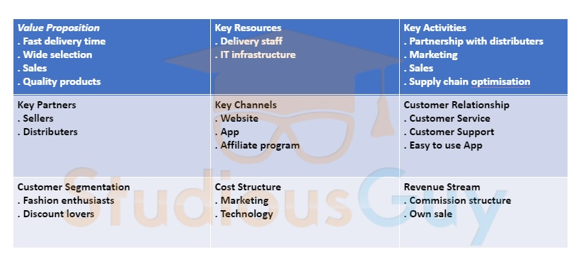

### ****Customer Relationship-****

Myntra operates through a self-service platform that is supported by 24/7 customer care service. It has also decreased its shipping time from 48 hours to 24 hours. It ensures it maintains a sound relationship with customers.

**Marketing Strategy of Myntra-**

Myntra also ropes in celebrities, like Sonakshi Sinha to promote the brand. It started a show called “fashion Influencer” in 2019 to market the brand more extensively. Other than that, Myntra also uses social media platforms, like Facebook and Instagram, to promote its sale season. In its End of Reason Sale (EORS) 2019, Myntra sold 1.77 lakh items within the first 10 minutes of the sale going live. Over 3.3 million products were sold on day one.

**Revenue Model-**

Myntra earns through an aggregator model. It buys current season merchandise from various brands and makes the product available on its website. It earns through commission. The revenue model of Myntra is that of B2C (Business to customer) now.

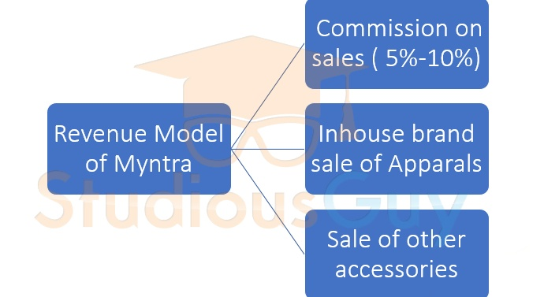

# How Myntra use data analytics to predict what you are going to buy?

Data analytics helps e-commerce players to identify both loyal and new customers by using data extraction and segmentation for tracking browsing habits and spending patterns.

[Walmart](https://www.livemint.com/Companies/ppYKfJ2OvpxR0Z9ZVyX5KO/Walmart-puts-Amazon-on-notice-but-Flipkart-a-bad-news.html)-backed Flipkart, India’s largest e-commerce player that also owns [Myntra and Jabong](https://www.livemint.com/Companies/PgkNUOseOWncBjl30Ib9eO/Walmart-to-layoff-200-at-Jabong-today-merge-it-with-Myntra.html), analyses every click and touch in every user session to construct something called the ‘journey’ of each customer.

“The journey of users helps us understand their flow and predict their next purchase.

For example, when a customer researches through the catalogues of a product range, the search patterns are recorded and a persona is created for the customer so that when he returns to the website, the searching time is drastically reduced by showing the most relevant product that the customer could be interested in buying.

“While this sounds really simple, to implement this on the scale of a catalogue that has billions of products requires a phenomenal amount of software and hardware. With the advent of machine learning techniques, the recommender system has reached its next level in evolution," explains EY India’s partner N. Balaji.

They use machine learning to match their product assortment/selection to the evolving consumer demand. This helps them to identify the selection gaps and provides the insights to their business leaders and sellers to fill these gaps.  
  
They follow a data-driven approach to evaluate their product and listing quality in real time. This signal is then used by their search algorithms to make sure that when the consumer searches for a product the best quality listings are shown to him.  
  
They has innovative models that help tailor customer experience and service elements such as speed of service, customer care and shopping experience to customer preferences.

**Summary**-

Myntra has become a worth competing fashion e-commerce company because of its unique business model and attractive discount offers. Myntra also keeps on revising its business strategies with exigencies of time. It started with the B2B model and shifted to the B2C model. Thus Myntra offers good competition to e-commerce companies, especially in the apparels sector.