UDAAN –

**ABOUT –**

**Established in 2016**, founded by Amod Malviya, Vaibhav Gupta, and Sujeet Kumar. Udaan is a **B2B e-commerce startup**that collects and brings all the manufacturers, traders, wholesalers, and retailers under a common platform. This allows the manufacturers to display their items through the platform with prospective traders having the liberty to choose and purchase them. Likewise, the wholesalers as well as retailers hold the same liberty to promote and purchase an item. Udaan’s platform features a variety of categories such as electronics, home and kitchen supplies, stationery, toys, as well as fruits, vegetables, and **various** other household items.

**Business Model of Udaan -**

**The whole business model of Udaan in very straight-forward and simple words. Udaan is a Business to business marketplace on which manufacturers and wholesalers can sell their products to retailers via an online platform or mobile app. And, the company provides logistics, secure payments, and technical support also. The company also offers accounting, order management and payment management solutions to merchants on their platform. The goal of Udaan is to cut the middlemen between the customer and the factory product so that the customer gets the product at the best prices. Usually, most of the firms have to go through two to three layers like exclusive wholesalers and distributors. To more understand their process from order to payment lets check below diagram ->**

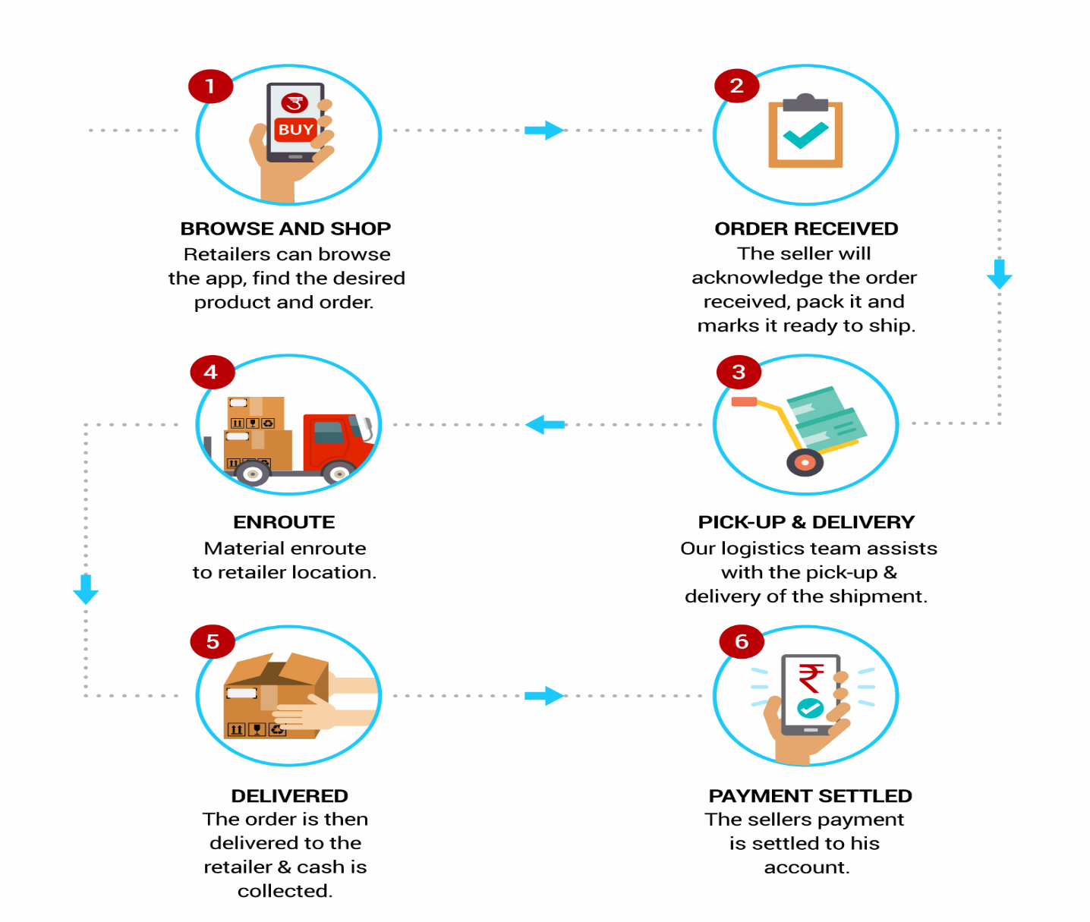

## ****Revenue Model of Udaan –****

## **Udaan basically charges a percentage on sales as commission which differs in varied categories. Alongside sales, the platform also charges for the logistics in the name of delivery charges from the buyer. This charge also differs in accordance with the item and its quality. Udaan’s revenue works on the 15% — 18% commission that it charges from the buyers for funding their purchase.**

## ****Growth of Udaan –****

## **As they started in 2016 but on those year they failed to achieved a good revenue and in the next year 2017 they successfully achieved a good revenue worth overall of Rs 7.25 crore and** 14.3X jump in operating revenues to Rs 46.36 crore during FY19 as compared to Rs 3.24 crore in FY18. Around 60% of Udaan’s earnings were generated through the delivery income of Rs 27.7 crore, which grew 12X from the Rs 2.3 crore it made in FY18.

## **A milestone -**

**And in 2020 one of the major milestones that Udaan achieved was when it entered the unicorn club. Udaan was the fastest company to achieve this milestone and mark its victory in just 26 months.**

## ****Marketing Analytics of Udaan –****

## Marketing Analytics is one of the most important things a business can do. Not only does marketing build brand awareness but it can also increase sales, grow businesses and engage customers****.****It is an important strategy to ensure the growth of your business.

## In the year 2016 they failed to achieve good revenue and also in 2017 again they did not achieve their target so they got an idea to apply marketing analytics techniques to their startup for this they hired Mohit Jain & Suvid Bajaj both are good in marketing analytics. They apply multiple techniques of marketing analytics at multiple segments like – Logistic, Customer Relation, Sales & Profit and Delivery.

## ****One of the technique of Marketing Analytics they used is Customer Segmentation & Targeting -****

**The customer segmentation is the practice of dividing a customer base into groups of individuals on the basis of their spending score and income. Customers, retailers fall under the customer segments of Udaan’s Business Model. In which they segment their retailers with their spending score like when first time they came they spent more and now they spend less and also segment those retailers whose sales more than their threshold, so in this way they segment their retailers from the purchasing of wholesalers and wholesalers from the manufacturer. After segmenting they decide their target users and target them with the offers and discounts. This technique helps them to growth.**

## ****They also did Survey Analysis –****

## **They did it for the brand awareness like before marketing campaign they did survey and after did marketing campaign and promotion they again did survey and for this they used **Paired Sample T-Test,** it helps to understanding how much user knows about them.**

## **And also before comping up with the new feature or changing some existing feature on their app they did online survey and then apply test on it and found insights that this may worth or not.**

## ****Market Basket Analysis –****

## 

## **This technique helps them to understand that which product are purchased simultaneously, so on the basis of past data they did market basket analysis and grouped the products so if any retailers ordered any product from the group they offer them to another product from those group.**

## **____________________________________________________________________**

## 

Marketing Strategy & Analytics in Udaan -