AllHomes Belconnen Sold-History Scraper
Project Documentation — Data Acquisition System
Region: Belconnen (ACT) · Source: allhomes.com.au research · Data-only · v1.0 · Commercial-in-confidence

Status: Delivered. The scraper has successfully harvested the full Belconnen sold-history dataset — 10,764 property records — across every street and surrounding suburb, with full per-property detail. This document describes what the system does, how it works, how to run it on the VM, the files involved, and the engineering measures that make it reliable.

Field | Detail
System | AllHomes Belconnen sold-history research scraper (data-only)
Records delivered | 10,764 properties
Coverage | Belconnen division — all streets + surrounding suburbs
Detail depth | Full per-property record (attributes, description, history, agents, etc.)
Data store | Local files (JSON/CSV/XLSX) + Supabase table
Audience | Engineering, operations, and project stakeholders

Contents
- 1. Executive Summary
- 2. Scope & Objectives
- 3. System Architecture
- 4. How It Works — Workflow
- 5. Anti-Bot Strategy
- 6. Blocked-Page Retry & Resume Policy
- 7. Data Captured
- 8. Data Quality & Reliability
- 9. Supabase Integration
- 10. Project Files & Responsibilities
- 11. Configuration Reference
- 12. Running on the VM
- 13. Output — What You Get
- 14. Resume, Checkpointing & Recovery
- 15. Problems Encountered & Resolutions
- 16. Results & Status
- 17. Operations & Maintenance
- 18. Glossary

1. Executive Summary
This system is a purpose-built, data-only scraper that collects the complete sold-history dataset for the Belconnen region from the allhomes.com.au research pages. It runs unattended on a virtual machine, drives a real browser to pass the site's bot-management, paginates the underlying data API to enumerate every property, visits each property for full detail, cleans and standardises the records, and stores them both as local files and in a Supabase database.
The run is fully resumable and crash-safe: it checkpoints continuously, never loses already-collected data, and re-attempts any property it could not reach on a later pass. The current delivery contains 10,764 records.
2. Scope & Objectives
2.1 In scope
- Source — allhomes.com.au research pages for the Belconnen division only.
- Coverage — every street and surrounding suburb within the division.
- Records — sold-history listings with full per-property detail.
- Outputs — clean JSON / CSV / XLSX files, a Supabase table, and a local viewer.
2.2 Out of scope
- Other regions or portals (separate efforts).
- Image bulk-download is optional and OFF by default (the dataset is data-only).
- Owner personal information is not collected.
3. System Architecture
A configuration file defines the target and options; a render engine drives a real browser past bot-management; the allhomes data API and detail pages are read and parsed; records are cleaned and given a stable identifier; and the results are written to local files, a checkpoint/state file, and Supabase.
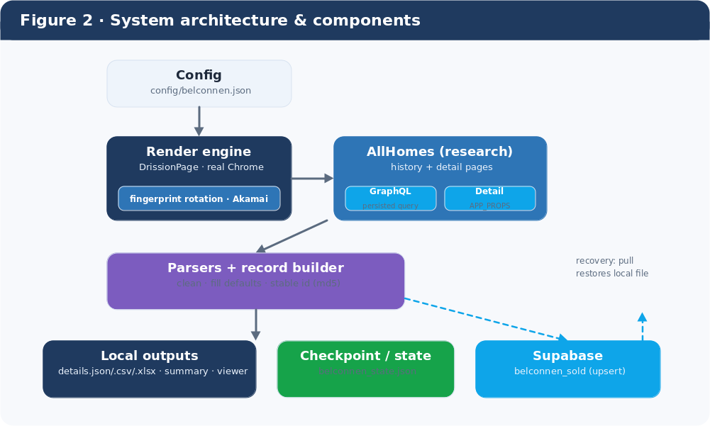
Figure 2 — System architecture and components.
4. How It Works — Workflow
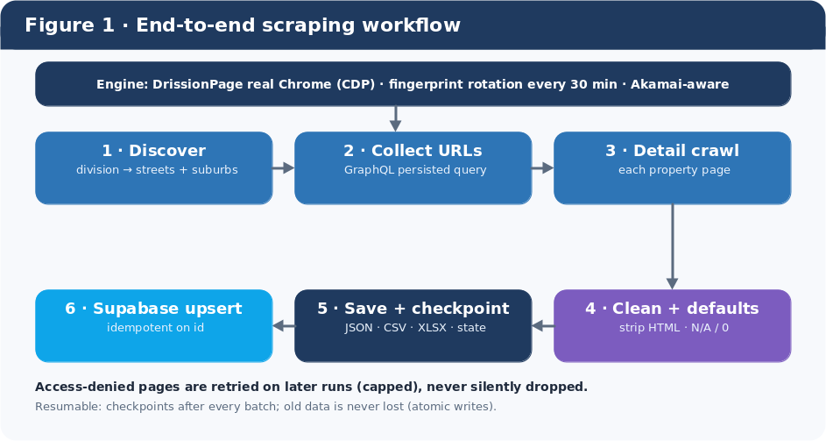
Figure 1 — End-to-end scraping workflow.
- Discover — read the Belconnen division page and enumerate every street and surrounding suburb.
- Collect URLs — page through each locality's sold history via the allhomes GraphQL persisted query (cache-proof), with adaptive paging.
- Detail crawl — visit each property page in a real browser and extract the full record.
- Clean + defaults — strip HTML from text, standardise units, and fill empty fields (text → "N/A", numbers → 0).
- Save + checkpoint — write JSON / CSV / XLSX and the resume state atomically after every batch.
- Supabase upsert — push records to the database, idempotent on a stable id, so re-runs update rather than duplicate.
Throughout the run: the browser fingerprint is rotated every 30 minutes to stay under the site's bot-management, and any property that returns access-denied is retried on a later run rather than skipped.

5. Anti-Bot Strategy
allhomes is protected by Akamai bot-management. The scraper therefore drives a real Chromium browser (via DrissionPage over the DevTools protocol) so requests carry genuine browser fingerprints, TLS and cookies rather than those of an HTTP client.
- Real browser — DrissionPage controls real Chrome; the genuine Chrome user-agent is used (a mismatched UA is itself a detection signal).
- Fingerprint rotation — the browser is relaunched on a fresh profile every 30 minutes to vary the fingerprint.
- Cache-proof paging — the allhomes GraphQL persisted query is used so pagination cannot be served a stale cached first page.
- Graceful degradation — blocked or transient responses are retried on later runs (Section 6), never silently dropped.
- Optional proxy / logged-in Chrome — a residential proxy or an attached logged-in Chrome can be configured if the run IP is challenged.
6. Blocked-Page Retry & Resume Policy
Access-denied is expected occasionally behind Akamai. The system treats it as a temporary condition, not a permanent skip, while still allowing the crawl to reach completion.
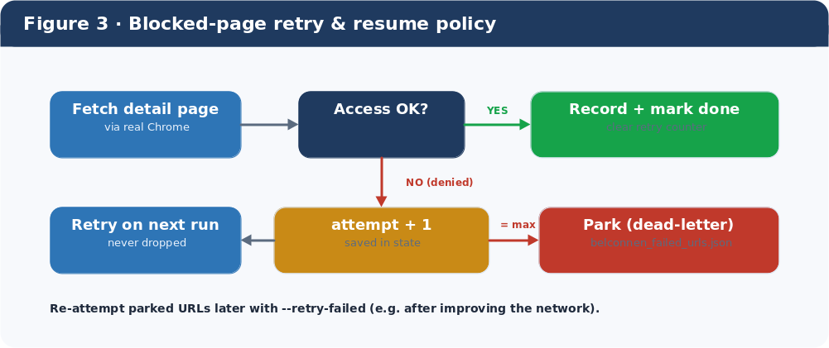
Figure 3 — Blocked-page retry and resume policy.
- A blocked property is NOT marked done, so it is retried automatically on the next run.
- Each attempt is counted and saved in the state file; after the configured maximum it is parked in a dead-letter list so the run can finish.
- Parked URLs are written to belconnen_failed_urls.json for review, and can be re-attempted with the --retry-failed option.
- A success clears the property's retry counter.
7. Data Captured
Each record carries full detail. Empty fields are filled with defaults so rows are never ragged.
Group | Fields
Identity | stable id, Listing ID, Listing URL, source locality, source type
Location | Address, Street, Suburb, State, Postcode
Price & status | Sold price, Status, Sold date, Listed date, Last updated, page views
Attributes | Property type, Bedrooms, Bathrooms, Parking, Building/Land size, EER
Rich detail | Description, Features, Key details, Block details, What's Nearby, Property history
People | Agent name & phone, Agency name & phone
Media (optional) | Image count, Image URLs (download OFF by default)

8. Data Quality & Reliability
- No data loss — all files are written atomically (write-temp-then-replace), so a crash or a full disk can never blank an existing file.
- Empty-field defaults — text → "N/A", numbers → 0 — every record has a consistent shape.
- Clean text — raw HTML (e.g. line-break tags) is stripped from descriptions before storage.
- De-duplication — a stable id (hash of the listing URL) keys every record; re-runs update in place rather than duplicate.
- Resumable — continuous checkpoints mean a stopped or crashed run continues exactly where it left off.
- Self-cleaning — temporary browser profiles are removed on every rotation so disk usage stays flat over long runs.
9. Supabase Integration
Records are upserted to a Supabase table (belconnen_sold) as the crawl proceeds, so the database stays current with the local files. The upsert is idempotent on the stable id, so repeated runs never create duplicates.
- Live upload — new records are pushed in batches during the detail crawl, with a final flush at the end.
- One-time table setup — a ready-to-run SQL file (belconnen_supabase_setup.sql) creates the table/columns.
- Sync & recovery — belconnen_supabase_push.py mirrors the local file to Supabase; belconnen_supabase_pull.py restores the local file from Supabase if needed.
- Keys — the Supabase project URL and key are read from the configuration / environment; they are not hard-coded.

10. Project Files & Responsibilities
The files required to run the system (everything else in the repository is supporting tooling).
File / folder | Responsibility
webarchiver/belconnen_research.py | The scraper: discovery, pagination, detail crawl, cleaning, checkpoints, Supabase, retry.
webarchiver/fetch/drission_engine.py | Real-Chrome render engine (DrissionPage) used to pass Akamai.
webarchiver/listings/allhomes_graphql.py | Builds/parses the allhomes GraphQL persisted-query requests.
webarchiver/listings/allhomes_detail.py | Parses a property detail page into a structured record.
webarchiver/report/exporters.py | Atomic JSON / CSV / XLSX writers.
config/belconnen.json | All run settings (target, paging, rotation, Supabase, etc.).
requirements.txt | Python dependencies.
belconnen_supabase_push.py / _pull.py | Supabase sync and recovery utilities.
belconnen_view.html | A local viewer for browsing the scraped data.
Google Chrome (system) | Required — the engine drives a real Chrome install.

11. Configuration Reference
Settings live in config/belconnen.json. Key options:
Option | Meaning
division_url | The Belconnen research page the crawl starts from.
include_streets / include_suburbs | Whether to crawl street pages / surrounding-suburb pages.
graphql_hash / page_size / graphql_chunk | allhomes persisted-query hash and paging sizes.
fingerprint_rotate_minutes | How often to relaunch the browser (default 30).
detail_delay_sec | Polite delay between detail-page visits.
max_detail_attempts | Retries before a blocked URL is parked (dead-letter).
headless / page_load_wait / request_timeout | Browser/render behaviour.
proxy / chrome_debugger_address | Optional residential proxy or attached logged-in Chrome.
supabase_url / supabase_key / supabase_table | Supabase project, key, and target table.
output_dir | Where results are written (website_backup/AllhomesBelconnen).

12. Running on the VM
The system runs on a Windows VM. One-time setup, then a single command to run (or resume).
12.1 One-time setup
- Install Python 3.12+ (tick "Add python.exe to PATH").
- Install Google Chrome (the engine drives a real Chrome).
- Create a virtual environment and install dependencies (below).
cd C:\Users\Administrator\Desktop\Webscraper
py -m venv .venv
.\.venv\Scripts\Activate.ps1
python -m pip install --upgrade pip
pip install -r requirements.txt
pip install supabase

12.2 Run, resume, and retry
Fresh run:
python -m webarchiver.belconnen_research --config config/belconnen.json

Resume after a stop/crash (keeps all data, continues where it left off):
python -m webarchiver.belconnen_research --config config/belconnen.json --resume

Re-attempt any properties that were parked after repeated access-denied:
python -m webarchiver.belconnen_research --config config/belconnen.json --resume --retry-failed

12.3 Supabase utilities
Restore the local file from Supabase (recovery), or push the local file up:
python belconnen_supabase_pull.py
python belconnen_supabase_push.py

Tip: keep the VM disk healthy — the run self-cleans its temporary browser profiles, but ensure a few GB free before long runs. Use the on-screen progress log and belconnen_summary.json to monitor.

13. Output — What You Get
All results are written under website_backup\AllhomesBelconnen\:
- belconnen_details.json / .csv / .xlsx — the property dataset (10,764 records).
- belconnen_summary.json — live run summary (counts, pending, parked).
- belconnen_state.json — the resume checkpoint.
- belconnen_failed_urls.json — any parked (dead-letter) URLs for review.
- belconnen_supabase_setup.sql — one-time table-creation SQL.
- belconnen_view.html — a local viewer to browse the data.
- Supabase belconnen_sold — the same records in the database.
14. Resume, Checkpointing & Recovery
- Checkpoints — state and data are saved atomically after every batch of detail records.
- Resume — --resume reloads the state and dataset, skips finished work, and re-opens the detail phase for anything missing.
- Never overwrites — the dataset is reloaded before finalising, so a resume can never blank it.
- Recovery — if the local file is ever lost, belconnen_supabase_pull.py rebuilds it from Supabase and reconciles the state so resume skips the recovered rows.
15. Problems Encountered & Resolutions
The significant issues met during development and operation, and how each was resolved.
Problem | Resolution
allhomes sold history returned a cached first page | Switched to the GraphQL persisted query (cache-proof) for paging
Akamai 'access denied' on some detail pages | Retry on later runs with an attempt cap + dead-letter (Section 6)
First-request block from a mismatched user-agent | Use the genuine Chrome user-agent by default
Long runs filled the disk with browser profiles | Managed temp profile, deleted on every fingerprint rotation
A failed save could blank the data file | All writes are atomic (write-temp-then-replace) — file never truncated
Run summary did not update mid-run | Summary is written at every checkpoint
Empty fields left records ragged | Defaults applied — text → 'N/A', numbers → 0
Raw HTML tags appeared in descriptions | HTML stripped to plain text before storage

16. Results & Status
Metric | Value
Records delivered | 10,764 properties
Coverage | Belconnen division — streets + surrounding suburbs
Detail depth | Full per-property record
Data stores | Local JSON/CSV/XLSX + Supabase (belconnen_sold)
Run mode | Unattended on the VM, resumable & crash-safe
Status | Delivered

17. Operations & Maintenance
- Refresh: re-run with --resume periodically to pick up new/changed sold listings (idempotent — no duplicates).
- Parked URLs: review belconnen_failed_urls.json and re-attempt with --retry-failed after any network/proxy improvement.
- Monitoring: watch the run log and belconnen_summary.json (details captured, pending, parked).
- Health: keep a few GB of free disk; the run self-cleans browser profiles each rotation.
- Backups: the Supabase table is a durable second copy; belconnen_supabase_pull.py can restore the local file at any time.
18. Glossary
Term | Meaning
Akamai | The bot-management service protecting allhomes.
DrissionPage | Library that drives a real Chrome browser via the DevTools protocol.
GraphQL persisted query | A pre-registered query referenced by hash — used for cache-proof pagination.
Upsert | Insert-or-update keyed on a unique id; the basis of duplicate-free syncing.
Dead-letter | A property parked after repeated failures so the run can complete; reviewable and re-runnable.
Checkpoint | A saved snapshot of progress that makes the run resumable.
Stable id | A hash of the listing URL used to identify a record across runs.

