**REST - Get country based on country code**   
  
Write a REST service that returns a specific country based on country code. The country code should be case insensitive.  
  
**Controller**: com.cognizant.spring-learn.controller.CountryController  
**Method Annotation:** @GetMapping("/countries/{code}")  
**Method Name**: getCountry(String code)  
**Method Implemetation**: Invoke countryService.getCountry(code)   
**Service Method:**com.cognizant.spring-learn.service.CountryService.getCountry(String code)  
  
**Service Method Implementation**:

* Get the country code using @PathVariable
* Get country list from country.xml
* Iterate through the country list
* Make a case insensitive matching of country code and return the country.
* Lambda expression can also be used instead of iterating the country list

**Sample Request**: http://localhost:8083/country/in  
  
**Sample Response**:

{

  "code": "IN",

  "name": "India"

}

**Hands On Solution**

Steps:

1. *Country.xml* code as follows:

<?xml version="1.0" encoding="UTF-8"?>

<beans xmlns="http://www.springframework.org/schema/beans"

xmlns:xsi="http://www.w3.org/2001/XMLSchema-instance"

xsi:schemaLocation="http://www.springframework.org/schema/beans

https://www.springframework.org/schema/beans/spring-beans.xsd">

<bean id="country" class="com.cognizant.spring_learn.Country">

<property name="code" value="IN"/>

<property name="name" value="India"/>

</bean>

<bean id="countryList" class="java.util.ArrayList">

<constructor-arg>

<list>

<bean class="com.cognizant.spring_learn.Country">

<property name="code" value="IN"/>

<property name="name" value="India"/>

</bean>

<bean class="com.cognizant.spring_learn.Country">

<property name="code" value="US"/>

<property name="name" value="United States"/>

</bean>

<bean class="com.cognizant.spring_learn.Country">

<property name="code" value="CN"/>

<property name="name" value="China"/>

</bean>

</list>

</constructor-arg>

</bean>

</beans>

1. *CountryController* code as follows:

**package** com.cognizant.spring_learn.controller;

**import** com.cognizant.spring_learn.Country;

**import** com.cognizant.spring_learn.service.CountryService;

**import** org.springframework.beans.factory.annotation.Autowired;

**import** org.springframework.web.bind.annotation.*;

@RestController

**public** **class** CountryController {

@Autowired

**private** CountryService countryService;

@GetMapping("/country")

**public** Country getCountryIndia() {

ApplicationContext context = **new** ClassPathXmlApplicationContext("country.xml");

Country country = (Country) context.getBean("country");

**return** country;

}

@GetMapping("/country/{code}")

**public** Country getCountry(@PathVariable String code) {

**return** countryService.getCountry(code);

}

}

1. *com.cognizant.spring_learn.service* package added to *com.cognizant.spring_learn*

4.class *CountryService* added to this package whose code as follows:

**package** com.cognizant.spring_learn.service;

**import** com.cognizant.spring_learn.Country;

**import** org.springframework.context.ApplicationContext;

**import** org.springframework.context.support.ClassPathXmlApplicationContext;

**import** org.springframework.stereotype.Service;

**import** java.util.List;

@Service

**public** **class** CountryService {

**public** Country getCountry(String code) {

ApplicationContext context = **new** ClassPathXmlApplicationContext("country.xml");

List<Country> countryList = (List<Country>) context.getBean("countryList");

**return** countryList.stream()

.filter(c -> c.getCode().equalsIgnoreCase(code))

.findFirst()

.orElse(**null**);

}

}

1. server.port = 8085 added in *application.properties*
2. Output as follows:

1. Browser links are as follows:

<http://localhost:8085/country/in>

<http://localhost:8085/country/US>

<http://localhost:8085/country/cn>

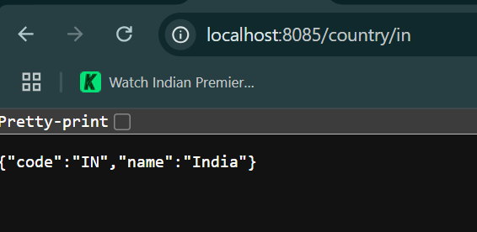

1. Postman:

