**Exercise 1: Control Structures**

**Scenario 1:** The bank wants to apply a discount to loan interest rates for customers above 60 years old.

**Question:** Write a PL/SQL block that loops through all customers, checks their age, and if they are above 60, apply a 1% discount to their current loan interest rates.

**Scenario 2:** A customer can be promoted to VIP status based on their balance.

**Question:** Write a PL/SQL block that iterates through all customers and sets a flag IsVIP to TRUE for those with a balance over $10,000.

**Scenario 3:** The bank wants to send reminders to customers whose loans are due within the next 30 days.

**Question:** Write a PL/SQL block that fetches all loans due in the next 30 days and prints a reminder message for each customer

**Solution**

First, we create two tables, load some sample data

CREATE TABLE CUSTOMER (

CUSTOMER_ID NUMBER PRIMARY KEY,

NAME VARCHAR2(50),

AGE NUMBER,

LOAN_INTEREST_RATE NUMBER(5,2),

BALANCE NUMBER(10,2),

ISVIP VARCHAR2(1) DEFAULT 'N'

);

-- LOAN table holds due dates

CREATE TABLE LOAN (

LOAN_ID NUMBER PRIMARY KEY,

CUSTOMER_ID NUMBER,

DUE_DATE DATE,

FOREIGN KEY (CUSTOMER_ID) REFERENCES CUSTOMER(CUSTOMER_ID)

);

-- Sample data

INSERT INTO CUSTOMER VALUES (1, 'Alice', 65, 7.50, 5000, 'N');

INSERT INTO CUSTOMER VALUES (2, 'Bob', 58, 8.00, 15000, 'N');

INSERT INTO CUSTOMER VALUES (3, 'Carol', 72, 7.75, 20000, 'N');

INSERT INTO CUSTOMER VALUES (4, 'David', 45, 6.90, 8000, 'N');

INSERT INTO CUSTOMER VALUES (5, 'Eve', 61, 8.25, 12000, 'N');

INSERT INTO LOAN VALUES (101, 1, SYSDATE + 10); -- due in 10 days

INSERT INTO LOAN VALUES (102, 2, SYSDATE + 40); -- due in 40 days

INSERT INTO LOAN VALUES (103, 3, SYSDATE + 25); -- due in 25 days

INSERT INTO LOAN VALUES (104, 4, SYSDATE + 5); -- due in 5 days

INSERT INTO LOAN VALUES (105, 5, SYSDATE - 2); -- already due

COMMIT;

**Scenario 1: 1% discount on loan interest for customers > 60**

BEGIN

FOR rec IN (SELECT CUSTOMER_ID, NAME, AGE, LOAN_INTEREST_RATE

FROM CUSTOMER)

LOOP

IF rec.AGE > 60 THEN

UPDATE CUSTOMER

SET LOAN_INTEREST_RATE = LOAN_INTEREST_RATE - 1

WHERE CUSTOMER_ID = rec.CUSTOMER_ID;

DBMS_OUTPUT.PUT_LINE(

'Applied 1% discount to ' || rec.NAME

|| ' (ID=' || rec.CUSTOMER_ID

|| '), new rate: '

|| TO_CHAR(rec.LOAN_INTEREST_RATE - 1, '90.00') || '%'

);

END IF;

END LOOP;

COMMIT;

END;

/

**OUTPUT**

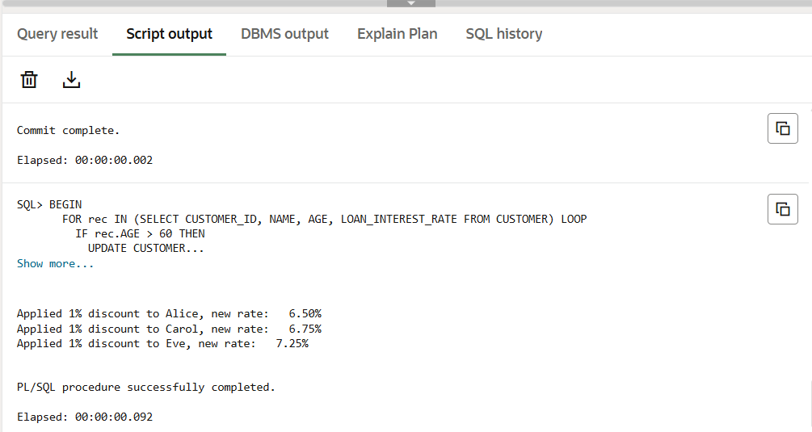

**Scenario 2: Promote to VIP if balance > 10,000**

BEGIN

FOR rec IN (SELECT CUSTOMER_ID, NAME, BALANCE

FROM CUSTOMER)

LOOP

IF rec.BALANCE > 10000 THEN

UPDATE CUSTOMER

SET ISVIP = 'Y'

WHERE CUSTOMER_ID = rec.CUSTOMER_ID;

DBMS_OUTPUT.PUT_LINE(

'Set VIP for ' || rec.NAME

|| ' (ID=' || rec.CUSTOMER_ID

|| '), balance: $' || TO_CHAR(rec.BALANCE, '999999.99')

);

END IF;

END LOOP;

COMMIT;

END;

/

**OUTPUT**

**Scenario 3: Reminders for loans due in next 30 days**

BEGIN

FOR loan_rec IN (

SELECT L.LOAN_ID, L.CUSTOMER_ID, L.DUE_DATE, C.NAME

FROM LOAN L

JOIN CUSTOMER C ON C.CUSTOMER_ID = L.CUSTOMER_ID

WHERE L.DUE_DATE BETWEEN SYSDATE AND SYSDATE + 30

ORDER BY L.DUE_DATE

)

LOOP

DBMS_OUTPUT.PUT_LINE(

'REMINDER: Loan ' || loan_rec.LOAN_ID

|| ' for ' || loan_rec.NAME

|| ' (CustID=' || loan_rec.CUSTOMER_ID

|| ') is due on '

|| TO_CHAR(loan_rec.DUE_DATE, 'DD‑Mon‑YYYY')

);

END LOOP;

END;

/

**OUTPUT**

