**FUNCTIONS:**

**def hello (str):**

**print("in function " + str)**

**print("after printing in function definition")**

**return;**

**print("1")**

**print("2")**

**hello("HEMA")**

**hello("HEMAS")**

**print("3")**

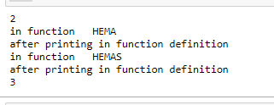

**def changeme( mylist ):**

**mylist.append([1,2,3,4]);**

**print ("Values inside the function: ", mylist)**

**return;**

**mylist = [10,20,30];**

**changeme( mylist );**

**print ("Values outside the function: ", mylist)**

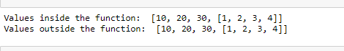

**def changeme( mylist ):**

**print ("BEFORE CHANGESValues inside the function: ", mylist)**

**mylist = [1,2,3,4];**

**print ("AFTER CHANGES Values inside the function: ", mylist)**

**return**

**mylist1 = [10,20,30];**

**changeme( mylist1 );**

**print ("Values outside the function: ", mylist1)**

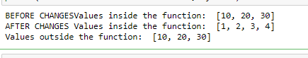

**def printme( str ):**

**print (str)**

**return;**

**printme( str = "My string")**



**def printinfo( name, age ):**

**print ("Name: ", name)**

**print ("Age ", age)**

**return;**

**printinfo( age=50, name="miki" )**

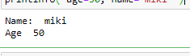

**def printinfo( name, age ):**

**print ("Name: ", name)**

**print ("Age ", age)**

**return;**

**printinfo( "miki",50 )**



**def printinfo( name, age = 35 ):**

**print ("Name: ", name)**

**print ("Age ", age)**

**return;**

**printinfo( age=50, name="miki" )**

**printinfo( name="miki" )**

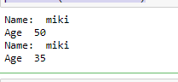

**def printinfo( name, age ):**

**print ("Name: ", name)**

**print ("Age ", age)**

**return;**

**printinfo( 50, "miki" )**

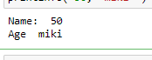

**def printinfo( arg1, *vartuple ):**

**print ("Output is: ")**

**print ("arg1==",arg1)**

**for var in vartuple:**

**print (var)**

**return;**

**printinfo( 10,78 )**

**printinfo( 70, 60, 50,90 )**

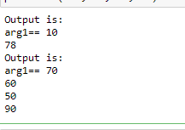

**sum = lambda arg1, arg2: arg1 + arg2;**

**print ("Value of total : ", sum( 10, 20 ))**

**print ("Value of total : ", sum( 20, 20 ))**

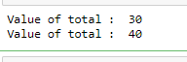

**def sum( arg1, arg2 ):**

**total = arg1 + arg2**

**print ("Inside the function : ", total)**

**return total;**

**total1 = sum( 10, 20 );**

**print ("Outside the function : ", total1 )**

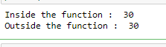

**total = 99;**

**def sum( arg1, arg2 ):**

**total = arg1 + arg2;**

**print ("Inside the function local total : ", total)**

**return total;**

**sum( 10, 20 );**

**print ("Outside the function global total : ", total )**

