**IF ELSE**

**num = int(input("enter the number? \n"))**

**if num%2 == 0:**

**print("Number is even")**

**print("bye")**

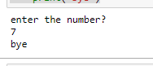

**a = int(input("Enter a- "));**

**b = int(input("Enter b- "));**

**c = int(input("Enter c- "));**

**if a>b and a>c:**

**print("a is largest");**

**if b>a and b>c:**

**print("b is largest");**

**if c>a and c>b:**

**print("c is largest");**

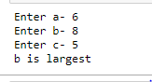

**age = int (input("Enter your age?\n "))**

**if age>=18:**

**print("You are eligible to vote !!");**

**else:**

**print("Sorry! you have to wait !!");**

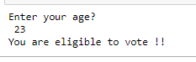

**num = int(input("enter the number?\n"))**

**if num%2 == 0:**

**print("Number is even...")**

**else:**

**print("Number is odd...")**

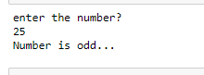

**number = int(input("Enter the number?\n"))**

**if number==10:**

**print("number is equals to 10")**

**elif number==50:**

**print("number is equal to 50");**

**elif number==100:**

**print("number is equal to 100");**

**else:**

**print("number is not equal to 10, 50 or 100");**

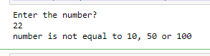

**number = input("Enter the number?")**

**if number==10:**

**print("number is equals to 10")**

**elif number==50:**

**print("number is equal to 50");**

**elif number==100:**

**print("number is equal to 100");**

**else:**

**print("number is not equal to 10, 50 or 100");**

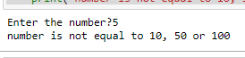

**marks = int(input("Enter the marks? "))**

**if marks > 85 and marks <= 100:**

**print("Congrats ! you scored grade A ...")**

**elif marks > 60 and marks <= 85:**

**print("You scored grade B + ...")**

**elif marks > 40 and marks <= 60:**

**print("You scored grade B ...")**

**elif (marks > 30 and marks <= 40):**

**print("You scored grade C ...")**

**else:**

**print("Sorry you are fail ?")**

