**LISTS:**

**list1 = ['physics', 'chemistry', 1997, 2000];**

**list2 = [1, 2, 3, 4, 5, 6, 7 ];**

**print ("list1[0]: ", list1[2])**

**print ("list2[1:5]: ", list2[1:3])**



**list = ['physics', 'chemistry', 1997, 2000];**

**print ("Value available at index 2 : ")**

**print (list[2])**

**list[2] = 999999;**

**print ("New value available at index 2 : ")**

**print (list[2])**

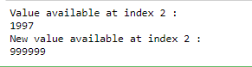

**list1 = ['physics', 'chemistry', 1997, 2000];**

**print (list1)**

**del (list1[2]);**

**print ("After deleting value at index 2 :")**

**print (list1)**

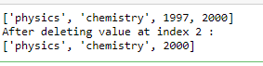

**list1, list2 = [123, 'xyz', 'zara'], [456, 'abc']**

**print ("First list length : ", len(list1))**

**print ("Second list length : ", len(list2))**



**aList = [123, 'xyz', 'zara', 'abc'];**

**aList.append( 2009 );**

**print ("Updated List : ", aList)**



**aList = [123, 'xyz', 'xyz', 'abc', 123];**

**print ("Count for xyz : ", aList.count('xyz'))**

**print ("Count for zara : ", aList.count('zara'))**



**aList = [123, 'xyz', 'zara', 'abc', 123];**

**bList = [2009, 'shabnam'];**

**aList.extend(bList)**

**print ("Extended List : ", aList)**



**aList = [123, 'xyz', 'zara', 'abc', 'zara'];**

**print ("Index for xyz : ", aList.index( 'xyz' ) )**

**print ("Index for zara : ", aList.index( 'zara' ) )**



**aList = [123, 'xyz', 'zara', 'abc']**

**aList.insert( 2, 2009)**

**print ("Final List : ", aList)**



**aList = [123, 'xyz', 'zara', 'abc'];**

**print(aList)**

**print ("List after popping last element : ", aList.pop())**

**print(aList)**

**print ("List after popping element from mentioned index: ", aList.pop(2))**

**print(aList)**

**aList.insert(1, 2009)**

**print(aList)**

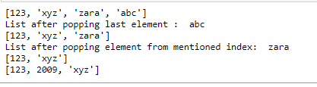

**aList = [123, 'xyz', 'zara', 'abc', 'xyz'];**

**aList.remove('xyz');**

**print ("List : ", aList)**

**aList.remove('abc');**

**print ("List : ", aList)**



**aList = ['shar', 'xyz', 'zara', 'abc', 'hema'];**

**aList.reverse();**

**print ("List : ", aList)**



**aList = ['blgr', 'shar', 'sona', 'hema', 'latha'];**

**aList.sort();**

**print ("List : ", aList)**



**aList = ['hem', 'xyz1', 'zara', 'abc', 'xyz','123'];**

**aList.sort();**

**print ("List : ", aList)**

