**LOOPS**

**str = "Python"**

**for i in str:**

**print(i)**

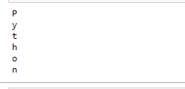

**list = [1,2,3,4,5,6,7,8,9,10]**

**n = 6**

**for i in list:**

**c = n*i**

**print(n," *",i, " =", c)**

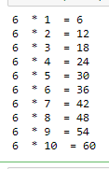

**list = [10,30,20,40,60,12]**

**sum = 0**

**for i in list:**

**sum = sum+i**

**print("The sum is:",sum)**



**for i in range(18):**

**print(i,end=' ')**



**n = int(input("Enter the number "))**

**for i in range(1,11):**

**c = n*i**

**print(n,"*",i,"=",c)**

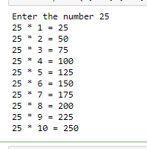

**n = int(input("Enter the number "))**

**for i in range(2,n,2):**

**print(i)**

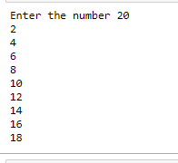

**list = ['Peter','Shar','cmr','soet']**

**for i in range(len(list)):**

**print("Hello",list[i])**

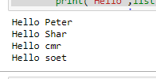

**for i in range(0,7):**

**print(i)**

**else:**

**print("for loop completely exhausted, since there is no break.")**

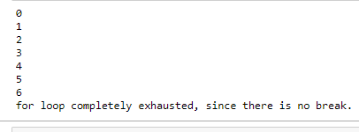

**for i in range(0,7):**

**print(i)**

**print("bye")**

**continue;**

**print("hello")**

**else:print("for loop is exhausted");**

**print("The loop is broken due to break statement...came out of the loop")**

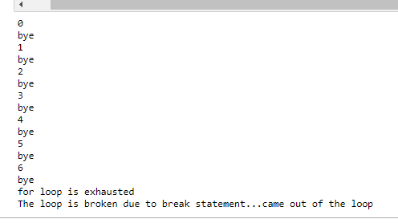

**# prints all letters except 'a' and 't'**

**i = 0**

**str1 = 'hemas'**

**print(str1)**

**while i < len(str1):**

**print('entered while loop before if statement')**

**if str1[i] == 'a' or str1[i] == 'u':**

**print('entered if statement')**

**i += 1**

**print('i incremented')**

**continue**

**print('after continue')**

**print('Current Letter :', str1[i])**

**i += 1**

**print('going back to starting of while loop')**

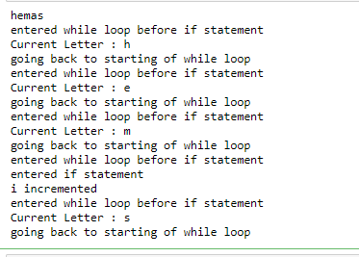

**i = 0**

**str1 = 'hemalatha'**

**while i < len(str1):**

**if str1[i] == 'n':**

**i += 1**

**break**

**print('Current Letter :', str1[i])**

**i += 1**

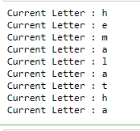

**#The pass statement is used to declare the empty loop.**

**#It is also used to define empty class, function, and control statement.**

**str1 = 'hemalatha'**

**i = 0**

**while i < len(str1):**

**i += 1**

**pass**

**print('Value of i :', i)**



**i=1**

**#The while loop will iterate until condition becomes false.**

**while(i<=10):**

**print(i)**

**i=i+1**

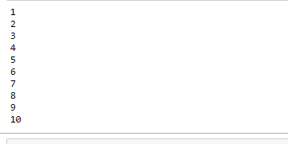

**i=1**

**number = int(input("Enter the number:"))**

**while i<=10:**

**print("%d X %d = %d \n"%(number,i,number*i))**

**i = i+1**

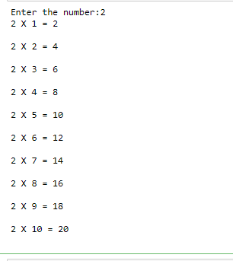

**while (1):**

**print("Hi! we are inside the infinite while loop")**

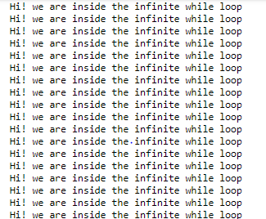

**var = 1**

**while(var != 2):**

**i = int(input("Enter the number:"))**

**print("Entered value is %d"%(i))**

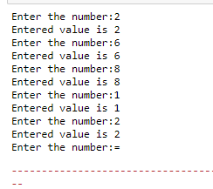

**i=1**

**while(i<=5):**

**print(i)**

**i=i+1**

**else:**

**print("The while loop exhausted")**

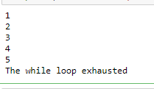

**i=1**

**while(i<=5):**

**print(i)**

**i=i+1**

**if(i==3):**

**break**

**else:**

**print("The while loop exhausted")**

**print("bye bye")**

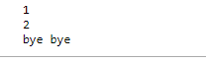

**list =[1,2,3,4]**

**i=1;**

**count = 2;**

**for i in list:**

**if i == 4:**

**print("item matched")**

**count = count + 1;**

**break**

**print("found at",count,"location");**



**str = "python"**

**for i in str:**

**if i == 'o':**

**break**

**print(I);**

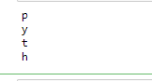

**n=2**

**while 1:**

**i=1;**

**while i<=10:**

**print("%d X %d = %d\n"%(n,i,n*i));**

**i = i+1;**

**choice = int(input("Do you want to continue printing the table, press 0 for no?"))**

**if choice == 0:**

**break;**

**n=n+1**

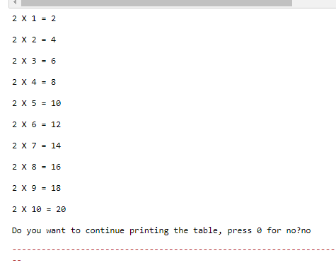

**i = 0**

**while(i < 10):**

**i = i+1**

**if(i == 5):**

**continue**

**print(i)**

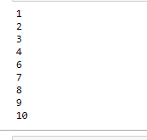

**str = "hemas"**

**for i in str:**

**if(i == 'm'):**

**continue**

**print(i)**

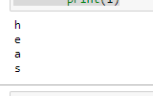

**list = [1,2,3,4,5]**

**flag = 0**

**for i in list:**

**print("Current element:",i,end=" ");**

**if i==3:**

**pass**

**print("\nWe are inside pass block\n");**

**flag = 1**

**if flag==1:**

**print("\nCame out of pass\n");**

**flag=0**

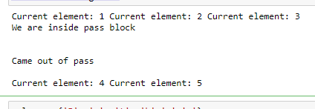

**values = {'P', 'y', 't', 'h','o','n'}**

**for val in values:**

**pass**

**for i in [1,2,3,4,5]:**

**if(i==4):**

**pass**

**print("This is pass block",i)**

**print(i)**

