**NUMPY:**

**import numpy as npa**

**npa= npp.array([1, 2, 3])**

**print(npa)**



**import numpy as npp**

**a = npp.array([[1 , 2, 3, 4], [5, 6, 7, 8], [9, 10, 11, 12]])**

**print(a)**

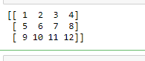

**import numpy as np**

**a=np.zeros(2)**

**print(a)**



**import numpy as np**

**a=np.ones(4)**

**print(a)**



**import numpy as np**

**ab=np.empty(4)**

**print(ab)**



**import numpy as np**

**a=np.arange(7)**

**print(a)**



**import numpy as np**

**a=np.arange(2,9,2)**

**print(a)**



**y = np.ones(2, dtype=int)**

**print(y)**

**y**



**arr = np.array([1, 2, 3, 4, 5, 6, 7, 8])**

**print(arr)**



**a = np.array([1, 2, 3, 4, 5, 6, 7, 8])**

**print(a)**

**a=np.delete(a, 1)**

**print(a)**

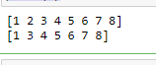

**a = np.array([19, 22, 34, 14, 55, 76, 47, 8])**

**print(a)**

**a=np.sort(a)**

**print(a)**

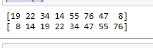

**import numpy as np**

**arr = np.array([[1, 2, 3], [4, 5, 6]])**

**a=arr.ndim**

**print(arr)**

**print("dimensions = ", a)**

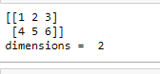

**import numpy as np**

**arr = np.array([[[1, 2, 3], [4, 5, 6]], [[11, 22, 33], [44, 55, 66]]])**

**a=arr.ndim**

**b=arr.size**

**print(arr)**

**print("dimensions = ", a)**

**print("size = ", b)**

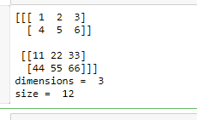

**import numpy as np**

**a = np.array(42)**

**b = np.array([1, 2, 3, 4, 5])**

**c = np.array([[1, 2, 3], [4, 5, 6]])**

**d = np.array([[[1, 2, 3], [4, 5, 6]], [[1, 2, 3], [4, 5, 6]]])**

**print(a)**

**print("dimension= ", a.ndim)**

**print(b)**

**print("dimension= ", b.ndim)**

**print(c)**

**print("dimension= ", c.ndim)**

**print(d)**

**print("dimension= ", d.ndim)**

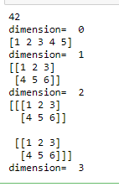

**import numpy as np**

**arr = np.array([[1, 2, 3, 4], [5, 6, 7, 8]])**

**print(arr.shape)**



**a = np.arange(6)**

**print(a)**

**b = a.reshape(3,2)**

**print(b)**

