**NUMPY SPLIT:**

**import numpy as np**

**arr = np.array([[1, 2, 3], [4, 5, 6], [7, 8, 9], [10, 11, 12], [13, 14, 15], [16, 17, 18]])**

**newarr = np.vsplit(arr, 3)**

**print("\n")**

**print(newarr[0])**

**print("\n")**

**print(newarr[1])**

**print("\n")**

**print(newarr[2])**



**import numpy as np**

**arr = np.array([1, 2, 3, 4, 5, 6])**

**newarr = np.array_split(arr, 4)**

**nn= np.split(arr, 4)**

**print(newarr)**

**//the result cannot be shown as it can't divide in equal divisions**

**import numpy as np**

**arr = np.array([1, 2, 3, 4, 5, 6])**

**newarr = np.array_split(arr, 3)**

**print(newarr[0])**

**print(newer[1])**

**print(newarr[2])**

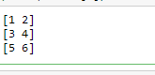

**import numpy as np**

**arr = np.array([[1, 2], [3, 4], [5, 6], [7, 8], [9, 10], [11, 12]])**

**newarr = np.array_split(arr, 3)**

**print("\n")**

**print(newarr[0])**

**print("\n")**

**print(newarr[1])**

**print("\n")**

**print(newarr[2])**

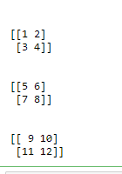

**import numpy as np**

**arr = np.array([[1, 2], [3, 4], [5, 6], [7, 8], [9, 10], [11, 12]])**

**newarr = np.array_split(arr, 4)**

**print("\n")**

**print(newarr[0])**

**print("\n")**

**print(newarr[1])**

**print("\n")**

**print(newarr[2])**

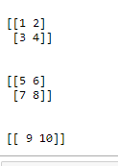

**import numpy as np**

**arr = np.array([[1, 2, 3], [4, 5, 6], [7, 8, 9], [10, 11, 12], [13, 14, 15], [16, 17, 18]])**

**newarr = np.array_split(arr, 3)**

**print("\n")**

**print(newarr[0])**

**print("\n")**

**print(newarr[1])**

**print("\n")**

**print(newarr[2])**

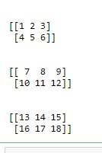

**import numpy as np**

**arr = np.array([[1, 2, 3], [4, 5, 6], [7, 8, 9], [10, 11, 12], [13, 14, 15], [16, 17, 18]])**

**newarr = np.array_split(arr, 3, axis=1)**

**print("\n")**

**print(newarr[0])**

**print("\n")**

**print(newarr[1])**

**print("\n")**

**print(newarr[2])**

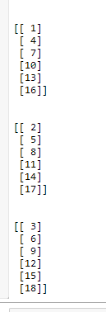

**import numpy as np**

**arr = np.array([[1, 2, 3], [4, 5, 6], [7, 8, 9], [10, 11, 12], [13, 14, 15], [16, 17, 18]])**

**newarr = np.hsplit(arr, 3)**

**print("\n")**

**print(newarr[0])**

**print("\n")**

**print(newarr[1])**

**print("\n")**

**print(newarr[2])**

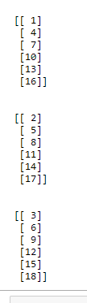

**import numpy as np**

**arr = np.array([[1, 2, 3], [4, 5, 6], [7, 8, 9], [10, 11, 12], [13, 14, 15], [16, 17, 18]])**

**newarr = np.vsplit(arr, 3)**

**print("\n")**

**print(newarr[0])**

**print("\n")**

**print(newarr[1])**

**print("\n")**

**print(newarr[2])**

