**TUPLES**

**tup= ('cse','it','mech')**

**print(tup)**

**tup1=(1,23,4,5,5,6)**

**print(tup1)**

**tup2=("abc","def")**

**print(tup2)**

**tup3="hema","latha"**

**print(tup3)**

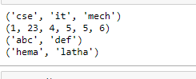

**tup1 = ()**

**print(tup1)**



**tup1 = '(24)'**

**print(tup1)**



**tup1 = (24)**

**print(tup1)**



**tup= ('cse','it','mech','ece','electrical')**

**print(tup[0])**

**print(tup[2])**

**print(tup[2:5])**

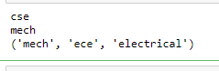

**tup1= ('cse','it','mech','ece','electrical')**

**print(tup1)**

**del(tup1)**

**print(tup1)**



**tup1= ('cse','it','mech','ece','electrical')**

**print(tup1)**

**tup2= ('hema','latha','reddy')**

**print(tup2)**

**tup3=tup1+tup2**

**print(tup3)**

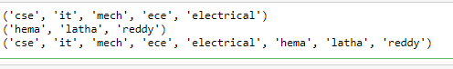

**tup1= ('cse','it','mech','ece','electrical')**

**print(tup1)**

**print("value at 3rd loc= ",tup1[3])**

**tup1[3]="hema" #not allowed ,update will not work in tuples**

**print("UPDATED value at 3rd loc= ",tup1[3])**

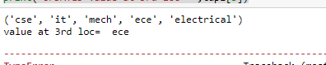

**tup1= ('cse','it','mech','ece','electrical')**

**print(tup1)**

**tup2= ('hema','latha','reddy')**

**print(tup2)**

**a=len(tup1)**

**b=len(tup2)**

**print(a)**

**print(b)**

**print(len(tup1))**

**print(len(tup2))**

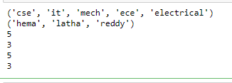

**tup1= ('cse','it','ece','electrical','mech','xyh',)**

**print(tup1)**

**tup2= ('hema','latha','reddy')**

**print(tup2)**

**print(max(tup1))**

**print(min(tup1))**

