**FILES**

**print ("Python is really a great language,", "isn't it ???")**



**str = input("Enter your input: ")**

**print ("Received input is :", str)**



**# Open a file**

**fo = open("cse7sem.txt", "wb")**

**print ("Name of the file: ", fo.name)**

**# Close opened file**

**fo.close()**



**f = open("cse7sem1.txt", "a")**

**f.write("hema")**

**f.close()**

**#open and read the file after the appending:**

**f = open("cse7sem1.txt", "r")**

**print(f.read())**



**# Open a file**

**fo = open("cse7sem.txt", "r+")**

**str = fo.read(10);**

**print ("Read String is : ", str)**

**# Close opened file**

**fo.close()**



**fo = open("cse7sem.txt", "wb")**

**print ("Name of the file: ", fo.name)**

**print ("Closed or not : ", fo.closed)**

**print ("Opening mode : ", fo.mode)**

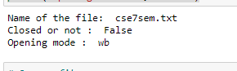

**# Open a file**

**fo = open("cse7sem1.txt", "r+")**

**str = fo.read(10)**

**print ("Read String is : ", str) #shabnamsha---output**

**# Check current position**

**position = fo.tell()**

**print ("Current file position : ", position)**

**# Reposition pointer at the beginning once again**

**position = fo.seek(1, 0);**

**str = fo.read(7)**

**print ("Again read String is : ", str)**

**ptr=fo.seek(0,1)**

**str1=fo.read(3)**

**print("my new string= ", str1)**

**# Close opened file**

**fo.close()**

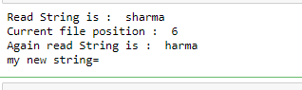

**import os**

**# Rename a file from test1.txt to test2.txt**

**os.rename("cse7sem.txt", "cse7semm.txt" )**

**import os**

**# Delete file test2.txt**

**os.remove("cse7semm.txt")**

**import os**

**# Create a directory "test"**

**os.mkdir("labex")**

**import os**

**# Changing a directory to "/home/newdir"**

**os.chdir("D:\text")**

**import os**

**# This would give location of the current directory**

**os.getcwd("tests")**

**# This would remove "/tmp/test" directory.**

**os.rmdir( "/tmp/tests" )**