**Dealer Ordering Dashboard using JEP**

|  |  |
| --- | --- |
| Reference: | Release Notes |
| Version: | v1.0 |
| Date: | 16th Sep |
| Status: | Initial |

**DOCUMENT CONTROL**

**Version History**

| Date | Author | Description |
| --- | --- | --- |
| 16th Sep 2019 | Varun Talus | Initial version v1 |
| 18th Sep 2019 | Varun Talus  Surendra baburavella | Updated the document post discussions with various stakeholders. |

**CONTENTS**

1. Introduction 6

1. Business/Use case Requirement Brief 6

2. Purpose and scope of this document 6

2. Delivery Checklist 6

1. Details of Components Used 6

2. Checklist 6

3. Data Flows 9

4. Source Information Owner 10

5. Table Name 10

6. Retention period (To be confirmed by Subhadeep) 11

7. Functional Diagram 12

8. Configuration Details 13

9. Reference Data 13

10. Business end users 13

11. Dashboards & Reports currently running 13

This is the first operational dashboard going LIVE using JEP platform. 13

12. Reconciliation Control logs 13

3. IMPACT aNALYSIS 13

4. Pre-EXECUTION STEPS 14

5. EXECUTION STEPS 17

1) Login as jep_daplatform user 17

6. SANITY STEPS 17

1) Check the status of Spark streaming Job in YARN 17

3) Check if Data is getting written to the tables: 17

7. Roll back STeps 17

8. PURGING POLICY (Subhadeep to comment) 18

NA 18

9. DaTA MIGRATION 18

10. Infosec Approval 18

a) PII Tagging detail 18

b) Ranger Policies 18

11. TEST RESULTS- DEV stats: 18

# Introduction

## Business/Use case Requirement Brief

Jio Technology Operations (TOPS) needs an end to end dashboard to monitor Dealer Order journey for Jio. The dealer orders (device and voucher) can be placed through RPOS or the ERP systems.

The intermediate TIBCO services which serve DealerOrder functionality publish logs and exceptions messages to JEP platform on specific TOPICs. The spark jobs will consume these messages and after some massaging insert these into ES and HIVE storages.

There is one generic dashboard created which then paints the Dealer Order journey, summary by fetching the records from HIVE storages.

## Purpose and scope of this document

# Delivery Checklist

This checklist, lists all the files required for the release.

## Details of Components Used

* Property files
  + Spark core property file
  + Client property file
* Standard Json
* Jars
* Jaas file
* Scripts (Spark submit)

## Checklist

|  |  |  |  |
| --- | --- | --- | --- |
| **Files** | **Description** | **Checksum** | **Files** |
| coe_spark_job.properties | Core property file to read Kafka, ES, Zookeeper configs | 1.7 Kb |  |
| coe_spark_job_client_diplatform_exception.properties | Client property file for exception spark job | 2 kb |  |
| coe_spark_job_client_diplatform_exception_pmc.properties | Client property file for exception pmc spark job | 2 kb |  |
| coe_spark_job_client_diplatform_log.properties | Client property file for log spark job | 2 kb |  |
| coe_spark_job_client_diplatform_log_pmc.properties | Client property file for log pmc spark job | 2 kb |  |
| Json.txt | Application Properties file for pmc spark jobs | 2 kb |  |
| hive_table_creation.hql | Hive table creation script | 3 kb |  |
| JEP_DAP_ExceptionEvents_consumer.sh | Exception consumer spark submit command | 1 kb |  |
| JEP_DAP_pmcExceptionEvents_consumer.sh | PMC Exception consumer spark submit command | 1 kb |  |
| JEP_DAP_LogEvents_consumer.sh | log consumer spark submit command | 1 kb |  |
| JEP_DAP_pmcLogEvents_consumer.sh | Log pmc consumer spark submit command | 1 kb |  |
| DAPLogging.jar | Log consumer and exception consumer jar file | 140251 kb |  |
| PMCEventsProcess.jar | Pmc events consumer jar | 140260 kb |  |

## 

## Data Flows

The data traffic flow through all the involved components is as explained below:

**TIBCO\DigitalAPI kubernetes k8s cluster Details:** DigitalAPI services publish messages on KAFKA TOPICs.

|  |  |  |
| --- | --- | --- |
| **K8s – Cluster1** |  | **K8s-cluster2** |
| 10.143.67.29  10.143.67.30  10.143.67.41  10.143.68.21  10.143.68.22  10.143.68.23  10.143.68.26  10.143.68.30  10.143.67.43 |  | 10.143.67.32  10.143.67.33  10.143.67.40  10.143.68.24  10.143.68.25  10.143.68.27  10.143.68.28  10.143.68.29  10.143.67.44 |

**KAFKA Cluster TOPICs:**

“daplatform-do-log”

“daplatform-do-exception”

**Spark Jobs:**

Below spark jobs are created to consume the messages from above KAFKA topics.

JEP_DAP_LogEvents_consumer

JEP_DAP_ExceptionEvents_consumer

JEP_DAP_pmcLogEvents_consumer

JEP_DAP_pmcExceptionEvents_consumer

**ElasticSearch:** Above spark jobs insert these messages in the ES and HIVE storages.

dap.dealerorder.log + datetime (appended)

dap.dealerorder.exception + datetime (appended)

**Hive:**

Please created below tables for this journey:

dap_do_log

dap_do_exception

dap_do_pmc

dap_do_audit

dap_do_autoretry

**DigitalAPI Backend API Service:**

This service connects to the HIVE tables and fetches the required details based on the submitted query through UI.

**Angular UI:**

This UI invokes the digitalAPI backendAPI service to paint the data on the dashboard.

## Source Information Owner

Details of source owner, along with contact details.

|  |  |  |  |
| --- | --- | --- | --- |
| **Source** | **Name** | **E-mail** | **Contact** |
| TIBCO | Subhadeep Sarkar  Pravin Rathod  Ranjeet Patil | [Subhadeep.sarkar@ril.com](mailto:Subhadeep.sarkar@ril.com)  [Pravin.c.rathod@ril.com](mailto:Pravin.c.rathod@ril.com)  [Ranjeet1.patil@ril.com](mailto:Ranjeet1.patil@ril.com) | +918828334759  +918356851454  +919082961118 |
| RPOS | Mayur Deshpande  Nilay Shah | [Mayur.deshpande@ril.com](mailto:Mayur.deshpande@ril.com)  [Nilay.m.shah@ril.com](mailto:Nilay.m.shah@ril.com) | +917718890029  +917710064112 |

## Table Name

**Schema: dealerorder**

**Table name(managed):**

1. dap_do_log
2. dap_do_exception
3. dap_do_pmc
4. dap_do_audit
5. dap_do_autoretry

## Retention period

**Hive:** 12 months (as per TRAI regulation)

**Elastic Search:** 7 days

## Functional Diagram

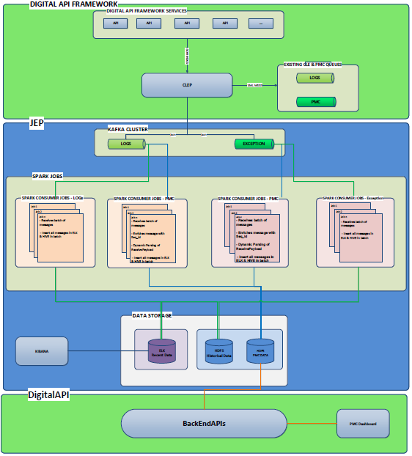

## Configuration Details

NA

## Reference Data

NA

## Business end users

|  |  |  |
| --- | --- | --- |
| Name | E-Mail | Contact |
| Vinay Kaushik | Vinay.Kaushik@ril.com | +918828327272 |

## Dashboards & Reports currently running

## This is the first operational dashboard going LIVE using JEP platform.

## Reconciliation Control logs

# IMPACT aNALYSIS

TIBCO and DigitalAPI services are impacted.

# Pre-EXECUTION STEPS

* 1. **Port opening**

Please ensure the connectivity and port opening between PRD k8s cluster worker nodes, KAFKA, kdc server & HIVE storages.

|  |  |  |  |  |  |  |  |
| --- | --- | --- | --- | --- | --- | --- | --- |
| **Source IP** | **Source Environment** | **Source Zone** | **Destination IP** | **Destination Environment** | **Destination Zones** | **Service Port** | **Rules Justification** |
| 10.143.67.29 10.143.67.30 10.143.67.41 10.143.68.21 10.143.68.22 10.143.68.23 10.143.68.26 10.143.68.30 10.143.67.43 10.143.67.32 10.143.67.33 10.143.67.40 10.143.68.24 10.143.68.25 10.143.68.27 10.143.68.28 10.143.68.29 10.143.67.44 | Production | Non-DMZ | 10.140.65.11 10.135.2.135 10.135.2.200 10.148.64.16 10.144.64.11 | Production | Non-DMZ | 88 on udp and tcp | Bi directional port opening for Kubernetes Kafka integration. |
| Production | Non-DMZ | 10.141.44.111 | Production | Non-DMZ | 88 on udp and tcp | Bi directional port opening for Kubernetes Kafka integration. |
| Production | Non-DMZ | 10.141.41.149 10.141.41.150 10.141.41.153 | Production | Non-DMZ | 6667 and 2181 | Bi directional port opening for Kubernetes Kafka integration. |
| Production | Non-DMZ | 10.141.41.149 10.141.41.153 | Production | Non-DMZ | 10000 | Bi directional port opening for Kubernetes Kafka integration. |
| Production | Non-DMZ | 10.141.41.150 | Production | Non-DMZ | 10500 and 10501 | Bi directional port opening for Kubernetes Kafka integration. |

|  |  |  |  |  |  |  |  |
| --- | --- | --- | --- | --- | --- | --- | --- |
| **Source IP** | **Source Environment** | **Source Zone** | **Destination IP** | **Destination Environment** | **Destination Zones** | **Service Port** | **Rules Justification** |
| 10.143.67.29 10.143.67.30 10.143.67.41 10.143.68.21 10.143.68.22 10.143.68.23 10.143.68.26 10.143.68.30 10.143.67.43 10.143.67.32 10.143.67.33 10.143.67.40 10.143.68.24 10.143.68.25 10.143.68.27 10.143.68.28 10.143.68.29 10.143.67.44 | Production | Non-DMZ | 10.141.41.153 10.141.41.149 10.141.41.150 | Production | Non-DMZ | 10000 & 10001 TCP | Bi directional port opening for Kubernetes Kafka integration. |
| Production | Non-DMZ | 10.131.40.83 10.131.40.86 10.131.40.85 10.131.40.84 10.135.2.135 10.140.65.11 10.144.64.11 10.148.64.16 10.135.2.200 | Production | Non-DMZ | Kerberos TCP and UDP-88 DNS TCP and UDP-53 RPC-TCP 135 MS-SMB-TCP and UDP-445 Global Catalog-3268 Secure Global Catalog-3269 LDAP-TCP UDP 389 LDAPS-636 TCP Dynamic 49152 to 65535 UDP Dynamic 49152 to 65535 UDP 123 UDP 137 UDP 138 TCP 139 | Bi directional port opening for Kubernetes Kafka integration. |

* 1. **Resource Allocation to DealerOrder Queue**

Compute resources are to be allocated to the queue<<queuename>> for this journey dashboard. Please find below the details for the same:

Resource Details & name for queue: **root.dap_dealeronboard** [10% Capacity]

Resources can be gathered from default & zeppelin queue [ 5% each ]

* 1. **User, key-tab, HDFS directory Creation**

Create User for service account: jep_daplatform along with keytab – jep_daplatform.keytab and principle – jep_daplatform<<>>. Also share the working jass.conf, hive-site.xml and krb5.conf files which can be used at the client side.

AD Service Account: [jep_daplatform@RJIL.RIL.COM](mailto:jep_daplatform@RJIL.RIL.COM)

AD Group: GALL--JEP--DAPLATFORM--JOURNEY

1. Give the daplatform user read, write and delete access to the below directory.

* keytab name: jep_daplatform.keytab
* Server: all the gateway nodes
* Location: /app/app_keytabs/
* Owner: jep_daplatform
* Group of keytab  and Group of user:  GALL--JEP--DAPLATFORM--JOURNEY

1. Create AD group: GALL--JEP--DAPLATFORM--JOURNEY.

Name: GALL--JEP--DAPLATFORM--JOURNEY

Business track: dealerorder reporting

Data source: Tibco, DigitalAPI services

1. Create HDFS directory for property files:
   * /config/bdplatform/jiobdasp-core-loadtransform-kafka/
   * /config/bdplatform/diplatform/logs/
   * Provide access to HIVE default warehouse directory.
2. Login to JEP spark job server, copy jar/files:

**CI Location**:

NA. Currently the jars will be manually shared. TOPs team is working on the CI\CD pipe for this requirement.

**Dest Location**: create path “/app/DAPDeployment/target/” and place all shared files as

/app/DAPDeployment/target/DAPLogging.jar

/app/DAPDeployment/target/PMCEventsProcess.jar

/app/DAPDeployment/target/JEP_DAP_ExceptionEvents_consumer.sh

/app/DAPDeployment/target/JEP_DAP_pmcExceptionEvents_consumer.sh

/app/DAPDeployment/target/JEP_DAP_LogEvents_consumer.sh

/app/DAPDeployment/target/JEP_DAP_pmcLogEvents_consumer.sh

1. Create below kafka topic in jep prod zone for Dealer Order .

**Topic name**: daplatform-do-log, daplatform-do-exception (user accessibility:jep_daplatform)

**Retention policy**: 2 days

**Kafka topic partition**: 6

**Replication**: 3

Also, set the required policy on ranger for user to publish and consume the messages in kafka.

# EXECUTION STEPS

## Login as jep_daplatform user

1. Connect to beeline:

beeline –u “<connection string>” –f hive_table_creation.hql

1. Place coe_spark_job_client_diplatform_exception.properties, coe_spark_job_client_diplatform_exception_pmc.properties, coe_spark_job_client_diplatform_log.properties, coe_spark_job_client_diplatform_log_pmc.properties, json.txt files in hdfs(path: /config/bdplatform/diplatform/logs/)
2. Create path “/daplatform/” in zookeeper and provide read write execute access to user.

Zookeeper directory will be used to manage kafka offsets.

**Steps:**

## Connect to zookeeper server (zkCli.sh -server <serverhostname:2181>

create /daplatform daplatform

setAcl /daplatform world:anyone:crdwa

Note: Since Service account is AD, Zookeeper does not recognize it. Hence all permissions are granted.

1. Place keytab, working_jass.conf,hive_site.xml files in path where jars available “/app/DAPDeployment/target/”
2. Create duplicate keytab file with another name in same folder.
3. Update all spark submit commands with proper locations of keytab,working_jass, hive_site.xmls and principle.
4. Execute the spark submit command from rundeck.

# SANITY STEPS

## Check the status of Spark streaming Job in YARN

2) Check if data is being written to elastic index

## 3) Check if Data is getting written to the tables:

* dap_do_log
* dap_do_exception
* dap_do_pmc
* dap_do_audit
* dap_do_autoretry

# Roll back STeps

* Stop the job in rundeck
* Kill the spark job from server

# PURGING POLICY

## Data older than 12 months needs to be purged.

# DaTA MIGRATION

NA

# Infosec Approval

### PII Tagging detail

NA

### Ranger Policies

NA

# TEST RESULTS- DEV stats:

Before concatenation of day 2019-09-14 hive data:

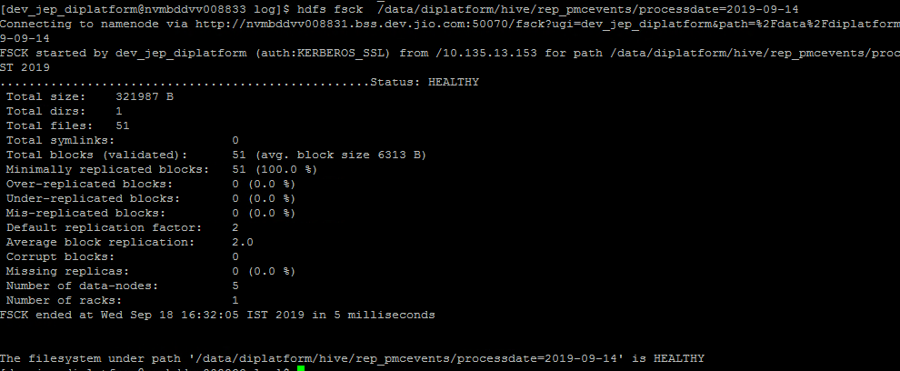

After concatenation of day 2019-09-14 hive data:

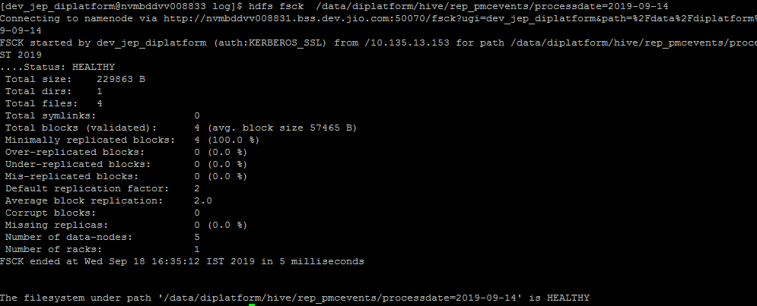

**ES screenshot:**

