**FIX ASSIGNMENT 4**

**Steps :**

On index.js of reducers I had to add the courses an enquiries on rootReducers

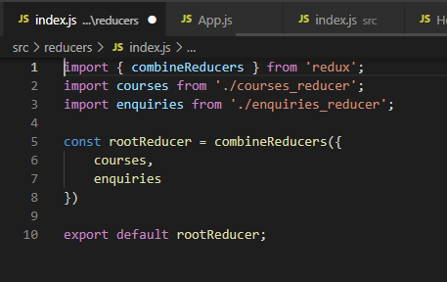

On Actions I had to change the URL to the json-server port

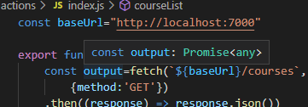

On courseList.js I had to add the .latest to the if validation

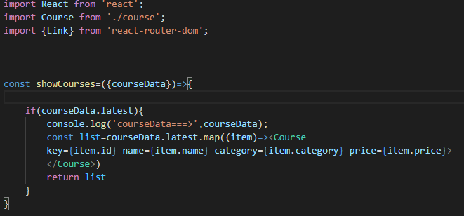

And some other little steps

**Code :**

<https://github.com/hemapunniakotti/ReactProjects/tree/main/Assignment4_CourselistRedux/assignmet4Fixed-main>

**Output :**

Now we can see all the courses

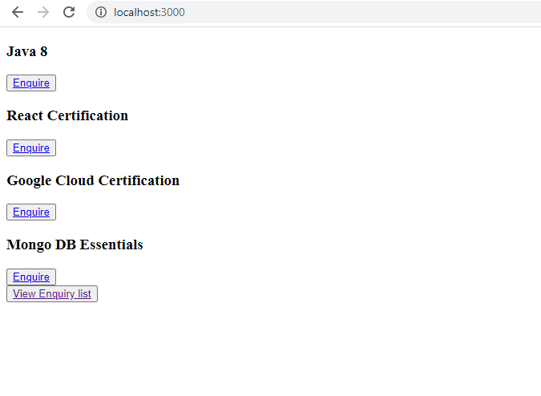

And the enquiries

