**Pizza Sales SQL Queries**

**KPI’s**

1. **Total Revenue**

SELECT

SUM(total_price) AS Total_Revenue

FROM

pizza_sales;

1. **Average Order Value**

SELECT

SUM(total_price) / COUNT(DISTINCT order_id) AS Avg_Order_Value

FROM

pizza_sales;

1. **Total Pizzas Sold**

SELECT

SUM(quantity) AS Total_Pizza_Sold

FROM

pizza_sales;

1. **Total Orders**

SELECT

COUNT(DISTINCT order_id) AS Total_Orders

FROM

pizza_sales;

1. **Average Pizzas Per Order**

SELECT

CAST((SUM(quantity) / COUNT(DISTINCT order_id))

AS DECIMAL (10 , 2 )) AS Avg_Pizza_Per_Order

FROM

pizza_sales;

**Charts Query**

1. **Daily Trend of Orders**

SELECT

DAYNAME(order_date) AS order_day,

COUNT(DISTINCT order_id) AS Total_Orders

FROM

pizza_sales

GROUP BY DAYNAME(order_date);

1. **Hourly Trend of Orders**

SELECT

HOUR(order_time) AS Hour,

COUNT(DISTINCT order_id) AS Total_Orders

FROM

pizza_sales

GROUP BY HOUR(order_time);

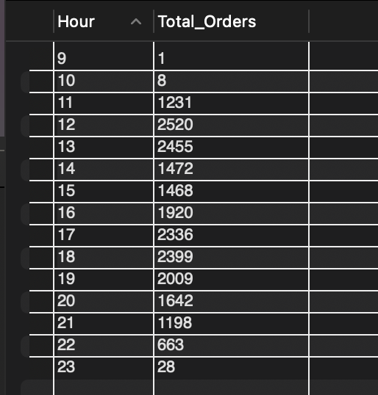

1. **Percentage of Sales by Pizza Category**

SELECT

pizza_category,

CAST(SUM(total_price) AS DECIMAL (10 , 2 )) AS Total_Sales,

CAST(SUM(total_price) * 100 / (SELECT

SUM(total_price)

FROM

pizza_sales)

AS DECIMAL (10 , 2 )) AS Per_Total_Sales

FROM

pizza_sales

GROUP BY pizza_category;

1. **Percentage of Sales by Pizza Size**

SELECT

pizza_size,

CAST(SUM(total_price) AS DECIMAL (10 , 2 )) AS Total_Sales,

CAST((SUM(total_price) * 100) / (SELECT

SUM(total_price)

FROM

pizza_sales)

AS DECIMAL (10 , 2 )) AS Per_Total_Sales

FROM

pizza_sales

GROUP BY pizza_size

ORDER BY Per_Total_Sales;

1. **Total Pizzas Sold by Pizza Category**

SELECT

pizza_category, SUM(quantity) AS Total_Pizza_Sold

FROM

pizza_sales

GROUP BY pizza_category;

1. **Top 5 Best Sellers by Total Pizzas Sold**

SELECT

pizza_name, SUM(quantity) AS Total_Pizza_Sold

FROM

pizza_sales

GROUP BY pizza_name

ORDER BY Total_Pizza_Sold DESC

LIMIT 5;

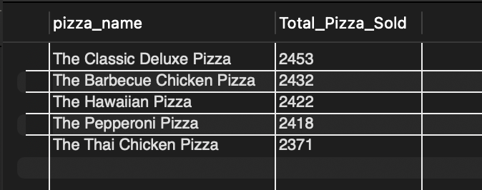

1. **Top 5 Worst Sellers by Total Pizzas Sold**

SELECT

pizza_name, SUM(quantity) AS Total_Pizza_Sold

FROM

pizza_sales

GROUP BY pizza_name

ORDER BY Total_Pizza_Sold

LIMIT 5;

