Reconnecting
Leader: Palada, Joshua
member:
Acop, Nel Laurice
Batiancila, Gene Auria
Hemar, Justine
Masallo, Archie
https://evalpro.infinityfree.me/
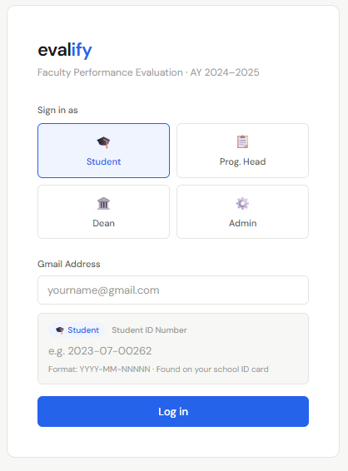

This is the sign-in page of the system. Users must select their role, Student, Program Head, Dean, or Admin, before logging in. To access an account, users are required to enter a valid Gmail address and their corresponding ID number.

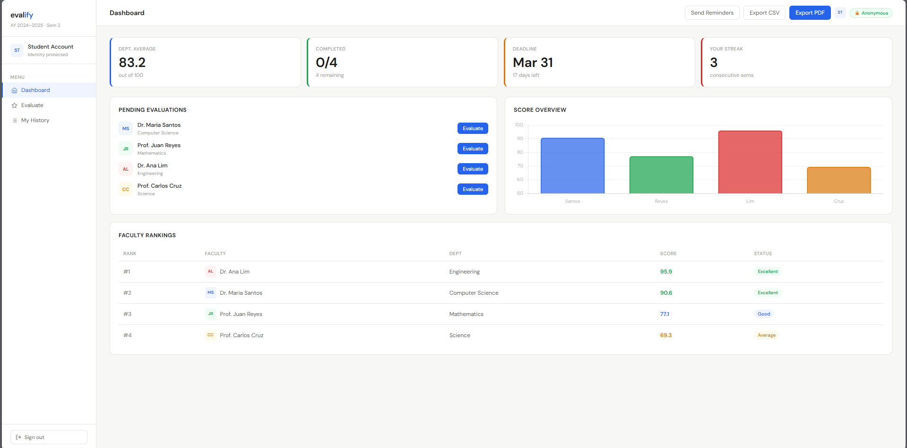
The Student Dashboard provides a central overview of your evaluation progress and department metrics, featuring key performance indicators like Department Average, Completion Status, and Evaluation Deadlines at the top, while displaying current Faculty Rankings and pending evaluation tasks below.
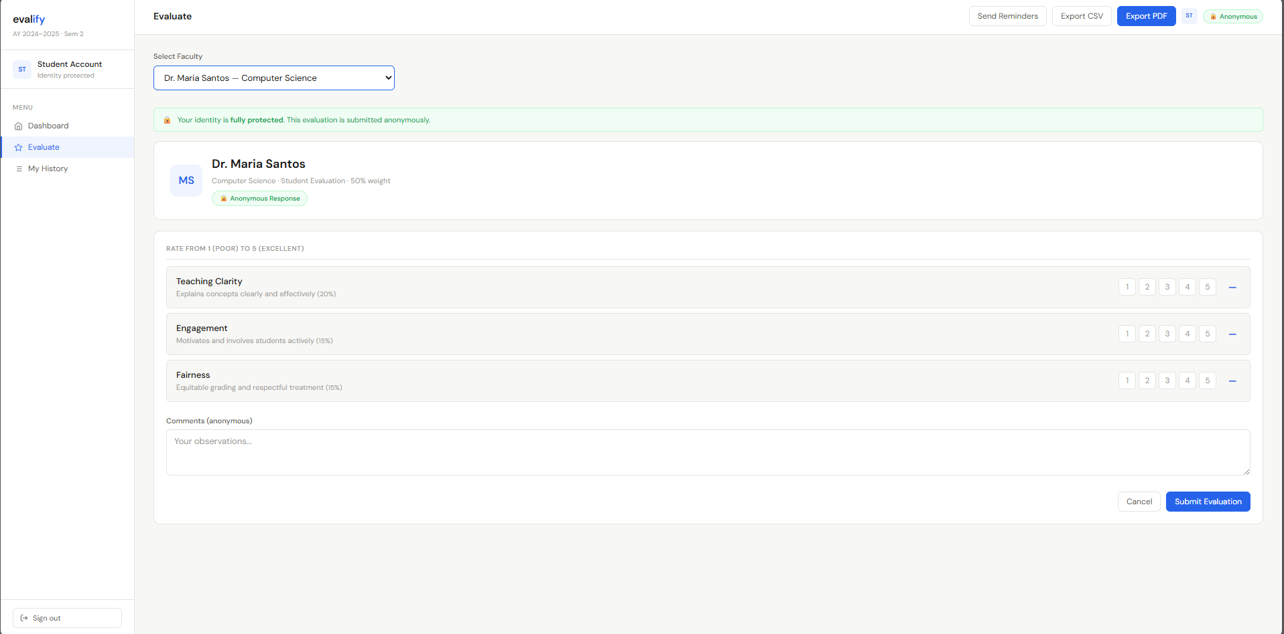
To begin your evaluation, select a faculty member from the dropdown menu, provide your performance ratings, and click submit to receive a confirmation of your successful entry.

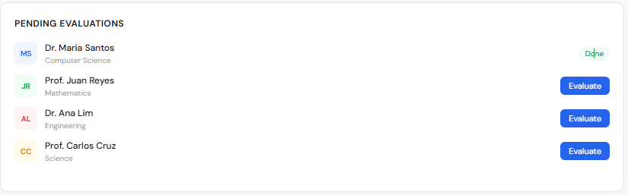
The Pending Evaluations section displays the status of your evaluations. Once you have completed evaluating a professor, the result will be marked accordingly
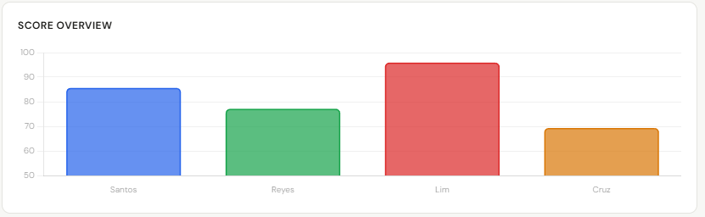
The Score Overview displays each professor’s evaluation results, showing score trends and overall rating levels.

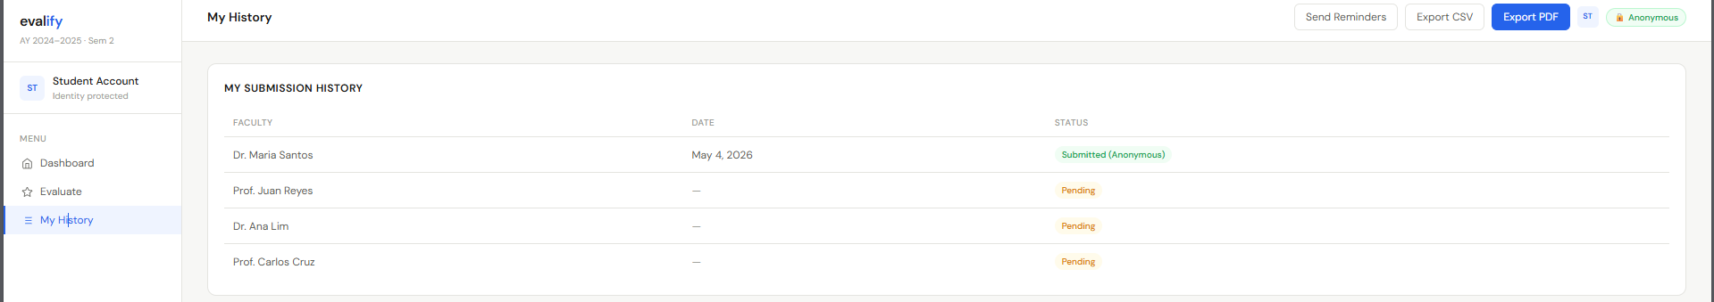
The Submission History section shows a record of all evaluations submitted by the student. It includes the date each evaluation was completed and its current status.

The system provides data export capabilities, allowing users to download comprehensive score reports in either CSV or PDF format for offline access.

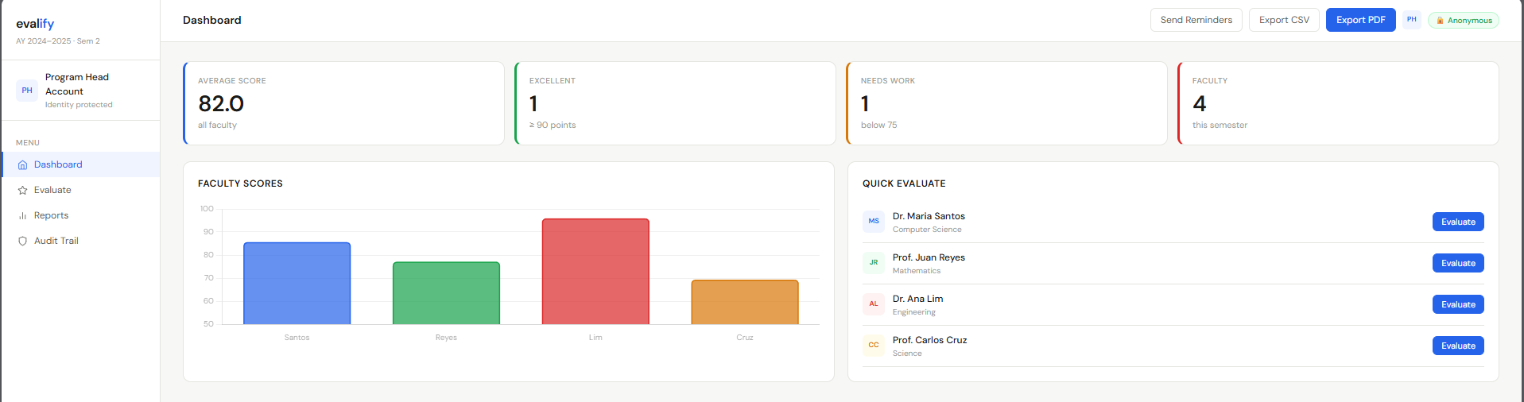
While similar to the student interface, the Program Head dashboard includes advanced metrics to track faculty excellence and areas for improvement, such as specific categories for top-tier and low-performing scores.

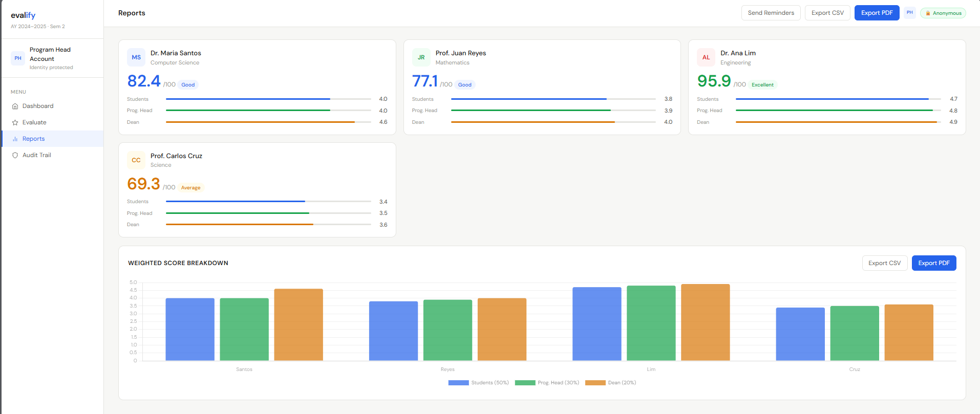
View comprehensive faculty performance data in the Weighted Score Breakdown, which combines multi-level stakeholder feedback and allows for quick data extraction in CSV or PDF formats.

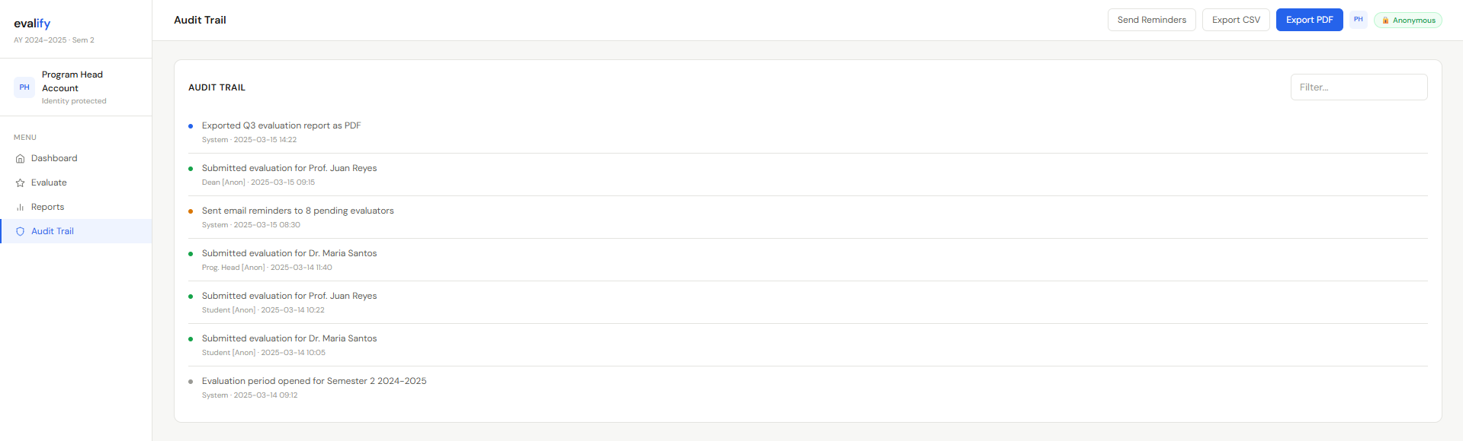
The Audit Trail provides a transparent log of all evaluation activities, identifying which users have submitted ratings for specific faculty members, while the Dean’s dashboard offers administrative oversight identical to that of the Program Head.

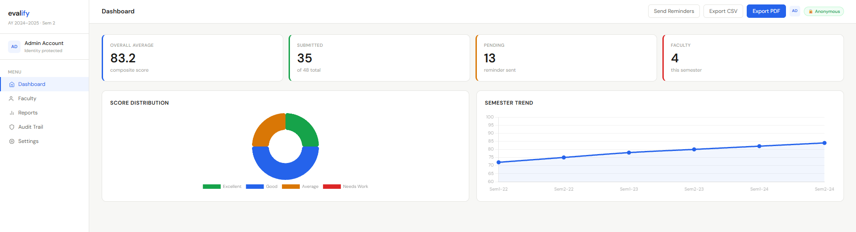
The Admin Dashboard provides a high-level overview of system activity, displaying total evaluation participation and reminder statuses alongside a 'Score Distribution' donut chart and a 'Semester Trend' line graph that tracks record volume across different academic terms.

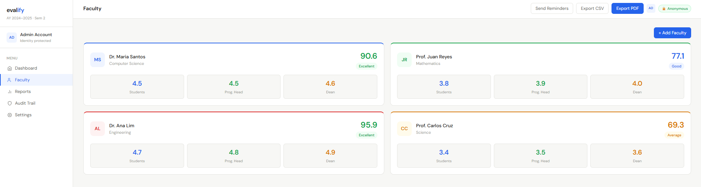
The faculty management module allows administrators to register new professors and monitor individual performance metrics through integrated scorecards.

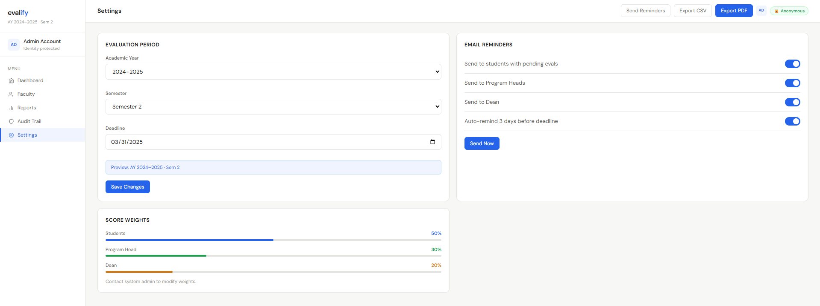
The Use of Settings page to update your evaluation timeline including the academic year and submission deadlines and to customize how email reminders are sent to students and faculty.

