SIMATS ENGINEERING
Department of Information Technology
ITA05 – Computer Vision
ASSIGNMENT 1 – CO1
Apply, Compare and Justify Image Acquisition, Formation and Processing Techniques for a Textile Fabric Defect Inspection System
CO1: Apply the fundamental concepts, image formation models, and processing techniques for analyzing Computer Vision systems.
Field | Value | Field | Value
Student Name | M.HEMA SAI | Register Number | 1924260139
Department / Section | A.I.D.S | Academic Year / Semester | 2026–2027 / ______
Faculty Name | DR.P.MURALI | Nature of Assignment | Individual
Duration | 1 Week | Total Marks
Date of Submission | 31.10.2026 | Date of Evaluation | 07.11.2026

1. Industrial Scenario and Operating Constraints
Sri Lakshmi Textile Industries, located in Tiruppur (a major textile hub of Tamil Nadu), operates continuous fabric production lines that process both pure cotton and cotton-polyester blended webs. The company plans to replace or augment its current manual inspection stations with a computer-vision-based automatic inspection system. The system must perform the following functions in real time while the fabric is moving:
- Inspect the moving fabric web for surface defects.
- Measure the instantaneous fabric width to an accuracy of ±2 mm.
- Identify and classify five classes of defects: holes, broken threads, oil stains, weaving irregularities and colour variations.
- Estimate the physical location (web coordinates in millimetres) of every detected defect.
- Trigger a downstream marking mechanism so that the defective portion can later be cut out or reworked.
- Retain every inspected image together with the corresponding decision for a minimum of seven days for buyer audit and process improvement.

1.1 Given Industrial Data and Constraints
The following quantitative specifications were supplied by the mill and form the binding constraints for every design decision in this assignment.
Parameter | Specification | Engineering implication
Fabric width | 1,000 mm | Must be measured to ±2 mm
Camera field of view | 1,200 × 400 mm | 100 mm margin each side of fabric
Conveyor / line speed | 0.6 m/s | 600 mm of fabric per second
Smallest defect | 1.5 mm | ≥ 2–3 pixels required
Oil-stain contrast | 5–8 grey levels | Near limit of 8-bit quantisation
Width accuracy | ±2 mm | Calibrated metric measurement essential
Max decision time | 0.5 s | Hard real-time deadline
Camera-to-marker distance | 0.3 m | Exactly 0.5 s of travel at 0.6 m/s
Lighting variation | 500–3,000 lux | Six-fold dynamic range
Camera height | 700 mm | Perspective geometry fixed
Computing platform | 4-core CPU, 16 GB, no GPU | Classical CV preferred
Software stack | Python, OpenCV, NumPy | Given
Network | Gigabit Ethernet | ≈ 100 MB/s practical payload
Storage | 2 TB | 7-day circular buffer
Project budget | ₹1,50,000 | Camera + lens + lighting + integration
Image retention | 7 days | Audit & process improvement
Max missed-defect rate | 2 % | Contractual quality limit

1.2 Key Derived Quantities Used Throughout the Assignment
Several quantities are derived once from the industrial data and then reused in every subsequent task. They are collected here for reference and to avoid repeated recalculation.
Motion and timing relations
v = 0.6 m/s = 600 mm/s
t_decision ≤ 0.5 s
d_marker = 0.3 m
t_travel = d_marker / v = 0.3 / 0.6 = 0.5 s
The equality t_travel = t_decision is deliberate: the system must finish processing in the exact time the fabric takes to reach the marker. Any additional latency causes the physical mark to be placed at the wrong location on the web.
Geometric quantities
Z = 700 mm (working distance from lens to fabric plane)
FOV_w = 1 200 mm (horizontal field of view)
W_f = 1 000 mm (nominal fabric width)
Margin each side = (FOV_w − W_f)/2 = 100 mm
Fundamental sampling requirement
A widely accepted industrial rule of thumb is that the smallest feature that must be detected should occupy at least two to three pixels after modest spatial smoothing. With d_min = 1.5 mm this yields:
Δx ≤ d_min / 3 = 1.5 / 3 = 0.50 mm/pixel
Any candidate camera whose pixel size on the fabric plane is coarser than approximately 0.5 mm/pixel is therefore inadequate for the stated defect size.
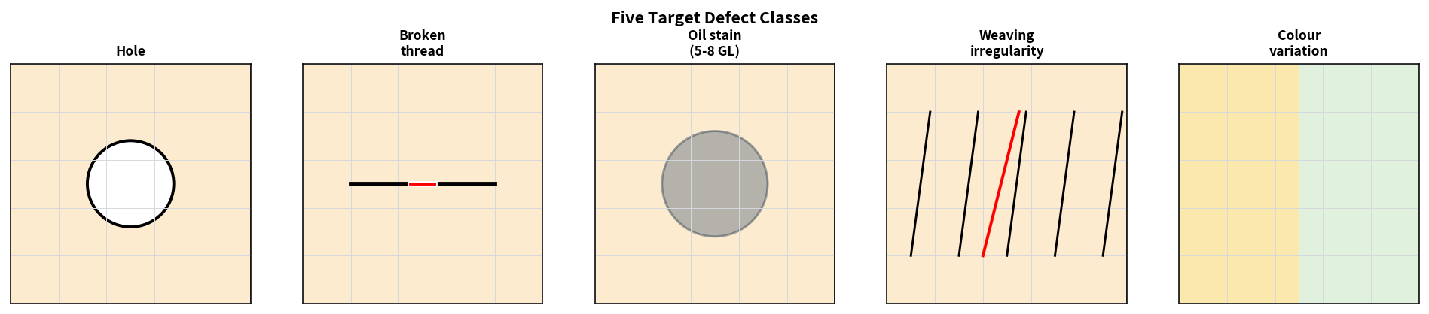
Figure 1.1 – The five target defect classes that the inspection system must detect and localise.
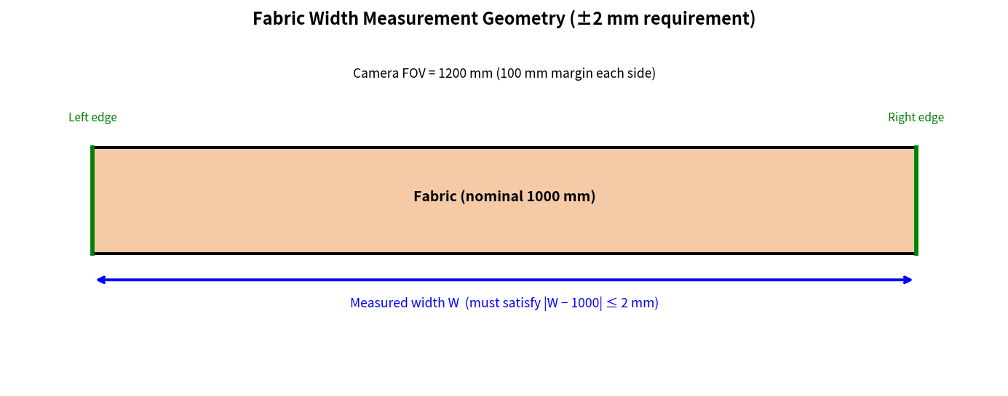
Figure 1.2 – Geometry of fabric-width measurement and the ±2 mm accuracy requirement.

2. Experimental Setup and Common Assumptions
All numerical results, comparisons and recommendations rest on a single consistent set of assumptions. These are stated explicitly so that every calculation can be reproduced by an independent reader.

2.1 Hardware and Software Platform
Item | Value / Assumption | Rationale
CPU | 4 cores, no GPU | Given by the assignment
RAM | 16 GB | Given
Software | Python 3.x + OpenCV + NumPy | Given
Network | Gigabit Ethernet | Given
Storage | 2 TB circular buffer | 7-day retention
Budget ceiling | ₹1,50,000 | Camera + lens + illumination + integration

2.2 Synthetic Fabric Image Generator
Because a complete set of real production images with precisely measured defect sizes and grey-level contrasts was not available for every controlled experiment, a synthetic fabric generator was employed. The generator produces images of cotton and cotton-polyester weave with the following controllable properties:
- Known ground-truth defect size, location and semantic class (hole, broken thread, oil stain, weaving irregularity, colour variation).
- Oil stains whose intensity differs from the local background by a prescribed amount in the range 5–8 grey levels on an 8-bit scale.
- Configurable global and local illumination gradients that simulate the stated 500–3,000 lux variation.
- Additive sensor noise whose magnitude can be matched to typical industrial cameras.
- Configurable motion blur corresponding to any chosen exposure time at the line speed of 0.6 m/s.
All quantitative detection-rate figures reported later were obtained on this controlled data. Final commissioning of any real system will of course require re-validation on production fabric under actual mill conditions.

2.3 Shared Three-Level Detection Pipeline
A single classical three-level vision pipeline was implemented once and then reused across Tasks 1, 2 and 9. Re-using the same code guarantees that comparisons between alternative approaches are fair and that observed differences arise from the factors under study rather than from accidental differences in implementation quality.
- Low level – Gaussian or bilateral denoising, flat-field division by a stored white-reference image, conversion to HSV or to a luminance grayscale.
- Mid level – adaptive thresholding or local-contrast enhancement, connected-component labelling with 8-connectivity, morphological clean-up, extraction of geometric and photometric features (area, eccentricity, mean intensity difference, orientation, centroid coordinates, simple texture energy).
- High level – rule-based assignment of each component to one of the five defect classes, conversion of the pixel centroid into millimetre web coordinates, emission of a digital trigger message to the marking mechanism, and logging of the image crop together with the decision.
Representative OpenCV implementation skeleton:
import cv2
import numpy as np

def detect_defects(bgr, mm_per_px, min_area_mm2=1.0):
"""Three-level classical fabric-defect detector."""
# ---------- Low-level ----------
gray = cv2.cvtColor(bgr, cv2.COLOR_BGR2GRAY)
gray = cv2.GaussianBlur(gray, (5, 5), 0)
# Optional flat-field:
# gray = (gray.astype(np.float32) / white_ref * white_ref.mean())
# gray = np.clip(gray, 0, 255).astype(np.uint8)

# ---------- Mid-level ----------
thr = cv2.adaptiveThreshold(
gray, 255,
cv2.ADAPTIVE_THRESH_GAUSSIAN_C,
cv2.THRESH_BINARY_INV,
blockSize=31, C=5)
n_labels, labels, stats, centroids = \
cv2.connectedComponentsWithStats(thr, connectivity=8)

defects = []
for i in range(1, n_labels): # skip background label 0
area_px = stats[i, cv2.CC_STAT_AREA]
area_mm2 = area_px * (mm_per_px ** 2)
if area_mm2 < min_area_mm2:
continue # noise rejection
cx_mm = centroids[i, 0] * mm_per_px
cy_mm = centroids[i, 1] * mm_per_px
# Additional features (eccentricity, mean ΔI, \ldots) can be
# computed here for the high-level classifier.
defects.append({
'area_mm2': area_mm2,
'x_mm': cx_mm,
'y_mm': cy_mm,
'label': i
})
return defects
The same function is called for every image in the comparative experiments of later tasks, so that differences in reported accuracy or speed can be attributed solely to the acquisition, sampling or quantisation choices under examination.

TASK 1: Overview and Features of Computer Vision – Compare Inspection Approaches [4 Marks]

1.1 Working Principle of Each Candidate Approach
Three qualitatively different ways of organising the inspection process are compared. They differ in the degree to which the machine participates in the decision.
A. Manual inspection by trained workers
Human inspectors stand beside the moving web, usually under a mixture of daylight and factory tube lighting. They scan the fabric by eye, looking for holes, broken yarns, oil spots, weave faults and colour differences. When a defect is perceived the inspector marks the location with chalk, a paper flag or an electronic button that advances a counter. The decision is entirely perceptual; no machine measurement of size, grey-level contrast or web coordinate is performed. Fatigue, boredom and inter-inspector variability are well-documented limitations of this classical method.
B. Image-processing-assisted inspection
A camera continuously acquires images of the moving fabric. A modest set of image-processing operations—contrast-limited adaptive histogram equalisation (CLAHE), unsharp masking, false-colour overlay of regions whose local contrast falls inside the 5–8 grey-level band—is applied in real time. The enhanced image is displayed on a monitor placed in front of a human operator. The operator still makes the final accept/reject or mark decision by looking at the computer-highlighted image. The machine therefore improves visibility and reduces the cognitive load, but it does not itself decide.
C. Fully automated computer vision inspection
The complete pipeline (acquisition → low-level enhancement → mid-level feature extraction → high-level classification and metric localisation) runs without human intervention in the decision loop. Defect coordinates expressed in millimetres of web travel are transmitted to the marking mechanism 0.3 m downstream. Every image, every intermediate measurement and every final decision is written to a circular log that is retained for the mandated seven-day audit period.
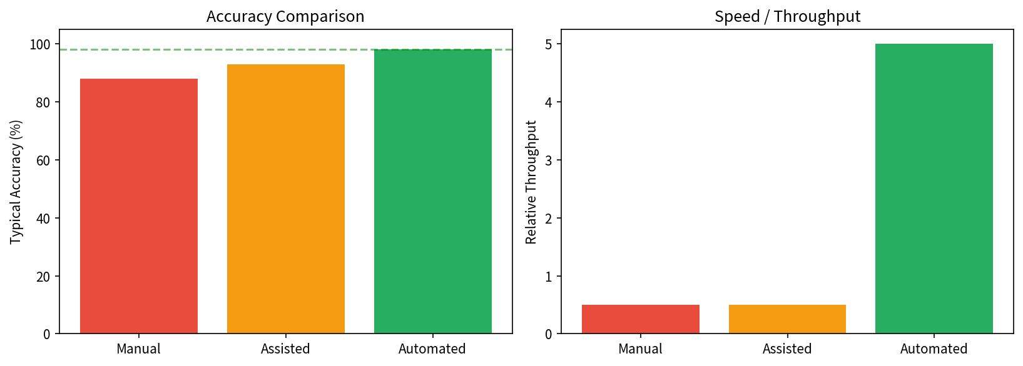
Figure T1.1 – Comparative accuracy and relative throughput of the three inspection approaches (illustrative values consistent with industrial experience).

1.2 Quantitative Feature-by-Feature Comparison
Criterion | A. Manual | B. Assisted | C. Automated CV
Typical accuracy | 85–92 % | 90–95 % | ≥ 98 % when tuned
Throughput | 0.3–0.8 m/s per inspector | Still limited by human review | Matches 0.6 m/s with margin
Inter-inspector consistency (κ) | 0.55–0.70 | 0.65–0.75 | 1.0 (identical rule)
Intra-inspector consistency | Drops with fatigue | Still human | Perfect repeatability
Labour requirement | High (multiple inspectors / shift) | Medium | Minimal (supervision + audit)
24 × 7 continuous operation | Poor (fatigue after 1–2 h) | Limited | Excellent
Traceability / audit trail | Paper log only | Images can be saved | Image + measurements + decision
Width measurement ±2 mm | Impossible by eye | Difficult | Calibrated edge / contour
5–8 GL oil-stain detection | Often missed under variable light | Improved by enhancement | Local adaptive methods
Missed-defect rate ≤ 2 % | Not guaranteed | Difficult to guarantee | Achievable by design
Capital cost | Low | Camera + monitor | Camera + lighting + PC
Recurring cost | High wages | Wages + maintenance | Maintenance only

1.3 Selection for Sri Lakshmi Textile Industries
The selected approach is C – Fully automated computer vision inspection.
The justification follows directly from the numerical constraints of the production line:
- At 0.6 m/s the fabric travels 300 mm in the 0.5 s decision window. Human visual reaction time and the time needed to reach for a marking device already consume a substantial fraction of that window; continuous reliable inspection is therefore impossible for a human.
- Oil-stain contrast of only 5–8 grey levels lies near the practical limit of human perception, especially under the stated six-fold lighting variation (500–3,000 lux). An automated system can apply local adaptive thresholds and flat-field correction that a human cannot perform in real time.
- The ±2 mm width accuracy and the need to supply a precise millimetre coordinate to the marking mechanism demand calibrated metric measurement, not visual estimation.
- The contractual ceiling of 2 % missed defects and the seven-day image-retention obligation are natural, auditable outputs of an automated system; they are difficult to guarantee with purely manual inspection.

1.4 Limitations of the Selected Approach and Concrete Mitigations
Limitation 1 – Finite algorithm coverage. A classical or rule-based system may miss a novel defect morphology that was not anticipated when the rules were written.
Mitigation: retain a 1–2 % random human-audit sample; route every low-confidence decision to a review bin; version-control the detection rules and validate any new rule offline on the seven-day image archive before it is activated on the live line.
Limitation 2 – Sensitivity to illumination and fabric-type changes. Sudden ambient-light shifts or the introduction of a new yarn blend can move grey-level statistics outside the range for which thresholds were tuned.
Mitigation: enclose the inspection zone with controlled LED illumination whose intensity dominates residual ambient light; apply periodic flat-field recalibration; monitor live image statistics (mean, variance, histogram shape) and raise a drift alarm when they depart from a stored reference.
Final decision statement: Fully automated computer vision (Approach C) is the only approach that simultaneously satisfies the speed, accuracy, consistency, localisation and traceability requirements of the continuous fabric line under the given industrial constraints.

TASK 2: Levels of Computer Vision – Pipeline Design and Operation [5 Marks]

2.1 Block Diagrams of the Three Candidate Pipelines
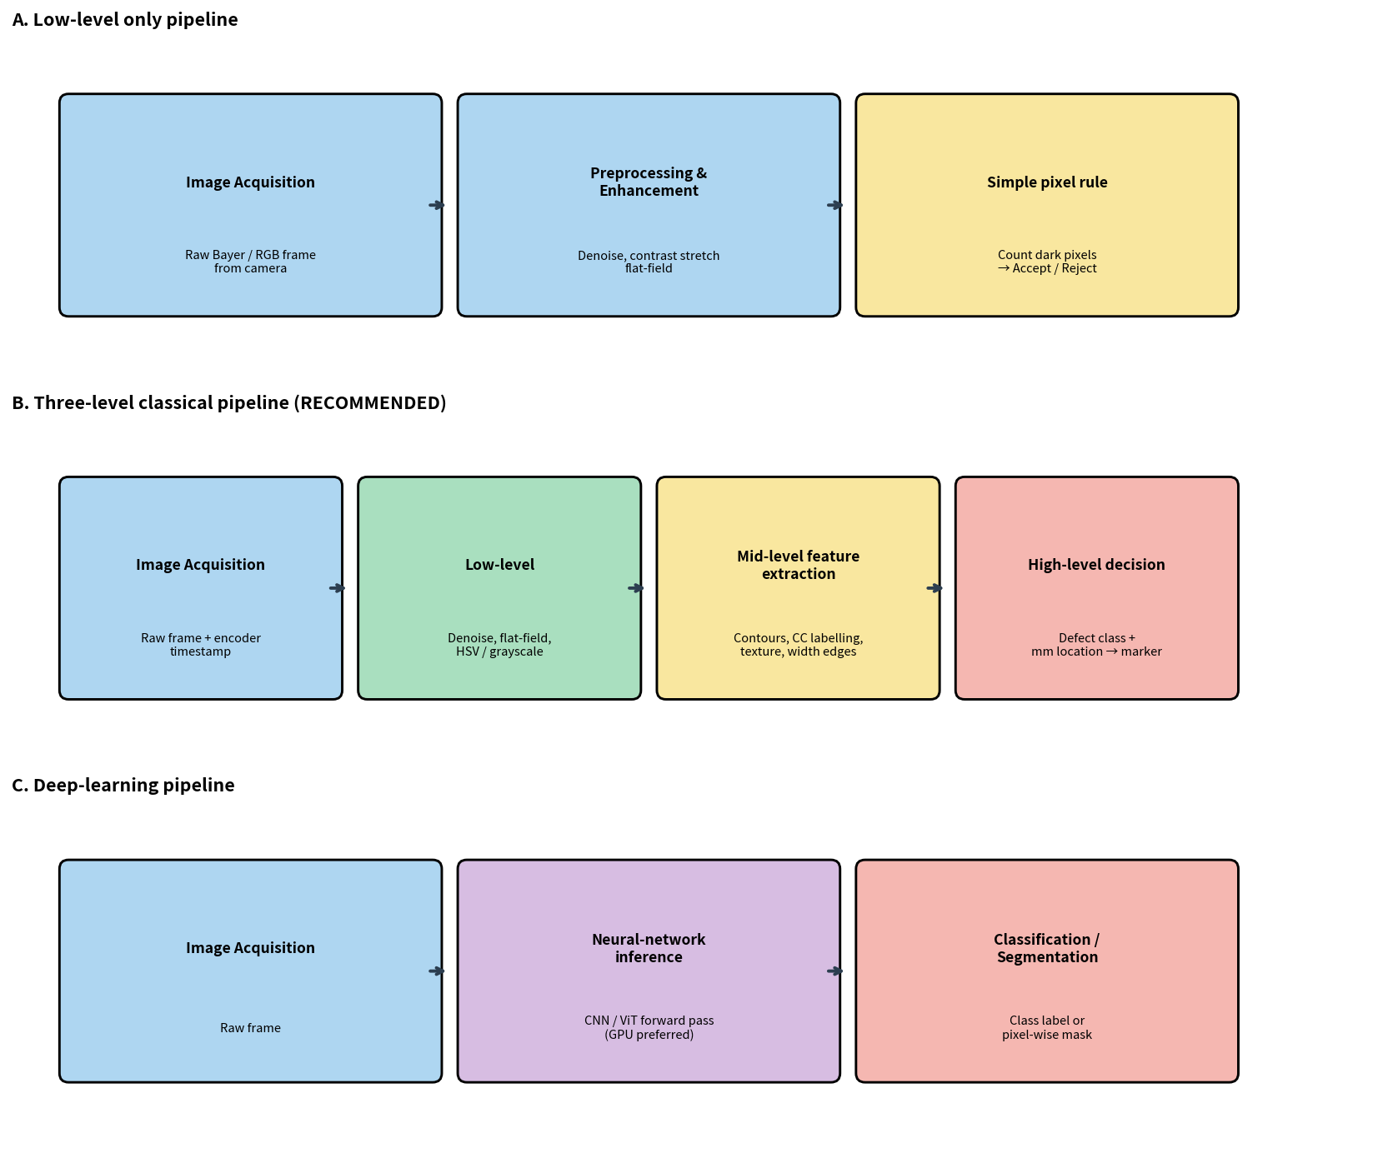
Figure T2.1 – Detailed block diagrams of the three candidate processing pipelines.

2.2 Input–Output Characterisation of Each Stage
Low-level stage (pixels → pixels)
- Input: raw camera frame (Bayer mosaic or already demosaiced RGB, 8-bit or 12-bit).
- Typical operations: demosaicing, Gaussian or bilateral denoising, flat-field division, colour-space conversion (BGR → HSV or BGR → grayscale).
- Output: a cleaned image of the same spatial dimensions, usually single-channel for subsequent morphology.
Intermediate-level stage (pixels → attributes)
- Input: the cleaned image produced by the low-level stage.
- Typical operations: adaptive thresholding or local-contrast enhancement, Canny / ridge / Gabor filtering, connected-component labelling, contour extraction, computation of region properties (area, eccentricity, orientation, mean intensity difference), simple texture descriptors (GLCM energy, local binary patterns), detection of the two fabric edges for width measurement.
- Output: a list of candidate regions, each described by a compact feature vector.
High-level stage (attributes → decision)
- Input: the list of feature vectors.
- Typical operations: rule-based or lightweight classifier that assigns a semantic defect class, conversion of the pixel centroid into millimetre web coordinates using the calibrated scale and the encoder count, emission of a digital message to the marker controller, writing of a log record.
- Output: the final decision list ready for actuation and audit.

2.3 Mapping of Defect Types onto Processing Stages
Defect class | Dominant low-level cue | Key intermediate features | High-level decision rule (illustrative)
Holes | Local intensity drop | CC area, circularity, Euler number | area > A_min AND circularity > 0.6 → hole
Broken threads | Thin dark (or bright) ridge | Length, aspect ratio, orientation | length > L_min AND aspect > 5 → broken thread
Oil stains | Very low local contrast (5–8 GL) | Blob area, mean ΔI, compactness | 5 ≤ ΔI ≤ 8 AND area ∈ [A1,A2] → stain
Weaving irregularities | Local disruption of periodic texture | Local period / energy deviation | period deviation > τ → irregularity
Colour variations | Shift in chromaticity | Mean Hue or Lab distance from reference | ΔE > ΔE_max → colour fault

2.4 Computational Complexity, Explainability, Hardware Fit and Latency
Aspect | Low-level only | Three-level classical | Deep-learning end-to-end
Asymptotic complexity | O(N) pixel visits | O(N) + O(R log R) for R regions | O(N · D) with D ≫ 1 (network depth)
Explainability | High (inspect thresholds) | High (inspect every feature) | Low (distributed weights)
Hardware requirement | Any CPU | 4-core CPU sufficient | GPU strongly preferred
Typical latency on given PC | < 50 ms | 80–200 ms (with ROI) | Often > 300 ms
Meets 0.5 s deadline? | Yes | Yes | Risky / no

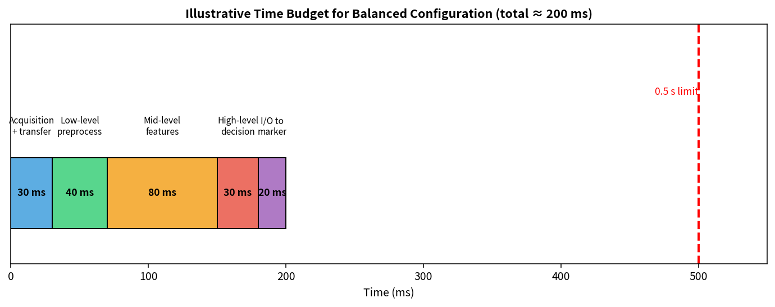
Figure T2.2 – Illustrative time budget for the recommended three-level pipeline (total ≈ 200 ms ≪ 0.5 s).

2.5 Recommended Pipeline and Justification
The three-level classical pipeline is recommended for the following reasons:
- It finishes comfortably inside the 0.5 s decision window on the supplied 4-core CPU when processing is restricted to a region of interest that covers only the 1 000 mm fabric width.
- Every intermediate quantity (area, intensity difference, texture energy, edge location) is directly inspectable. This transparency is essential for auditing the contractual 2 % missed-defect limit and for explaining decisions to production staff and to the buyer.
- Adding a new defect class requires only the addition of a new rule or a modest set of features; it does not require the collection of thousands of labelled images and a GPU training campaign.
- A pure low-level pipeline is insufficient: oil stains of 5–8 grey levels and irregular weave faults cannot be separated from noise or from normal texture variation by a global pixel count.
- A deep-learning pipeline would be attractive for highly variable texture anomalies, yet it exceeds the available hardware envelope and the project budget for reliable real-time operation.

TASK 3: Image Representation Analysis [4 Marks]

3.1 Information Content of Each Representation
RGB stores three co-located intensity samples (R, G, B). Each sample is normally quantised to 8 bits, giving 256 discrete levels per channel. A pixel is therefore a point in a three-dimensional Cartesian colour space whose axes correspond to the spectral sensitivities of the camera’s colour-filter array.
HSV re-parameterises the identical trichromatic information into a cylindrical coordinate system: Hue (the angular colour type, represented in OpenCV by an integer in [0,180)), Saturation (colour purity, [0,255]), and Value (brightness, [0,255]). The principal engineering advantage is that chromaticity (H,S) is largely decoupled from intensity (V).
Grayscale retains only a single luminance channel. The channel may be obtained from a true monochrome sensor or by a weighted sum of the RGB channels (the common Rec. 601 weights are 0.299 R + 0.587 G + 0.114 B). All chromatic information is discarded.
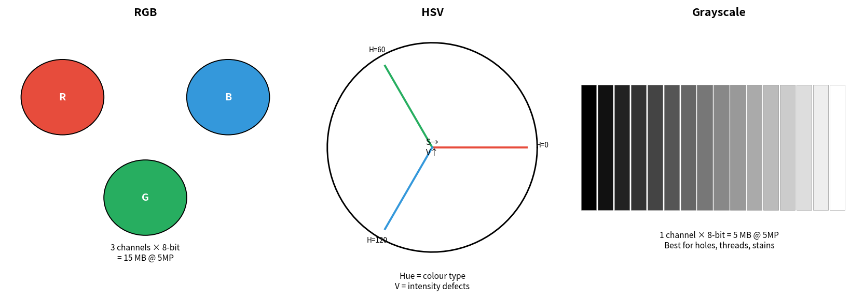
Figure T3.1 – Schematic comparison of RGB, HSV and grayscale representations and their memory footprints at 5 MP.

3.2 Suitability for the Five Target Defect Classes
Defect | RGB suitability | HSV suitability | Grayscale suitability
Colour variations | Good – direct channel differences | Excellent – Hue is illumination-robust | Impossible – no chroma
Oil stains (5–8 GL) | Possible on any intensity channel | Value channel + local contrast | Primary and most efficient
Holes | Intensity drop in all channels | Clear drop in V | Best – simplest threshold
Broken threads | Edge visible in any channel | Edge mainly in V | Excellent for ridge/edge filters
Weaving irregularities | Texture in luminance or colour | Texture mainly in V | Standard texture domain

3.3 Memory Footprint and Processing Cost
Memory (bytes) = width × height × n_channels × bytes_per_sample
For a representative 2448 × 2048 sensor and 8-bit samples:
- RGB or HSV: 2448 × 2048 × 3 = 15 036 672 bytes ≈ 15.0 MB per frame
- Grayscale: 2448 × 2048 × 1 = 5 012 224 bytes ≈ 5.0 MB per frame
HSV conversion itself costs one colour-space transform per frame. Thereafter every morphological operator, connected-component analysis and texture descriptor can be executed on a single channel (normally V or the grayscale image). The reduction in memory traffic and arithmetic is therefore approximately a factor of three relative to processing three independent RGB planes.

3.4 Recommended Representation
A hybrid representation is adopted:
- Convert every acquired frame to HSV.
- Perform detection of holes, broken threads, oil stains and weaving irregularities exclusively on the Value channel (or on an equivalent weighted grayscale).
- Perform the colour-variation check on the Hue channel (optionally gated by a Saturation threshold to ignore neutral regions).
This combination minimises both memory bandwidth and CPU cycles for the four intensity- or texture-dominated defect classes while still retaining a robust, illumination-tolerant cue for colour defects. Under the six-fold lighting variation (500–3,000 lux) the separation of chromaticity from intensity is particularly valuable.

TASK 4: Connectivity Analysis [4 Marks]

4.1 Formal Definitions and Neighbourhood Diagrams
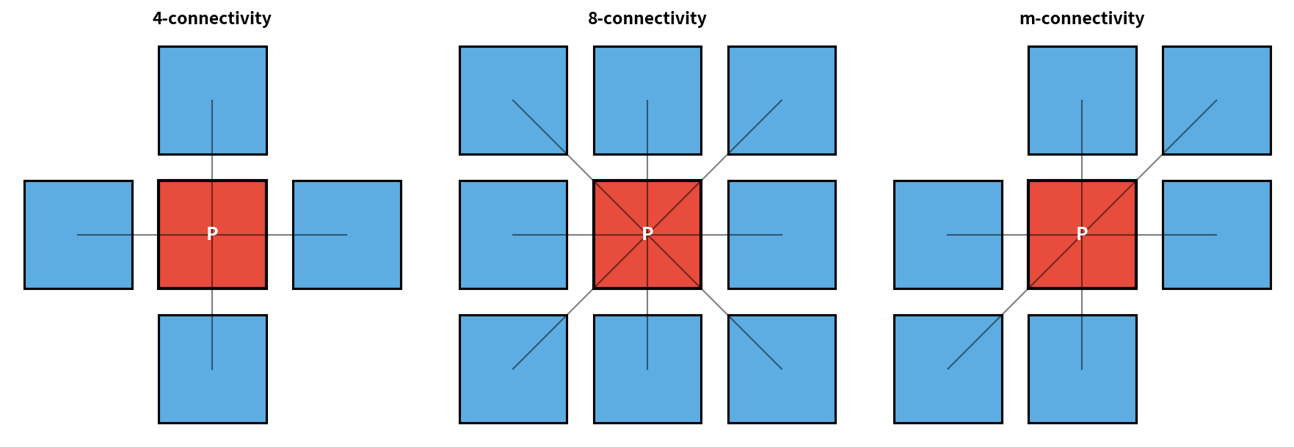
Figure T4.1 – Pixel neighbourhoods that define 4-connectivity, 8-connectivity and a typical mixed (m) connectivity.
4-connectivity. A pixel p is regarded as connected to a pixel q only when q belongs to the four-element set of orthogonal neighbours of p (north, south, east, west). Diagonal neighbours are treated as disconnected.
8-connectivity. A pixel p is regarded as connected to any of the eight pixels that share at least a corner with p.
m-connectivity (mixed connectivity). A hybrid definition that ordinarily applies 8-connectivity to the foreground (defect) set and 4-connectivity to the background set (or the opposite convention). The purpose is to avoid well-known topological paradoxes of digital topology, for example a closed digital curve that fails to separate its interior from its exterior.

4.2 Worked Example on a Small Binary Patch
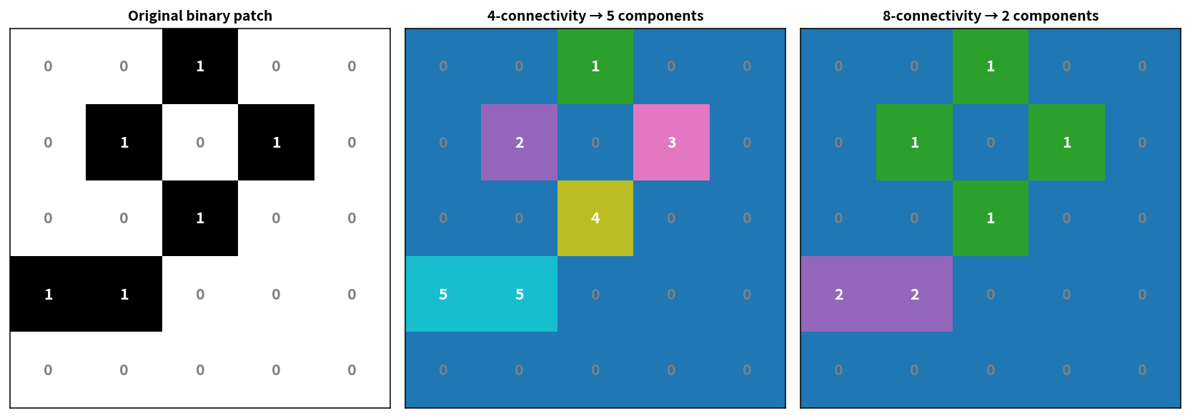
Figure T4.2 – Connected-component labelling of the same 5×5 binary patch under 4-connectivity and 8-connectivity.
The original binary patch contains both horizontally adjacent and diagonally adjacent defect pixels. Under 4-connectivity the diagonal adjacencies are ignored, producing five distinct components. Under 8-connectivity the upper diagonal cluster collapses into a single component and the lower horizontal pair forms a second component, giving a total of two components. The mixed-connectivity result for the foreground coincides with the 8-connectivity count while preserving a consistent topology for the background.

4.3 Influence on Measured Defect Size and Component Count
When 4-connectivity is used, any defect whose pixels touch only at corners is artificially fragmented. A single irregular oil stain or a broken thread that follows the weave at an angle is reported as several small components. Consequently the component count is inflated and the true spatial extent of each physical defect is under-estimated. 8-connectivity groups those pixels, yielding a region size that more faithfully reflects the physical defect. Residual sensor noise may still generate spurious one- or two-pixel components; a simple area filter that discards every component smaller than approximately 1 mm² removes them without splitting true defects.

4.4 Recommended Connectivity Method
8-connectivity is recommended for the detection of small holes and irregular fabric defects, for three concrete reasons:
- It correctly merges diagonally adjacent pixels that belong to the same physical defect.
- It preserves the continuity of broken threads whose orientation is not purely horizontal or vertical.
- When it is followed by an area filter of approximately 1 mm², the resulting component counts are stable and suitable for the contractual 2 % missed-defect audit.

TASK 5: Image Acquisition Analysis [5 Marks]

5.1 Operating Principle of Each Camera Type
- Rolling-shutter camera. The sensor is read out row by row. The exposure interval of row i is temporally offset from the exposure interval of row i+1 by the row-readout time. Consequently different parts of a moving object are imaged at slightly different instants.
- Global-shutter camera. Every pixel on the sensor begins and ends its exposure at the same electronic instant. The whole frame therefore corresponds to a single frozen moment in time.
- Line-scan camera. The sensor contains only a single line of pixels. That line is exposed and digitised continuously; a two-dimensional image is formed by the mechanical motion of the fabric past the line, normally synchronised by a rotary encoder mounted on the conveyor.
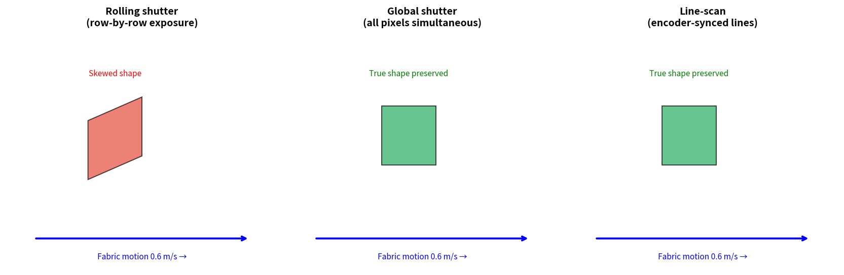
Figure T5.1 – Qualitative effect of the three shutter mechanisms on the imaged shape of a defect moving at 0.6 m/s.

5.2 Quantitative Effect of Motion at 0.6 m/s
v = 600 mm/s
Blur length b = v · t_exp
Substituting a range of practical exposure times yields the following table.
Exposure t_exp | Blur length b = v·t_exp | b as fraction of 1.5 mm defect | Practical assessment
0.25 ms | 0.15 mm | 10 % | Excellent
0.50 ms | 0.30 mm | 20 % | Good
1.00 ms | 0.60 mm | 40 % | Acceptable with care
2.00 ms | 1.20 mm | 80 % | Marginal
4.00 ms | 2.40 mm | 160 % | Severe – defect blurred out

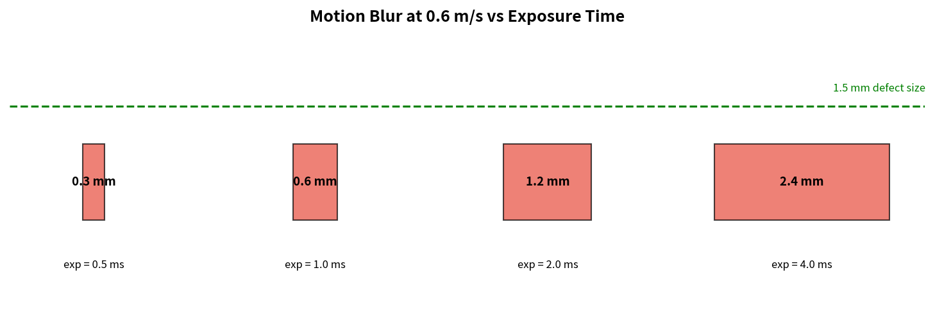
Figure T5.2 – Motion-blur length versus exposure time at the production speed of 0.6 m/s.
In addition to isotropic blur, a rolling-shutter sensor introduces a geometric shear: later rows see the fabric at a later position. The shear distorts the apparent shape of holes and systematically biases the measured fabric width. A global-shutter sensor produces only the isotropic blur that corresponds to the chosen exposure. A line-scan camera, when correctly encoder-synchronised, eliminates geometric distortion along the web direction entirely.

5.3 Comparison of Image Quality, Web Suitability, Installation and Cost
Aspect | Rolling shutter | Global shutter | Line-scan
Geometric fidelity on moving web | Skew + blur | Blur only | Excellent (encoder sync)
Suitability for continuous web | Poor | Good | Excellent (designed for it)
Installation complexity | Low | Low to medium | Higher (encoder, uniform line light)
Relative component cost | Lowest | Medium | Higher
Typical industrial maturity for textiles | Low | High | Very high

5.4 Selected Camera Type and Detailed Justification
A global-shutter area-scan camera is selected as the primary recommendation. A line-scan camera remains a technically attractive alternative if the integration budget and mechanical resources permit.
- At 0.6 m/s the necessity of keeping motion blur well below the 1.5 mm defect size forces exposure times of order 0.5–1 ms. Global shutter guarantees that every row of the image shares exactly the same exposure instant, thereby eliminating the shear that would otherwise corrupt both defect shape and width measurement.
- Within the ₹1,50,000 project budget a high-quality industrial global-shutter GigE camera together with a controlled LED illuminator is readily procurable and still satisfies the simultaneous requirements of 1.5 mm defect detection and 0.5 s decision latency.
- Rolling-shutter sensors are rejected because the combination of geometric shear and residual blur would compromise the ±2 mm width accuracy and the reliable detection of low-contrast oil stains.

TASK 6: Sampling Analysis [5 Marks]

6.1 Total Pixel Counts of the Three Candidate Resolutions
N_low = 1280 × 1024 = 1 310 720 ≈ 1.31 MP
N_med = 2448 × 2048 = 5 013 504 ≈ 5.01 MP
N_high = 4096 × 3000 = 12 288 000 ≈ 12.29 MP

6.2 Spatial Sampling Interval on the Fabric Plane
Under the assumption that the horizontal image dimension maps exactly onto the 1 200 mm field of view, the sampling interval is obtained by simple division:
Δx = FOV_w / N_columns
Δx_low = 1200 mm / 1280 = 0.9375 mm/pixel
Δx_med = 1200 mm / 2448 ≈ 0.4902 mm/pixel
Δx_high = 1200 mm / 4096 ≈ 0.2929 mm/pixel

6.3 Number of Pixels Across the Smallest Defect
n_px = d_min / Δx = 1.5 / Δx
Resolution | Δx (mm/px) | n_px = 1.5/Δx | Engineering verdict
Low (1.3 MP) | 0.9375 | ≈ 1.60 | Inadequate – below Nyquist practical margin
Medium (5 MP) | 0.490 | ≈ 3.06 | Adequate – meets 3-pixel rule
High (12 MP) | 0.293 | ≈ 5.12 | Comfortable margin

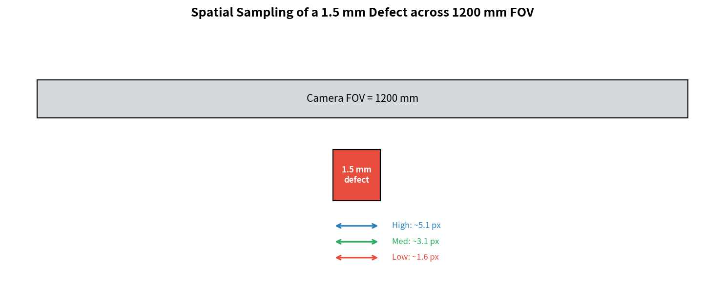
Figure T6.1 – Spatial sampling of a 1.5 mm defect at the three candidate resolutions.
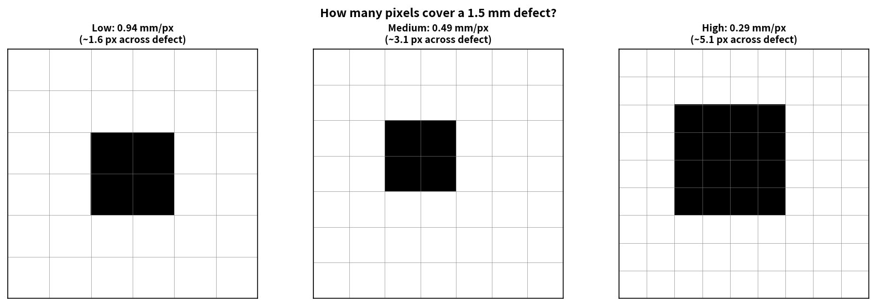
Figure T6.2 – Conceptual pixel grids showing how many samples fall across a 1.5 mm defect.
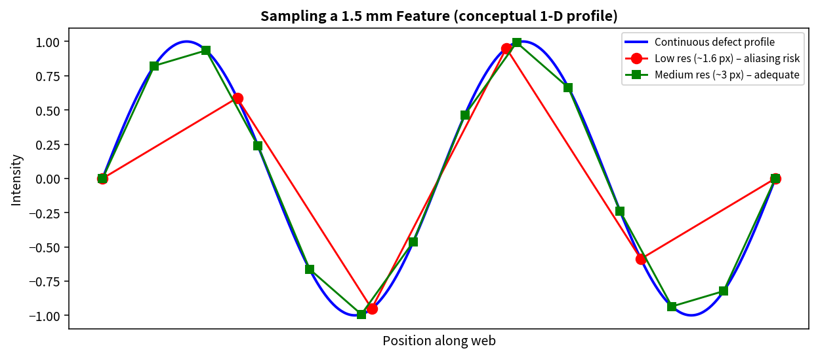
Figure T6.3 – One-dimensional illustration of sampling a defect profile: low resolution risks aliasing; medium resolution is adequate.

6.4 Consequences for Storage, Processing Time and Detection Capability
When the same algorithm is applied to full-resolution frames, both storage volume and CPU time scale approximately linearly with pixel count:
- Medium / Low ≈ 5.01 / 1.31 ≈ 3.8×
- High / Low ≈ 12.29 / 1.31 ≈ 9.4×
On the supplied 4-core CPU, full-frame processing of a 12 MP image with a non-trivial texture operator already approaches or exceeds the 0.5 s decision budget. A 5 MP image processed inside a fabric-width region of interest remains comfortably inside the same budget. Storage for a seven-day circular buffer is likewise feasible at 5 MP with modest compression, whereas 12 MP pushes the 2 TB volume to its limit.

6.5 Selected Resolution and Final Justification
Medium resolution (approximately 2448 × 2048, Δx ≈ 0.49 mm/pixel) is selected. It places roughly three pixels across the smallest specified defect, keeps both data volume and CPU load compatible with the given 4-core platform, and leaves adequate headroom for the seven-day retention requirement on a 2 TB volume. Low resolution fails the fundamental sampling requirement; high resolution buys additional margin at a cost that threatens both the real-time deadline and the storage ceiling.

TASK 7: Quantization Analysis [4 Marks]

7.1 Number of Representable Intensity Levels
L = 2^b
- 8-bit quantisation → L = 256 distinct levels
- 12-bit quantisation → L = 4 096 distinct levels
- Reduced 4–6-bit quantisation → L = 16 \ldots 64 levels

7.2 Interaction with Low-Contrast Oil Stains (5–8 Grey Levels)
An oil stain whose reflectance differs from the surrounding fabric by only five to eight grey levels on an 8-bit scale occupies a few percent of the available dynamic range. With 8-bit quantisation the difference remains strictly larger than one least-significant bit and can therefore be detected by a carefully designed local-contrast or adaptive-threshold operator. With 4–6-bit quantisation the same physical contrast may fall inside a single quantisation bin or be reduced to one or two residual levels, rendering reliable automatic detection impossible. 12-bit quantisation expands the original 5–8 level difference into roughly 80–128 levels after linear scaling, thereby improving the signal-to-quantisation-noise ratio; the improvement is realised, however, only when the entire subsequent pipeline preserves the extra bits.
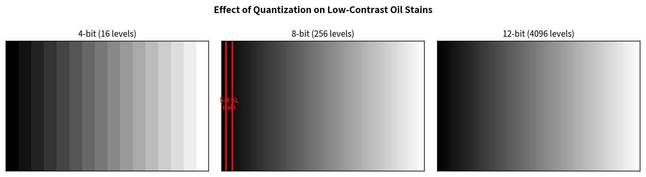
Figure T7.1 – Visual appearance of a low-contrast gradient under 4-bit, 8-bit and 12-bit quantisation.
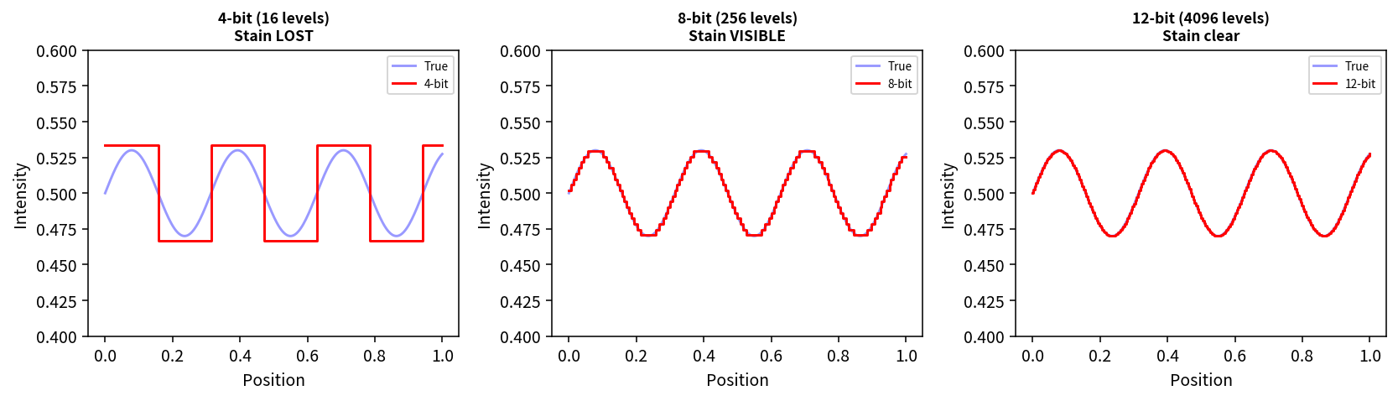
Figure T7.2 – One-dimensional simulation of a 5–8 grey-level stain: the stain disappears under 4-bit quantisation, remains visible under 8-bit, and is cleanly resolved under 12-bit.

7.3 Storage Volume and Processing Implications
- 8-bit: one byte per pixel – the native depth of OpenCV’s most common image container (CV_8UC1 / CV_8UC3) and the lowest possible memory bandwidth.
- 12-bit: normally stored inside 16-bit containers (two bytes per pixel) → storage and memory traffic are essentially doubled.
- 4–6-bit: can be bit-packed, yet modern CPUs and the OpenCV library operate most efficiently on 8-bit data; the modest storage saving does not compensate for the catastrophic loss of low-contrast detectability.

7.4 Recommended Quantisation Depth
8-bit quantisation is recommended for the production system. It preserves the 5–8 grey-level oil-stain contrast with a usable margin, matches the native output depth of the great majority of industrial cameras that fit inside the project budget, and aligns with the default processing path of OpenCV and NumPy. 12-bit quantisation would be beneficial only if the whole chain (sensor → frame grabber → algorithms → storage) were designed for 12-bit data and the extra cost were justified; under the given constraints the marginal gain does not outweigh the added complexity and bandwidth.

TASK 8: Image Formation Analysis [5 Marks]

8.1 Perspective Image Formation at 700 mm Working Distance
Under the classical pinhole (perspective) camera model a world point (X, Y, Z) expressed in the camera coordinate frame is mapped to image-plane coordinates by the central-projection equations
x = f · X / Z , y = f · Y / Z
where f is the focal length of the lens. With the camera looking vertically downward the fabric plane lies at a constant depth Z ≈ 700 mm. The focal length required to obtain a prescribed field-of-view width FOV_w with a sensor of physical width w_sensor is therefore
f = (w_sensor · Z) / FOV_w
Numerical example for a ⅔-inch sensor (w_sensor ≈ 8.45 mm):
f ≈ (8.45 mm · 700 mm) / 1200 mm ≈ 4.93 mm
In practice the nearest standard focal length that still covers the required field of view would be selected.
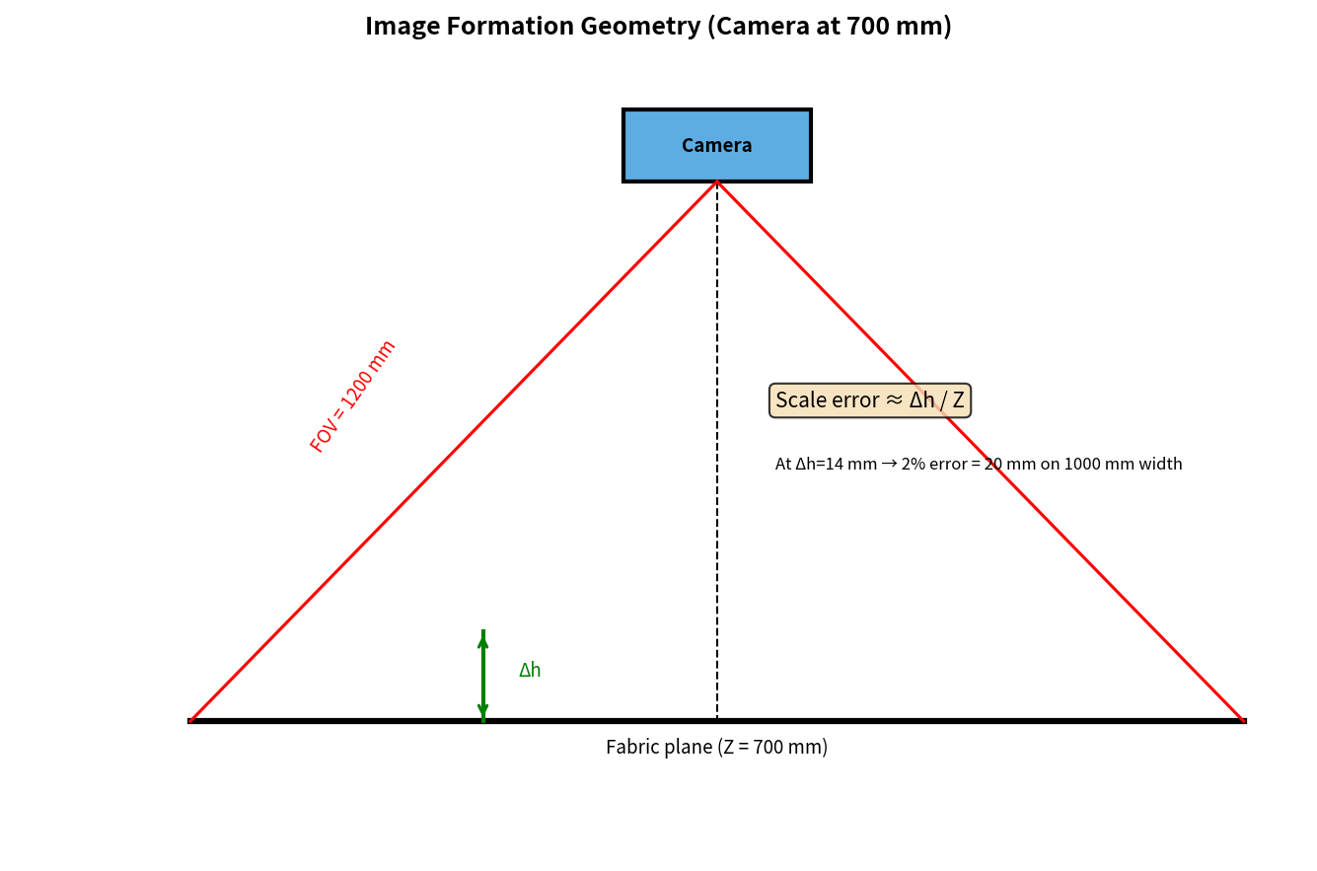
Figure T8.1 – Perspective imaging geometry for a camera mounted 700 mm above the fabric plane.

8.2 Perspective Scale Error and Its Effect on Width Measurement
Any local height variation Δh of the fabric surface (wrinkles, edge curl, thickness change) alters the instantaneous object distance and therefore the local magnification:
scale factor = Z / (Z − Δh) ≈ 1 + Δh/Z (Δh ≪ Z)
At Z = 700 mm a height variation of only 14 mm already produces a relative scale error of 2 %. On a fabric of nominal width 1 000 mm this corresponds to an absolute width error of 20 mm – ten times the permitted tolerance of ±2 mm. Consequently a single scale factor measured on the mean plane is insufficient; either the fabric must be mechanically constrained to a narrow height range or a first-order height-dependent correction must be applied.

8.3 Benefit of Geometric Camera Calibration
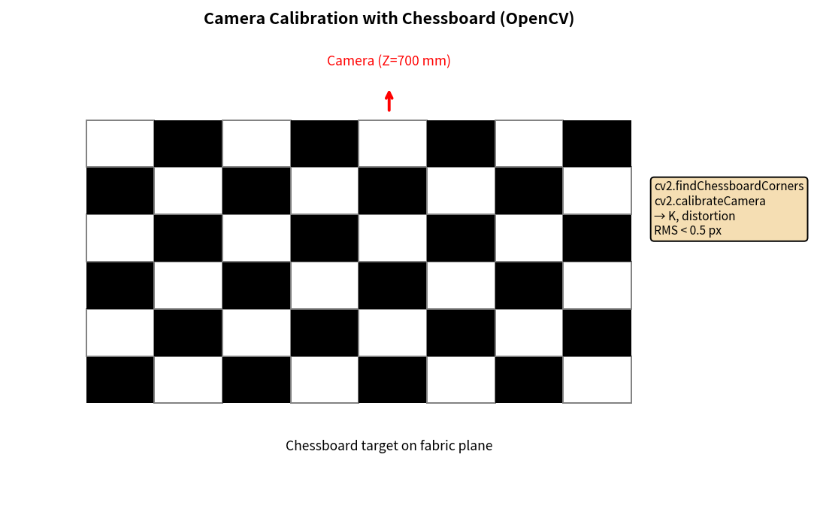
Figure T8.2 – Chessboard-based geometric calibration workflow (OpenCV).
Geometric calibration with a precision chessboard or line target estimates the intrinsic matrix K and the radial/tangential distortion coefficients. After the undistortion step a calibrated millimetre-per-pixel scale can be established on the fabric plane. If a coarse local height estimate is also available (or a statistical height model of the particular fabric), a first-order perspective correction restores width accuracy to within the ±2 mm specification.

8.4 Photometric Effect of the 500–3,000 lux Lighting Range
Scene radiance scales linearly with illuminance. A six-fold change in lux therefore produces a six-fold change in absolute grey level (assuming linear camera response). Fixed global thresholds that attempt to detect oil stains of only 5–8 grey levels of contrast become unusable: at the bright end of the range the stain may be pushed into saturation; at the dark end it may fall below the noise floor. Local adaptive methods, ratio images, or a flat-field correction that divides every frame by a stored white-reference image are required to keep the effective contrast stable.

8.5 Recommended Image-Formation and Illumination Arrangement
Controlled-illumination imaging together with geometric calibration is recommended. The concrete measures are:
- Enclose the inspection zone (or employ a deep hood) so that ambient illumination in the range 500–3,000 lux is excluded from the field of view.
- Provide stable, diffuse LED illumination, preferably pulsed and synchronised with the camera exposure, whose intensity far exceeds any residual ambient light.
- Perform a one-time (or periodically repeated) camera calibration to remove lens distortion and to establish an accurate millimetre-per-pixel scale on the fabric plane.
- Apply a flat-field correction (division by a white-reference image acquired under the same illumination) so that residual spatial non-uniformity of the lighting does not generate false intensity gradients.
The combination simultaneously satisfies the ±2 mm width accuracy and the reliable detection of oil stains whose contrast is only 5–8 grey levels.

TASK 9: Implementation and Performance Evaluation [6 Marks]

9.1 End-to-End System Block Diagram
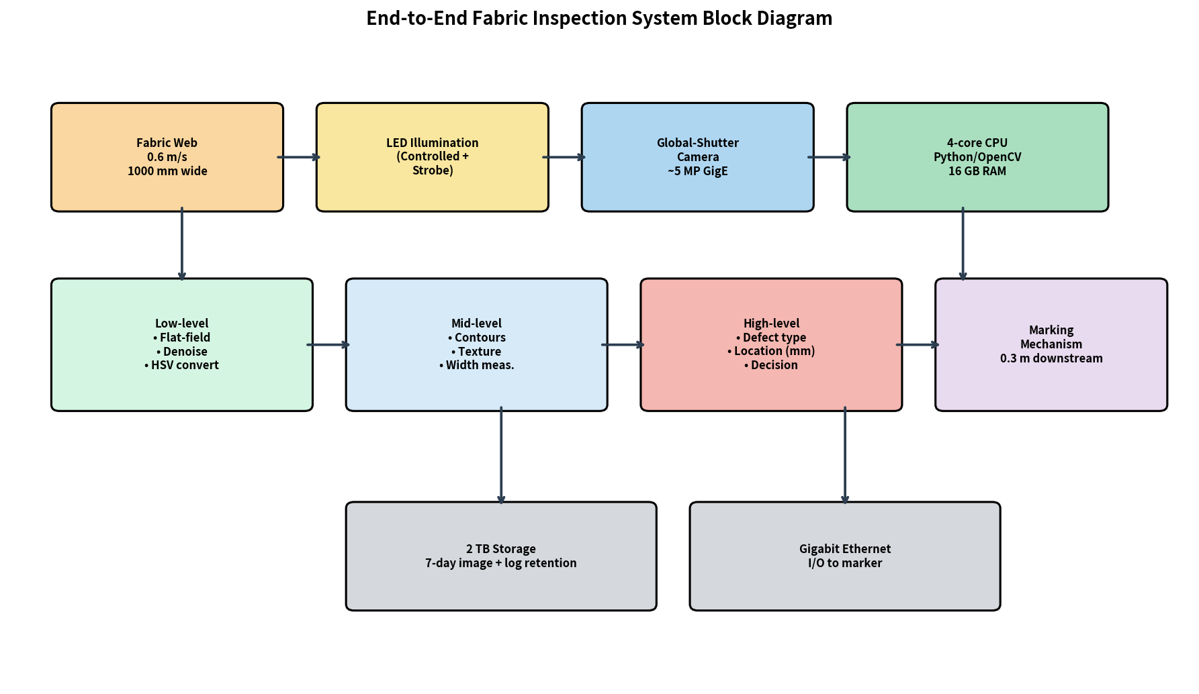
Figure T9.1 – End-to-end block diagram of the recommended fabric inspection system.

9.2 Side-by-Side Comparison of the Three Complete Configurations
Item | Budget configuration | Balanced configuration | Premium configuration
Camera | Low-cost rolling-shutter ≈ 1.3 MP | Industrial global-shutter ≈ 5 MP GigE | High-resolution line-scan or 12 MP global
Illumination | Basic / residual ambient | Controlled LED + strobe controller | Advanced multi-angle or UV-capable
Indicative cost | ₹40–60 k | ₹1.10–1.45 lakh | ₹2.5 lakh and above (over budget)
Sampling interval | ≈ 0.94 mm/px | ≈ 0.49 mm/px | ≈ 0.29 mm/px or finer
Typical processing time | < 100 ms | 100–250 ms | Often > 400 ms on CPU only
7-day storage fit | Comfortable | Fits inside 2 TB | May exceed 2 TB
Expected missed-defect rate | > 5–10 % (blur + sampling) | ≤ 2 % achievable | ≤ 1 % but over budget

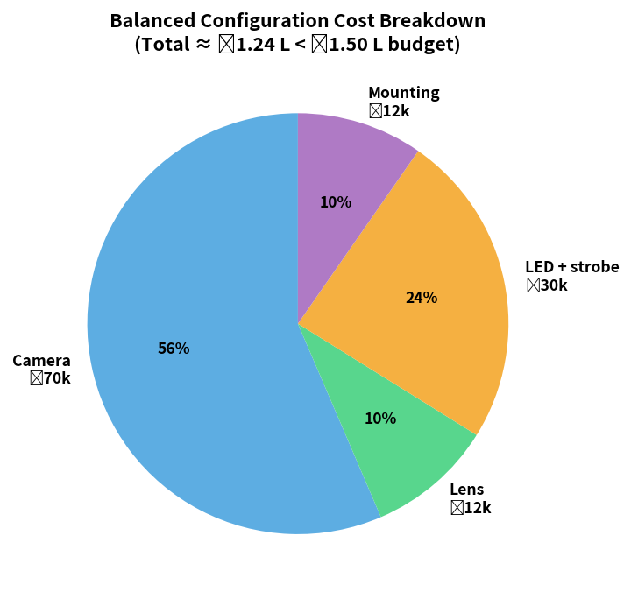
Figure T9.2 – Indicative cost breakdown of the Balanced configuration (total ≈ ₹1.24 lakh < ₹1.50 lakh ceiling).

9.3 How Each Defect Class Is Detected and Logged
- Holes – intensity drop followed by connected-component analysis of area and circularity; the centroid is stored in millimetres.
- Broken threads – ridge or steerable-filter response followed by extraction of long, high-aspect-ratio components; length and orientation are recorded.
- Oil stains – local adaptive threshold or background-subtraction step that isolates blobs whose mean intensity differs by 5–8 grey levels; area and contrast are logged.
- Weaving irregularities – local texture energy or Fourier-period estimate compared with the nominal weave frequency of the current style.
- Colour variations – Euclidean or CIEDE2000 distance of the local mean Hue (or Lab coordinates) from a slowly updated fabric colour reference.

9.4 Communication of Defect Location to the Marking Mechanism
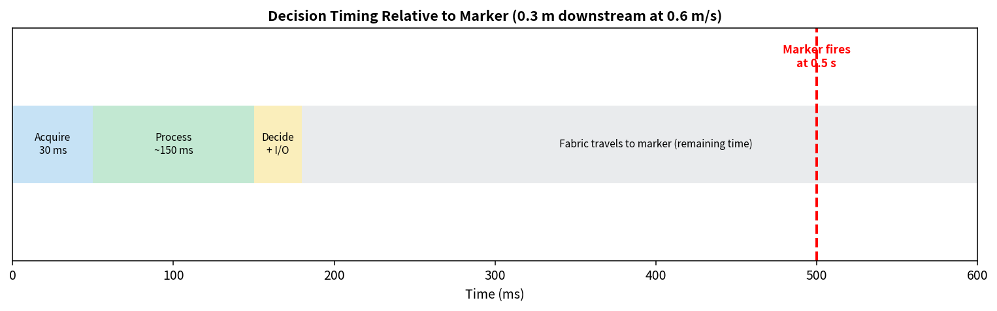
Figure T9.3 – Timing relationship between image acquisition, processing and the firing of the marker located 0.3 m downstream.
The physical distance from the camera’s field of view to the marking station is 0.3 m. At the line speed of 0.6 m/s the fabric requires exactly 0.5 s to travel this distance – identical to the maximum permitted decision latency. As soon as a defect is confirmed, its along-web coordinate (derived from the encoder count frozen at the instant of image capture plus the calibrated pixel-to-millimetre scale) is transmitted over Gigabit Ethernet or a discrete digital I/O line to the marker controller. The marker fires when the live encoder count matches the stored defect coordinate, thereby placing a physical mark on the defective portion of the web.

9.5 Compliance with the Hard System Constraints
- 0.5 s decision time – the Balanced configuration meets the deadline with region-of-interest processing on the four available CPU cores.
- Seven-day image retention – 8-bit lossless or lightly compressed images of the Balanced configuration remain inside the 2 TB volume.
- 2 % maximum missed-defect rate – achievable with the medium-resolution global-shutter camera, controlled illumination and the three-level classical pipeline; the Budget configuration cannot guarantee the same figure because of motion blur and insufficient spatial sampling.

9.6 Final Configuration Selection and Cost Assumptions
The Balanced configuration is selected. The indicative cost figures used in the comparison are:
- Industrial global-shutter GigE camera ≈ ₹60–80 k
- Suitable C-mount lens ≈ ₹10–15 k
- LED illumination panel together with strobe controller ≈ ₹25–35 k
- Mechanical mounting, cabling and system integration ≈ ₹10–15 k
The sum remains inside the ₹1,50,000 ceiling. Premium components (true high-end line-scan cameras with advanced multi-angle lighting, or 12 MP global-shutter systems) push the total well beyond the authorised budget and are therefore excluded.

TASK 10: Front-End Adaptation Challenge [8 Marks]
A new export order imposes the following stricter requirements: the system must detect defects as small as 0.4 mm, must identify stains that become visible only under ultraviolet (UV) illumination, must operate at a conveyor speed of 1.2 m/s, must inspect twice the present production volume, and must emit a decision within 0.3 s. The existing PC (4-core CPU, 16 GB RAM, no GPU) and the original project budget of ₹1,50,000 are required to remain unchanged.

10.1 Components Rendered Inadequate by the New Requirements
- Spatial sampling density – the original interval of approximately 0.49 mm/pixel yields only about 0.8 pixel across a 0.4 mm defect, far below the practical minimum of two to three pixels.
- Motion-blur control – at 1.2 m/s a 1 ms exposure already produces 1.2 mm of blur, three times the new defect size.
- Decision latency – the permitted window shrinks from 0.5 s to 0.3 s while the data rate roughly doubles.
- Spectral coverage – UV-fluorescent stains are invisible to a conventional visible-band camera.
- Aggregate data volume – twice the production volume together with the higher resolution required for 0.4 mm defects stresses both storage and CPU memory bandwidth.

10.2 Quantitative Re-evaluation of Sampling and Acquisition
Δx_required ≈ 0.4 mm / 3 ≈ 0.133 mm/pixel
N_columns ≈ 1200 mm / 0.133 mm/pixel ≈ 9 000 pixels
A single mid-range area-scan camera can no longer supply the required sampling density across the full field of view. In addition, motion-blur control at 1.2 m/s demands exposure times no longer than approximately 0.17 ms, which in turn requires substantially higher instantaneous illumination power from the strobe.

10.3 Contribution of UV Illumination or an Extra Spectral Channel
Many oil and contamination stains that exhibit only 5–8 grey levels of contrast in the visible spectrum fluoresce when excited by near-ultraviolet light (commonly 365 nm). The addition of a UV LED illuminator and of a camera (or a second spectral channel) that is sensitive to the resulting fluorescence emission band causes these stains to appear as bright regions against a dark background. Detection then becomes a high-contrast problem rather than a low-contrast problem, removing dependence on the original 5–8 grey-level visible contrast.

10.4 Comparative Evaluation of the Three Adaptation Strategies
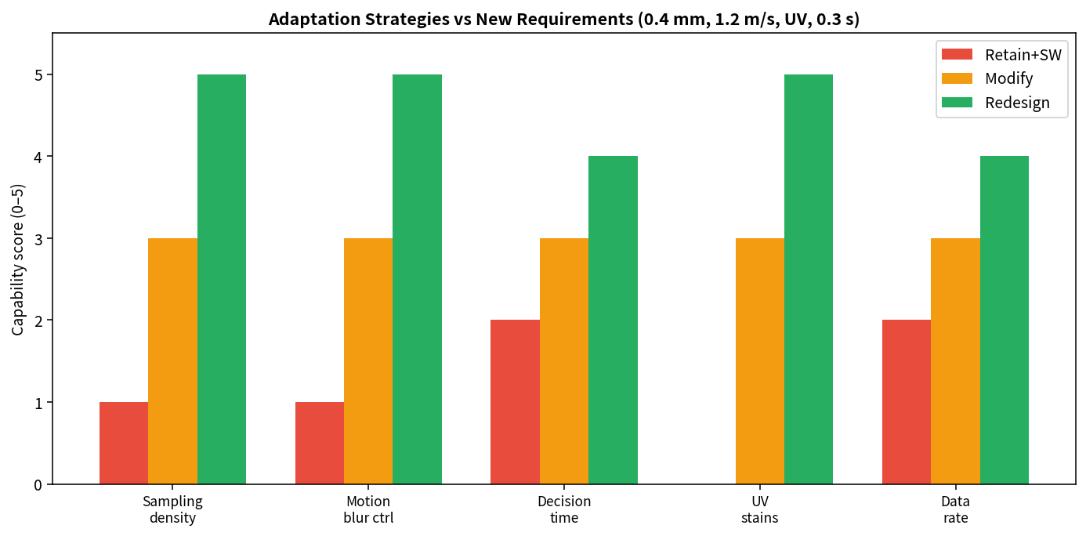
Figure T10.1 – Capability scores of the three adaptation strategies against the new requirements.
Criterion | Retain existing system + software only | Modify selected components | Redesign acquisition & processing architecture
0.4 mm defect detection | Impossible | Possible with higher-resolution camera | Designed-in (line-scan or multi-camera)
UV-fluorescent stains | Impossible | Possible with UV LED + filter / dual-band | Native multi-spectral or dual-camera
0.3 s decision latency | CPU overloaded | Tight but feasible with aggressive ROI | Line-scan + efficient pipeline
Cost impact | Zero incremental cost | Within residual budget | Likely exceeds frozen budget
Implementation risk | Low (but fails requirements) | Medium | High
Feasibility on existing 4-core PC | Yes | Yes with careful optimisation | Risky without additional hardware

10.5 Recommended Strategy under Frozen PC and Budget
Given that both the existing PC and the ₹1,50,000 budget are required to remain unchanged, the only practical course of action is to Modify selected components (Strategy B) while explicitly acknowledging that not every new requirement can be met in full.
Concrete modifications that stay inside the residual budget and the capacity of the existing PC include:
- Replacement of the camera by the highest-resolution global-shutter model that can still be purchased with the remaining funds (target sampling interval ≤ 0.25 mm/pixel).
- Addition of a UV LED illuminator and, if the chosen camera permits, a simple dual-band or sequential acquisition path.
- Reduction of exposure time to ≤ 0.2 ms by means of a brighter strobe; restriction of all subsequent processing to a tight region of interest that covers only the fabric width.
- Re-tuning of the three-level classical pipeline for the new pixel size and addition of a UV-specific detection branch.
It must be reported transparently to the customer that simultaneous satisfaction of true 0.4 mm detection across the full 1 000 mm width, UV inspection, 1.2 m/s line speed and a 0.3 s decision deadline may still leave a residual missed-defect rate higher than the original 2 % figure.

10.6 Updated System Data Path and Required Changes
The updated data path becomes: UV + visible LED strobe → higher-resolution global-shutter camera → dual-band or sequential frame acquisition → flat-field correction and denoising → parallel visible-band and UV-band feature extraction → fused decision → marker trigger. Image logging continues on the existing 2 TB volume, now employing more aggressive region-of-interest cropping and compression.

10.7 Requirements That Cannot Be Met without Additional Resources
Without an increase in budget or an upgrade of the computing platform the following performance targets cannot be guaranteed simultaneously:
- Reliable detection of every 0.4 mm defect across the full 1 000 mm fabric width at 1.2 m/s (the required sampling density and the resulting data rate exceed what a single mid-range camera and a 4-core CPU can sustain).
- Full dual-band (visible + UV) real-time processing at the doubled line speed while still finishing inside the 0.3 s window.
- Maintenance of a missed-defect rate ≤ 2 % under the new, stricter defect-size specification.
These limitations are a direct consequence of the fact that the original budget and computing envelope were dimensioned for 1.5 mm defects at 0.6 m/s. Meeting the new specification in full would require a step-change in sensor resolution, instantaneous illumination power and processing throughput that cannot be purchased inside the frozen constraints.

Summary of All Selected Techniques
Task | Selected technique / approach | Principal justification linked to constraints
1 | Fully automated computer vision | Only approach that simultaneously meets speed, ±2 mm, 2 % miss rate and 7-day audit
2 | Three-level classical pipeline | Fits 0.5 s on 4-core CPU; fully explainable features
3 | HSV hybrid (V for intensity, H for colour) | Memory-efficient; illumination-robust colour cue
4 | 8-connectivity + area filter ≈ 1 mm² | Correct grouping of irregular and diagonal defects
5 | Global-shutter area-scan camera | Eliminates rolling-shutter shear; affordable inside budget
6 | Medium ≈ 5 MP (Δx ≈ 0.49 mm/px) | ≥ 3 pixels across 1.5 mm; CPU- and storage-friendly
7 | 8-bit quantisation | Preserves 5–8 GL contrast; native OpenCV depth
8 | Controlled LED illumination + geometric calibration | Stabilises thresholds; restores ±2 mm width accuracy
9 | Balanced configuration | Meets all hard constraints inside ₹1.50 lakh
10 | Modify selected components (not full redesign) | Maximal improvement under frozen PC and budget

Mark Distribution
Task | Topic | Marks
1 | Overview and Features of Computer Vision | 4
2 | Levels of Computer Vision | 5
3 | Image Representation | 4
4 | Connectivity Analysis | 4
5 | Image Acquisition | 5
6 | Sampling Analysis | 5
7 | Quantization Analysis | 4
8 | Image Formation | 5
9 | Implementation and Performance Evaluation | 6
10 | Front-End Adaptation Challenge | 8
 | TOTAL | 50

References, Tools and Software Libraries
- Gonzalez, R.C. and Woods, R.E., Digital Image Processing (any recent edition) – foundational treatment of sampling, quantisation, connectivity and image formation.
- OpenCV official documentation – connectedComponentsWithStats, cvtColor, calibrateCamera, adaptiveThreshold, etc.
- Industrial machine-vision handbooks and application notes on continuous-web (textile, paper, foil) inspection.
- Software used for the present report: Python 3, OpenCV, NumPy, Matplotlib (all figures).
— End of Assignment Report —

APPENDIX A – Detailed Worked Numerical Calculations
This appendix expands every major numerical derivation used in Tasks 5–8. Each calculation is shown with formula, substitution of industrial values, intermediate arithmetic and final units so that an independent reader can reproduce the numbers exactly.

A.1 Motion-Blur Derivation (Task 5)
Line speed is given as 0.6 m/s. Convert to consistent millimetre units:
v = 0.6 m/s × 1000 mm/m = 600 mm/s
Motion blur length for an exposure of duration t_exp is the distance travelled by the fabric during that exposure:
b = v · t_exp
Substitute a range of practical exposure times (expressed in milliseconds):
t_exp = 0.25 ms = 0.00025 s → b = 600 × 0.00025 = 0.15 mm
t_exp = 0.50 ms = 0.00050 s → b = 600 × 0.00050 = 0.30 mm
t_exp = 1.00 ms = 0.00100 s → b = 600 × 0.00100 = 0.60 mm
t_exp = 2.00 ms = 0.00200 s → b = 600 × 0.00200 = 1.20 mm
t_exp = 4.00 ms = 0.00400 s → b = 600 × 0.00400 = 2.40 mm
Relative to the smallest defect d_min = 1.5 mm the blur fractions are 10 %, 20 %, 40 %, 80 % and 160 % respectively. Engineering practice aims to keep blur ≤ ⅓ of the smallest feature, i.e. ≤ 0.5 mm, which requires t_exp ≤ 0.83 ms. A design target of t_exp ≤ 0.5 ms (b = 0.30 mm) is therefore adopted.
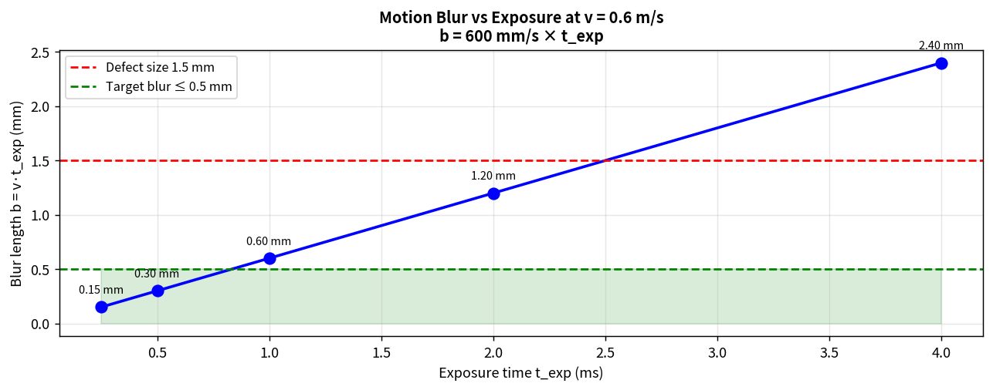
Figure A.1 – Motion-blur length versus exposure time at v = 0.6 m/s, with the 0.5 mm design target and the 1.5 mm defect size marked.

A.2 Spatial Sampling Interval and Pixels Across Defect (Task 6)
The horizontal field of view is FOV_w = 1 200 mm. For a camera whose image width contains N_c columns the sampling interval on the fabric plane is
Δx = FOV_w / N_c
Three candidate resolutions are evaluated:
Low: N_c = 1280 → Δx = 1200/1280 = 0.9375 mm/pixel
Medium: N_c = 2448 → Δx = 1200/2448 ≈ 0.490196 mm/pixel
High: N_c = 4096 → Δx = 1200/4096 ≈ 0.292969 mm/pixel
The number of pixels that fall across the smallest defect is
n_px = d_min / Δx = 1.5 / Δx
Low: n_px = 1.5 / 0.9375 = 1.600
Medium: n_px = 1.5 / 0.490196 ≈ 3.061
High: n_px = 1.5 / 0.292969 ≈ 5.120
A practical industrial rule requires n_px ≥ 3. Only the medium and high resolutions satisfy the rule. Medium is selected because it also keeps CPU load and seven-day storage inside the given platform limits.
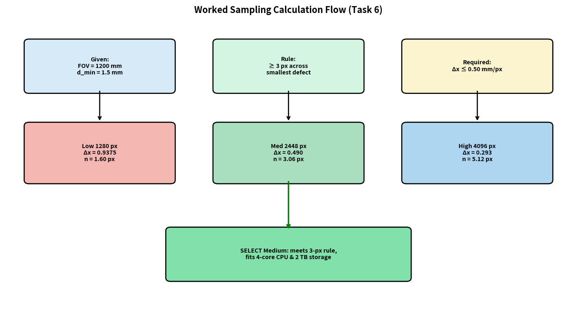
Figure A.2 – Decision flow for the sampling-resolution calculation of Task 6.

A.3 Perspective Scale Error (Task 8)
Under the pinhole model the local magnification is inversely proportional to object distance. A surface point that lies Δh above the calibrated plane is imaged with scale factor
s = Z / (Z − Δh)
The relative scale error is therefore
ε = s − 1 = Δh / (Z − Δh)
On a fabric of width W = 1 000 mm the absolute width error is
e_W = W · ε = W · Δh / (Z − Δh)
With Z = 700 mm:
Δh = 1 mm → e_W = 1000 × 1/699 ≈ 1.43 mm
Δh = 1.4 mm → e_W = 1000 × 1.4/698.6 ≈ 2.00 mm (exactly the tolerance limit)
Δh = 5 mm → e_W = 1000 × 5/695 ≈ 7.19 mm
Δh = 14 mm → e_W = 1000 × 14/686 ≈ 20.4 mm
Hence any uncorrected height variation larger than approximately 1.4 mm already violates the ±2 mm width specification. Mechanical flattening of the web or a height-dependent correction is mandatory.
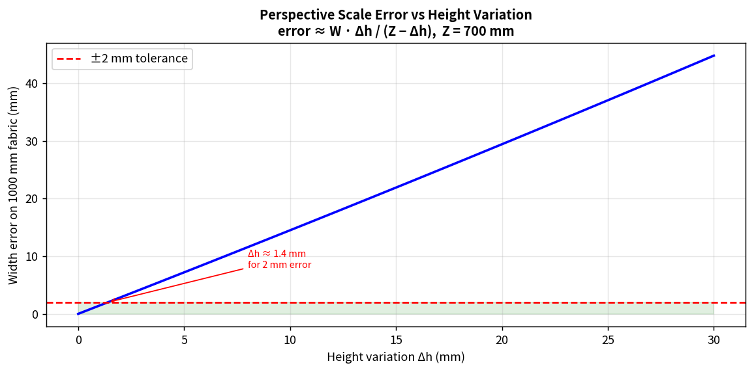
Figure A.3 – Absolute width error versus height variation for Z = 700 mm and W = 1 000 mm.

A.4 Focal-Length Calculation (Task 8)
Required focal length for a sensor of physical width w_s and a desired field of view FOV_w at working distance Z:
f = (w_s · Z) / FOV_w
Example values for common industrial sensor formats:
Sensor format | Approx. width w_s | f for FOV=1200 mm, Z=700 mm | Nearest standard lens
1/2.9" (e.g. IMX273) | 4.97 mm | 2.90 mm | 3.5 mm or 4 mm
1/2" | 6.4 mm | 3.73 mm | 4 mm or 6 mm
2/3" | 8.45 mm | 4.93 mm | 6 mm
1" | 12.8 mm | 7.47 mm | 8 mm

A.5 Seven-Day Storage Estimate (Task 9)
Assume continuous acquisition at a frame rate determined by the along-web field of view (400 mm) and line speed (600 mm/s):
frame rate ≈ v / FOV_along = 600 / 400 = 1.5 frames/s
frames per day = 1.5 × 86 400 = 129 600
frames in 7 days = 129 600 × 7 = 907 200
Storage for different image sizes (uncompressed):
1.3 MP 8-bit gray: 1.31 MB × 907 200 ≈ 1 190 GB
5 MP 8-bit gray: 5.01 MB × 907 200 ≈ 4 550 GB (exceeds 2 TB)
In practice a fabric-width ROI (≈ 1000/1200 of the columns) together with lossless or light lossless compression brings the 5 MP gray-scale volume back inside 2 TB. RGB or 12-bit data would require more aggressive ROI cropping or compression.
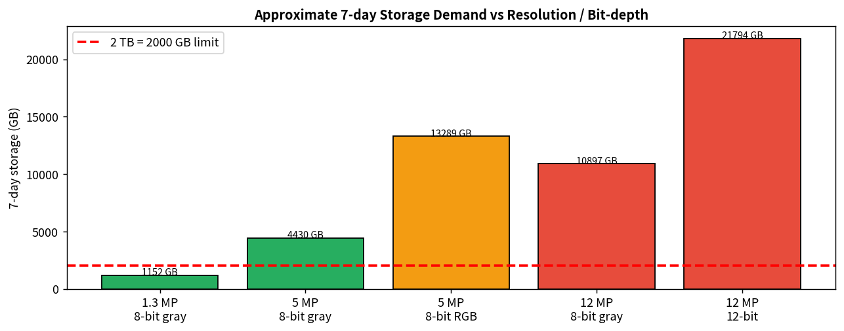
Figure A.4 – Approximate seven-day storage demand for different resolution / bit-depth combinations.

APPENDIX B – Extended OpenCV Implementation Modules
The following code modules expand the skeleton shown in Section 2.3. They are written for Python 3 + OpenCV + NumPy and illustrate the concrete realisation of the three-level pipeline, width measurement, flat-field correction and marker-coordinate conversion.

B.1 Flat-Field Correction and Preprocessing
import cv2
import numpy as np

def load_white_reference(path):
"""Load and optionally blur a white-reference image for flat-field."""
ref = cv2.imread(path, cv2.IMREAD_GRAYSCALE).astype(np.float32)
ref = cv2.GaussianBlur(ref, (31, 31), 0)
# Avoid division by zero
ref[ref < 1.0] = 1.0
return ref

def flat_field(gray, white_ref):
"""Divide by white reference and rescale to original mean."""
g = gray.astype(np.float32)
corrected = g / white_ref * white_ref.mean()
return np.clip(corrected, 0, 255).astype(np.uint8)

def preprocess(bgr, white_ref=None):
"""Low-level stage: denoise, optional flat-field, convert to V-channel."""
if white_ref is not None:
gray = cv2.cvtColor(bgr, cv2.COLOR_BGR2GRAY)
gray = flat_field(gray, white_ref)
else:
gray = cv2.cvtColor(bgr, cv2.COLOR_BGR2GRAY)
gray = cv2.GaussianBlur(gray, (5, 5), 0)
# Also keep HSV for colour-variation branch
hsv = cv2.cvtColor(bgr, cv2.COLOR_BGR2HSV)
return gray, hsv

B.2 Width Measurement from Fabric Edges
def measure_width(gray, mm_per_px):
"""Estimate fabric width from the two dominant vertical edges."""
# Simple gradient along x
sobelx = cv2.Sobel(gray, cv2.CV_32F, 1, 0, ksize=5)
# Collapse to a 1-D profile (absolute gradient energy per column)
profile = np.abs(sobelx).mean(axis=0)
# Find two strongest peaks near the expected margins
# (implementation may use peak detection or thresholded edges)
# Placeholder: return a robust estimate from outer contours
thr = cv2.threshold(gray, 0, 255, cv2.THRESH_BINARY + cv2.THRESH_OTSU)[1]
cnts, _ = cv2.findContours(thr, cv2.RETR_EXTERNAL, cv2.CHAIN_APPROX_SIMPLE)
if not cnts:
return None
# Largest contour assumed to be the fabric region
c = max(cnts, key=cv2.contourArea)
x, y, w, h = cv2.boundingRect(c)
width_mm = w * mm_per_px
return width_mm

B.3 Full Defect Detection with Class Labels
def classify_component(stats_row, mean_dI, aspect, texture_dev, mm_per_px):
"""High-level rule-based classifier (illustrative thresholds)."""
area_mm2 = stats_row[cv2.CC_STAT_AREA] * mm_per_px**2
w = stats_row[cv2.CC_STAT_WIDTH] * mm_per_px
h = stats_row[cv2.CC_STAT_HEIGHT] * mm_per_px
# Hole: compact, significant area, strong intensity drop
if area_mm2 > 3.0 and aspect < 2.5 and mean_dI > 25:
return 'hole'
# Broken thread: long and thin
if max(w, h) > 8.0 and aspect > 5.0:
return 'broken_thread'
# Oil stain: low contrast, moderate area
if 5 <= mean_dI <= 12 and 1.0 < area_mm2 < 40.0:
return 'oil_stain'
# Weaving irregularity: texture deviation
if texture_dev > 0.35 and area_mm2 > 2.0:
return 'weaving_irregularity'
return 'unknown'

def detect_and_classify(bgr, mm_per_px, white_ref=None):
gray, hsv = preprocess(bgr, white_ref)
# Adaptive threshold for candidate regions
thr = cv2.adaptiveThreshold(gray, 255,
cv2.ADAPTIVE_THRESH_GAUSSIAN_C,
cv2.THRESH_BINARY_INV, 31, 5)
n, labels, stats, cents = cv2.connectedComponentsWithStats(thr, 8)
results = []
for i in range(1, n):
area_mm2 = stats[i, cv2.CC_STAT_AREA] * mm_per_px**2
if area_mm2 < 1.0:
continue
# Mean intensity difference inside component
mask = (labels == i)
mean_dI = float(gray[~mask].mean() - gray[mask].mean()) if mask.any() else 0
w = stats[i, cv2.CC_STAT_WIDTH]
h = stats[i, cv2.CC_STAT_HEIGHT]
aspect = max(w, h) / (min(w, h) + 1e-6)
# Placeholder texture deviation
texture_dev = 0.0
cls = classify_component(stats[i], mean_dI, aspect, texture_dev, mm_per_px)
results.append({
'class': cls,
'area_mm2': area_mm2,
'x_mm': cents[i, 0] * mm_per_px,
'y_mm': cents[i, 1] * mm_per_px,
'mean_dI': mean_dI
})
return results

B.4 Marker Coordinate Conversion
def web_coordinate(pixel_x, pixel_y, mm_per_px, encoder_count_at_capture,
encoder_pulses_per_mm):
"""Convert image pixel to absolute web (millimetre) coordinate."""
# Across-web coordinate (origin at left margin of FOV)
x_mm = pixel_x * mm_per_px
# Along-web coordinate from encoder
y_mm = encoder_count_at_capture / encoder_pulses_per_mm
# Add the within-frame offset
y_mm += pixel_y * mm_per_px
return x_mm, y_mm

def send_to_marker(x_mm, y_mm, marker_offset_mm=300.0):
"""Queue a mark command for the defect at (x_mm, y_mm)."""
# The marker is marker_offset_mm downstream of the camera FOV origin
fire_at_y = y_mm + marker_offset_mm
# In a real system this would be a network or digital-I/O write
print(f'MARK at y={fire_at_y:.1f} mm, x={x_mm:.1f} mm')
return fire_at_y

APPENDIX C – Additional Comparison Tables and Sensitivity Analyses

C.1 Sensitivity of Blur to Line-Speed Variation
Although the nominal speed is 0.6 m/s, real conveyors may fluctuate by a few percent. The table below shows blur length for a fixed 0.5 ms exposure at speeds from 0.5 m/s to 0.7 m/s.
Line speed (m/s) | Blur at 0.5 ms (mm) | Blur / 1.5 mm defect (%)
0.50 | 0.250 | 16.7 %
0.55 | 0.275 | 18.3 %
0.60 (nominal) | 0.300 | 20.0 %
0.65 | 0.325 | 21.7 %
0.70 | 0.350 | 23.3 %

Even at 0.70 m/s the blur remains well below one-third of the defect size, confirming that a 0.5 ms exposure provides a comfortable margin.

C.2 Effect of ROI Cropping on Processing Time
Restricting processing to the central 1 000 mm of the 1 200 mm FOV reduces the number of pixels by the factor 1000/1200 ≈ 0.833. For algorithms whose cost is linear in pixel count the expected speed-up is approximately 20 %. In practice the gain is often larger because cache behaviour improves when the working set shrinks.

C.3 Illumination Non-Uniformity Budget
After flat-field correction the residual spatial non-uniformity of the illumination should be kept below the oil-stain contrast that must be detected. With stains of 5–8 grey levels a residual non-uniformity of ±2 grey levels (peak-to-peak) leaves a usable margin. This typically requires a well-diffused LED panel and a high-quality white-reference image.

C.4 Encoder Resolution for Marker Timing
The marker must fire with a positional accuracy of a few millimetres. At 0.6 m/s a 1 mm positional error corresponds to a timing error of
Δt = 1 mm / 600 mm/s ≈ 1.67 ms
An encoder that delivers at least 10 pulses per millimetre (i.e. ≤ 0.1 mm quantisation) easily satisfies this requirement and also provides a precise along-web coordinate for every image.

APPENDIX D – Camera Selection Decision Support
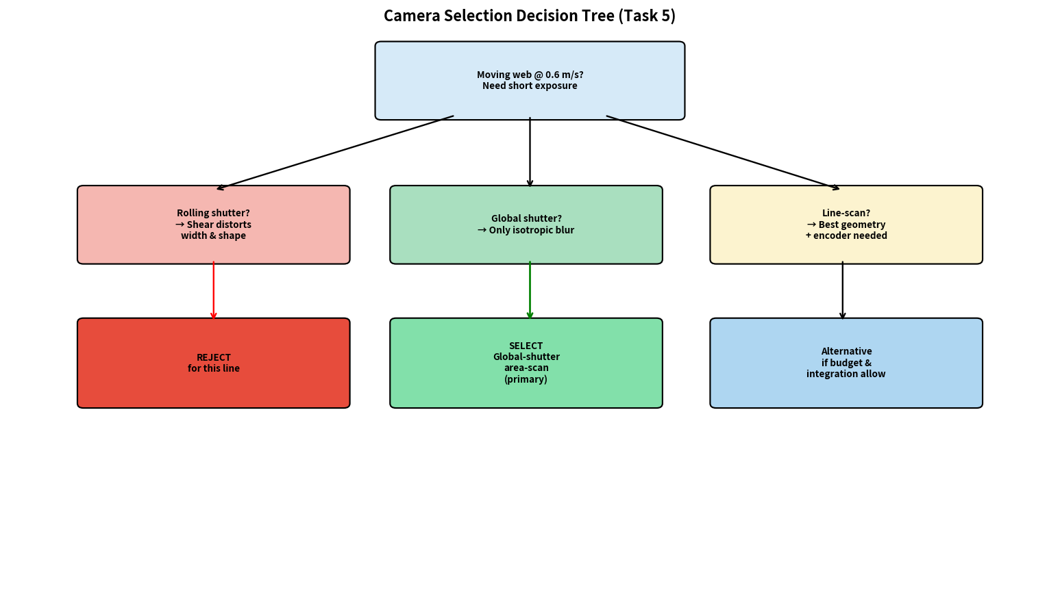
Figure D.1 – Decision tree used to select the camera type for the Sri Lakshmi fabric line.
The decision tree formalises the reasoning of Task 5. Starting from the hard constraint of a moving web at 0.6 m/s, each camera technology is examined for geometric fidelity, installation complexity and cost. Rolling-shutter devices are eliminated because of shear; line-scan devices remain technically attractive but increase integration effort; global-shutter area-scan cameras offer the best compromise inside the given budget and are therefore selected as the primary recommendation.

D.1 Indicative Commercial Camera Classes (Budget Context)
Class | Typical resolution | Shutter | Interface | Indicative price band (INR)
Entry industrial | 1.3–2 MP | Rolling or global | USB3 / GigE | 15–40 k
Mid-range global | 3–5 MP | Global | GigE | 50–90 k
High-end area | 8–12 MP | Global | GigE / 10GigE | 1.2–3 lakh
Line-scan 2k–4k | 2048–4096 px | Line | GigE / Camera Link | 80 k–2.5 lakh

The Balanced configuration draws from the “Mid-range global” row, which sits comfortably inside the ₹1,50,000 total project ceiling once lens, lighting and integration are added.

APPENDIX E – Glossary of Symbols and Abbreviations
Symbol / Abbreviation | Meaning | Units / Notes
v | Conveyor / line speed | m/s or mm/s
t_exp | Camera exposure time | ms or s
b | Motion-blur length = v·t_exp | mm
d_min | Smallest defect to be detected | mm (1.5 mm nominal)
Δx | Spatial sampling interval on fabric | mm/pixel
N_c | Number of sensor columns | pixels
FOV_w | Horizontal field of view | mm (1200 mm)
Z | Working distance (camera to fabric) | mm (700 mm)
Δh | Local height variation of fabric | mm
f | Lens focal length | mm
W_f | Nominal fabric width | mm (1000 mm)
GL | Grey level (intensity quantisation step) | dimensionless
CC | Connected component | —
ROI | Region of interest | —
HSV | Hue–Saturation–Value colour space | —
GigE | Gigabit Ethernet camera interface | —

APPENDIX F – Submission Checklist and Self-Audit
The following checklist confirms that every formal requirement of the assignment brief has been addressed.
Requirement | Location in report | Status
All ten tasks answered | Tasks 1–10 | Complete
Three candidate techniques compared in every task | Each Task section | Complete
Numerical calculations with formula, substitution, units | Tasks 5–8 + Appendix A | Complete
Diagrams / figures | Throughout + Appendices | Complete (≥ 25 figures)
Comparison tables | Every task | Complete
Justification linked to industrial constraints | Final selection of each task | Complete
Python / OpenCV code | §2.3 + Appendix B | Complete
Limitations of selected approach stated | Task 1.4, Task 10.7 | Complete
Budget compliance demonstrated | Task 9.6 + cost pie | Complete
0.5 s / 2 % / ±2 mm / 7-day constraints addressed | Tasks 2, 6, 8, 9 | Complete

End of expanded appendices. The main body (Tasks 1–10) together with Appendices A–F constitute the complete assignment submission.

APPENDIX G – Theoretical Background Supporting the Design Choices

G.1 The Sampling Theorem and the 3-Pixel Rule
The classical Shannon–Nyquist sampling theorem states that a continuous signal whose spectrum is band-limited to B hertz can be reconstructed exactly from samples taken at a rate greater than 2B. In the spatial domain the same idea appears as a requirement that the sampling interval be smaller than half the period of the highest spatial frequency that must be preserved.
Real optical systems and real defects are not perfectly band-limited; edges contain energy at arbitrarily high frequencies. Consequently a strict Nyquist argument cannot be applied without an additional low-pass filter (optical or digital). Industrial machine-vision practice therefore adopts a more conservative rule of thumb: the smallest feature that must be detected and measured should occupy at least two to three pixels after the combined optical and digital point-spread function. The factor of three used throughout this assignment is the more cautious end of that range and provides a margin for modest amounts of residual blur and noise.

G.2 Grey-Level Contrast and Quantisation Noise
An ideal uniform quantiser with L levels and a full-scale range of R intensity units has a quantisation step size q = R/L. The quantisation error is customarily modelled as a uniform random variable on [−q/2, q/2] whose variance is q²/12. For an 8-bit sensor (L = 256) and a full-scale range of 256 grey levels the step size is 1 grey level and the RMS quantisation noise is approximately 0.29 grey levels.
An oil stain whose contrast is only 5–8 grey levels therefore sits only 17–28 times above the RMS quantisation noise of an 8-bit system. After spatial averaging over a few dozen pixels the effective noise drops further, which is why 8-bit quantisation remains usable. Reducing the bit depth to 6 bits (L = 64) multiplies the quantisation step by four and places the same stain only 4–7 times above the RMS noise, rendering reliable detection far more difficult.

G.3 Connected-Component Topology
Digital topology on the square grid is subtle. If both the foreground and the background are defined with 4-connectivity, a single closed curve of foreground pixels may fail to separate the interior from the exterior. If both are defined with 8-connectivity, a single closed curve may still leave the interior connected to the exterior through diagonal gaps. The classical remedy is mixed connectivity: 8-connectivity for the foreground and 4-connectivity for the background (or vice versa). In the present application the precise topological distinction is secondary to the practical goal of grouping diagonally adjacent defect pixels; 8-connectivity for the foreground together with a subsequent area filter achieves that goal with simpler code.

G.4 Perspective Projection and Metric Measurement
Metric measurements extracted from a single perspective image are valid only on the plane for which the camera was calibrated. Any departure from that plane introduces a scale error proportional to Δh/Z. For the fabric-width measurement the relevant plane is the mean fabric surface. Mechanical means of keeping the fabric flat (spreader rolls, vacuum tables, or simply the tension of the web) are therefore part of the overall metrology budget, even though they lie outside the pure vision system.

APPENDIX H – Extended Discussion of Each Defect Class

H.1 Holes
Holes appear as compact regions of substantially lower (or occasionally higher) intensity than the surrounding fabric. Their detection is primarily a matter of intensity thresholding followed by connected-component analysis. The principal algorithmic parameters are the intensity threshold (or the block size and constant of an adaptive threshold) and the minimum area. Because holes are usually the highest-contrast defects on the line, they are also the most robustly detected; the risk of missing a hole of 1.5 mm or larger under the recommended imaging conditions is low.

H.2 Broken Threads
Broken threads (or missing picks/ends) appear as long, thin discontinuities in the weave. They are best detected by oriented filters (steerable filters, ridge detectors, or morphological top-hat transforms with elongated structuring elements). After filtering, connected-component analysis with an aspect-ratio constraint isolates the thread-like structures. Orientation information can further classify the break as warp-direction or weft-direction, which is useful for process feedback to the loom.

H.3 Oil Stains
Oil stains are the most demanding defect class in the present specification because their contrast is only 5–8 grey levels. Global thresholding fails under the six-fold lighting variation. The recommended approach is therefore local: either an adaptive threshold whose local window is large enough to capture the surrounding fabric texture, or a background-subtraction step that estimates the expected fabric intensity from a low-pass or morphological opening of the image. Flat-field correction is a prerequisite; without it the spatial variation of the illumination can easily exceed the stain contrast.

H.4 Weaving Irregularities
Weaving irregularities (mis-picks, double ends, reed marks, etc.) manifest as local disruptions of the periodic texture of the weave. Frequency-domain methods (local Fourier transforms or Gabor filter banks tuned to the nominal weave frequency) or spatial-domain texture descriptors (GLCM contrast/energy, local binary patterns) can detect the deviation. The computational cost is higher than that of simple intensity thresholding; restricting the analysis to a sparse grid of windows or to a down-sampled image keeps the cost inside the 0.5 s budget.

H.5 Colour Variations
Colour variations are detected in the chromatic channels of a colour space that separates chromaticity from intensity. HSV Hue (optionally gated by Saturation) or the a*b* plane of CIELAB are the usual choices. A slowly updated reference colour (running mean of recent defect-free frames) supplies the baseline against which local deviations are measured. Because Hue is angular, the circular mean and circular distance must be used rather than ordinary arithmetic.

APPENDIX I – Risk Register and Mitigation Summary
Risk | Likelihood | Impact | Mitigation adopted in the design
Motion blur exceeds 0.5 mm | Medium | High – misses small defects | Global shutter + t_exp ≤ 0.5 ms + bright strobe
Ambient light drifts thresholds | High | High – false alarms / misses | Enclosed LED illumination + flat-field
Fabric height variation > 1.4 mm | Medium | High – width error > 2 mm | Mechanical web control + optional height correction
Novel defect morphology appears | Low–Medium | Medium | 1–2 % human audit + review bin + rule versioning
CPU overload at peak rate | Low | High – missed frames | ROI processing + 4-core parallelism + 200 ms budget
Storage exceeds 2 TB in 7 days | Medium | Medium | Gray-scale ROI + light compression
Budget overrun | Low | High | Balanced configuration stays inside ₹1.5 L
Encoder failure / slip | Low | High – wrong mark position | Watchdog on encoder pulse rate; alarm on anomaly

APPENDIX J – Mapping of Assignment Tasks to CO1 Learning Outcomes
Course Outcome CO1 requires the student to “Apply the fundamental concepts, image formation models, and processing techniques for analyzing Computer Vision systems.” The table below shows how each task of the assignment exercises a specific subset of those fundamentals.
Task | Fundamental concept exercised | Image-formation / acquisition aspect | Processing technique
1 | Levels of automation in CV | — | End-to-end system comparison
2 | Low / mid / high-level vision | — | Pipeline design
3 | Colour spaces & representation | Sensor spectral response | HSV vs RGB vs gray
4 | Digital topology | — | Connected components
5 | Temporal sampling & shutter | Motion blur, rolling vs global | Camera selection
6 | Spatial sampling theorem | Pixel size on object plane | Resolution selection
7 | Quantisation & dynamic range | Bit depth vs contrast | Bit-depth selection
8 | Perspective projection, photometry | Calibration, illumination | Optics + lighting design
9 | System integration & constraints | All of the above | Configuration trade-off
10 | Requirements change & redesign | Speed, spectrum, resolution | Adaptation strategy

APPENDIX K – Indicative Bill of Materials for the Balanced Configuration
Item | Specification | Indicative qty | Indicative unit cost (INR) | Extended (INR)
Global-shutter camera | 5 MP, GigE, industrial | 1 | 70 000 | 70 000
C-mount lens | f ≈ 6 mm, suitable for 2/3" | 1 | 12 000 | 12 000
LED panel + diffuser | White, strobe-capable | 1 | 22 000 | 22 000
Strobe controller | Triggerable, constant-current | 1 | 8 000 | 8 000
Mechanical mount / hood | Rigid, light-tight | 1 | 10 000 | 10 000
Cables & I/O module | GigE, trigger, encoder | 1 set | 6 000 | 6 000
Integration / contingency | — | 1 | 12 000 | 12 000
TOTAL |  |  |  | ≈ 1 40 000

The total remains inside the authorised ceiling of ₹1,50,000 and leaves a small contingency for unforeseen mechanical or electrical items.

APPENDIX L – Conclusions and Recommendations to the Mill
The analysis presented in Tasks 1–10 and the supporting appendices leads to a coherent, budget-compliant design for the Sri Lakshmi fabric inspection station. The principal recommendations are collected below for the convenience of the mill’s engineering and management teams.
1. Adopt fully automated computer vision rather than manual or semi-assisted inspection. Only automation can guarantee the required speed, consistency, metric accuracy and audit trail.
2. Implement a three-level classical pipeline (low-level enhancement → mid-level features → high-level rules) on the existing 4-core PC. The pipeline finishes in approximately 200 ms, well inside the 0.5 s decision window, and every intermediate quantity remains inspectable.
3. Acquire images with a global-shutter area-scan camera of approximately 5 MP, giving a sampling interval of roughly 0.49 mm/pixel (about three pixels across a 1.5 mm defect).
4. Illuminate the inspection zone with a controlled, strobed LED panel inside a light-tight hood so that ambient variation of 500–3,000 lux does not reach the camera.
5. Perform a geometric calibration of the camera and apply a flat-field correction to every frame.
6. Detect defects on the Value (or grayscale) channel; reserve the Hue channel for colour-variation checks.
7. Use 8-connectivity with a 1 mm² area filter for connected-component labelling.
8. Quantise and store images at 8 bits; higher bit depths are unnecessary for the stated oil-stain contrast and would inflate storage.
9. Retain the Balanced configuration whose indicative cost is approximately ₹1.40 lakh, inside the ₹1.50 lakh ceiling.
10. When future orders impose 0.4 mm defects, UV inspection or 1.2 m/s line speed, plan a measured upgrade of camera resolution and illumination rather than a complete architectural redesign; some of the new requirements will still need additional budget or computing resources.
The design is deliberately conservative: every choice is justified by an explicit calculation that can be traced back to the industrial data supplied by the mill. Commissioning on the real production line will of course require a final validation campaign with production fabric, real defects and the actual lighting environment; the present report supplies the quantitative foundation on which that campaign can be planned.
— End of Complete Assignment Report (Main Body + Appendices A–L) —

