1. Write a Java Program to generate Fibonacci sequence for n numbers.
Aim: Write a Java Program to generate Fibonacci sequence for n numbers.
Program:
import java.lang.*;
import java.util.*;
class Fibonacci
{
public static void main(String args[])
{
int n,ft,st,nt;
ft=0;
st=1;
Scanner sc=new Scanner(System.in);
System.out.println("enter the n number");
n=sc.nextInt();
System.out.println("the Fibonacci series "+n+" terms");
for(int i=1;i<=n;i++)
{
System.out.print( " " +ft);
nt=ft + st;
ft=st;
st=nt;
}
}
}

Output:
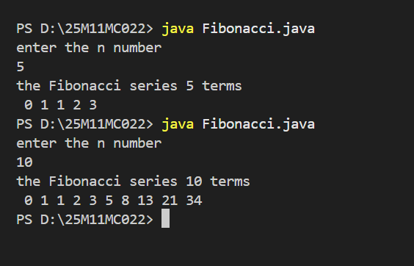

2. Write a Java Program that prompts the user for an integer and then prints out all the prime numbers up to the integer.
Aim: Write a Java Program that prompts the user for an integer and then prints out all the prime numbers up to the integer.
Program:
import java.util.Scanner;
public class PrimeNumber
{
public static void main(String args[])
{
int n,count,j,i;
Scanner sc=new Scanner(System.in);
System.out.println("Enter any Number");
n=sc.nextInt();
System.out.println("The Prime Numbers are:");
for(i=2;i<=n;i++)
{
count=0;
for(j=1;j<=n;j++)
{
if(i%j==0)
count++;
}
if(count==2)
{
System.out.println(i);
}
}
}
}

Output:
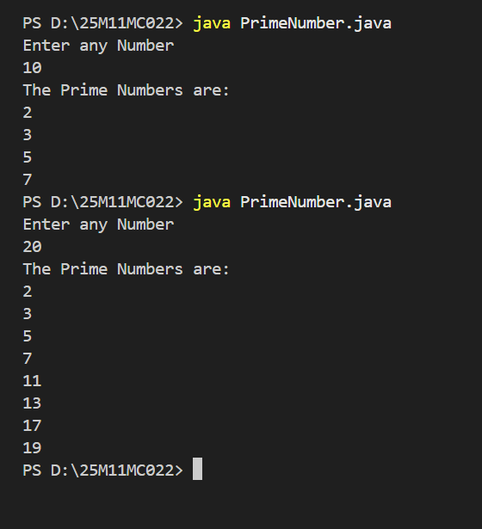

3. Write a Java Program to demonstrate String and String Buffer class Methods.
3.1. Write a Java Program to demonstrate String methods.
Aim: Write a Java Program to demonstrate String methods.
Program :
import java.lang.*;
class Strings {
public static void main(String args[]) {
String s=" Welcome"; //case conversion
System.out.println("Uppercase: "+s.toUpperCase());
System.out.println("Lowercase: "+s.toLowerCase()); //whitespace removal
System.out.println("Trimmed: "+s.trim()); //check starting and ending
System.out.println("Starts with 'e': "+s.startsWith("e"));
System.out.println("Ends with 'e': "+s.endsWith("e")); //character access
System.out.println("charAt(0): "+s.charAt(0));
System.out.println("charAt(6): "+s.charAt(6)); //index search
System.out.println("First index of 'e': "+s.indexOf("e"));
System.out.println("Last indexof 'e': "+s.lastIndexOf("e")); //length of string
System.out.println("Length: "+s.length()); //replace
System.out.println("Replace with e->y: "+s.replace("e","y")); //substring
System.out.println("Substring(0,4): "+s.substring(0,4)); //equals check
String s1="welcome";
System.out.println("Equals: "+s.equals(s1));
System.out.println("Equals Ignore Case: "+s.equalsIgnoreCase(s1)); //contains
System.out.println("Contains 'ome': "+s.contains("ome")); //isEmpty
String s2="";

System.out.println("Is empty string: "+s2.isEmpty()); //concat(concatenation)
System.out.println("Concatenation: "+s.concat("java"));
}
}

Output:
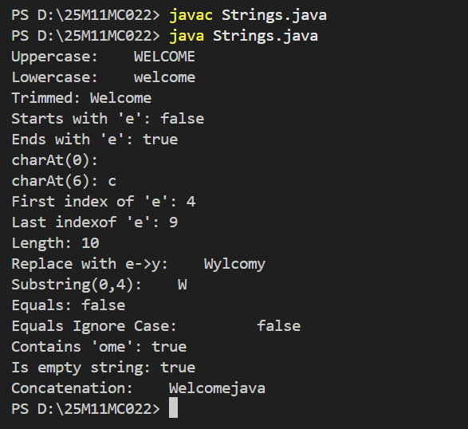

3.2. Write a java program to demonstrate String Buffer Methods
Aim: Write a java program to demonstrate String Buffer methods.
Program:
class StringBufferMethods
{
public static void main(String args[])
{
StringBuffer sb=new StringBuffer("Welcome");
sb.append(" java");
System.out.println("After append: "+sb);
sb.insert(8,"to ");
System.out.println("After insert: "+sb);
sb.setCharAt(4,'a');
System.out.println("After setCharAt: "+sb);
sb.delete(0,7); //delete characters from 0 to 6
System.out.println("After delete: "+sb);
sb.replace(0,4,"hello");
System.out.println("After replace: "+sb);
sb.reverse();
System.out.println("After reverse: "+sb);
System.out.println("Length: "+sb.length());
}
}
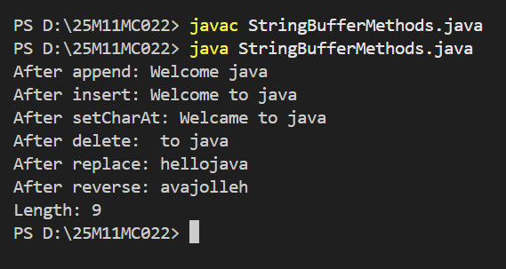

4. Implement the concept of constructor overloading.
Aim: Implement the concept of constructor overloading.
Program:
public class Constuctoroverloading{
String name;
int rollNo;
// Default constructor
Constuctoroverloading() {
name = "Chinthagunta Hemasatyasai";
rollNo = 22;
}
// Constructor with one parameter
Constuctoroverloading(String n) {
name = n;
rollNo = 0;
}
// Constructor with two parameters
Constuctoroverloading(String n, int r) {
name = n;
rollNo = r;
}
void display() {
System.out.println("Name: " + name + ", Roll No: " + rollNo);
}
public static void main(String[] args) {
Constuctoroverloading s1 = new Constuctoroverloading();
Constuctoroverloading s2 = new Constuctoroverloading("satya");
Constuctoroverloading s3 = new Constuctoroverloading("sai", 20);
s1.display();
s2.display();
s3.display();
}
}

Output:

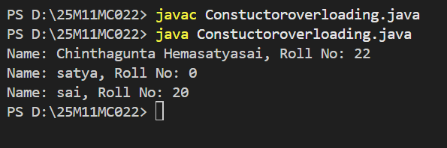

5. Implement concept of Inheritance, super, abstract and final keywords.
5.1. Write a java program on the Single Inheritance concept
Aim: Write a java program on the single Inheritance concepts
Program:
class Parent{
public void display() {
System.out.println("This is a parent class");
}
}
class Child extends Parent{
public void show() {
System.out.println("This is a Child class");
}
}
public class Singleinheritance{
public static void main(String args[])
{
System.out.println("This is called single inheritance");
Child obj = new Child();
obj.display();
obj.show();
}
}

Output:
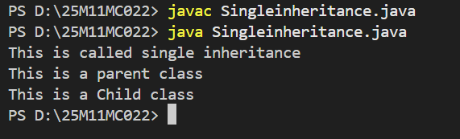

5.2. Write a java program on the Hierarchal Inheritance concept.
Aim : Write a java program on the Hierarchal Inheritance concept.
Program:
import java.lang.*;
class Parent
{
public void parentmsg() {
System.out.println("This is a parent class");
}
}
class Child1 extends Parent
{
public void child1msg() {
System.out.println("This is a intermediate class");
}
}
class Child2 extends Parent
{
public void child2msg() {
System.out.println("This is a child class");
}
}
class HierarchallevelInheritance
{
public static void main(String args[]) {
System.out.println("This is a hirearical inheritance");
Child1 obj1=new Child1();
obj1.parentmsg();
obj1.child1msg();
Child2 obj2=new Child2();
obj2.parentmsg();
obj2.child2msg();
}
}

Output :
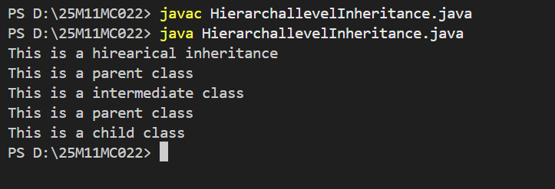

5.3. Write a java program on the Multilevel Inheritance concept.
Aim : Write a java program on the Multilevel Inheritance concept.
Program:
class Base {
public void basemsg() {
System.out.println("This is a base class");
}
}
class Intermediate extends Base {
public void intermsg() {
System.out.println("This is a intermediate class");
}
}
class Derived extends Intermediate {
public void derivemsg()
{
System.out.println("This is a derived class");
}
}
public class Multilevelinheritance{
public static void main(String args[])
{
System.out.println("This is Multilevel Inheritance");
Derived obj=new Derived();
obj.basemsg();
obj.intermsg();
obj.derivemsg();
}
}

Output :

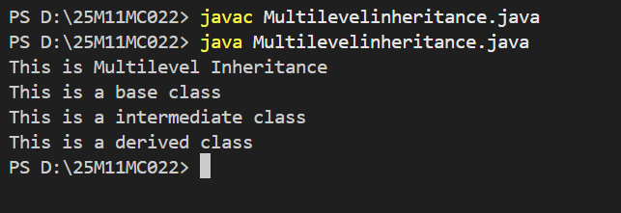

5.4. Write a java program for the Super Keyword.
Aim: Write a java program for the Super Keyword.
Program:
class Animal{
String name="Animal class";
Animal() {
System.out.println("This is the Animal class");
}
void sleep() {
System.out.println("Animal is sleeping");
}
}
class cat extends Animal {
String name="Cat class";
cat() {
super();
System.out.println("This is cat class");
}
void sleep()
{
super.sleep();
System.out.println("cat is sleeping");
}
void PrintName() {
System.out.println("Name:" +super.name);
System.out.println("Subclass name:" +name);
}
}
class Mainsuperkey{
public static void main(String args[]) {
System.out.println("Main class");
cat obj=new cat();
obj.sleep();
obj.PrintName();
}
}

Output:

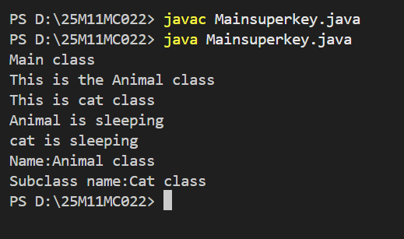

5.5. Write a java program for Abstract keyword.
Aim: Write a java program for Abstract keyword.
Program:
abstract class Student {
abstract void display();
void read() {
System.out.println("I am learning java");
}
}
class Dog extends Student{
void display() {
System.out.println("I am a Student");
}
}
class Abstract {
public static void main(String args[])
{
Dog d1=new Dog();
d1.display();
d1.read();
}
}
Output:
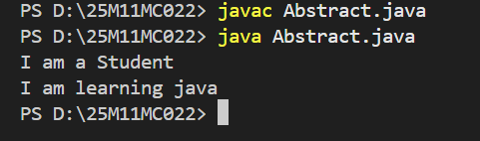

5.6. Write a java program for the Final keyword
Aim: Write a java program for the Final keyword
Program:
class FinalKeyinInheritance
{
public static void main(String args[])
{
final int b=5;
System.out.println(b);
b=10;
System.out.println(b);
}
}
// Method using final keyword
class Parent
{
final public void msg()
{
System.out.println("this is parent class");
}
}
class Child extends Parent
{
public void msg()
{
System.out.println("this is child class");
}
}
class FinalKeyinInheritance
{
public static void main(String args[]) {
System.out.println("this is sample class");
Child obj=new Child();
obj.msg();
obj.msg();
}
}
// Class using final keyword
final class Parent
{
public void msg()
{
System.out.println("this is parent class");
}
}
class Child extends Parent
{
public void msg()
{
System.out.println("this is child class");
}
}
class Finall
{
public static void main(String args[])
{
System.out.println("this is sample class");
Child obj=new Child();
obj.msg();
obj.msg();
}
}

Output:

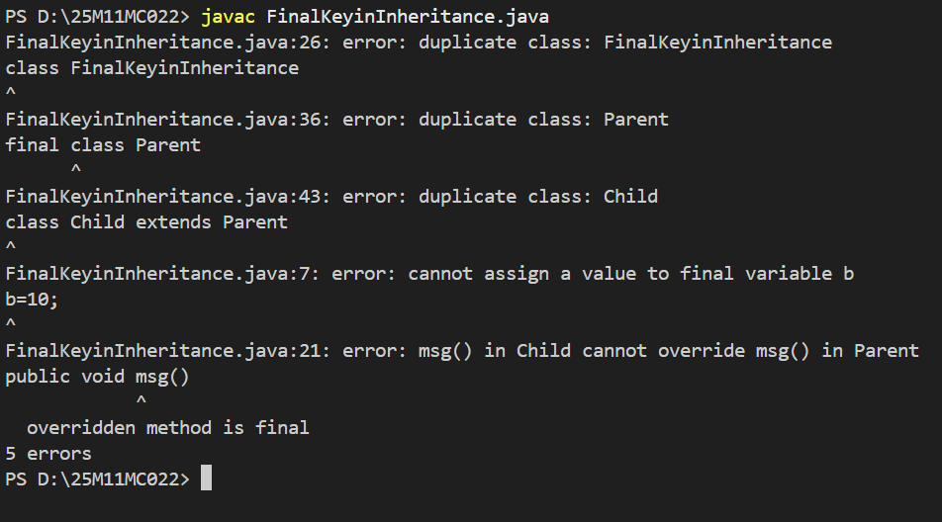

6. Write a java program for dynamic dispatch of methods.
Aim: Write a java program for dynamic dispatch of methods.
Program:
class Vehicle {
void run() {
System.out.println("vehicle is running");
}
void SpeedLimit() {
System.out.println("Every vehicle has speed limit");
}
}
class Bus extends Vehicle
{
void run() {
System.out.println("Bus is running");
}
void Wheels() {
System.out.println("Bus has four wheels");
}
}
class Dynamic{
public static void main(String []args)
{
Vehicle obj=new Bus();
obj.run();
obj.SpeedLimit();
}
}

Output:

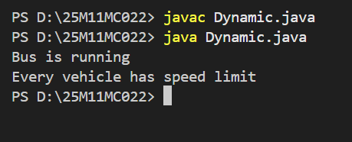

7. Write a java program to create and demonstrate packages.
Aim: Write a java program to create and demonstrate packages.
Program:
package mypack;
public class Addition {
int x,y;
public int Add(int a, int b){
x = a;
y = b;
return x +y;
}
}
package mypack;
public class Subtraction {
int a;
int b;}
public Subtraction() {
public int sub(int var1, int var2) {
this.a = var1;
this.b = var2;
return this.a - this.b;
}
}
package mypack;
public class Multi {
int a,b;
public int mul(int x,int y){
a=x;
b=y;
return x*y;
}
}

import mypack.*;
public class MainPackage {
public static void main(String[] args) {
Addition obj1 = new Addition();
int r1 = obj1.Add(12, 12);
System.out.println("Sum="+r1);
Subtraction obj2 =new Subtraction();
int r2 = obj2.sub(16,14);
System.out.println("Sub="+r2);
Multi obj3 = new Multi();
int r3 = obj3.mul(21,23);
System.out.println("Multi="+r3);
}
}

Output:
