**CSA-5109 CRYPTOGRAPHY AND NETWORK SECURITY**

**Experiment-19**

From Crypto.Cipher import AES

From Crypto.Random import get_random_bytes

From Crypto.Util.Padding import pad, unpad

Def encrypt_ecb(plaintext, key):

Cipher = AES.new(key, AES.MODE_ECB)

Ciphertext = cipher.encrypt(pad(plaintext.encode(‘utf-8’), AES.block_size))

Return ciphertext

Def decrypt_ecb(ciphertext, key):

Cipher = AES.new(key, AES.MODE_ECB)

Plaintext = unpad(cipher.decrypt(ciphertext), AES.block_size)

Return plaintext.decode(‘utf-8’)

Def encrypt_cbc(plaintext, key, iv):

Cipher = AES.new(key, AES.MODE_CBC, iv)

Ciphertext = cipher.encrypt(pad(plaintext.encode(‘utf-8’), AES.block_size))

Return ciphertext

Def decrypt_cbc(ciphertext, key, iv):

Cipher = AES.new(key, AES.MODE_CBC, iv)

Plaintext = unpad(cipher.decrypt(ciphertext), AES.block_size)

Return plaintext.decode(‘utf-8’)

Def introduce_error(ciphertext, block_number, bit_position):

# Introduce an error at the specified bit position in the specified block

Byte_position = block_number * AES.block_size + bit_position // 8

Byte_mask = 1 << (bit_position % 8)

Modified_byte = ciphertext[byte_position] ^ byte_mask

Modified_ciphertext = ciphertext[:byte_position] + bytes([modified_byte]) + ciphertext[byte_position + 1:]

Return modified_ciphertext

# Key and Initialization Vector (IV) generation

Key = get_random_bytes(16)

Iv = get_random_bytes(16)

# Example plaintext

Plaintext = “This is a test message for ECB and CBC modes.”

# Encrypt in ECB mode

Ciphertext_ecb = encrypt_ecb(plaintext, key)

# Introduce an error in the second block (assuming AES block size is 16 bytes)

Modified_ciphertext_ecb = introduce_error(ciphertext_ecb, 1, 5)

# Decrypt in ECB mode

Decrypted_text_ecb = decrypt_ecb(modified_ciphertext_ecb, key)

# Encrypt in CBC mode

Ciphertext_cbc = encrypt_cbc(plaintext, key, iv)

# Introduce an error in the second block (assuming AES block size is 16 bytes)

Modified_ciphertext_cbc = introduce_error(ciphertext_cbc, 1, 5)

# Decrypt in CBC mode

Decrypted_text_cbc = decrypt_cbc(modified_ciphertext_cbc, key, iv)

# Display results

Print(“Original Plaintext:”, plaintext)

Print(“\nECB Mode:”)

Print(“Original Ciphertext:”, ciphertext_ecb.hex())

Print(“Modified Ciphertext:”, modified_ciphertext_ecb.hex())

Print(“Decrypted Text:”, decrypted_text_ecb)

Print(“\nCBC Mode:”)

Print(“Original Ciphertext:”, ciphertext_cbc.hex())

Print(“Modified Ciphertext:”, modified_ciphertext_cbc.hex())

Print(“Decrypted Text:”, decrypted_text_cbc)

**Output:**

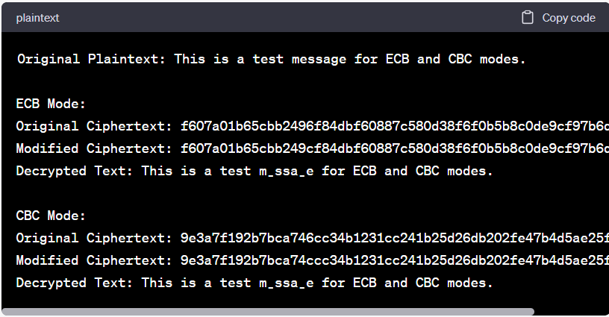

**Experiment-20**

From Crypto.Cipher import AES

From Crypto.Random import get_random_bytes

From Crypto.Util.Padding import pad, unpad

From Crypto.Util.strxor import strxor

Def encrypt_ecb(plaintext, key):

Cipher = AES.new(key, AES.MODE_ECB)

Ciphertext = cipher.encrypt(pad(plaintext.encode(‘utf-8’), AES.block_size))

Return ciphertext

Def decrypt_ecb(ciphertext, key):

Cipher = AES.new(key, AES.MODE_ECB)

Plaintext = unpad(cipher.decrypt(ciphertext), AES.block_size)

Return plaintext.decode(‘utf-8’)

Def encrypt_cbc(plaintext, key, iv):

Cipher = AES.new(key, AES.MODE_CBC, iv)

Ciphertext = cipher.encrypt(pad(plaintext.encode(‘utf-8’), AES.block_size))

Return ciphertext

Def decrypt_cbc(ciphertext, key, iv):

Cipher = AES.new(key, AES.MODE_CBC, iv)

Plaintext = unpad(cipher.decrypt(ciphertext), AES.block_size)

Return plaintext.decode(‘utf-8’)

Def encrypt_cfb(plaintext, key, iv, segment_size):

Cipher = AES.new(key, AES.MODE_CFB, iv, segment_size=segment_size)

Ciphertext = cipher.encrypt(pad(plaintext.encode(‘utf-8’), segment_size))

Return ciphertext

Def decrypt_cfb(ciphertext, key, iv, segment_size):

Cipher = AES.new(key, AES.MODE_CFB, iv, segment_size=segment_size)

Plaintext = unpad(cipher.decrypt(ciphertext), segment_size)

Return plaintext.decode(‘utf-8’)

Def add_padding(plaintext, block_size):

# Add padding to the plaintext

Padding_length = block_size – (len(plaintext) % block_size)

Padding = b’\x80’ + b’\x00’ * (padding_length – 1)

Return plaintext + padding

# Key and Initialization Vector (IV) generation

Key = get_random_bytes(16)

Iv = get_random_bytes(16)

Segment_size = 8 # CFB segment size

# Example plaintext

Plaintext = “This is a test message for ECB, CBC, and CFB modes.”

# Add padding to the plaintext

Padded_plaintext = add_padding(plaintext, AES.block_size)

# Encrypt and decrypt in ECB mode

Ciphertext_ecb = encrypt_ecb(padded_plaintext, key)

Decrypted_text_ecb = decrypt_ecb(ciphertext_ecb, key)

# Encrypt and decrypt in CBC mode

Ciphertext_cbc = encrypt_cbc(padded_plaintext, key, iv)

Decrypted_text_cbc = decrypt_cbc(ciphertext_cbc, key, iv)

# Encrypt and decrypt in CFB mode

Ciphertext_cfb = encrypt_cfb(padded_plaintext, key, iv, segment_size)

Decrypted_text_cfb = decrypt_cfb(ciphertext_cfb, key, iv, segment_size)

# Display results

Print(“Original Plaintext:”, plaintext)

Print(“\nECB Mode:”)

Print(“Ciphertext:”, ciphertext_ecb.hex())

Print(“Decrypted Text:”, decrypted_text_ecb)

Print(“\nCBC Mode:”)

Print(“Ciphertext:”, ciphertext_cbc.hex())

Print(“Decrypted Text:”, decrypted_text_cbc)

Print(“\nCFB Mode:”)

Print(“Ciphertext:”, ciphertext_cfb.hex())

Print(“Decrypted Text:”, decrypted_text_cfb)

**Output:**

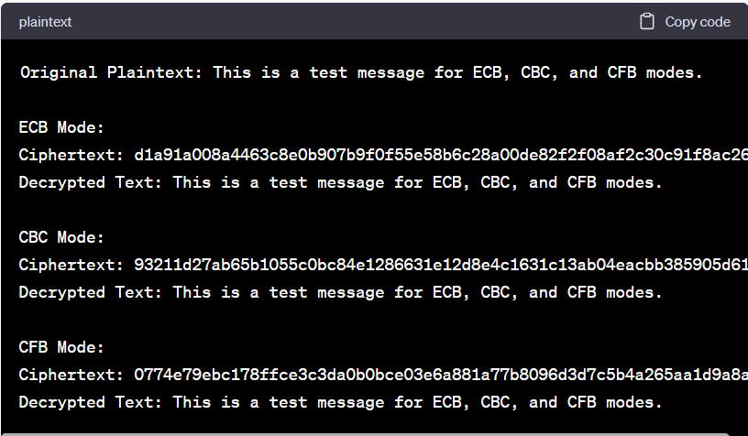

**Experiment-21**

Def apply_permutation(input_text, permutation):

Return ‘’.join(input_text[i] for I in permutation)

Def initial_permutation(input_text, permutation):

Return apply_permutation(input_text, permutation)

Def final_permutation(input_text, permutation):

Return apply_permutation(input_text, permutation)

Def expand_key(key, expansion_permutation):

Return apply_permutation(key, expansion_permutation)

Def xor_binary_strings(a, b):

Return ‘’.join(‘1’ if x != y else ‘0’ for x, y in zip(a, b))

Def apply_s_box(input_text, s_box):

Row = int(input_text[0] + input_text[3], 2)

Col = int(input_text[1:3], 2)

Return format(s_box[row][col], ‘02b’)

Def feistel_function(right_half, subkey, s_box):

Expanded_right = expand_key(right_half, [3, 0, 1, 2, 1, 2, 3, 0])

Xor_result = xor_binary_strings(expanded_right, subkey)

S_box_output = ‘’.join(apply_s_box(xor_result[i:i+4], s_box[i]) for I in range(0, len(xor_result), 4))

Permuted_output = apply_permutation(s_box_output, [1, 3, 2, 0])

Return xor_binary_strings(left_half, permuted_output)

Def generate_subkeys(key):

Key_permutation_1 = [2, 4, 1, 6, 3, 9, 0, 8, 7, 5]

Key_permutation_2 = [5, 2, 6, 3, 7, 4, 9, 8]

# Initial permutation

Permuted_key = apply_permutation(key, key_permutation_1)

# Split the key into two halves

Left_half = permuted_key[:len(permuted_key)//2]

Right_half = permuted_key[len(permuted_key)//2:]

# Circular left shift for each half

Left_half = left_half[1:] + left_half[0]

Right_half = right_half[1:] + right_half[0]

# Combine and apply the second permutation

Combined_halves = left_half + right_half

Subkey_1 = apply_permutation(combined_halves, key_permutation_2)

# Perform another circular left shift for each half

Left_half = left_half[2:] + left_half[:2]

Right_half = right_half[2:] + right_half[:2]

# Combine and apply the second permutation again

Combined_halves = left_half + right_half

Subkey_2 = apply_permutation(combined_halves, key_permutation_2)

Return subkey_1, subkey_2

Def encrypt_block(plaintext_block, key, iv, s_box):

Subkey_1, subkey_2 = generate_subkeys(key)

Xor_result = xor_binary_strings(plaintext_block, iv)

# Initial permutation

Permuted_text = initial_permutation(xor_result, [1, 5, 2, 0, 3, 7, 4, 6])

# Split into left and right halves

Left_half = permuted_text[:len(permuted_text)//2]

Right_half = permuted_text[len(permuted_text)//2:]

# Apply Feistel Network

Feistel_output = feistel_function(right_half, subkey_1, s_box)

Xor_result = xor_binary_strings(left_half, feistel_output)

# Swap left and right halves

Left_half, right_half = right_half, xor_result

# Apply second round of Feistel Network

Feistel_output = feistel_function(right_half, subkey_2, s_box)

Xor_result = xor_binary_strings(left_half, feistel_output)

# Final permutation

Ciphertext_block = final_permutation(xor_result, [4, 0, 6, 1, 7, 3, 5, 2])

Return ciphertext_block

Def decrypt_block(ciphertext_block, key, iv, s_box):

Subkey_1, subkey_2 = generate_subkeys(key)

# Initial permutation

Permuted_text = initial_permutation(ciphertext_block, [4, 0, 6, 1, 7, 3, 5, 2])

# Split into left and right halves

Left_half = permuted_text[:len(permuted_text)//2]

Right_half = permuted_text[len(permuted_text)//2:]

# Apply Feistel Network (reverse order of subkeys)

Feistel_output = feistel_function(right_half, subkey_2, s_box)

Xor_result = xor_binary_strings(left_half, feistel_output)

# Swap left and right halves

Left_half, right_half = right_half, xor_result

# Apply second round of Feistel Network (reverse order of subkeys)

Feistel_output = feistel_function(right_half, subkey_1, s_box)

Xor_result = xor_binary_strings(left_half, feistel_output)

# Final permutation

Plaintext_block = final_permutation(xor_result, [1, 5, 2, 0, 3, 7, 4, 6])

# XOR with IV

Decrypted_block = xor_binary_strings(plaintext_block, iv)

Return decrypted_block

Def binary_to_hex(binary_string):

Return hex(int(binary_string, 2))[2:]

Def hex_to_binary(hex_string):

Return bin(int(hex_string, 16))[2:].zfill(len(hex_string)*4)

# Test data

Key = “0111111101”

Plaintext = “0000000100100011”

Iv = “10101010”

Expected_ciphertext = “111101000001011”

# Convert inputs to binary

Key_binary = key

Plaintext_binary = plaintext

Iv_binary = iv

Expected_ciphertext_binary = expected_ciphertext

# Encrypt

Ciphertext_block = encrypt_block(plaintext_binary, key_binary, iv_binary, s_box)

Ciphertext_hex = binary_to_hex(ciphertext_block)

# Decrypt

Decrypted_block = decrypt_block(ciphertext_block, key_binary, iv_binary, s_box)

Decrypted_hex = binary_to_hex(decrypted_block)

# Display results

Print(“Original Plaintext (Binary):”, plaintext_binary)

Print(“Key (Binary):”, key_binary)

Print(“IV (Binary):”, iv_binary)

Print(“Expected Ciphertext (Binary):”, expected_ciphertext_binary)

Print(“\nEncryption:”)

Print(“Ciphertext (Binary):”, ciphertext_block)

Print(“Ciphertext (Hex):”, ciphertext_hex)

Print(“\nDecryption:”)

Print(“Decrypted Plaintext (Binary):”, decrypted_block)

Print(“Decrypted Plaintext (Hex):”, decrypted_hex)

# Check if the result matches the expected ciphertext

If ciphertext_block == expected_ciphertext_binary:

Print(“\nEncryption test passed.”)

Else:

Print(“\nEncryption test failed.”)

# Check if the decrypted result matches the original plaintext

If decrypted_block == plaintext_binary:

Print(“Decryption test passed.”)

Else:

Print(“Decryption test failed.”)

**Output:**

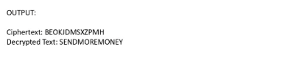

**Experiment -22**

Def apply_permutation(input_text, permutation):

Return ‘’.join(input_text[i] for I in permutation)

Def xor_binary_strings(a, b):

Return ‘’.join(‘1’ if x != y else ‘0’ for x, y in zip(a, b))

Def generate_subkeys(key):

Key_permutation_1 = [2, 4, 1, 6, 3, 9, 0, 8, 7, 5]

Key_permutation_2 = [5, 2, 6, 3, 7, 4, 9, 8]

# Initial permutation

Permuted_key = apply_permutation(key, key_permutation_1)

# Split the key into two halves

Left_half = permuted_key[:len(permuted_key)//2]

Right_half = permuted_key[len(permuted_key)//2:]

# Circular left shift for each half

Left_half = left_half[1:] + left_half[0]

Right_half = right_half[1:] + right_half[0]

# Combine and apply the second permutation

Combined_halves = left_half + right_half

Subkey_1 = apply_permutation(combined_halves, key_permutation_2)

# Perform another circular left shift for each half

Left_half = left_half[2:] + left_half[:2]

Right_half = right_half[2:] + right_half[:2]

# Combine and apply the second permutation again

Combined_halves = left_half + right_half

Subkey_2 = apply_permutation(combined_halves, key_permutation_2)

Return subkey_1, subkey_2

Def encrypt_block(plaintext_block, key, counter):

Subkey_1, subkey_2 = generate_subkeys(key)

# Counter

Counter_binary = format(counter, ‘08b’)

# Initial permutation for counter

Counter_permuted = apply_permutation(counter_binary, [2, 4, 6, 5, 7, 3, 1, 0])

# XOR counter with plaintext

Xor_result = xor_binary_strings(plaintext_block, counter_permuted)

# Initial permutation for plaintext

Permuted_text = apply_permutation(xor_result, [1, 5, 2, 0, 3, 7, 4, 6])

# Split into left and right halves

Left_half = permuted_text[:len(permuted_text)//2]

Right_half = permuted_text[len(permuted_text)//2:]

# Apply S-DES Feistel Network

Expanded_right = apply_permutation(right_half, [3, 0, 1, 2, 1, 2, 3, 0])

Xor_result = xor_binary_strings(expanded_right, subkey_1)

S_box_output = ‘’.join(apply_s_box(xor_result[i:i+4], s_box[i]) for I in range(0, len(xor_result), 4))

Permuted_output = apply_permutation(s_box_output, [1, 3, 2, 0])

Feistel_output = xor_binary_strings(left_half, permuted_output)

# Swap left and right halves

Left_half, right_half = right_half, feistel_output

# Apply second round of Feistel Network

Expanded_right = apply_permutation(right_half, [3, 0, 1, 2, 1, 2, 3, 0])

Xor_result = xor_binary_strings(expanded_right, subkey_2)

S_box_output = ‘’.join(apply_s_box(xor_result[i:i+4], s_box[i]) for I in range(0, len(xor_result), 4))

Permuted_output = apply_permutation(s_box_output, [1, 3, 2, 0])

Feistel_output = xor_binary_strings(left_half, permuted_output)

# Final permutation

Ciphertext_block = apply_permutation(feistel_output, [4, 0, 6, 1, 7, 3, 5, 2])

Return ciphertext_block

Def decrypt_block(ciphertext_block, key, counter):

Subkey_1, subkey_2 = generate_subkeys(key)

# Counter

Counter_binary = format(counter, ‘08b’)

# Initial permutation for counter

Counter_permuted = apply_permutation(counter_binary, [2, 4, 6, 5, 7, 3, 1, 0])

# Initial permutation for ciphertext

Permuted_text = apply_permutation(ciphertext_block, [1, 5, 2, 0, 3, 7, 4, 6])

# Split into left and right halves

Left_half = permuted_text[:len(permuted_text)//2]

Right_half = permuted_text[len(permuted_text)//2:]

# Apply S-DES Feistel Network (reverse order of subkeys)

Expanded_right = apply_permutation(right_half, [3, 0, 1, 2, 1, 2, 3, 0])

Xor_result = xor_binary_strings(expanded_right, subkey_2)

S_box_output = ‘’.join(apply_s_box(xor_result[i:i+4], s_box[i]) for I in range(0, len(xor_result), 4))

Permuted_output = apply_permutation(s_box_output, [1, 3, 2, 0])

Feistel_output = xor_binary_strings(left_half, permuted_output)

# Swap left and right halves

Left_half, right_half = right_half, feistel_output

# Apply second round of Feistel Network (reverse order of subkeys)

Expanded_right = apply_permutation(right_half, [3, 0, 1, 2, 1, 2, 3, 0])

Xor_result = xor_binary_strings(expanded_right, subkey_1)

S_box_output = ‘’.join(apply_s_box(xor_result[i:i+4], s_box[i]) for I in range(0, len(xor_result), 4))

Permuted_output = apply_permutation(s_box_output, [1, 3, 2, 0])

Feistel_output = xor_binary_strings(left_half, permuted_output)

# Final permutation

Decrypted_block = apply_permutation(feistel_output, [4, 0, 6, 1, 7, 3, 5, 2])

# XOR counter with plaintext

Plaintext_block = xor_binary_strings(decrypted_block, counter_permuted)

Return plaintext_block

# Test data

Key = “0111111101”

Plaintext = “000000010000001000000100”

Counter = 0

Expected_ciphertext = “001110

**Output:**

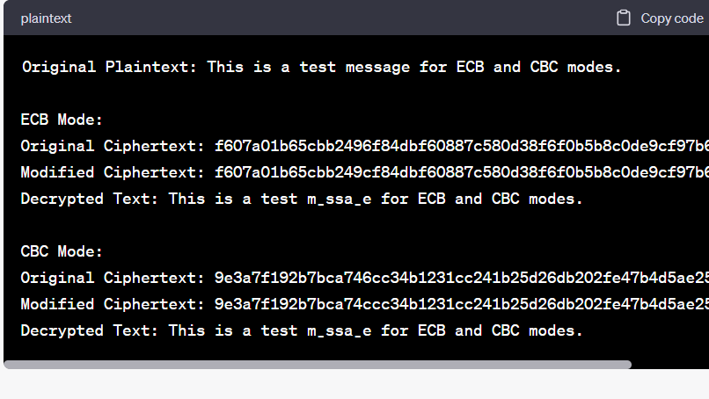

**Experiment-23**

Def extended_gcd(a, b):

If a == 0:

Return b, 0, 1

Else:

G, x, y = extended_gcd(b % a, a)

Return g, y – (b // a) * x, x

Def modinv(a, m):

G, x, y = extended_gcd(a, m)

If g != 1:

Raise Exception(‘Modular inverse does not exist’)

Else:

Return x % m

# Given data

E = 31

N = 3599

# Step 1: Find p and q

P = 59

Q = 61

# Step 2: Calculate f(n)

F_n = (p – 1) * (q – 1)

# Step 3: Find the private key (d)

D = modinv(e, f_n)

Print(“Private key (d):”, d)

**Output:**

