Part – 1

Insights into the Sales leadership Team:
Before moving further, I want to clarify that
Data Sets Used:
- PBJ (Payroll-Based Journal)
- Providers Information
Technologies Used:
- Python
Platform:
- Google Colab
Insight – 1:

Insight to Leadership Team:
  - RNDON (Registered Nurse Donor)
Based on the data from the line chart and the analysis of the RNDON (Registered Nurse Donor) roles, there are some key observations that need attention. The chart clearly highlights the dominance of contractor hours over employee hours, particularly in Kansas (KS), where the reliance on contract workers is significantly higher. This trend suggests that Kansas is heavily dependent on contract workers, likely driven by regional economic factors, fluctuating demand, or the need for temporary or flexible staffing solutions.
Specifically, in the RNDON role, which spans both administrative and clinical responsibilities, the impact of contractor hours is especially pronounced. Approximately 66% of the total staff in this role consists of contractors, while only 33% are full-time employees. This imbalance is more evident in Kansas, where 80% of the workforce in this role is made up of contractors.
This over-reliance on contract workers raises concerns regarding labor inefficiency, as it may lead to challenges in managing the number of hours allocated to full-time employees. This, in turn, could impact on the finances of the state, as more reliance on contractors could lead to higher overall costs and possibly affect the quality of care provided.

Key Focus Areas for Further Exploration:
- Workforce Distribution:
The spike difference between employee and contractor staffing in Kansas, particularly in the RNDON roles, suggests that we need to explore the reasons behind this imbalance
- Skill Matrix and Hiring: One possible factor contributing to this discrepancy is the skill matrix—a critical pain point in hiring for specialized roles like nursing. It’s essential to assess whether the skills gap or other hiring challenges are causing this heavy reliance on contract workers in certain regions, especially in Kansas.
- Future Strategy: Our goal should be to better balance the proportion of contractors and employees in these roles. By addressing the issues related to hiring and the skill matrix, we can aim to make the workforce more stable and efficient, reducing the dependence on contractors and creating a more sustainable and cost-effective staffing model.





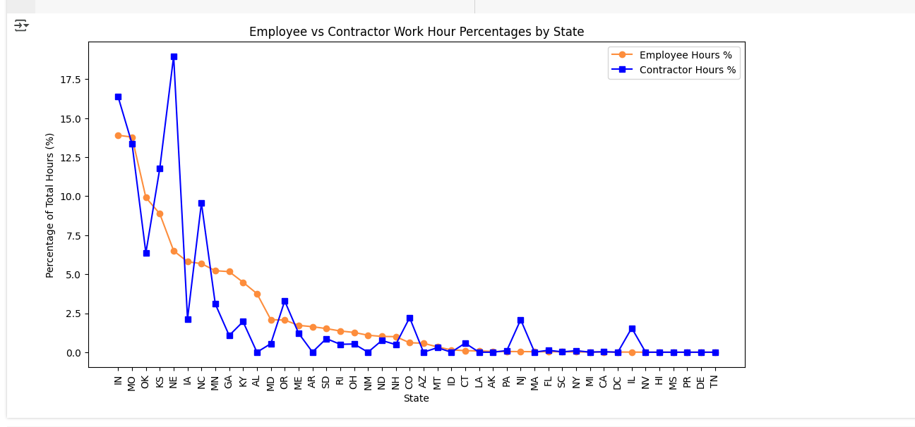

  - Registered Nurse Administrators

Insight into RNadmin Role in New York:
In the RNadmin (Registered Nurse Administration) role, a notable trend emerges with a significant spike in the reliance on contract workers in New York (NY). Approximately 80% of the workforce in this role consists of contractors, while only 20% are full-time employees. This heavy dependence on contract workers in New York highlights a potential challenge in the workforce structure, where contractor hours dominate, and full-time positions are less prevalent.
This disproportionate reliance on contractors could be driven by factors such as regional economic conditions, staffing flexibility requirements, or short-term demand fluctuations in the healthcare sector. The imbalance in workforce distribution may also indicate challenges with hiring full-time staff or meeting skill requirements in the state.
Implications:
- Labor Efficiency Concerns: The high percentage of contractors in New York could suggest potential inefficiencies in labor management, particularly in the RNadmin roles, where stable, full-time staffing might be preferable.
- Cost and Stability: Over-reliance on contractors can result in higher operational costs and may lead to concerns about the continuity of care and workforce stability





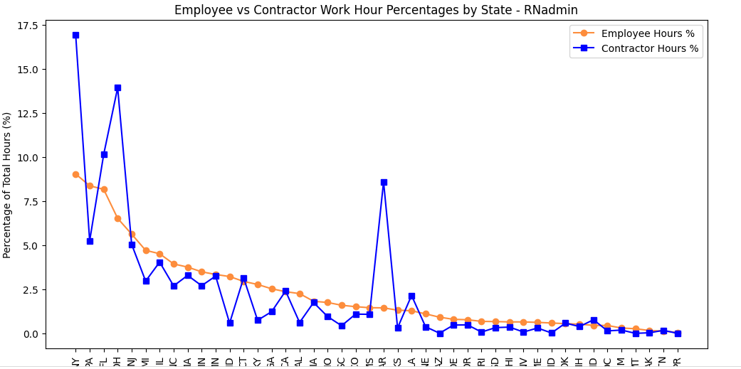

  - Licensed Practical Nurse Administration

- Insight on LPNadmin Role and Outlier in Contract Hours:

- In the LPNadmin (Licensed Practical Nurse Administration) role, a significant outlier is observed, where the percentage of contract hours is notably higher compared to employee hours. This anomaly highlights a potential concern in staffing practices for this role. Given that the LPNadmin role overlaps between administrative and clinical duties, this heavy reliance on contract workers could have long-term implications for workforce management, quality of care, and overall operational efficiency.

- The high percentage of contract hours in this role suggests a possible challenge in maintaining a consistent workforce, which could directly affect service delivery and the continuity of care. As LPNadmin roles are critical in both clinical and administrative settings, having a large percentage of contract workers may impact the training and experience level within the team, leading to inefficiencies in day-to-day operations.

- Suggestions for Leadership

  - We may need to check further immediately here because if we have disproportions, there may be inconsistencies in care delivery also
  - As the word contractors mean, they work for the specified time and will be continuing in the same agency or not will be decided further if they don’t move forward, it will create a lot of Skill gap and to train each Nurse would take considerate amount of time
  - A workforce dominated by contract workers in the LPNadmin role might result in lower morale among full-time employees, as they might feel less stable or valued compared to their contract counterparts. This can affect employee retention, engagement, and the overall work culture.
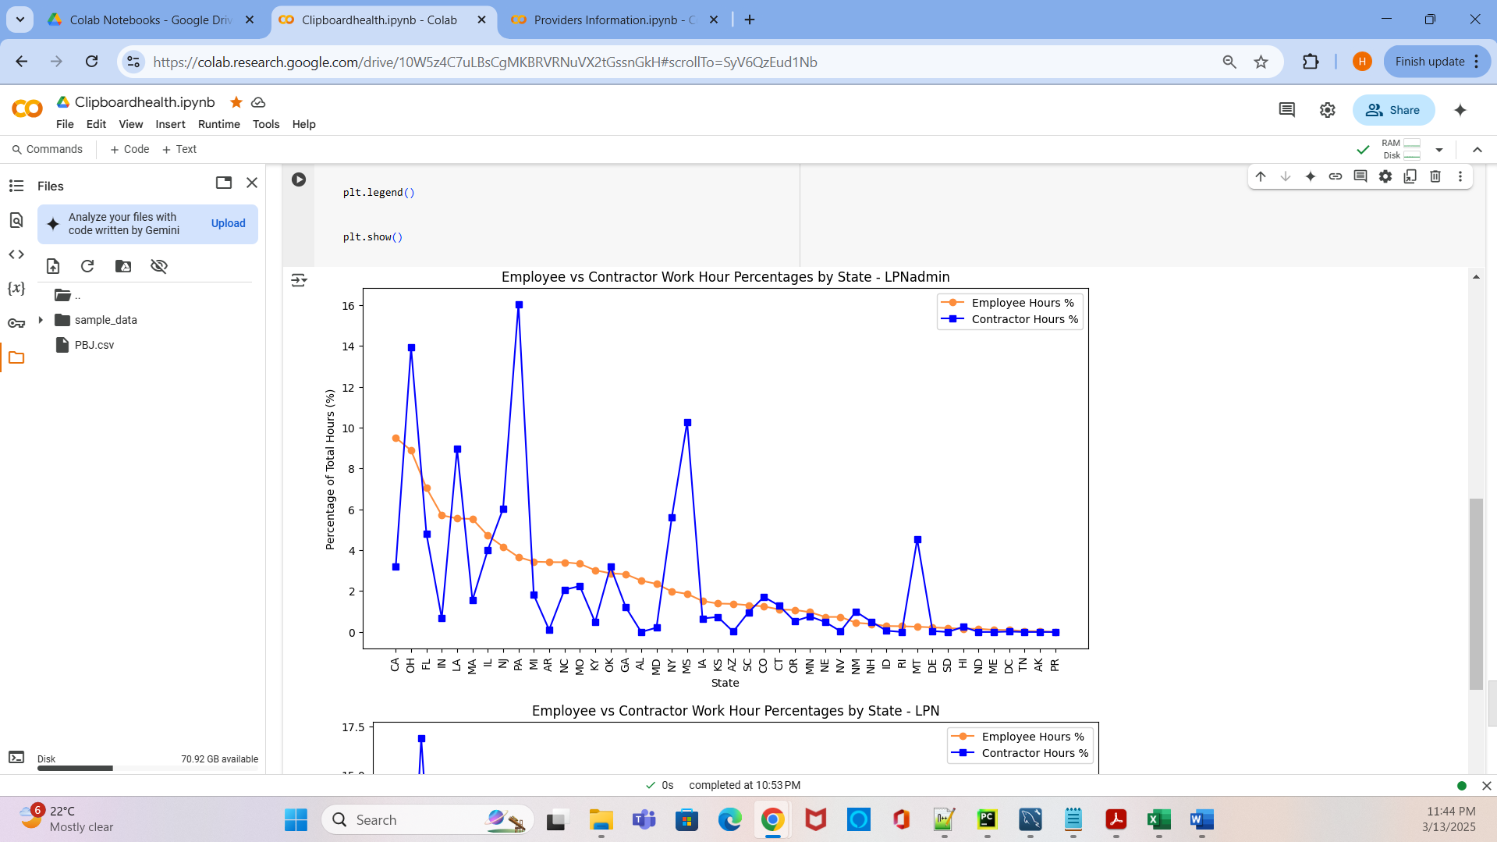

Conclusion:
Overall Impact:
- The over-reliance on contract workers in specific roles and states raises concerns about labor stability, costs, and service quality.
- There is a pressing need to balance the workforce distribution, ensuring that full-time employees are adequately represented in key roles, especially in clinical and administrative positions.
- Addressing skills gaps, hiring challenges, and workforce inefficiencies should be a priority to create a more stable, cost-effective, and efficient staffing model.

Insight – 2
Insight on MedAide Role in Kansas (KS):
In Kansas (KS), the data for the MedAide role, which typically involves the supply and management of medical equipment and supplies, shows a significant reliance on contract workers. Over 90% of the workforce in this role is made up of contractors, indicating a heavy dependency on temporary labor to meet the demand for healthcare supplies and equipment. While this may reflect an effort to manage short-term staffing needs, it also raises questions about long-term sustainability and quality of service.
Interestingly, despite the large number of contractors, a considerable number of counties in Kansas have less than 3-star ratings in the data. This suggests that, even though the required resources—such as beds and equipment—are being allocated, there may be operational inefficiencies or issues with the quality of service being provided in these counties. The reliance on contractors in the MedAide role could potentially lead to a lack of continuity in operations, inconsistent supply chains, or less familiarization with local healthcare needs, contributing to the low ratings.
Implications:
- Quality of Service: While the required beds and equipment are being allocated, the heavy use of contract workers in the MedAide role might be impacting the quality of care and service delivery. Contractors may not be as familiar with the specific requirements or challenges of each county, leading to potential supply chain disruptions, equipment shortages, or delayed responses.
- Operational Efficiency: The reliance on contractors in Kansas suggests that there might be operational inefficiencies, where temporary staff may lack the training or experience necessary to manage healthcare equipment effectively. This inefficiency could contribute to lower performance ratings in counties, despite meeting the basic equipment and bed allocation requirements.
- Impact on County Ratings: The low county ratings (less than 3 stars) in Kansas, despite adequate resources being allocated, indicate that quality and continuity of service might be suffering. The contract labor force might be unable to ensure a consistent and reliable level of care, which is essential for achieving high ratings.
Recommendation for the Leadership:
To address these issues, the following steps should be considered:
- Investigate Root Causes: Explore whether the heavy reliance on contract workers is due to regional staffing shortages, specific contractual limitations, or issues with hiring full-time employees in Kansas.
- Improve Workforce Stability: Reducing the reliance on contract workers and increasing the proportion of full-time employees in the MedAide role could help create a more stable workforce that is better equipped to manage equipment needs consistently across counties.
- Focus on Quality Assurance: Even with adequate resources, the focus should shift to improving the quality of service and efficiency in handling medical supplies and equipment. Strengthening training programs and ensuring that employees have a deeper understanding of local healthcare needs would help improve overall county ratings.
- Monitor and Adapt: Ongoing monitoring of county performance and staffing levels can help identify patterns and potential areas for improvement. This will enable better adaptation to fluctuating needs and ensure that the MedAide role is staffed adequately to maintain high standards.

Conclusion:
The data suggests that Kansas (KS) faces significant challenges in balancing the reliance on contract workers with the need for stable, high-quality care, especially in the MedAide role. While required resources such as beds and equipment are being allocated, the heavy dependence on contractors and the corresponding low county ratings indicate potential efficiency gaps and service quality issues. By addressing staffing imbalances, enhancing training programs, and focusing on quality assurance, Kansas could improve its performance and county ratings, ensuring better healthcare outcomes for residents.






Insight 3:
Insight on RN Role in New York (NY):
When examining the RN (Registered Nurse) role in New York, the data shows a significant over-representation of contract workers. In this case, contract workers are highly prevalent in clinical and administrative roles, with contract workers taking up a substantial portion of the workforce compared to full-time employees. This is especially evident when comparing the number of contract workers in New York to the number of full-time registered nurses.
As the RN role involves an overlap between clinical and administrative responsibilities, the fact that contract workers dominate this role raises several questions about staffing strategies, workforce preferences, and the challenges associated with maintaining a stable, full-time workforce.
Key Questions:
- Is the reliance on contract workers driven by higher pay rates?
Given the nature of the RN role as a combination of clinical and administrative duties, contractors may be drawn to these positions due to potentially higher pay rates, benefits, and the flexibility that comes with temporary contracts. Full-time employees, on the other hand, may not be as willing to accept these roles if they offer lower compensation or fewer benefits compared to contractors. Does this indicate a pay disparity between contractors and full-time employees?
- Is the difficulty in hiring full-time employees causing this imbalance?
Another possible reason could be hiring challenges in New York. Is there a lack of qualified full-time staff available for these roles, or is there an over-reliance on temporary staffing agencies to fill these positions? Could this be a result of regional hiring challenges, or is there a broader industry trend where healthcare facilities in New York struggle to recruit and retain full-time employees?
- Are full-time employees not preferred in these roles?
The RN role involves clinical and administrative tasks, which can require a high level of specialized skills and flexibility. Is it possible that full-time employees are not attracted to these roles because of the complexity or stress involved, or do they prefer to work in roles with clearer boundaries between clinical and administrative tasks? Could there be factors related to job satisfaction, work-life balance, or workplace culture that make these roles less appealing to full-time employees?
- Is there a temporary demand spike that necessitates more contractors?
Could the need for temporary contract workers in these roles be due to short-term demand fluctuations, such as seasonal increases in patient volume or administrative workload? Are there short-term projects or urgent staffing needs that require a temporary workforce to meet demand, rather than a focus on hiring more full-time employees?
- Is there a preference for contract workers in this specific role due to flexibility?
The RN role might be especially attractive to contract workers due to the flexibility it offers, both in terms of work schedule and the opportunity to work in different healthcare settings without long-term commitment. Could this preference for flexibility explain the high proportion of contractors, even in the face of staffing shortages for full-time employees?
- Impact on quality of care and continuity:
The heavy reliance on contractors for the RN role, which includes both clinical and administrative duties, could lead to variability in care quality and continuity of service. Contract workers may not have the same level of familiarity with a facility’s policies, procedures, and staffing culture, potentially leading to gaps in the quality of care. Is this an area of concern for the facility's leadership in terms of patient outcomes?
Summary:
The data clearly shows that New York (NY) is heavily reliant on contract workers in the RN role, where administrative and clinical responsibilities overlap. This raises important questions regarding pay disparities, hiring difficulties, and the preference for flexibility among contractors. The lack of full-time employees in these positions may point to challenges related to compensation, work-life balance, and job satisfaction, or it could reflect the need for temporary workers to meet short-term demand.
Recommendation:
To address these concerns, it would be valuable to:
- Investigate whether contract workers are indeed compensated more generously than full-time staff and whether this is driving the imbalance.
- Examine the reasons why full-time employees are not as attracted to these roles and explore potential improvements in compensation, training, and career development opportunities to make these roles more appealing.
- Assess whether the heavy reliance on contract workers is causing disruptions in care continuity or if it is necessary to meet short-term staffing demands.
By addressing these questions, New York could develop a more balanced workforce, ensuring that both contract and full-time workers are adequately represented to maintain high standards of care quality and employee satisfaction.



