DBMS – PRODUCT AND CATEGORY MANAGEMENT
Project title- Meesho Jewellery Marketplace Database
- Database Design
1.1 category table
Attribute | Data Type | Constraint
CATEGORY_ID | NUMBER(5) | Primary Key
CATEGORY_NAME | VARCHAR2(50) | NOT NULL
CATEGORY_DESCRIPTION | VARCHAR2(200) | —

  - Product Table
Attribute | Data Type | Constraint
PRODUCT_ID | NUMBER(5) | Primary Key
PRODUCT_NAME | VARCHAR2(100) | NOT NULL
DESCRIPTION | VARCHAR2(200) | —
PRICE | NUMBER(10,2) | NOT NULL
STOCK | NUMBER(5) | NOT NULL
IMAGE | VARCHAR2(200) | —
SELLER_ID | NUMBER(5) | —
CATEGORY_ID | NUMBER(5) | Foreign Key
2. Primary and Foreign Key Relationship
Category → Product
- CATEGORY.CATEGORY_ID → Primary Key
- PRODUCT.PRODUCT_ID → Primary Key
- PRODUCT.CATEGORY_ID → Foreign Key referencing CATEGORY.CATEGORY_ID
- Relationship: One-to-Many (1:M)
3. Table Creation
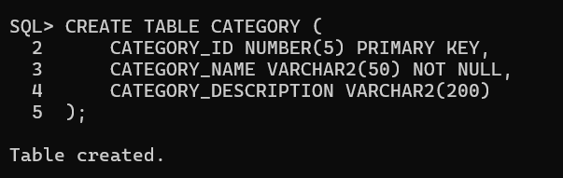
3.1 Create Category Table

3.2 Create Product Table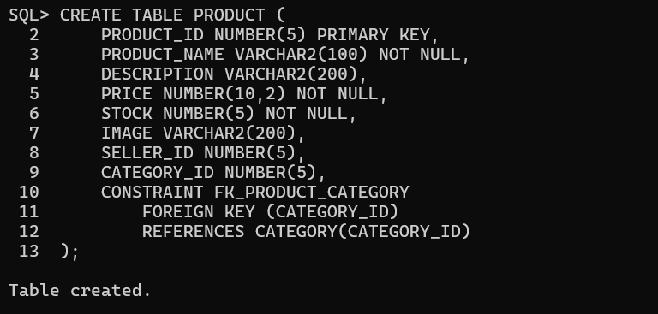
4. Data Insertion
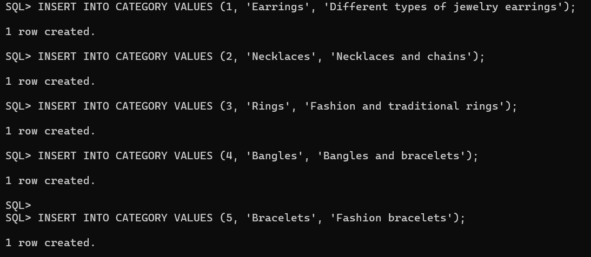
4.1 Category Records
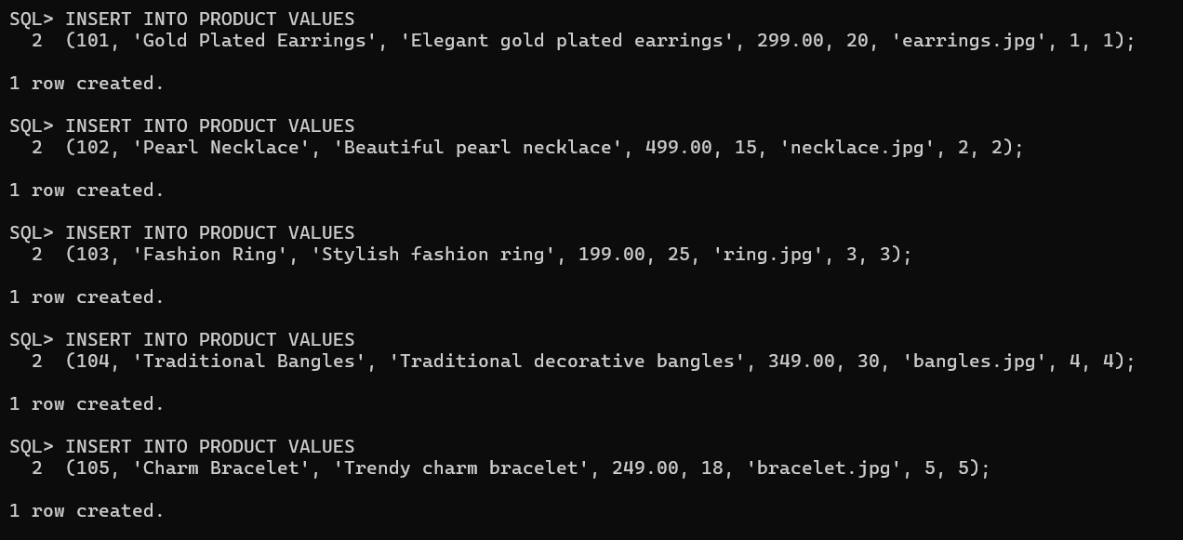
4.2 Product Records
5. Data Retrieval
5.1 Display Category Records
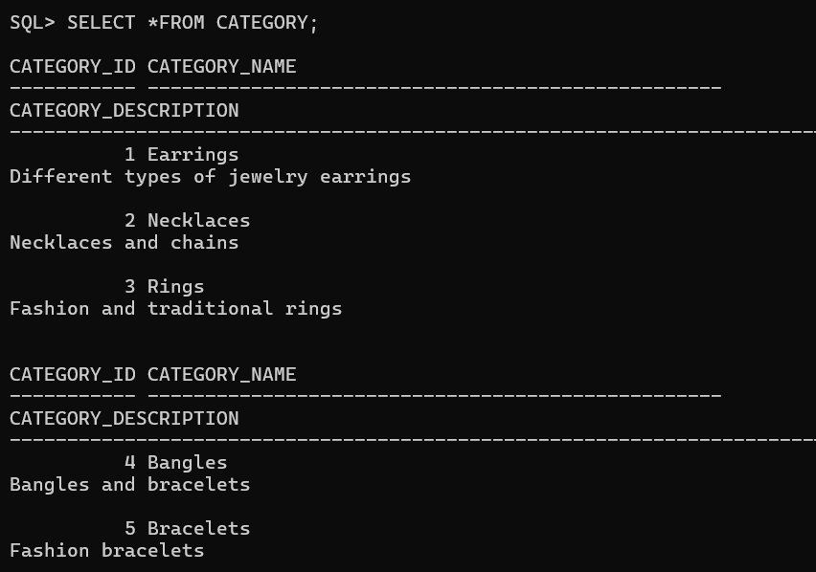

5.2 Display Product Record
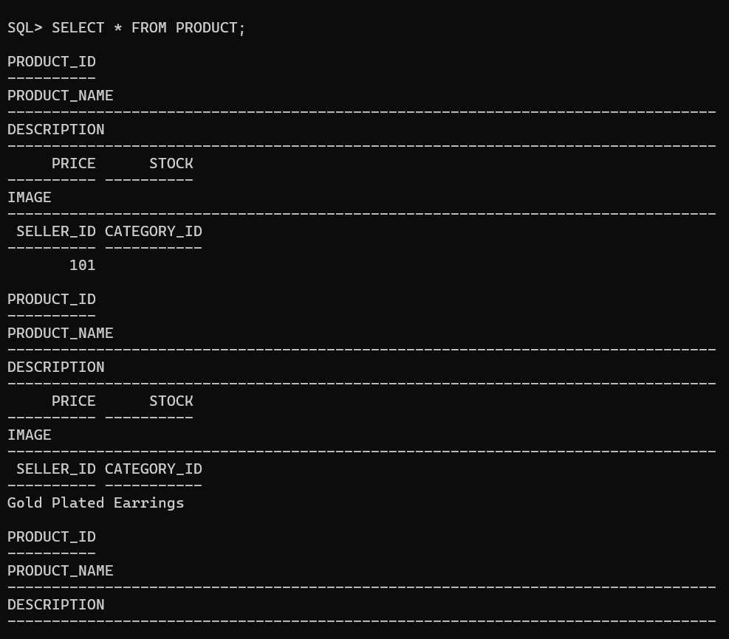
6.Product update
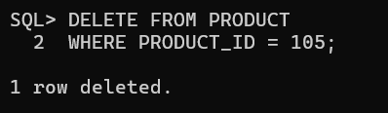
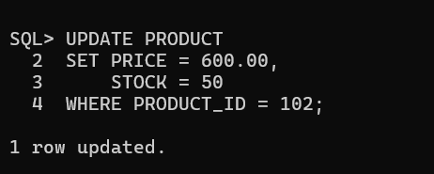
7.Product Delete

8. Category-wise Product Reports
8.1 Product Listing by Category
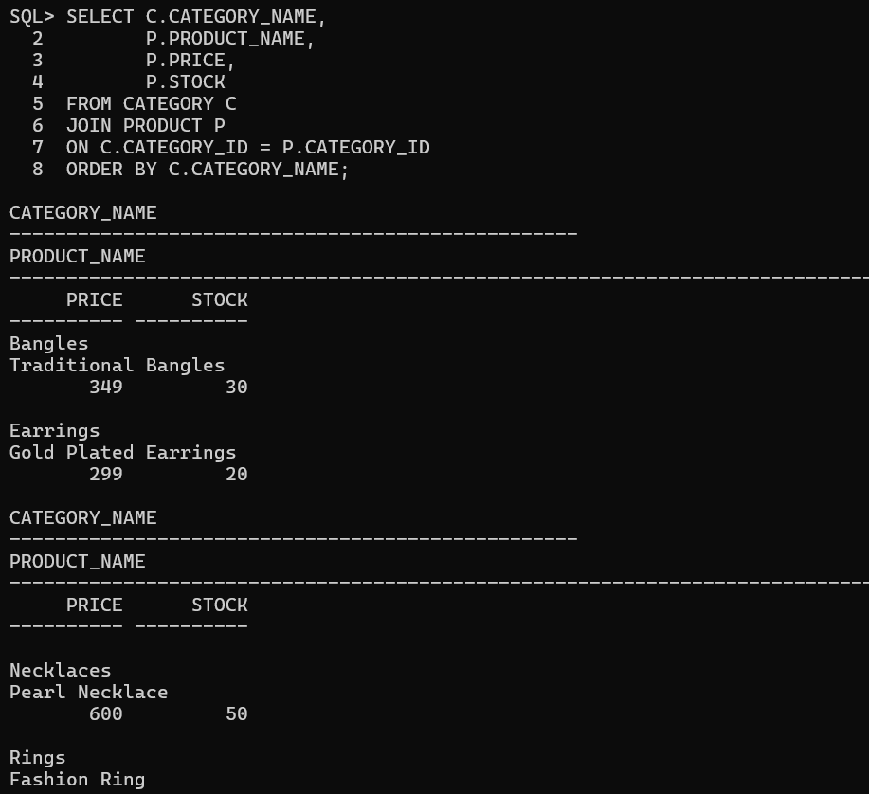
This report displays the category name along with the products belonging to each category.

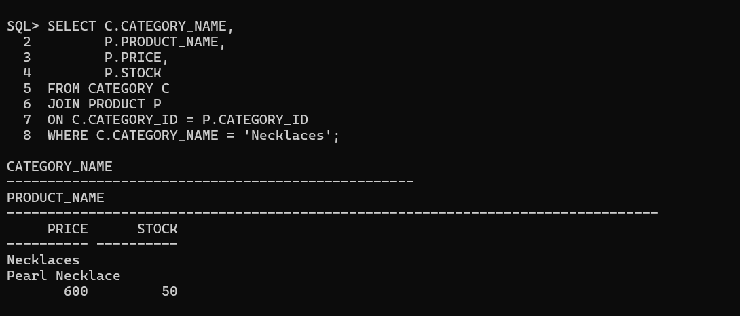
8.2 Product Listing By Specific Category

8.3 Product Count by Category
