DBMS – PAYMENT MANAGEMENT SYSTEM
Meesho Jewelry Marketplace Database

1. Objectives
- Create a PAYMENT table.
- Store payment details such as payment mode, date, amount, and status.
- Manage successful, failed, and pending transactions.
- Analyze payment methods used by customers.
- Generate payment transaction reports.

2. Database Design
The PAYMENT table is designed to store payment information related to customer orders.
Column Name | Data Type | Description
PAYMENT_ID | NUMBER(5) | Unique ID for each payment
ORDER_ID | NUMBER(5) | Identifies the related order
PAYMENT_MODE | VARCHAR2(30) | Mode used for payment
PAYMENT_DATE | DATE | Date of payment
PAYMENT_AMOUNT | NUMBER(10,2) | Amount paid
PAYMENT_STATUS | VARCHAR2(30) | Status of the payment

3. Relationship
The PAYMENT table is connected to the ORDERS table using ORDER_ID.
Relationship:
ORDERS 1 : 1 PAYMENT
- ORDERS.ORDER_ID → Primary Key
- PAYMENT.ORDER_ID → Foreign Key
This relationship connects each payment transaction with its corresponding order.

4. Table Creation
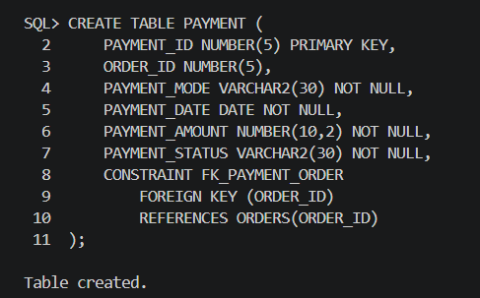

5. Data Insertion
Six payment records were inserted based on the existing orders.
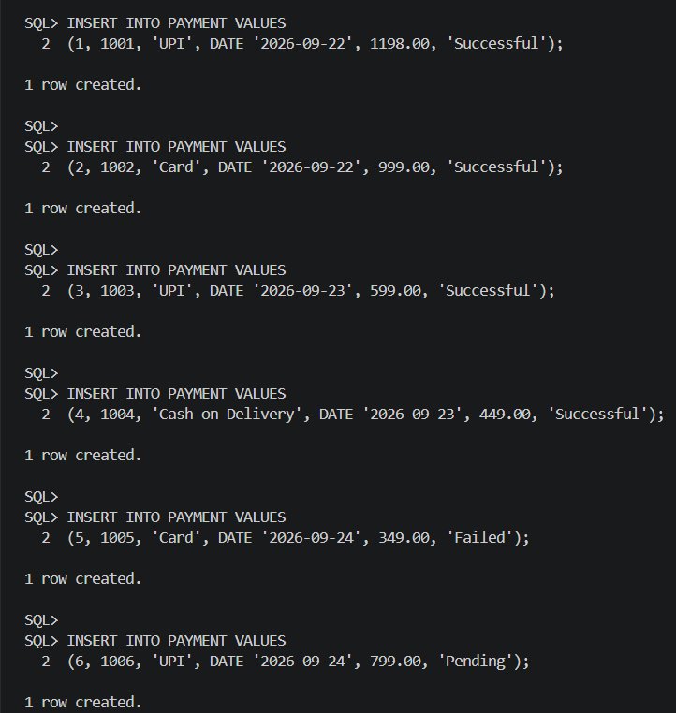
6. Managing Payment Transactions
Successful Transactions
This query displays all successfully completed payment transactions.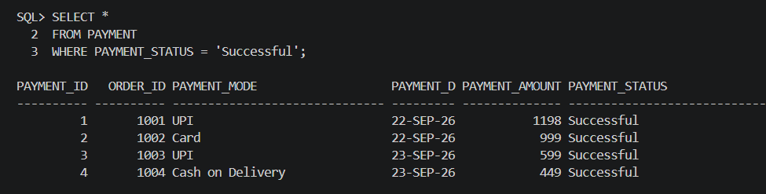

Failed Transactions
This query displays payment transactions that were unsuccessful.
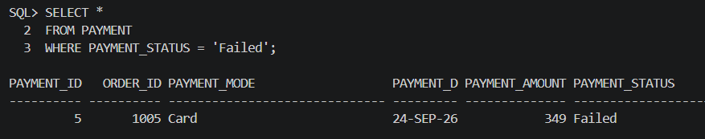

Pending Transactions
This query displays transactions that are still pending.
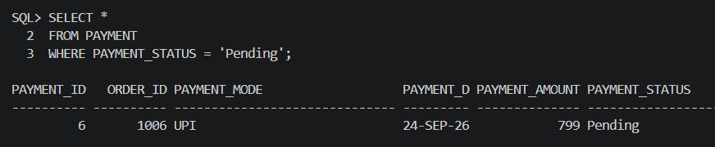

7. Analyzing Payment Methods
The number of transactions made using each payment method can be analyzed using:
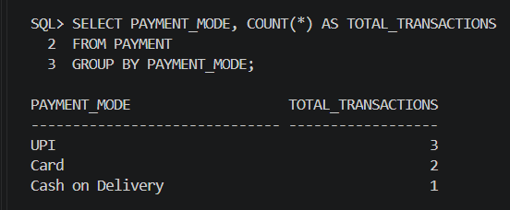

This helps identify the different payment methods used by customers and the number of transactions made through each method.
Total Amount by Payment Method
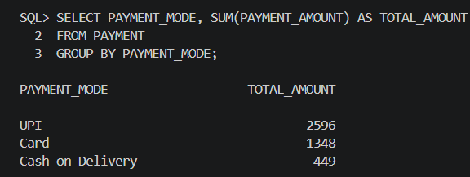
This query calculates the total payment amount processed through each payment method.

8. Payment Transaction Report
A complete payment transaction report can be generated by joining the PAYMENT and ORDERS tables.
