DBMS – ORDERS AND ORDER DETAILS MANAGEMENT
PROJECT TITLE: MEESHO JEWELRY MARKETPLACE DATABASE
1. Objectives
- Design ORDERS and ORDER_DETAILS tables.
- Manage customer product orders.
- Store order date, quantity, and total amount.
- Perform order insertion and modification operations.
- Generate customer order history reports.

2. Database Design
2.1 Orders Table
The ORDERS table stores the main information about a customer's order.
Attribute | Data Type | Constraint | Description
Order_ID | NUMBER(5) | Primary Key | Unique order identification
Customer_ID | NUMBER(5) | Foreign Key | Identifies the customer
Order_Date | DATE | NOT NULL | Date when the order was placed
Total_Amount | NUMBER(10,2) | NOT NULL | Total amount of the order
Order_Status | VARCHAR2(30) | NOT NULL | Current status of the order

2.2 Order_Details Table
The ORDER_DETAILS table stores the products included in each order and their quantities.
Attribute | Data Type | Constraint | Description
Order_Detail_ID | NUMBER(5) | Primary Key | Unique order detail identification
Order_ID | NUMBER(5) | Foreign Key | Identifies the related order
Product_ID | NUMBER(5) | Foreign Key | Identifies the ordered product
Quantity | NUMBER(5) | NOT NULL | Number of units ordered
3. Primary and Foreign Key Relationship
CUSTOMER
|
| 1 : M
↓
ORDERS
|
| 1 : M
↓
ORDER_DETAILS
|
| M : 1
↓
PRODUCT

4. Table Creation
4.1 Create Orders Table
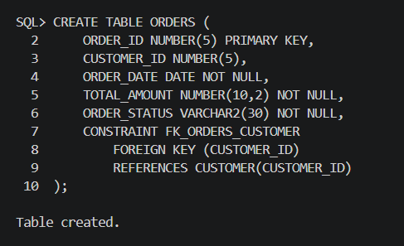

4.2 Create Order_Details Table
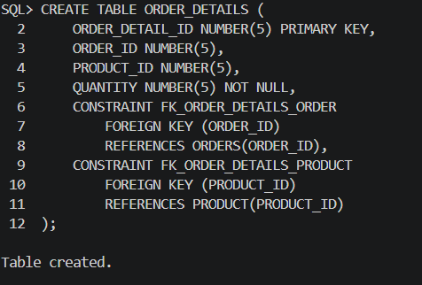
5. Data Insertion
5.1 Orders Records
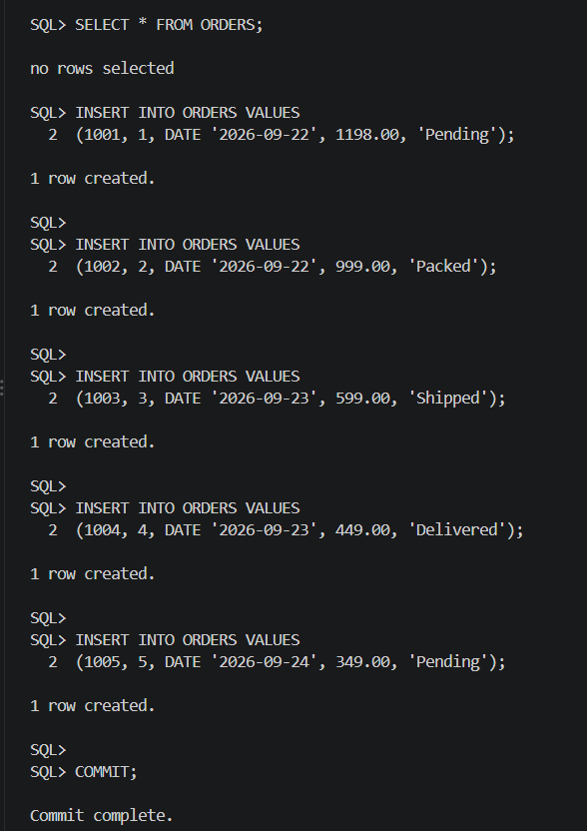

5.2 Order_Details Records
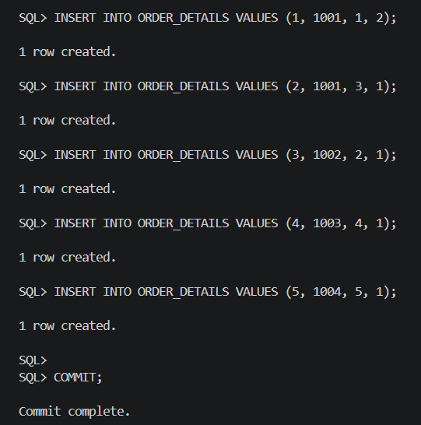

6. Data Retrieval
6.1 Display Orders
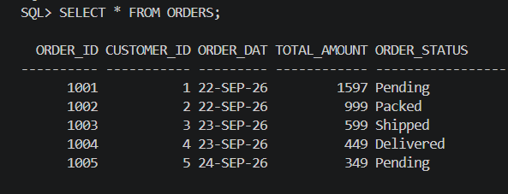
6.2 Display Order Details
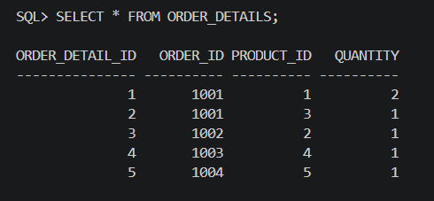
7. Order Insertion and Modification
7.1 Insert a New Order
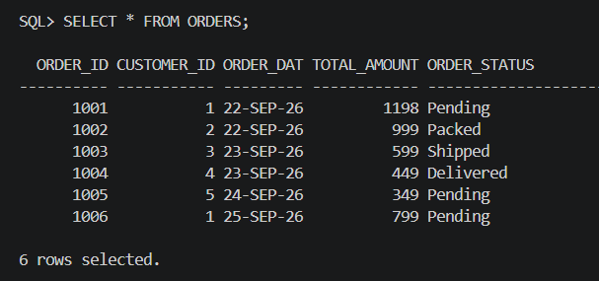
7.2 Modify Order Status
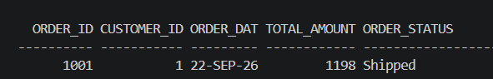
8. Customer Order History Report
