- Hello.c

#include<stdio.h>

int main()
{
printf("Hello Linux\n");
return 0;
}

Compile: gcc hello.c -o hello

./hello
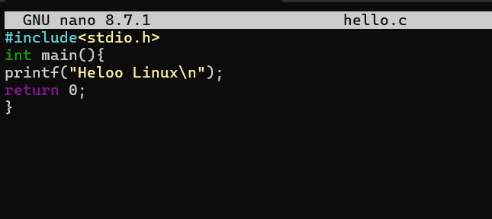
Output:
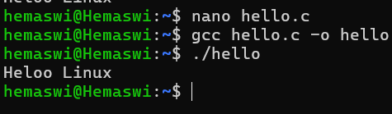

- Read User Name

#include<stdio.h>

int main()
{
char name[30];

printf("Enter your name: ");
scanf("%s",name);

printf("Welcome %s\n",name);

return 0;
}
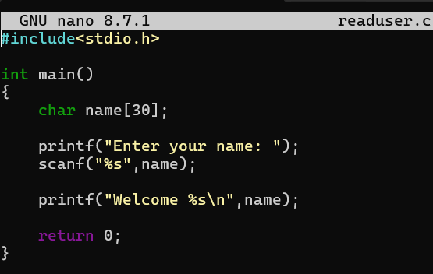
Output:
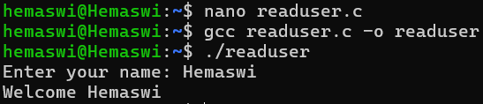

- Display Process ID

#include<stdio.h>
#include<unistd.h>

int main()
{
printf("Process ID = %d\n",getpid());

return 0;
}
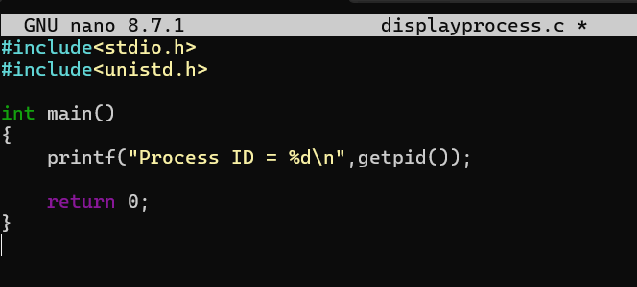
OUTPUT:
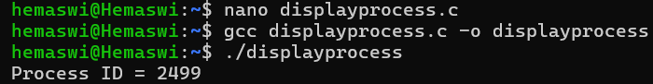

- Fork()

#include<stdio.h>
#include<unistd.h>

int main()
{
fork();

printf("Hello\n");

return 0;
}
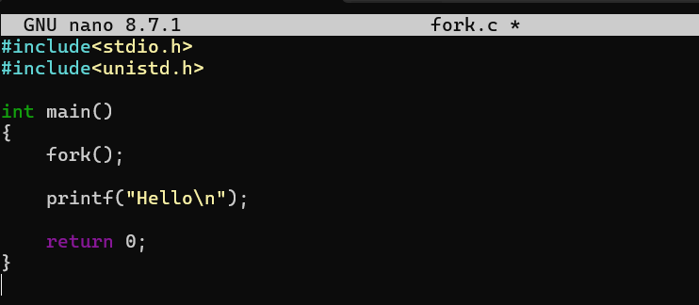
OUTPUT:
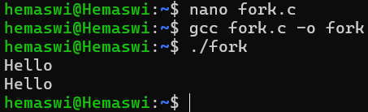

- Parent and Child
#include<stdio.h>
#include<unistd.h>

int main()
{
pid_t pid;

pid=fork();

if(pid==0)
{
printf("I am Child Process\n");
}
else
{
printf("I am Parent Process\n");
}

return 0;
}
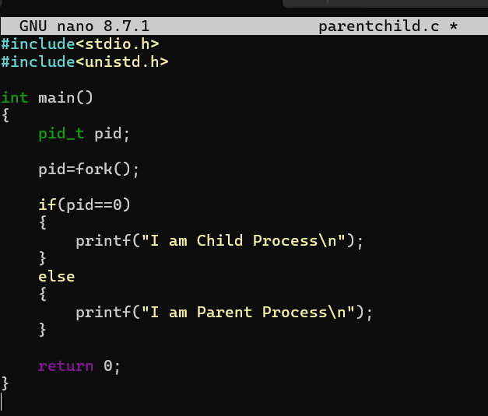
OUTPUT:
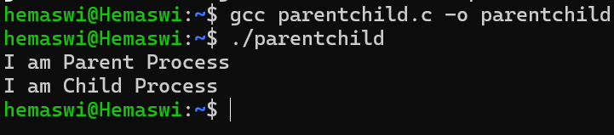

- Display parent and Child PID

#include<stdio.h>
#include<unistd.h>

int main()
{
pid_t pid;

pid=fork();

if(pid==0)
{
printf("Child PID = %d\n",getpid());
printf("Parent PID = %d\n",getppid());
}
else
{
printf("Parent PID = %d\n",getpid());
}

return 0;
}
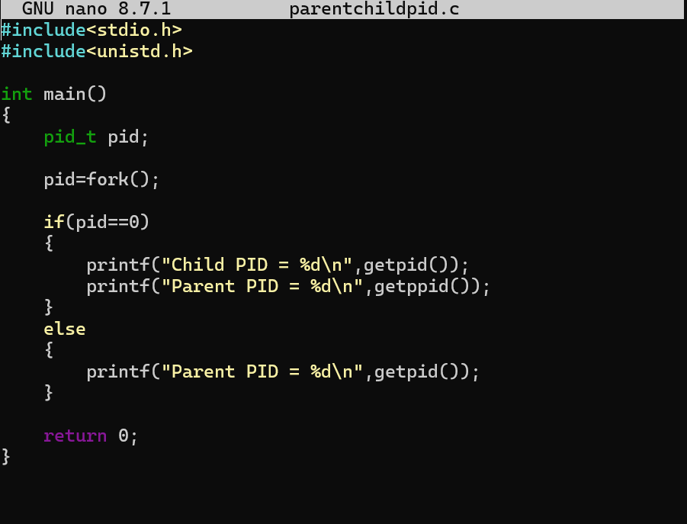
Output:
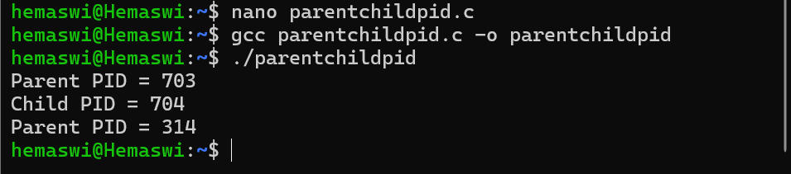

- Wait()

#include<stdio.h>
#include<unistd.h>
#include<sys/wait.h>

int main()
{
pid_t pid;

pid=fork();

if(pid==0)
{
printf("Child Running\n");
}
else
{
wait(NULL);

printf("Parent Running After Child\n");
}

return 0;
}
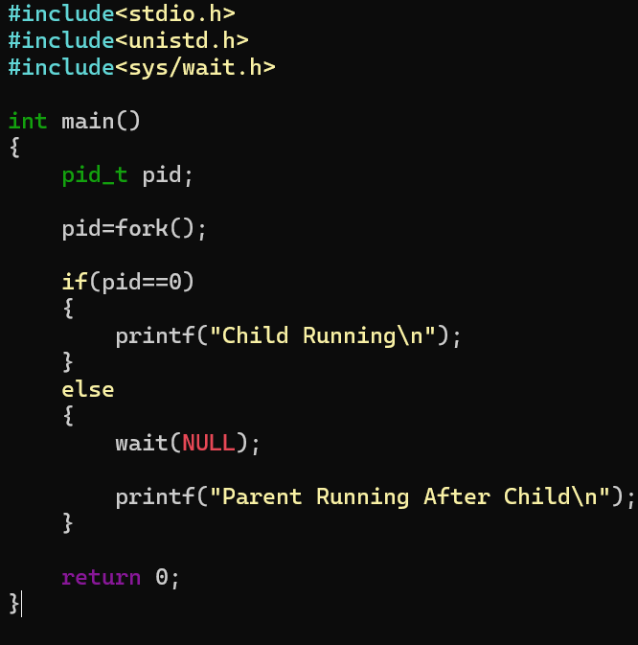
OUTPUT:
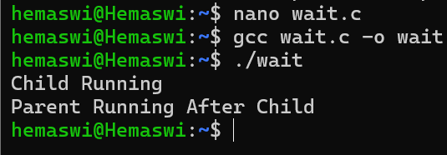

- Wait()

#include<stdio.h>
#include<unistd.h>

int main()
{
printf("Before exec()\n");

execlp("ls","ls",NULL);

printf("After exec()\n");

return 0;
}
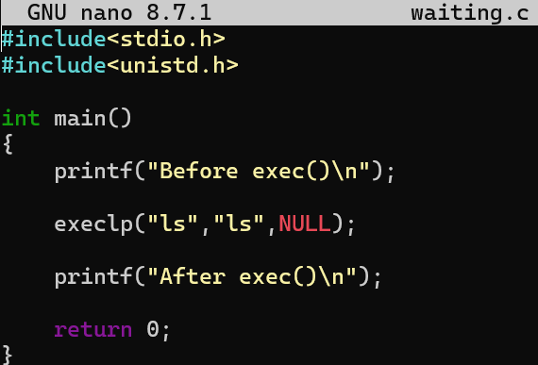
OUTPUT:
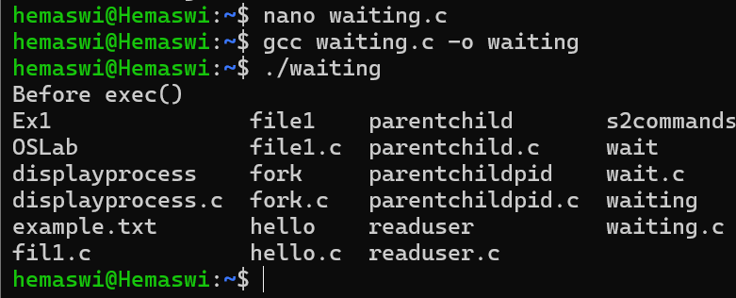

- fork() + exec()

#include<stdio.h>
#include<unistd.h>
#include<sys/wait.h>

int main()
{
pid_t pid;

pid=fork();

if(pid==0)
{
execlp("date","date",NULL);
}
else
{
wait(NULL);

printf("Child Completed\n");
}

return 0;
}
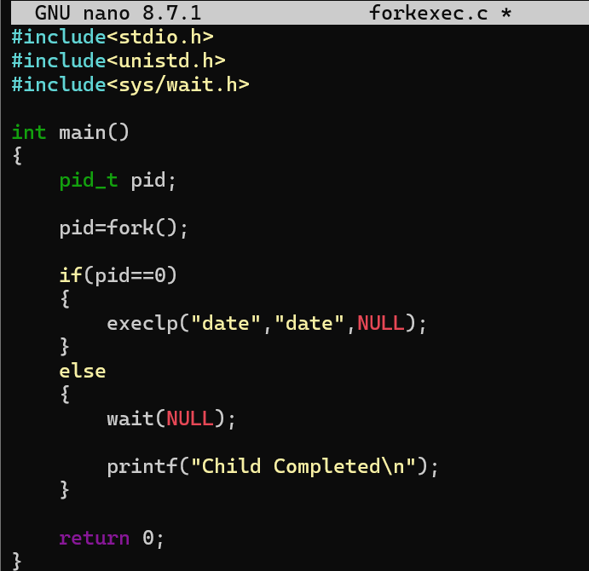
OUTPUT:
