M S RAMAIAH INSTITUTE OF TECHNOLOGY

(Autonomous Institute affiliated to VTU, Belgaum)

MSR Nagar, Bangalore-560054



January to June 2016

Department of Computer Science & Engineering

**SYNOPSIS ON   
REDUCING ACCIDENTS USING TRAFFIC DATA ANALYSIS AND DETECTION**

Submitted by

**ABHINAV SHIKHAR 1MS12CS002  
NAVEEN JS 1MS13CS416**

**SANDEEP KUMAR 1MS12CS097**

**T HEMA 1MS12CS139**

Under the guidance of

Sowmya BJ

Assistant Professor, MSRIT

**SYNOPSIS**

The International Traffic Safety Data & Analysis Group (IRTAD) conducts surveys to get aware of the several reasons leading to the accidents.

Few of the very concerning problems leading to accidents are mentioned below:   
  
1. A very recent headline in an English newspaper revealed that only three of England's 32 ambulance services reach a large majority of 'immediately life-threatening' call-outs within eight minutes, according to the latest statistics. There are more than thousands of people who lose their lives struggling in ambulances to reach the hospitals every day.

2. Most of the hospitals and schools are located at some random places in the country. This makes the schools to be located in the areas which are more prone to the accidents and where the most of the fatalities are related to kids.

3. The process of notifying the police is very slow and it usually takes a lot of time for the police to reach the spot after the occurrence of the accidents.

4. An article dated November 22, 2011, published in The Hindu in India states that 70 per cent of the road accidents happened in India in 2011 was due to drunken driving.

5. There is no process to notify the concerned car insurance agent, life insurance agent as well as the blood banks in case of medical emergencies.

Our idea is to solve many such problems by performing an analysis on the collected data. This analysis would use machine learning and data mining concepts to reveal certain hidden information.

The proposed solutions for each of these problems are as follows:

1**.** The drivers of ambulances would get notifications about accidents so that they can reach the spot faster. These ambulance drivers, instead of being at random places in the city, can be suggested some of the places which are more likely to have more accidents. This would reduce the time taken for the ambulance to reach the spot.

2. The setup and relocation of hospitals and schools easier by suggesting them the best place in the city based on the results of analysis. They can obtain the locations where the maximum and the minimum number of accidents are happening.

3. This spot of accident is tracked and sent to the police for the further investigation. The GPS module for Raspberry Pi allows to connection to the Raspberry Pi board to get position, altitude, speed etc. The GSM module is used for sending the location of the accident to the police.

4. We can find out the locations where most of the accidents are caused due to the consumption of alcohol. This feature would be helpful for the cab companies to know the areas where people are more likely to book their cabs after consuming alcohol so that they can always keep some cabs waiting in those areas. Another idea could be to introduce cabs meant only for the picking and the dropping of the drunken people.

5. The concerned car insurance and life insurance organizations can also be intimated with the notifications regarding the accidents. The blood banks can also be notified in case of any medical urgencies leading to the requirement of blood.  
  
  
  
  
  
We plan to detect the accident, analyze it and notify the concerned people for further actions. The vibration sensors will be fit into the cars, which will help in the collection of the real time accident data. The most commonly used vibration sensors are piezoelectric sensors which use the [piezoelectric effect](https://en.wikipedia.org/wiki/Piezoelectric_effect) to measure changes in [pressure](https://en.wikipedia.org/wiki/Pressure), [acceleration](https://en.wikipedia.org/wiki/Acceleration), [temperature](https://en.wikipedia.org/wiki/Temperature),

[strain](https://en.wikipedia.org/wiki/Strain_(materials_science)) or [force](https://en.wikipedia.org/wiki/Force) by converting them to an [electrical charge](https://en.wikipedia.org/wiki/Electrical_charge). The location could be tracked using the GPS module with Raspberry Pi and the data is stored onto the cloud. The GSM module is used to send messages, notifications or alerts. The app communicates with the data stored on to the cloud.

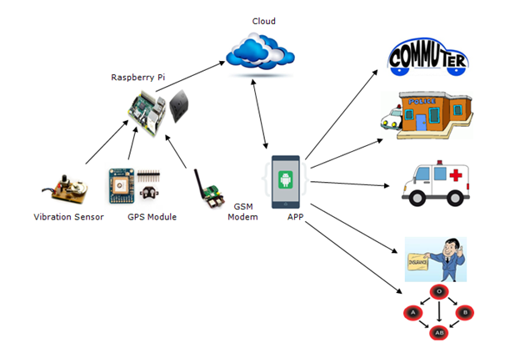The modules for this project are mentioned below:

1. **Sensing Module** – This module consists of the following :   
   1. **Vibration Sensors -** The project would use vibration sensors for the detection of accidents, which are piezoelectric sensors and use the [piezoelectric effect](https://en.wikipedia.org/wiki/Piezoelectric_effect) to measure changes in [pressure](https://en.wikipedia.org/wiki/Pressure), [acceleration](https://en.wikipedia.org/wiki/Acceleration), [temperature](https://en.wikipedia.org/wiki/Temperature), [strain](https://en.wikipedia.org/wiki/Strain_(materials_science)) or [force](https://en.wikipedia.org/wiki/Force) by converting them to an [electrical charge](https://en.wikipedia.org/wiki/Electrical_charge). The sensors are in definite numbers, 10 to 12, the more they would be, the better would be the performance. These sensors are placed at various places in the vehicle to ensure the detection of accidents at each and every part of the vehicle.
   2. **GPS Module** - The sole idea of using GPS module is to track the location of the vehicle in case of accidents. This location is further sent to the police for the further investigation. The location is also sent to the ambulance drivers, insurance agents and blood banks. The GPS module for Raspberry Pi allows to connection to the Raspberry Pi board to get position, altitude, speed etc.
   3. **GSM Modem** – The GSM module is used for sending the location of the accident to the police, ambulance drivers, insurance agents and blood banks. GPRS/GSM Module (SIM900) offers GPRS connection to Raspberry Pi, send SMS, make calls and create TCP / UDP sockets.
2. **Monitoring Module :** The sensors send the real-time data to cloud and the cloud can communicate with the app also.
3. **Analysis Module ( Cloud Infrastructure )** – The huge data collected from the vehicles using the sensors are analyzed by using data analysis concepts and certain predictions are done using the machine learning techniques. The decision tree algorithm could be used to determine the severity of the accidents. The clustering algorithms could be used to obtain better insights. The mispredictions could be minimized by using pruning techniques to trim the levels of the decision tree and produce optimum results.
4. **Android Application Modules**

The android app would contain lots of modules, each dedicated to a specific functionality. Following are some of the modules listed –

1. Redirection of traffic
2. Alerting using App
3. Cab drivers
4. Notify Ambulances
5. Inform Insurance Agents