M S RAMAIAH INSTITUTE OF TECHNOLOGY

(Autonomous Institute affiliated to VTU, Belgaum)
MSR Nagar, Bangalore-560054



January to June 2016

Department of Computer Science & Engineering

DESIGN DOCUMENT ON
REDUCING ACCIDENTS USING TRAFFIC DATA ANALYSIS AND DETECTION

Submitted by

ABHINAV SHIKHAR 1MS12CS002
NAVEEN JS 1MS13CS416
SANDEEP KUMAR 1MS12CS097
T HEMA 1MS12CS139

Under the guidance of
Sowmya BJ
Assistant Professor, MSRIT

1. Introduction
a) Description of the organization of the document
The design document gives us an insight into how the requirements stated in the SRS will be met. The system is divided into a number of modules, each module focusing on the delivery of a particular functionality. The design document starts with details of the modules used, the architecture diagram of the system, the various user interfaces. Further, various modelling diagrams such as class diagram, sequence diagram and data flow diagram are provided to get a better understanding of the system.

b) Number of Modules:
The project can be broadly divided into 4 modules, which are:
- Sensing Module
- Monitoring Module
- Computing and Analysis Module (Cloud Infrastructure)
- Web and Mobile Interface Module

c) Modules Description:
A detailed description of the various modules used in the project is as follows:

- Sensing Modules: This module consists of the following :
  - Vibration Sensor: The project would use vibration sensors for the detection of accidents, which are piezoelectric sensors and use the piezoelectric effect to measure changes in pressure, acceleration, temperature, strain or force by converting them to an electrical charge. The sensors are in definite numbers, 10 to 12, the more they would be, the better would be the performance. These sensors are placed at various places in the vehicle to ensure the detection of accidents at each and every part of the vehicle.
  - Tilt Sensor: The tilt sensor will measure the orientation of the vehicle with respect to the ground. Usually when the accidents occur, the vehicles aren’t in the same level as the road.
  - Fire Sensor: The fire sensor will sense the presence of fire or smoke caused due to the burning of fuel.
  - Pressure Sensor: The pressure sensor will sense the amount of force with which the collision has taken place. This can be used to determine the severity of the accident. The accident would be generally more severe when the value of force/pressure applied during the collision is high.
  - GPS Module: The sole idea of using GPS module is to track the location of the vehicle in case of accidents. This location is further sent to the police for the further investigation. The location is also sent to the ambulance drivers, insurance agents and blood banks.
  - USB Dongle Module: This module is used to send data in real time from the monitoring module to cloud infrastructure.
- Monitoring Module: The sensors send the real-time data to the monitoring module, which in our project is Raspberry Pi Model 2. Each vehicle is equipped with a monitoring module and various sensors. The data received from sensors is sent in real time to the cloud infrastructure.

- Computing and Analysis Module (Cloud Infrastructure):

  - Detecting an Accident: The values from various sensors are analyzed based on many parameters by using our algorithm to detect the accident. Based on previous accident information, the algorithm keeps learning to detect an accident more accurately.

  - Obtaining various Statistics: The huge data collected from the vehicles using the sensors are analyzed by using data analysis concepts and certain predictions are done using the machine learning techniques. The decision tree algorithm could be used to determine the severity of the accidents. The clustering algorithms could be used to obtain better insights.

- Algorithm design
Step 1: Import the libraries.

Step 2: Extract the dataset in a R variable.

Step 3: Identify the dependant and independent variables present in the dataset.

Step 4: Analyze the relation between dependent and independent variable based on certain conditions.

Step 5: Attach the new observation column corresponding to the results obtained in Step 4 to the dataset.

Step 6: Remove the dependant column from the extracted dataset.

Step 7: Apply Machine learning techniques on the training data sample.
train_var <- training(dataset) #training of dataset.

Step 8: Apply Machine learning techniques on the testing data sample
test_var <- testing(dataset) #testing of dataset.

Step 9: Measure the accuracy of the prediction based on the results obtained from Step 7 and Step 8.
predicted_var <- mean(test_var!=train_var) # Mean of the differences between both
tree <- plot_tree(predicted_var) # Plotting the decision tree

Step 10: Optimize the prediction by performing the prune the decision tree obtained from Step 9.
val <- prune(tree) # pruning is performed

Repeat Step 9 until the value of the predicted_var is minimum.

2. Architecture Design
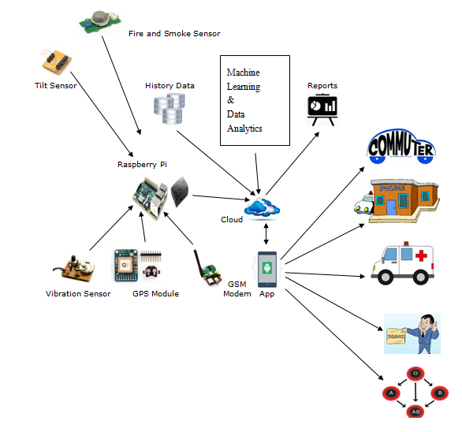

3. Graphical User Interface

- Web Interfaces:
The following Web Interfaces will be created as a part of this project:
- For Hospital Staff:
- The hospitals located in the vicinity will get immediate notifications about an accident.
- They have to make sure that the doctors and resources are available and send a response back as soon as possible, so that the ambulance drivers are notified.
- For Insurance Companies:
All accident details and logs will be maintained on this website, which will act as proof in order to avail insurance.
- For police Inspectors, Ambulances, Hospitals, Cab Companies, Schools, NGO’s and other interested organizations:
- All statistics about accidents, such as the most prone areas, most common reason for the accident, most affected age groups, etc. are provided on this website for all the relevant organizations.
- The trends for a given time periods will also be displayed.
- All details will be updated in real time. The statistics can be viewed for different time durations, such as daily, weekly, monthly, quarterly, half yearly, yearly, whole history.
- However, to ensure privacy and prevent misuse of data, there will be different access rights for each type of user.

ii. Mobile Interfaces:
The following mobile interfaces, in the form of android app will be developed in this project:
- For traffic police staff:
The following 2 functionalities are implemented:
- Get the location of the accident immediately, as a pop up notification
- User friendly form to log all possible details about the accidents once he reaches the accident location.
- For ambulance drivers:
- The ambulance drivers located closest to the accident spot will get immediate notifications of the accident.
- If the driver is available and can reach the spot without delay, he can send his confirmation.
- He’ll get a notification about which hospital is the closest and has its doctors on stand -by to attend to the accident victims.
iii. Emails
Automated emails will be sent to the Traffic Police Inspectors and Sub Inspectors periodically, that is, weekly, monthly, quarterly, half yearly and yearly. This will help them make better decisions in deploying their manpower and utilizing their resources. The mails will contain informative maps, graphs, pie charts which will highlight the most severe issues to be tackled. It’ll also contain the website link to get the detailed analysis.

4. Class Diagram and Classes
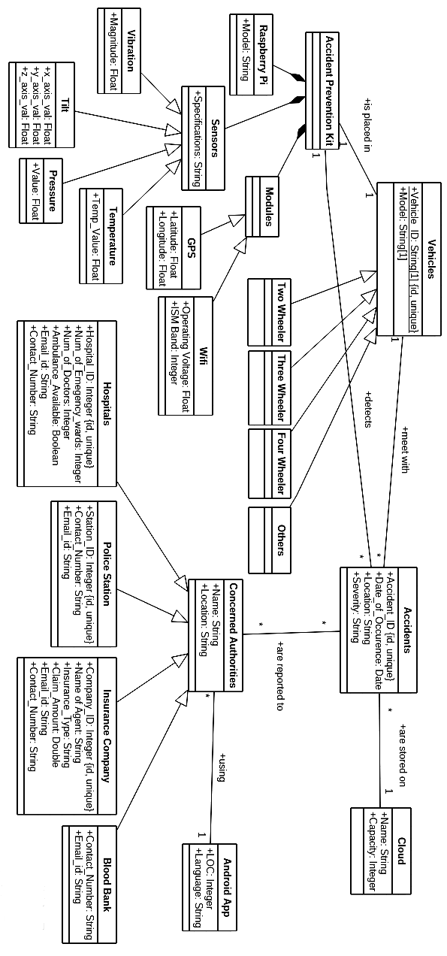

5.Sequence Diagram

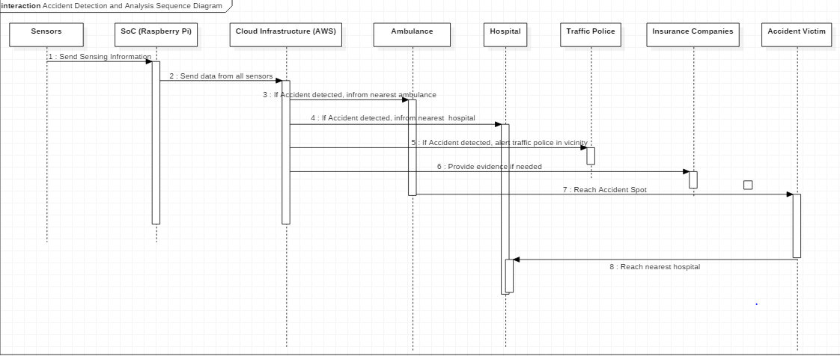

6.Data flow diagram

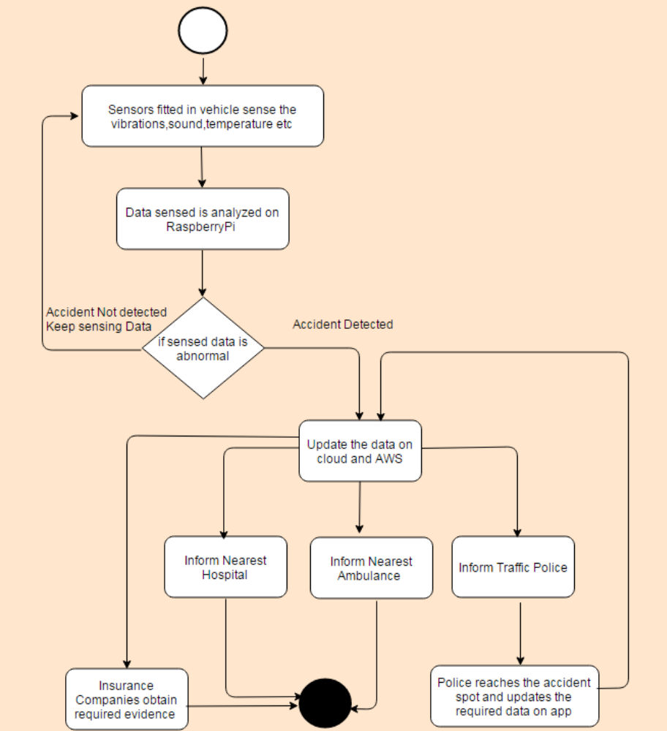

7. References

[1] http://www.ijarcce.com/upload/2014/february/IJARCCE3H__s_sonika_Intelligent.pdf
[2] http://www.ijareeie.com/upload/2014/july/33_Automatic.pdf
[3] http://www.projectsof8051.com/vehicle-accident-detection-with-gps-and-gsm-modem/
[4] Design of vehicle positioning system based on arm---- IEEE-2011. Zhang Wen ; Dept. of Phys. &
Electron. Inf. Eng., Neijiang Teachers Coll., Neijiang, China ; Jiang Meng may 2011.
[5] www.ijircce.com/upload/2015/april/105_49_Accident.pdf
[6] gyti.techpedia.in/project-detail/...accident-detection-and...system.../2741
[7] http://gyti.techpedia.in/project-detail/automatic-vehicle-accident-detection-and-
messaging-system-using-gsm-and/2741
[8] http://www.ijsrp.org/research_paper_apr2012/ijsrp-apr-2012-83.pdf
[9] http://www.ijarcce.com/upload/2014/march/IJARCCE6I%20%20%20S%20%20nit
in%20Design%20and%20Development%20of%20Automatic.pdf
[10] http://www.ijerd.com/paper/vol10-issue4/Version_4/B1042528.pdf
[11] http://www.ijser.org/researchpaper%5CAutomatic-Vehicle-Accident-Detection-
And- Messaging-System-Using-GPS-and-GSM-Modems.pdf
[12] Praticò Filippo.G (Reggio Calabria Mediterranean University), Vaiana Rosolino
(Researcher, DIPITER Department Of Territorial Planning, University of Calabria-
Arcavacata Campus (Cosenza)), Accident Data Analysis: An experimental Investigation
for a rural, multilane, median separated, Italian Road.
[13] Heinz Hautzinger, Claus Pastor, Manfred Pfeiffer, Jochen Schmidt, Analysis Methods for
Accident and Injury Risk Studies.
[14] Chen Lei, Xu Nuo, Analyzing Method of Traffic Accident Causation through Experts
Method and Statistical Analysis.

