Hope Artificial Intelligence
Classification Assignment
Problem Statement or Requirement:
A requirement from the Hospital, Management asked us to create a predictive
model which will predict the Chronic Kidney Disease (CKD) based on the
several parameters. The Client has provided the dataset of the same.

1.) Identify your problem statement
using three step problem identification:
Domain – machine learning
Learning – supervised learning
Type - classification

2.) Tell basic info about the dataset (Total number of rows, columns)
(399, 25) == (rows, column)

3.) Mention the pre-processing method if you’re doing any :
a)get_dummies – to process nominal categorical data
b)standard scaler – to process range of numbers between columns in standard way

4.) Develop a good model with good evaluation metric. You can use any
machine learning algorithm; you can create many models. Finally, you
have to come up with final model.
Methodology followed: Yes

5.) All the research values of each algorithm should be documented.
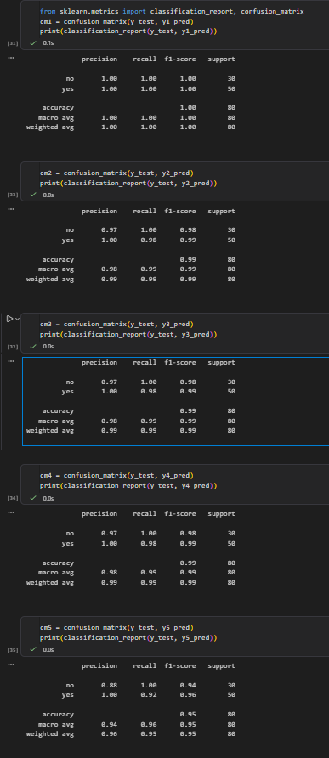
6.) Mention your final model, justify why u have chosen the same.
Solution : Logistic Regression for this Problem statement
Why: More Accurate model than others

