Software Requirements Specification

for

<Student Mental Wellness Support Platform>
Version 1.0 approved
Prepared by <Hemavarni.S>
<Coimbatore Institute Of Technology>
<date created>
Table of Contents
1. Introduction 1
1.1 Purpose 1
1.2 Document Conventions 1
1.3 Intended Audience and Reading Suggestions 2
1.4 Product Scope 2
1.5 References 3
2. Overall Description 3
2.1 Product Perspective 3
2.2 Product Functions 3
2.3 User Classes and Characteristics 4
2.4 Operating Environment 6
2.5 Design and Implementation Constraints 6
2.6 User Documentation 6
2.7 Assumptions and Dependencies 7
3. External Interface Requirements 11
3.1 User Interfaces 11
3.2 Hardware Interfaces 13
3.3 Software Interfaces 13
3.4 Communications Interfaces 14
4. System Features 14
4.1 User Registration and Authentication 14
4.2 Student Wellness Assessment 15
4.3 Wellness History and Monitoring 16
4.4 Personalized Wellness Recommendations 16
4.5 Support Request Management 17
4.6 Counsellor Case Management 17
4.7 Administrator Management 18
4.8 Role-Based Access Control 19
5. Other Nonfunctional Requirements 19
5.1 Performance Requirements 19
5.2 Safety Requirements 19
5.3 Security Requirements 20
5.4 Software Quality Attributes 20
5.5 Business Rules 20
6. Other Requirements 21
6.1 Database Requirements 21
6.2 Backup and Recovery Requirements 22
6.3 Internationalization Requirements 22
6.4 Legal and Privacy Requirements 22
6.5 Future Extension Requirements 22
Appendix : ANALYSIS MODELS 23

Revision History
Name | Date | Reason For Changes | Version

Introduction

Purpose
The Student Mental Wellness Support Platform is a software application designed to improve the mental well-being of students by providing an accessible, secure, and confidential digital support system. In today's academic environment, students often face stress, anxiety, depression, academic pressure, and personal challenges that can negatively affect their academic performance and overall quality of life. Unfortunately, many students hesitate to seek professional help due to fear of judgment, lack of awareness, or limited access to counselling services.
The primary purpose of this project is to develop a centralized platform where students can easily monitor their emotional well-being, perform regular mental health self-assessments, receive personalized wellness recommendations, and schedule counselling appointments without difficulty. The system also provides counselors with tools to manage appointments, review student wellness reports, and offer timely support while maintaining complete confidentiality.
This Software Requirements Specification (SRS) document defines the functional and non-functional requirements of the proposed system. It serves as a reference for developers, testers, project supervisors, and stakeholders throughout the software development life cycle. The document ensures that all project members have a clear understanding of the system's objectives, requirements, constraints, and expected outcomes before implementation begins.

Document Conventions
This document follows the IEEE Software Requirements Specification (SRS) format to ensure consistency, readability, and proper documentation. The following conventions are used throughout this document:

- Numbered headings and subheadings are used for easy navigation.
- Bold text indicates important terms, modules, and key concepts.
- Tables are used wherever structured information is required.
- The word System refers to the Student Mental Wellness Support Platform.
- The terms Student, Counselor, and Administrator represent the three primary user roles of the application.
- All functional requirements are described using simple and clear language to avoid ambiguity.
- Technical terminology is kept to a minimum so that both technical and non-technical stakeholders can understand the document.

These conventions improve document readability and help maintain uniformity throughout the project documentation.

Intended Audience and Reading Suggestions
This document is intended for all stakeholders involved in the development, testing, deployment, and usage of the Student Mental Wellness Support Platform. The intended audience includes:
- Project Guide and Faculty Members
- Software Developers
- System Analysts
- Database Designers
- Software Testers
- College Administrators
- Professional Counsellors
- Students
- Project Evaluators
Readers who are responsible for system development should carefully study the functional and non-functional requirements before beginning implementation. Testers should refer to the requirements while designing test cases. Administrators and counsellors should understand the system features before deployment, while students can use the documentation as a guide to understand the services provided by the platform.

Product Scope
The Student Mental Wellness Support Platform aims to create a supportive digital environment where students can seek mental wellness assistance conveniently and confidentially. The platform provides a variety of features that encourage students to actively monitor and improve their emotional health.
Students can perform regular mood tracking, complete scientifically designed self-assessment questionnaires, access reliable mental health resources, and receive personalized wellness suggestions based on their assessment results. The platform also enables students to book counselling appointments online, reducing the need for manual scheduling and long waiting times.
Counsellors can securely access appointment schedules, review assessment reports, monitor students' progress, and provide timely guidance. Administrators can manage users, maintain mental health resources, monitor system performance, and generate reports for institutional analysis.
The project is developed using software engineering principles, including requirement analysis, system design, implementation, testing, deployment, and maintenance. The system focuses on usability, reliability, security, scalability, and privacy. By providing easy access to mental wellness support, the platform helps educational institutions promote healthier learning environments and improve students' overall well-being.

References
The development of the Student Mental Wellness Support Platform is based on established software engineering standards and mental health resources. The following references were used during requirement analysis and system design:
- IEEE Recommended Practice for Software Requirements Specifications (IEEE 830).
- Roger S. Pressman – Software Engineering: A Practitioner's Approach.
- Ian Sommerville – Software Engineering.
- World Health Organization (WHO) – Mental Health Guidelines.
- National Institute of Mental Health (NIMH).
- Research articles related to student mental health and digital wellness systems.
- Official documentation of HTML, CSS, JavaScript, Python/PHP, and MySQL.

Overall Description

Product Perspective
The Student Mental Wellness Support Platform is a standalone web-based application designed specifically for educational institutions. It serves as a centralized digital platform that connects students, counsellors, and administrators in a secure and organized manner.
The platform replaces traditional manual counselling appointment systems with an automated solution that simplifies scheduling, communication, and record management. It allows students to access mental wellness support anytime and anywhere through an internet connection. The system securely stores assessment history, appointment details, and wellness records while ensuring confidentiality through authentication and encryption mechanisms.
The application is designed with a user-friendly interface so that students with minimal technical knowledge can easily navigate and use its features. It can also be expanded in the future by integrating AI-based mental health analysis, chatbot support, emergency assistance, and wearable health monitoring devices

Product Functions
The Student Mental Wellness Support Platform provides several important functions that improve mental health support services within educational institutions.
Major functions include:
- Student Registration and Login with secure authentication.
- Profile management for students, counsellors, and administrators.
- Daily mood tracking and emotional wellness monitoring.
- Mental health self-assessment questionnaires.
- Personalized wellness recommendations based on assessment results.
- Online counselling appointment booking.
- Appointment approval and management by counsellors.
- Notification and reminder system for scheduled appointments.
- Access to educational articles, meditation exercises, stress management techniques, and motivational resources.
- Counsellor dashboard to monitor student progress.
- Administrator dashboard to manage users, reports, and system resources.
- Secure storage and retrieval of student records.
- Report generation for institutional analysis while maintaining user privacy.
These functions work together to provide an efficient and reliable mental wellness support system.

User Classes and Characteristics
The system consists of four primary user categories.

1.Student
Students are the primary users of the platform. They can register, log in securely, complete mood assessments, track emotional well-being, access wellness resources, book counselling appointments, receive appointment reminders, and monitor their personal wellness history. Students require only basic computer or smartphone knowledge to use the system.

2.Counsellor
Counsellors are responsible for reviewing appointment requests, monitoring assessment reports, providing mental health guidance, updating counselling records, and maintaining confidential communication with students. They require authorization from the institution before accessing the system.

3.Administrator
Administrators manage the entire platform. Their responsibilities include user management, counsellor account management, maintaining educational resources, monitoring system security, generating reports, managing backups, and ensuring smooth system operation.

4. Faculty Mentor
Faculty mentors can monitor the overall well-being of students under their guidance without accessing confidential counselling details. They help identify students who may require additional academic or emotional support.

Use case diagram:
Student:
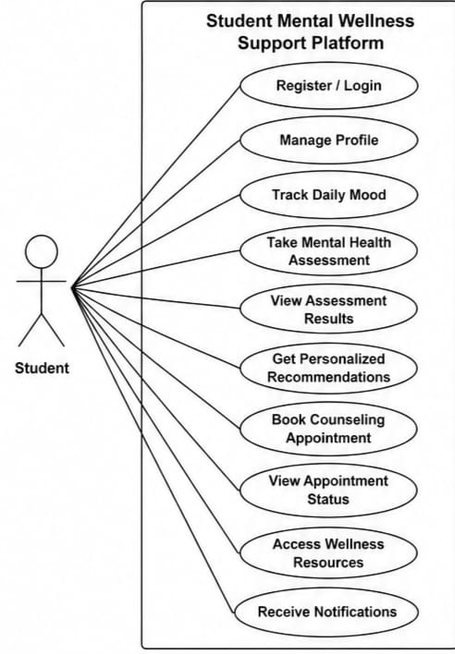
Use case Description:
Primary Actor: Student
Secondary Actor: Counsellor, System Administrator
Precondition: Student has registered and logged into the system.
Trigger: Student wants to schedule a counselling session.
Main Success Scenario
- Student logs into the Mental Wellness Support Platform.
- Student selects Book Counselling Appointment.
- System displays the list of available counsellors along with available dates and time slots.
- Student selects the preferred counsellor, date, and time.
- System checks counsellor availability.
- System confirms the appointment and stores the details in the database.
- Student receives an appointment confirmation notification.
- Counsellor receives the appointment request for review.
Exception Scenario
a) Selected time slot is already booked.
System informs the student and displays other available slots.
b) Student is not logged in.
System redirects the student to the Login page.
c) Counsellor is unavailable.
System suggests another counsellor or another available date.

Counsellor:
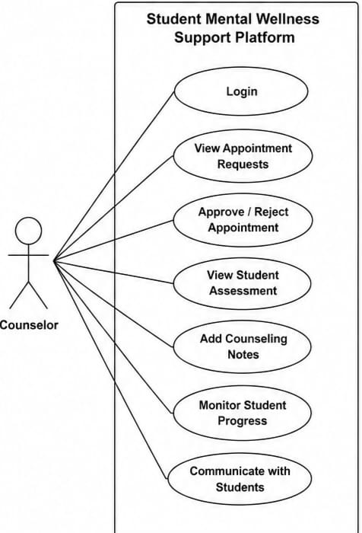
Use case Description:
Primary Actor: Counsellor
Secondary Actor: Student, System Administrator
Precondition: Counsellor has logged into the Student Mental Wellness Support Platform. The student has completed the mental wellness assessment and booked an appointment.
Trigger: Counsellor selects a scheduled appointment to review the student's assessment.
Main Success Scenario
- Counsellor logs into the system.
- Counsellor views the list of scheduled appointments.
- Counsellor selects a student's appointment.
- System displays the student's mental wellness assessment report and mood history.
- Counsellor reviews the student's assessment results.
- Counsellor provides counselling notes, recommendations, and wellness advice.
- Counsellor updates the appointment status as Completed.
- System securely saves the counselling notes and updates the student's wellness record.
- Student receives a notification that the counselling session has been completed along with any recommendations (if applicable).
Exception Scenario
a) Student assessment report is unavailable.
System displays an error message and informs the counsellor that no assessment data is available.
b) Student does not attend the scheduled appointment.
Counsellor marks the appointment as Missed, and the system allows the student to reschedule.
c) System or network failure occurs while saving counselling notes.
System displays an error message and requests the counsellor to save the information again after the connection is restored.

Administrator:
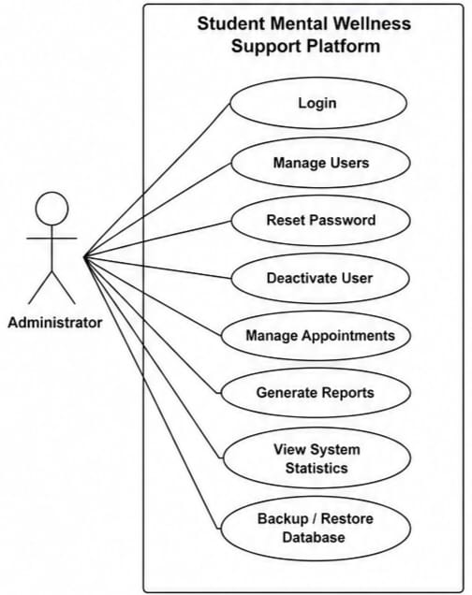
Use case Description:
Use Case – 3: Manage Users
Primary Actor: Administrator
Secondary Actor: System
Precondition: Administrator has logged into the system.
Trigger: Administrator selects the Manage Users option.
Main Success Scenario
- Administrator logs into the system.
- Administrator views the list of users.
- Administrator adds, updates, or removes user accounts.
- System validates the changes.
- System updates the database successfully.

Exception Scenario
a) Invalid user information is entered.
System displays an error message and requests valid details.
b) Database connection fails.
System displays an error and cancels the operation.

Faculty:
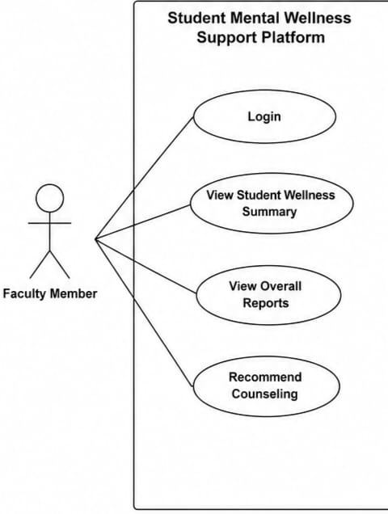
Use case Description:

Use Case – 4: View Student Wellness Status
Primary Actor: Faculty Mentor
Secondary Actor: System
Precondition: Faculty Mentor has logged into the system.
Trigger: Faculty Mentor selects View Student Wellness Status.
Main Success Scenario
- Faculty Mentor logs into the system.
- Faculty Mentor selects a student or class.
- System displays the student's overall wellness status.
- Faculty Mentor reviews the information.
- Faculty Mentor recommends counselling if required.
Exception Scenario
a) Student wellness data is unavailable.
System displays an appropriate message.
b) Faculty Mentor is not authorized to view the data.
System denies access and displays an authorization error.

Operating Environment

The Student Mental Wellness Support Platform is designed to operate efficiently across multiple devices and operating systems.
Hardware Requirements
- Computer or Laptop
- Android Smartphone
- Stable Internet Connection
Software Requirements
- Windows 10/11
- Linux
- Android
- iOS
Development Technologies
- HTML5
- CSS3
- JavaScript
- Python (Flask/Django) or PHP
- MySQL Database
Supported Browsers
- Google Chrome
- Mozilla Firefox
- Microsoft Edge
- Safari
The platform supports responsive design, allowing users to access the application from desktops, tablets, and smartphones.

Design and Implementation Constraints
Several constraints must be considered during system development.
- Only authenticated users can access the platform.
- Student data must remain confidential at all times.
- Passwords should be securely encrypted.
- Database backups should be performed regularly.
- The system should be responsive across multiple devices.
- The application should provide high availability and reliability.
- Performance should remain stable even with multiple simultaneous users.
- The platform should follow secure coding practices to prevent unauthorized access and data breaches.
- Compliance with institutional privacy policies must be maintained.

User Documentation
The platform will include comprehensive documentation to help different categories of users.
Documentation includes:
- User Manual
- Administrator Manual
- Counsellor Guide
- Installation Guide
- System Maintenance Guide
- Frequently Asked Questions (FAQ)
- Online Help Module
- Technical Documentation for Future Developers
These documents will ensure smooth system operation and simplify maintenance.

Assumptions and Dependencies
- Assumptions
- Students have access to internet-enabled devices.
- Users provide honest responses during mental health assessments.
- Educational institutions appoint qualified counsellors.
- Users possess basic digital literacy.
- Counselling services are available during working hours.
- Dependencies
The successful operation of the platform depends on:
- Stable internet connectivity.
- Web server hosting.
- MySQL Database Server.
- Email/SMS notification services.
- Secure authentication services.
- Regular database backup systems.
- Updated web browsers and operating systems.
The platform may also depend on institutional policies regarding student counselling and data privacy.

External Interface Requirements

User Interfaces
The Student Mental Wellness Support Platform shall provide a simple, responsive, and user-friendly web interface for students, counsellors, faculty members, and administrators.
The system shall provide separate interfaces based on the user's role.
Student Interface
The student interface shall include:
- Student registration and login.
- Student dashboard.
- Wellness assessment form.
- Wellness score and risk-level display.
- Assessment history.
- Personalized wellness recommendations.
- Support request form.
- Support request history and status.
- Profile management.
- Logout option.
The assessment interface shall contain questions related to academic pressure, stress, sleep, mood, social well-being, and energy levels. The system shall present questions in a clear and easy-to-understand format.
Counsellor Interface
The counsellor interface shall include:
- Counsellor login.
- Counsellor dashboard.
- List of assigned student support cases.
- Student wellness information relevant to the case.
- Support request details.
- Case status management.
- Counselling notes.
- Follow-up management.
- Case closure functionality.
Faculty Interface
The faculty interface shall provide:
- Faculty login.
- Student wellness alerts where authorized.
- Student support status information where permitted.
- Referral functionality.
- Basic monitoring information without exposing unnecessary private student information.
Administrator Interface
The administrator interface shall include:
- Administrator login.
- User management.
- Role management.
- Counsellor authorization.
- Faculty management.
- Monitoring of support requests.
- System-level reports.
- Management of system configuration.
Common Interface Requirements
- All pages shall use a consistent navigation structure.
- Forms shall provide appropriate labels and validation messages.
- Mandatory fields shall be clearly indicated.
- Invalid inputs shall generate understandable error messages.
- Successful operations shall display confirmation messages.
- The interface shall be responsive on desktop, tablet, and mobile devices.
- Unauthorized users shall not be allowed to access restricted pages.
- A logout function shall be available for authenticated users.
- The interface shall avoid displaying sensitive information unnecessarily.

Hardware Interfaces
The system is primarily a web-based software application and does not require specialized hardware.
The system shall support the following hardware:
- Desktop computers.
- Laptop computers.
- Tablets.
- Smartphones.
- Standard keyboard and mouse/touchscreen input devices.
- Standard display devices.
- Internet-connected network devices.
The minimum recommended client configuration shall include:
- Dual-core processor or equivalent.
- Minimum 4 GB RAM.
- Modern web browser.
- Internet connectivity.
- Display resolution suitable for viewing responsive web pages.
The application shall communicate with hardware indirectly through the operating system and web browser. No specialized sensors, biometric devices, or external hardware devices are required

Software Interfaces
The Student Mental Wellness Support Platform shall interact with the following software components:
Software Component | Purpose
HTML5 | Defines the structure of web pages
CSS3 | Provides styling and responsive layout
JavaScript | Provides client-side functionality and validation
Firebase Authentication | Provides user authentication
Cloud Firestore | Stores user, assessment, and support-request data
Web Browser | Provides access to the application
Firebase SDK | Connects the web application with Firebase services
Machine Learning/NLP Module | Supports wellness text analysis and classification where implemented
Operating System
The system shall support commonly used operating systems including:
- Windows 10/11
- Linux
- macOS
- Android
- iOS
Database Interface
Cloud Firestore shall be used for storing application data.
The database shall contain information such as:
- User profiles.
- User roles.
- Wellness assessments.
- Wellness scores.
- Risk levels.
- Support requests.
- Counselling case information.
- Recommendations.
- Timestamps.
Access to database information shall be controlled according to the user's role.
Authentication Interface
Firebase Authentication shall provide authentication services for registered users.
The system shall:
- Authenticate users before accessing protected resources.
- Maintain the authenticated user's session.
- Identify the user's role.
- Prevent unauthorized access to role-specific functionality.

Communications Interfaces
The system shall operate through an Internet-based communication environment.
The following communication standards shall be used:
- HTTP/HTTPS for web communication.
- HTTPS shall be used for secure communication between the client and server/cloud services.
- Firebase APIs shall be used for communication with Firebase services.
- JSON-based data exchange may be used between application components and cloud services.
Communication Requirements
- All sensitive information shall be transmitted using encrypted communication.
- The application shall communicate with Firebase services through secure APIs.
- The system shall handle temporary network failures gracefully.
- Appropriate error messages shall be displayed when network connectivity is unavailable.
- Data synchronization shall occur between the client application and cloud database.
- Authentication information shall not be transmitted through insecure communication channels.

System Features
4.1 User Registration and Authentication
4.1.1 Description and Priority
This feature allows students, counsellors, faculty members, and administrators to securely register or log into the platform.
Priority: High
4.1.2 Stimulus/Response Sequences
- User opens the login page.
- User enters email/username and password.
- System validates the entered information.
- System authenticates the user.
- System identifies the user's role.
- System redirects the user to the appropriate dashboard.
For registration:
- User opens the registration page.
- User enters the required details.
- System validates the information.
- System creates the user account.
- System displays a successful registration message.
4.1.3 Functional Requirements
REQ-AUTH-01: The system shall allow authorized users to log in using registered credentials.
REQ-AUTH-02: The system shall validate mandatory login fields.
REQ-AUTH-03: The system shall display an error message when invalid credentials are provided.
REQ-AUTH-04: The system shall identify the role of the authenticated user.
REQ-AUTH-05: The system shall redirect users to role-specific dashboards.
REQ-AUTH-06: The system shall prevent unauthenticated users from accessing protected pages.
REQ-AUTH-07: The system shall provide a logout function.
REQ-AUTH-08: The system shall prevent duplicate account registration using the same registered email address.

4.2 Student Wellness Assessment

4.2.1 Description and Priority
This feature allows students to complete wellness assessments related to stress, academic pressure, sleep, mood, social well-being, and energy.
Priority: High

4.2.2 Stimulus/Response Sequences
1. Student logs into the system.
2. Student opens the wellness assessment.
3. System displays assessment questions.
4. Student enters responses.
5. Student submits the assessment.
6. System validates the responses.
7. System calculates or determines the wellness score and risk level.
8. System stores the assessment result.
9. System displays the result to the student.

4.2.3 Functional Requirements
REQ-ASSESS-01: The system shall provide a wellness assessment form to authenticated students.
REQ-ASSESS-02: The system shall validate all mandatory assessment responses.
REQ-ASSESS-03: The system shall calculate a wellness score based on the configured assessment criteria.
REQ-ASSESS-04: The system shall classify the assessment result into an appropriate risk level.
REQ-ASSESS-05: The system shall store assessment results securely.
REQ-ASSESS-06: The system shall display the student's assessment result after successful submission.
REQ-ASSESS-07: The system shall maintain the student's previous assessment records.
REQ-ASSESS-08: The system shall prevent incomplete assessments from being submitted.

4.3 Wellness History and Monitoring

4.3.1 Description and Priority
This feature allows students to view their previous wellness assessments and observe changes in their wellness indicators over time.
Priority: High

4.3.2 Stimulus/Response Sequences
1. Student logs into the system.
2. Student opens assessment history.
3. System retrieves the student's previous assessment records.
4. System displays the records with date, score, risk level, and relevant indicators.

4.3.3 Functional Requirements
REQ-HISTORY-01: The system shall store each completed assessment with its submission date.
REQ-HISTORY-02: The system shall allow students to view their previous assessment results.
REQ-HISTORY-03: The system shall display wellness score and risk level for each assessment.
REQ-HISTORY-04: The system shall display relevant indicators such as stress, sleep, academic pressure, mood, social well-being, and energy.
REQ-HISTORY-05: The system shall restrict students from viewing another student's assessment history.

4.4 Personalized Wellness Recommendations

4.4.1 Description and Priority
The system shall provide recommendations based on the student's wellness assessment results and identified areas of concern.
Priority: High

4.4.2 Stimulus/Response Sequences
1. Student completes an assessment.
2. System analyzes the assessment result.
3. System identifies areas requiring attention.
4. System retrieves suitable wellness recommendations.
5. System displays recommendations to the student.

4.4.3 Functional Requirements
REQ-REC-01: The system shall generate wellness recommendations based on assessment results.
REQ-REC-02: The system shall provide recommendations related to identified wellness areas.
REQ-REC-03: The system shall display recommendations in understandable language.
REQ-REC-04: The system shall allow students to access recommendations from their dashboard.
REQ-REC-05: The system shall not present automated recommendations as a medical diagnosis.

4.5 Support Request Management

4.5.1 Description and Priority
This feature allows students to request support from authorized counsellors or other appropriate support personnel.
Priority: High

4.5.2 Stimulus/Response Sequences
1. Student selects the support option.
2. Student chooses the required support type.
3. Student enters a description of the concern.
4. Student selects the appropriate priority where applicable.
5. Student submits the request.
6. System validates the information.
7. System stores the support request.
8. Authorized counsellor receives the request.
9. Counsellor processes the request.
10. Student can view the request status.

4.5.3 Functional Requirements
REQ-SUPPORT-01: The system shall allow authenticated students to create support requests.
REQ-SUPPORT-02: The system shall allow students to select a support type.
REQ-SUPPORT-03: The system shall allow students to provide a description of their concern.
REQ-SUPPORT-04: The system shall store the support request with a timestamp.
REQ-SUPPORT-05: The system shall assign an initial status to each support request.
REQ-SUPPORT-06: Authorized counsellors shall be able to view assigned support requests.
REQ-SUPPORT-07: Counsellors shall be able to update the status of a support request.
REQ-SUPPORT-08: Students shall be able to view the current status of their support requests.

4.6 Counsellor Case Management

4.6.1 Description and Priority
This feature allows authorized counsellors to manage student support cases and record follow-up information.
Priority: High

4.6.2 Stimulus/Response Sequences
1. Counsellor logs into the system.
2. System verifies counsellor authorization.
3. System displays assigned cases.
4. Counsellor selects a case.
5. System displays relevant student and support information.
6. Counsellor records case updates.
7. Counsellor changes the case status.
8. System stores the updated information.

4.6.3 Functional Requirements
REQ-CASE-01: The system shall allow only authorized counsellors to access case-management functionality.
REQ-CASE-02: The system shall display assigned support cases to counsellors.
REQ-CASE-03: The system shall allow counsellors to view relevant support-request information.
REQ-CASE-04: The system shall allow counsellors to update case status.
REQ-CASE-05: The system shall allow counsellors to record appropriate follow-up information.
REQ-CASE-06: The system shall record the date and time of case updates.
REQ-CASE-07: The system shall restrict counsellors from accessing cases that are not authorized for them.

4.7 Administrator Management

4.7.1 Description and Priority
This feature allows administrators to manage users, roles, counsellor authorization, and system-level information.
Priority: High

4.7.2 Stimulus/Response Sequences
1. Administrator logs into the system.
2. System verifies administrator privileges.
3. Administrator opens the management dashboard.
4. System displays available management options.
5. Administrator performs an authorized operation.
6. System validates the operation.
7. System updates the relevant information.

4.7.3 Functional Requirements
REQ-ADMIN-01: The system shall provide a protected administrator interface.
REQ-ADMIN-02: The administrator shall be able to manage user roles.
REQ-ADMIN-03: The administrator shall be able to authorize counsellor accounts.
REQ-ADMIN-04: The system shall prevent non-administrators from accessing administrator functions.
REQ-ADMIN-05: The system shall maintain records of relevant administrative changes.

4.8 Role-Based Access Control

4.8.1 Description and Priority
The system shall provide different permissions according to the user's role.
Priority: High

4.8.2 Stimulus/Response Sequences
1. User logs into the platform.
2. System identifies the user's role.
3. System loads the permissions associated with that role.
4. System provides access only to authorized functionality.

4.8.3 Functional Requirements
REQ-RBAC-01: The system shall support Student, Counsellor, Faculty, and Administrator roles.
REQ-RBAC-02: The system shall assign permissions based on user role.
REQ-RBAC-03: The system shall prevent users from accessing unauthorized functions.
REQ-RBAC-04: The system shall protect sensitive student information from unauthorized access.

5. Other Nonfunctional Requirements

5.1 Performance Requirements
1. The system should load normal web pages within 3 seconds under a standard network connection.
2. Assessment submission should be processed within 5 seconds under normal operating conditions.
3. Dashboard information should be retrieved without unnecessary delay.
4. The system should support multiple users accessing the application simultaneously.
5. Database queries should be optimized to avoid unnecessary data retrieval.
6. The system should provide appropriate feedback when network communication is delayed.

5.2 Safety Requirements
1. The system shall not claim to provide medical or psychological diagnosis.
2. Automated assessment results shall be presented as wellness indicators rather than professional diagnoses.
3. The system shall encourage students requiring professional assistance to contact appropriate qualified professionals.
4. The system shall prevent unauthorized modification of wellness records.
5. Sensitive information shall not be unnecessarily displayed.
6. The system shall provide appropriate guidance when a student indicates a serious concern.
7. The system shall not replace professional counselling or emergency services.

5.3 Security Requirements
1. Users shall be authenticated before accessing protected resources.
2. Passwords shall not be stored as plain text by the application.
3. Role-based access control shall be implemented.
4. Students shall only be able to access their own private assessment information.
5. Counsellors shall only access cases they are authorized to manage.
6. Administrators shall have controlled access to administrative functions.
7. Data transmitted between the client and cloud services shall use HTTPS.
8. Firebase security rules shall restrict unauthorized database access.
9. Sensitive information shall not be exposed through client-side error messages.
10. User sessions shall be terminated when the user logs out.
11. Database access shall follow the principle of least privilege.

5.4 Software Quality Attributes
Usability: The system shall provide a simple and understandable interface that can be used by students with minimal training.
Reliability: The system shall correctly store and retrieve assessment and support-request information.
Availability: The system should be available whenever the required cloud and network services are operational.
Maintainability: The application shall use modular HTML, CSS, JavaScript, and Firebase components so that individual modules can be modified without affecting the entire system.
Scalability: The system architecture shall support the addition of more students, counsellors, faculty members, and administrators.
Security: The system shall protect authentication information and student wellness data from unauthorized access.
Portability: The system shall be accessible through commonly used modern web browsers and operating systems.
Testability: The system shall be designed so that authentication, assessment, database operations, access control, and support-request workflows can be tested independently.
Interoperability: The system shall communicate with Firebase services through supported APIs and SDKs.
Responsiveness: The user interface shall adapt to desktop, tablet, and mobile screen sizes.

5.5 Business Rules
BR-01: Only registered and authenticated users shall access protected system functionality.
BR-02: Every user shall have an assigned role.
BR-03: Students can create and view their own wellness assessments.
BR-04: Students can submit support requests.
BR-05: Only authorized counsellors can manage counselling cases.
BR-06: Counsellors cannot access student information unrelated to their authorized cases.
BR-07: Administrators can manage user roles and counsellor authorization.
BR-08: Students cannot modify completed assessment results.
BR-09: Wellness scores and risk levels shall be generated according to predefined assessment rules.
BR-10: Automated recommendations shall support wellness awareness and shall not be treated as professional medical diagnosis.
BR-11: Access to confidential student information shall be restricted according to role and authorization.
BR-12: Closed support cases shall remain available for authorized record-keeping purposes.

6. Other Requirements

6.1 Database Requirements
The system shall use Cloud Firestore for persistent data storage.
The database shall maintain collections/documents for:
• Users
• Assessments
• Support Requests
• Counselling Cases
• Recommendations
• Notifications, where implemented
Each assessment should contain information such as:
• Student ID
• Assessment date
• Wellness score
• Risk level
• Stress indicator
• Sleep indicator
• Academic-pressure indicator
• Mood indicator
• Social indicator
• Energy indicator
Each support request should contain:
• Student ID
• Support type
• Priority
• Description
• Status
• Created date/time
• Updated date/time
• Assigned counsellor, where applicable

6.2 Backup and Recovery Requirements
1. Important application data shall be stored in the cloud database.
2. Database backup and recovery mechanisms should be configured according to the deployment environment.
3. The system should minimize data loss in case of temporary service failures.
4. Failed database operations should generate appropriate error messages.

6.3 Internationalization Requirements
The initial version of the system shall use English as the primary interface language.
The system architecture should allow additional languages to be added in future versions without requiring major changes to the core application.

6.4 Legal and Privacy Requirements
1. Student wellness information shall be treated as confidential information.
2. The system shall collect only information required for its intended functionality.
3. Users shall be informed about the purpose of collecting wellness information.
4. Access to personal and wellness information shall be restricted according to authorization.
5. Data shall not be shared with unauthorized users.
6. The project shall follow applicable institutional policies and relevant data-protection requirements.

6.5 Future Extension Requirements
1. AI/NLP-based analysis of student feedback.
2. BERT/DistilBERT-based text classification.
3. Multi-label classification of student concerns.
4. Early-warning notifications.
5. Advanced wellness trend analysis.
6. Counsellor appointment scheduling.
7. Email or notification integration.
8. Anonymous feedback.
9. Advanced analytics dashboard.
10. Mobile application support.
Appendix :ANALYSIS MODELS
CLASS DIAGRAM:
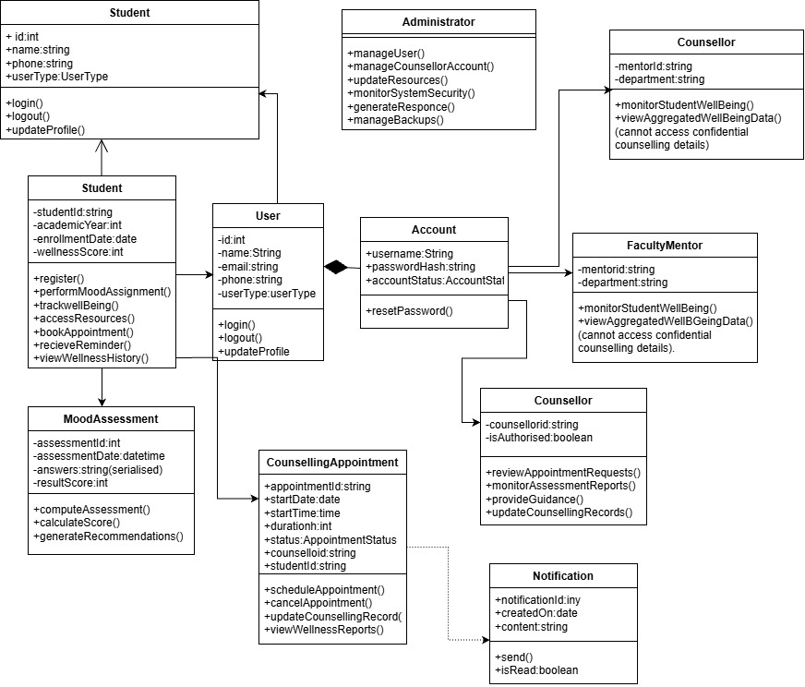
ACTIVITY DIAGRAM:
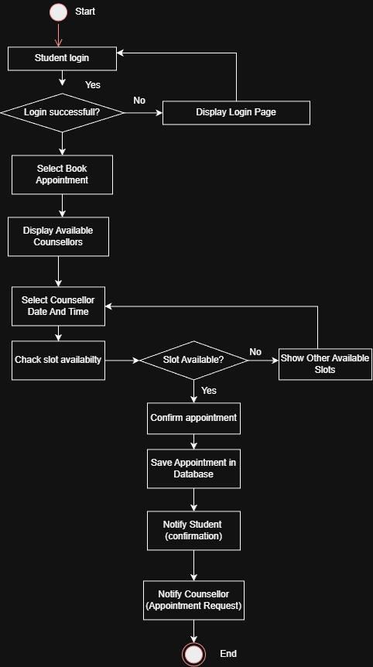
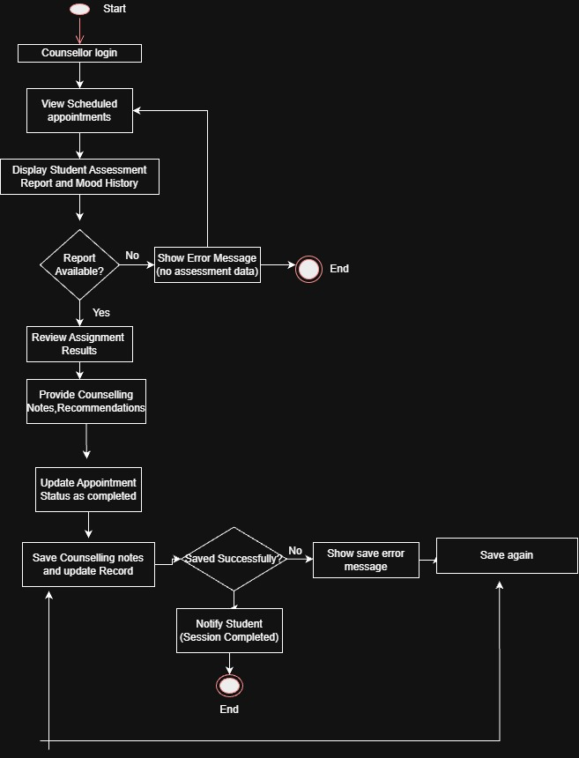
SEQUENCE DIAGRAM:
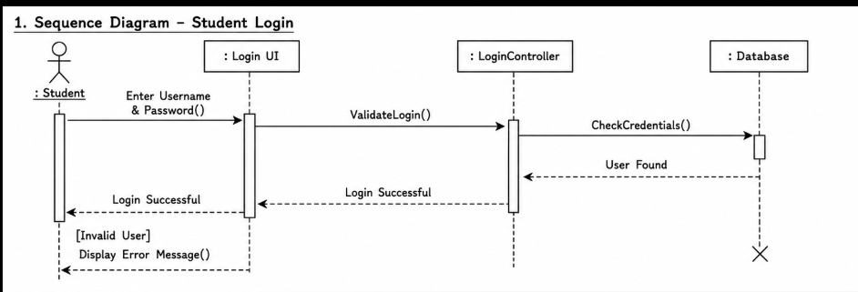

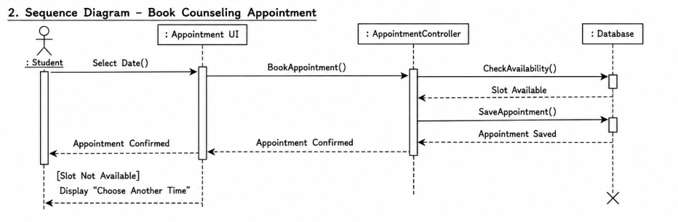
Deployment diagram:

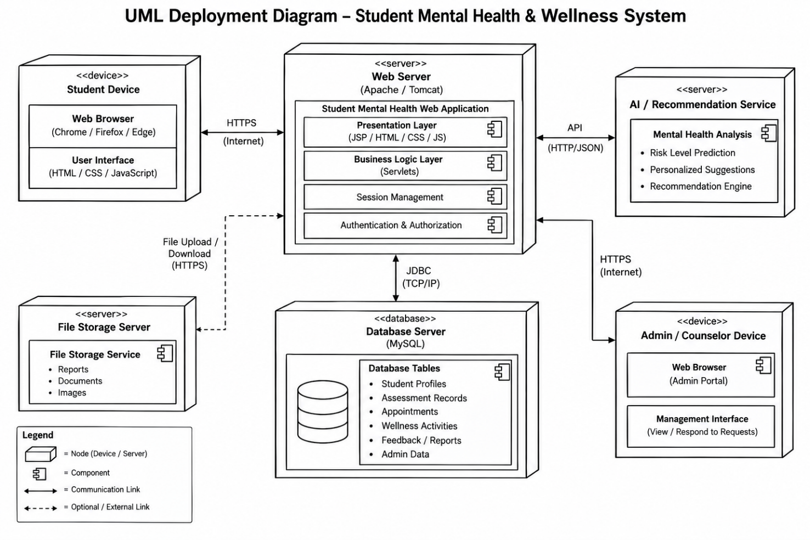

Component diagram:
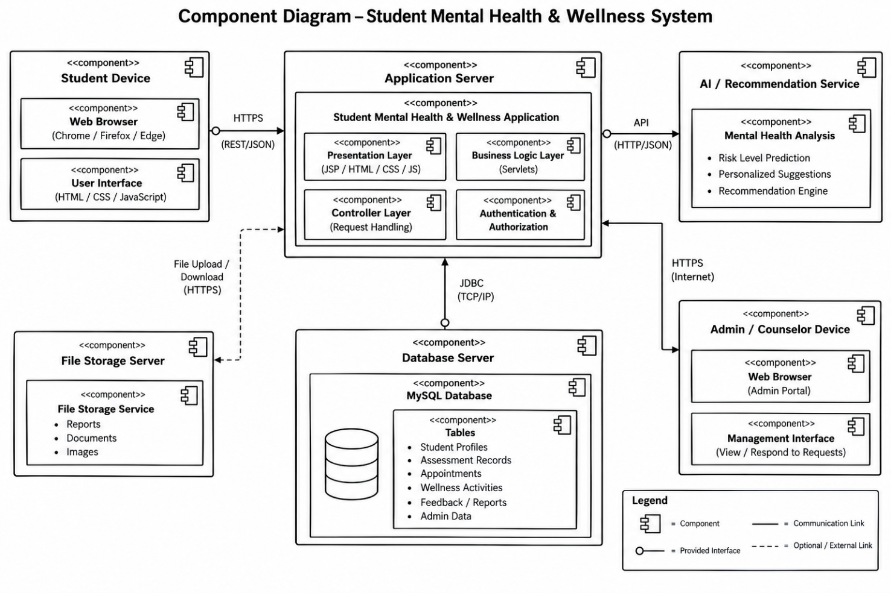
State chart diagram:
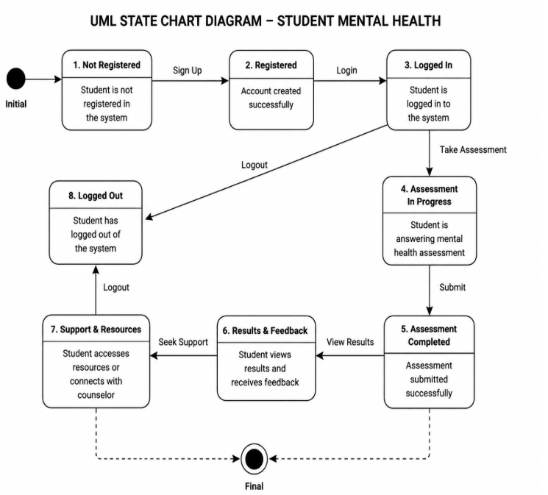
Source code:
Index.html:
<!DOCTYPE html>
<html lang="en">

<head>
<meta charset="UTF-8">
<meta name="viewport" content="width=device-width, initial-scale=1.0">

<title>Student Wellness & Early Intervention</title>

<link rel="stylesheet" href="css/style.css">
</head>

<body>

<header>
<div class="logo">
Student Wellness
</div>

<nav>
<a href="index.html">Home</a>
<a href="#about">About</a>
<a href="#features">Features</a>
</nav>
</header>

<main>

<section class="hero">

<div class="hero-content">

<p class="tagline">
STUDENT WELLNESS & EARLY INTERVENTION
</p>

<h1>
Supporting Student
<span>Wellness</span>
</h1>

<p>
A digital platform that helps students monitor
their wellbeing and connects them with the right
support when they need it.
</p>

<div class="hero-buttons">

<button onclick="window.location.href='login.html'">
Login
</button>

<button class="secondary"
onclick="window.location.href='register.html'">
Student Registration
</button>

</div>

</div>

</section>

<section id="about" class="section">

<h2>About the System</h2>

<p>
The Student Wellness & Early Intervention System
provides a centralized platform for students,
counsellors, faculty members and administrators.
</p>

<p>
The system uses wellness assessments, support
requests and role-based access to help identify
students who may require additional support.
</p>

</section>

<section id="features" class="section">

<h2>System Features</h2>

<div class="feature-container">

<div class="feature-card">
<h3>Student Wellness</h3>
<p>
Complete wellness assessments and monitor
your wellbeing over time.
</p>
</div>

<div class="feature-card">
<h3>Counselling Support</h3>
<p>
Connect with counsellors and manage
support cases.
</p>
</div>

<div class="feature-card">
<h3>Faculty Referral</h3>
<p>
Faculty can refer students who may require
academic or wellness support.
</p>
</div>

<div class="feature-card">
<h3>Administration</h3>
<p>
Administrators can monitor users, cases
and system statistics.
</p>
</div>

</div>

</section>

</main>

<footer>

<p>
Student Wellness & Early Intervention System
</p>

<p>
Academic Project
</p>

</footer>

</body>

</html>
Student_register.html:
<!DOCTYPE html>
<html lang="en">

<head>
<meta charset="UTF-8">
<meta name="viewport" content="width=device-width, initial-scale=1.0">

<title>Student Registration | Student Wellness</title>

<link rel="stylesheet" href="../css/style.css">
<link rel="stylesheet" href="../css/forms.css">
</head>

<body>

<header class="main-header">
<div class="container">
<h2>Student Wellness</h2>

<nav>
<a href="../index.html">Home</a>
<a href="login.html">Login</a>
</nav>
</div>
</header>

<main class="form-page">

<div class="form-container">

<h1>Student Registration</h1>

<p class="form-subtitle">
Create your account to access wellness support.
</p>

<form id="registerForm">

<div class="form-group">
<label for="name">Full Name</label>
<input
type="text"
id="name"
placeholder="Enter your full name"
required>
</div>

<div class="form-group">
<label for="email">Email Address</label>
<input
type="email"
id="email"
placeholder="Enter your email"
required>
</div>

<div class="form-group">
<label for="department">Department</label>

<select id="department" required>
<option value="">Select Department</option>
<option value="CSE">Computer Science and Engineering</option>
<option value="ECE">Electronics and Communication Engineering</option>
<option value="EEE">Electrical and Electronics Engineering</option>
<option value="MECH">Mechanical Engineering</option>
<option value="CIVIL">Civil Engineering</option>
</select>
</div>

<div class="form-group">
<label for="password">Password</label>

<input
type="password"
id="password"
placeholder="Create a password"
required>
</div>

<div class="form-group">
<label for="confirmPassword">Confirm Password</label>

<input
type="password"
id="confirmPassword"
placeholder="Confirm your password"
required>
</div>

<button type="submit" class="btn-primary">
Create Account
</button>

<p id="message"></p>

</form>

<p class="form-footer">
Already have an account?
<a href="login.html">Login here</a>
</p>

</div>

</main>

<script type="module" src="../js/auth.js"></script>

</body>

</html>
Assessment.html:
<!DOCTYPE html>
<html lang="en">

<head>
<meta charset="UTF-8">
<meta name="viewport" content="width=device-width, initial-scale=1.0">

<title>Wellness Assessment | Student Wellness</title>

<link rel="stylesheet" href="../css/style.css">
<link rel="stylesheet" href="../css/forms.css">
</head>

<body>

<header class="dashboard-header">

<div class="container">

<h2>Student Wellness</h2>

<nav>
<a href="dashboard.html">Dashboard</a>
<a href="assessment.html">Assessment</a>
<a href="login.html">Logout</a>
</nav>

</div>

</header>

<main class="form-page">

<div class="form-container assessment-container">

<h1>Wellness Assessment</h1>

<p class="form-subtitle">
Answer the following questions honestly to understand
your current wellness status.
</p>

<form id="assessmentForm">

<!-- Stress -->

<div class="form-group">

<label for="stress">
1. How would you rate your current stress level?
</label>

<select id="stress" required>

<option value="">
Select an option
</option>

<option value="1">
Very Low
</option>

<option value="2">
Low
</option>

<option value="3">
Moderate
</option>

<option value="4">
High
</option>

<option value="5">
Very High
</option>

</select>

</div>

<!-- Sleep -->

<div class="form-group">

<label for="sleep">
2. How would you rate your sleep quality?
</label>

<select id="sleep" required>

<option value="">
Select an option
</option>

<option value="5">
Very Good
</option>

<option value="4">
Good
</option>

<option value="3">
Average
</option>

<option value="2">
Poor
</option>

<option value="1">
Very Poor
</option>

</select>

</div>

<!-- Academic Pressure -->

<div class="form-group">

<label for="academic">
3. How much academic pressure are you experiencing?
</label>

<select id="academic" required>

<option value="">
Select an option
</option>

<option value="1">
Very Low
</option>

<option value="2">
Low
</option>

<option value="3">
Moderate
</option>

<option value="4">
High
</option>

<option value="5">
Very High
</option>

</select>

</div>

<!-- Mood -->

<div class="form-group">

<label for="mood">
4. How would you describe your overall mood?
</label>

<select id="mood" required>

<option value="">
Select an option
</option>

<option value="5">
Very Positive
</option>

<option value="4">
Positive
</option>

<option value="3">
Neutral
</option>

<option value="2">
Low
</option>

<option value="1">
Very Low
</option>

</select>

</div>

<!-- Social Wellbeing -->

<div class="form-group">

<label for="social">
5. How connected do you feel with friends,
classmates or family?
</label>

<select id="social" required>

<option value="">
Select an option
</option>

<option value="5">
Very Connected
</option>

<option value="4">
Connected
</option>

<option value="3">
Neutral
</option>

<option value="2">
Isolated
</option>

<option value="1">
Very Isolated
</option>

</select>

</div>

<!-- Energy -->

<div class="form-group">

<label for="energy">
6. How would you rate your energy level?
</label>

<select id="energy" required>

<option value="">
Select an option
</option>

<option value="5">
Very High
</option>

<option value="4">
High
</option>

<option value="3">
Moderate
</option>

<option value="2">
Low
</option>

<option value="1">
Very Low
</option>

</select>

</div>

<!-- Submit -->

<button type="submit" class="btn-primary">
Submit Assessment
</button>

<p id="assessmentMessage"></p>

</form>

</div>

</main>

<script type="module" src="../js/assessment.js"></script>

</body>

</html>
Support_history.js:
import {
onAuthStateChanged,
signOut
} from "https://www.gstatic.com/firebasejs/12.18.0/firebase-auth.js";

import {
collection,
query,
where,
orderBy,
getDocs
} from "https://www.gstatic.com/firebasejs/12.18.0/firebase-firestore.js";

import { auth, db } from "./firebase.js";

const supportBody =
document.getElementById("supportBody");

const logoutBtn =
document.getElementById("logoutBtn");

/* =================================
CHECK STUDENT LOGIN
================================= */

onAuthStateChanged(
auth,
async function (user) {

if (!user) {

window.location.href =
"login.html";

return;
}

try {

const requestsRef =
collection(
db,
"supportRequests"
);

const requestsQuery =
query(
requestsRef,
where(
"studentId",
"==",
user.uid
),
orderBy(
"createdAt",
"desc"
)
);

const snapshot =
await getDocs(
requestsQuery
);

supportBody.innerHTML = "";

/* =================================
NO REQUESTS
================================= */

if (snapshot.empty) {

supportBody.innerHTML = `
<tr>
<td colspan="5">
No support requests found.
</td>
</tr>
`;

return;
}

/* =================================
DISPLAY REQUESTS
================================= */

snapshot.forEach(
function (requestDoc) {

const data =
requestDoc.data();

let date =
"Not available";

if (data.createdAt) {

date =
data.createdAt
.toDate()
.toLocaleDateString();

}

const row =
document.createElement("tr");

row.innerHTML = `

<td>
${date}
</td>

<td>
${data.supportType ||
"Not specified"}
</td>

<td>
${data.priority ||
"Not specified"}
</td>

<td>
${data.description ||
"No description"}
</td>

<td>
<strong>
${data.status ||
"Pending"}
</strong>
</td>

`;

supportBody.appendChild(row);

}
);

} catch (error) {

console.error(
"Error loading support requests:",
error
);

supportBody.innerHTML = `
<tr>
<td colspan="5">
Unable to load support requests.
</td>
</tr>
`;

}

}
);

/* =================================
LOGOUT
================================= */

logoutBtn.addEventListener(
"click",
async function () {

try {

await signOut(auth);

window.location.href =
"login.html";

} catch (error) {

console.error(
"Logout failed:",
error
);

}

}
);

Case.html:
<!DOCTYPE html>
<html lang="en">

<head>

<meta charset="UTF-8">

<meta name="viewport"
content="width=device-width, initial-scale=1.0">

<title>Case Management | Student Wellness</title>

<link rel="stylesheet"
href="../css/style.css">

<link rel="stylesheet"
href="../css/dashboard.css">

<style>

.case-page {
max-width: 1000px;
margin: 0 auto;
}

.case-header {
margin-bottom: 25px;
}

.case-header h1 {
color: #12355b;
margin-bottom: 8px;
}

.case-header p {
color: #666;
}

.case-grid {
display: grid;
grid-template-columns: 1fr 1fr;
gap: 20px;
}

.case-card {
background: white;
padding: 25px;
border-radius: 10px;
box-shadow: 0 4px 15px rgba(0, 0, 0, 0.08);
}

.case-card h2 {
color: #12355b;
font-size: 20px;
margin-top: 0;
margin-bottom: 20px;
}

.case-field {
margin-bottom: 18px;
}

.case-field label {
display: block;
font-weight: bold;
color: #444;
margin-bottom: 7px;
}

.case-value {
padding: 11px;
background: #f4f7fb;
border-radius: 6px;
color: #333;
line-height: 1.5;
}

.case-card select,
.case-card textarea,
.case-card input {
width: 100%;
padding: 11px;
border: 1px solid #ccc;
border-radius: 6px;
font-size: 14px;
box-sizing: border-box;
}

.case-card textarea {
resize: vertical;
min-height: 140px;
}

.case-card select:focus,
.case-card textarea:focus,
.case-card input:focus {
outline: none;
border-color: #1d5d9b;
}

.case-actions {
margin-top: 25px;
display: flex;
gap: 15px;
}

.save-case-btn {
padding: 11px 22px;
border: none;
border-radius: 6px;
background: #12355b;
color: white;
cursor: pointer;
font-size: 15px;
}

.save-case-btn:hover {
background: #1d5d9b;
}

.back-btn {
padding: 11px 22px;
border: none;
border-radius: 6px;
background: #ddd;
color: #333;
cursor: pointer;
font-size: 15px;
}

.back-btn:hover {
background: #ccc;
}

#caseMessage {
margin-top: 15px;
font-weight: bold;
}

@media (max-width: 700px) {

.case-grid {
grid-template-columns: 1fr;
}

.case-actions {
flex-direction: column;
}

}

</style>

</head>

<body>

<!-- HEADER -->

<header class="dashboard-header">

<div class="container">

<h2>
Student Wellness
</h2>

<nav>

<a href="dashboard.html">
Dashboard
</a>

<button id="logoutBtn">
Logout
</button>

</nav>

</div>

</header>

<!-- MAIN -->

<main class="dashboard">

<div class="container case-page">

<!-- PAGE TITLE -->

<div class="case-header">

<h1>
Case Management
</h1>

<p>
Review the student's support request
and manage the counselling case.
</p>

</div>

<!-- CASE INFORMATION -->

<div class="case-grid">

<!-- STUDENT REQUEST -->

<div class="case-card">

<h2>
Student Request
</h2>

<div class="case-field">

<label>
Student Email
</label>

<div class="case-value"
id="studentEmail">
Loading...
</div>

</div>

<div class="case-field">

<label>
Support Type
</label>

<div class="case-value"
id="supportType">
Loading...
</div>

</div>

<div class="case-field">

<label>
Priority
</label>

<div class="case-value"
id="priority">
Loading...
</div>

</div>

<div class="case-field">

<label>
Date Submitted
</label>

<div class="case-value"
id="createdDate">
Loading...
</div>

</div>

<div class="case-field">

<label>
Student's Concern
</label>

<div class="case-value"
id="description">
Loading...
</div>

</div>

</div>

<!-- CASE MANAGEMENT -->

<div class="case-card">

<h2>
Manage Case
</h2>

<div class="case-field">

<label for="caseStatus">
Case Status
</label>

<select id="caseStatus">

<option value="Pending">
Pending
</option>

<option value="In Progress">
In Progress
</option>

<option value="Resolved">
Resolved
</option>

</select>

</div>

<div class="case-field">

<label for="followUpDate">
Follow-up Date
</label>

<input
type="date"
id="followUpDate"
>

</div>

<div class="case-field">

<label for="counsellingNotes">
Counselling Notes
</label>

<textarea
id="counsellingNotes"
placeholder="Enter counselling notes, observations or follow-up details..."
></textarea>

</div>

<div class="case-actions">

<button
type="button"
class="save-case-btn"
id="saveCaseBtn">

Save Case

</button>

<button
type="button"
class="back-btn"
id="backBtn">

Back to Dashboard

</button>

</div>

<p id="caseMessage"></p>

</div>

</div>

</div>

</main>

<script
type="module"
src="../js/case.js">
</script>

</body>

</html>

Demonstration:
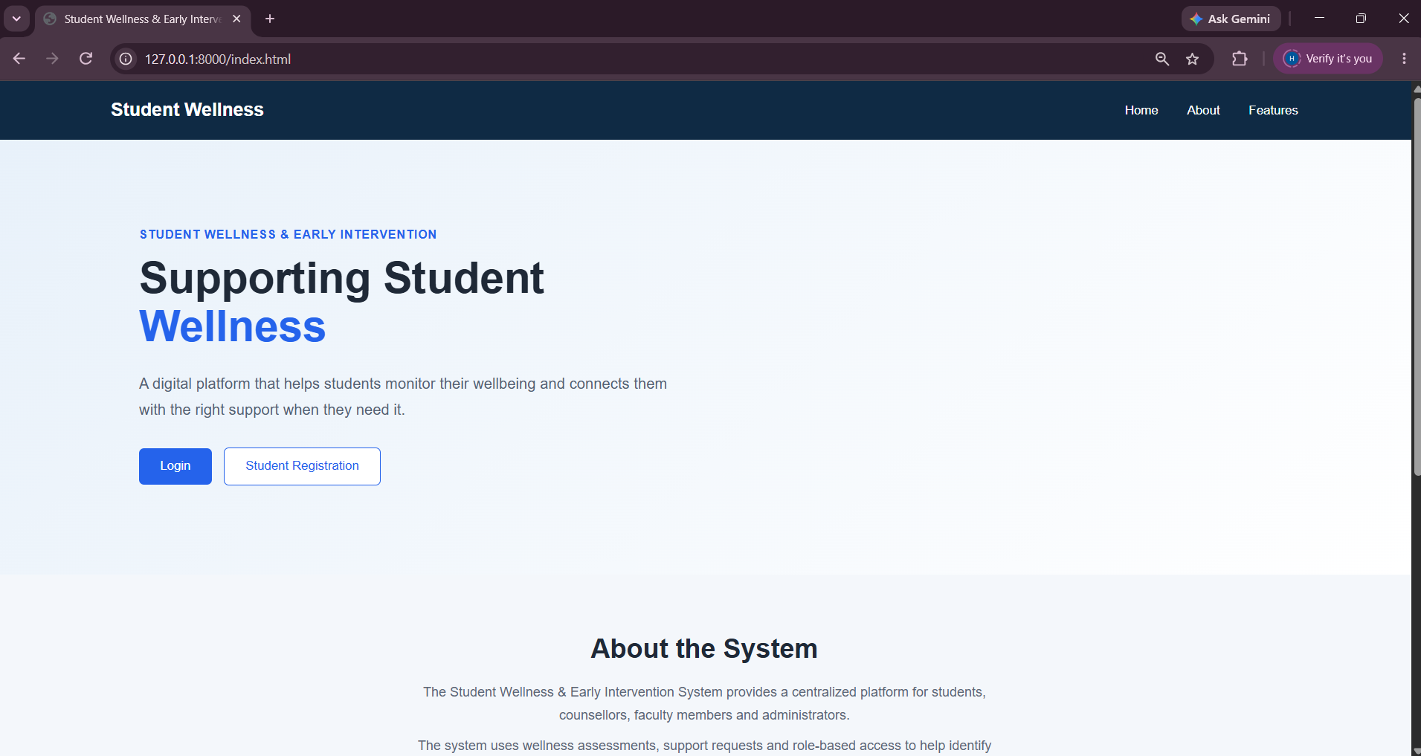

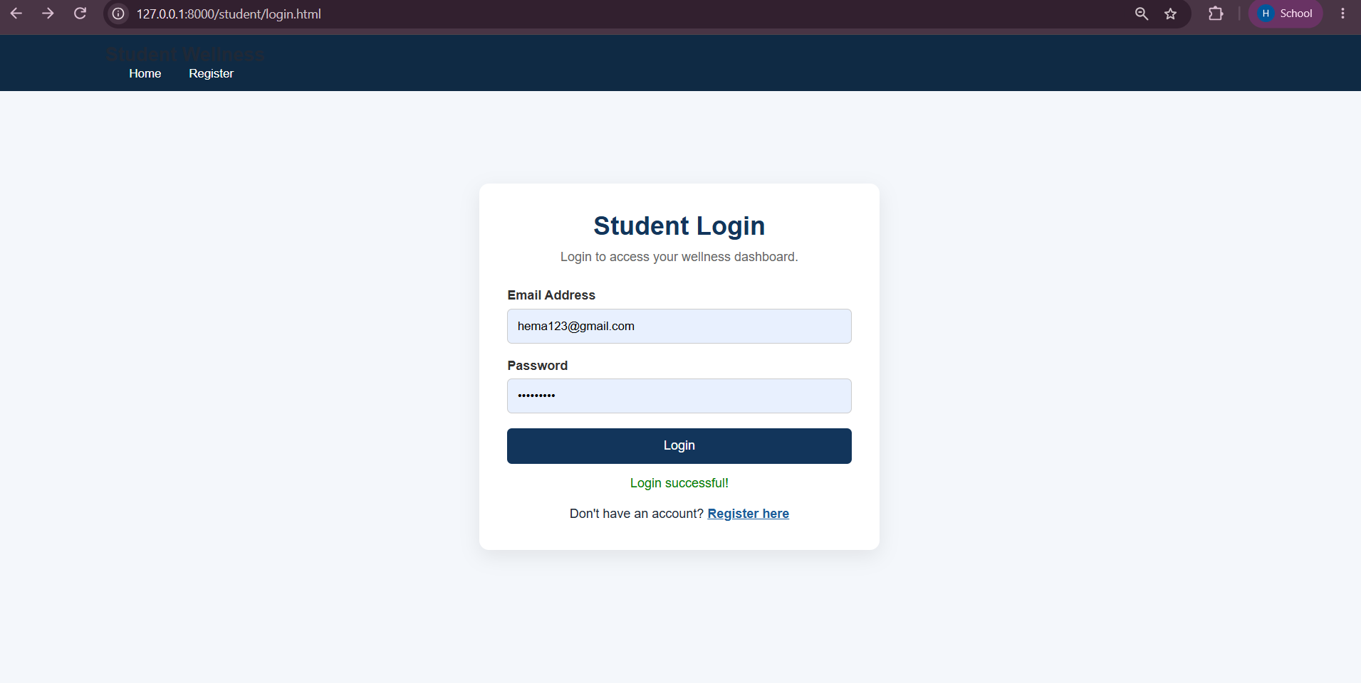

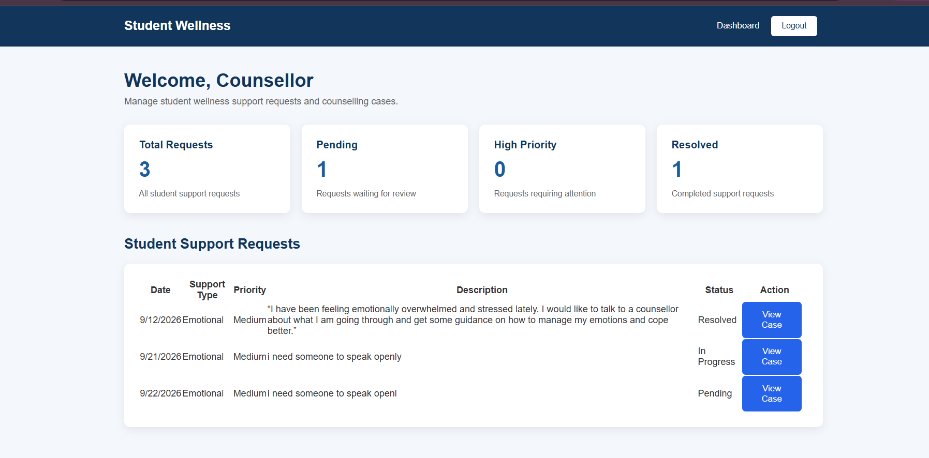
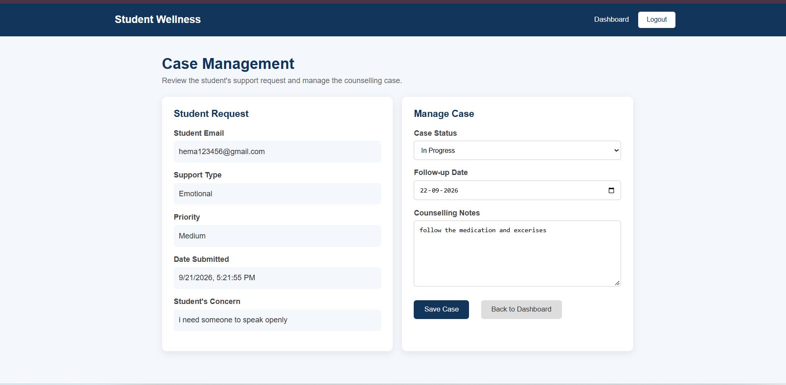

E-Resources:
https://github.com/hemavasanthi1985-maker/StudentWellnessPro

