DAY 2

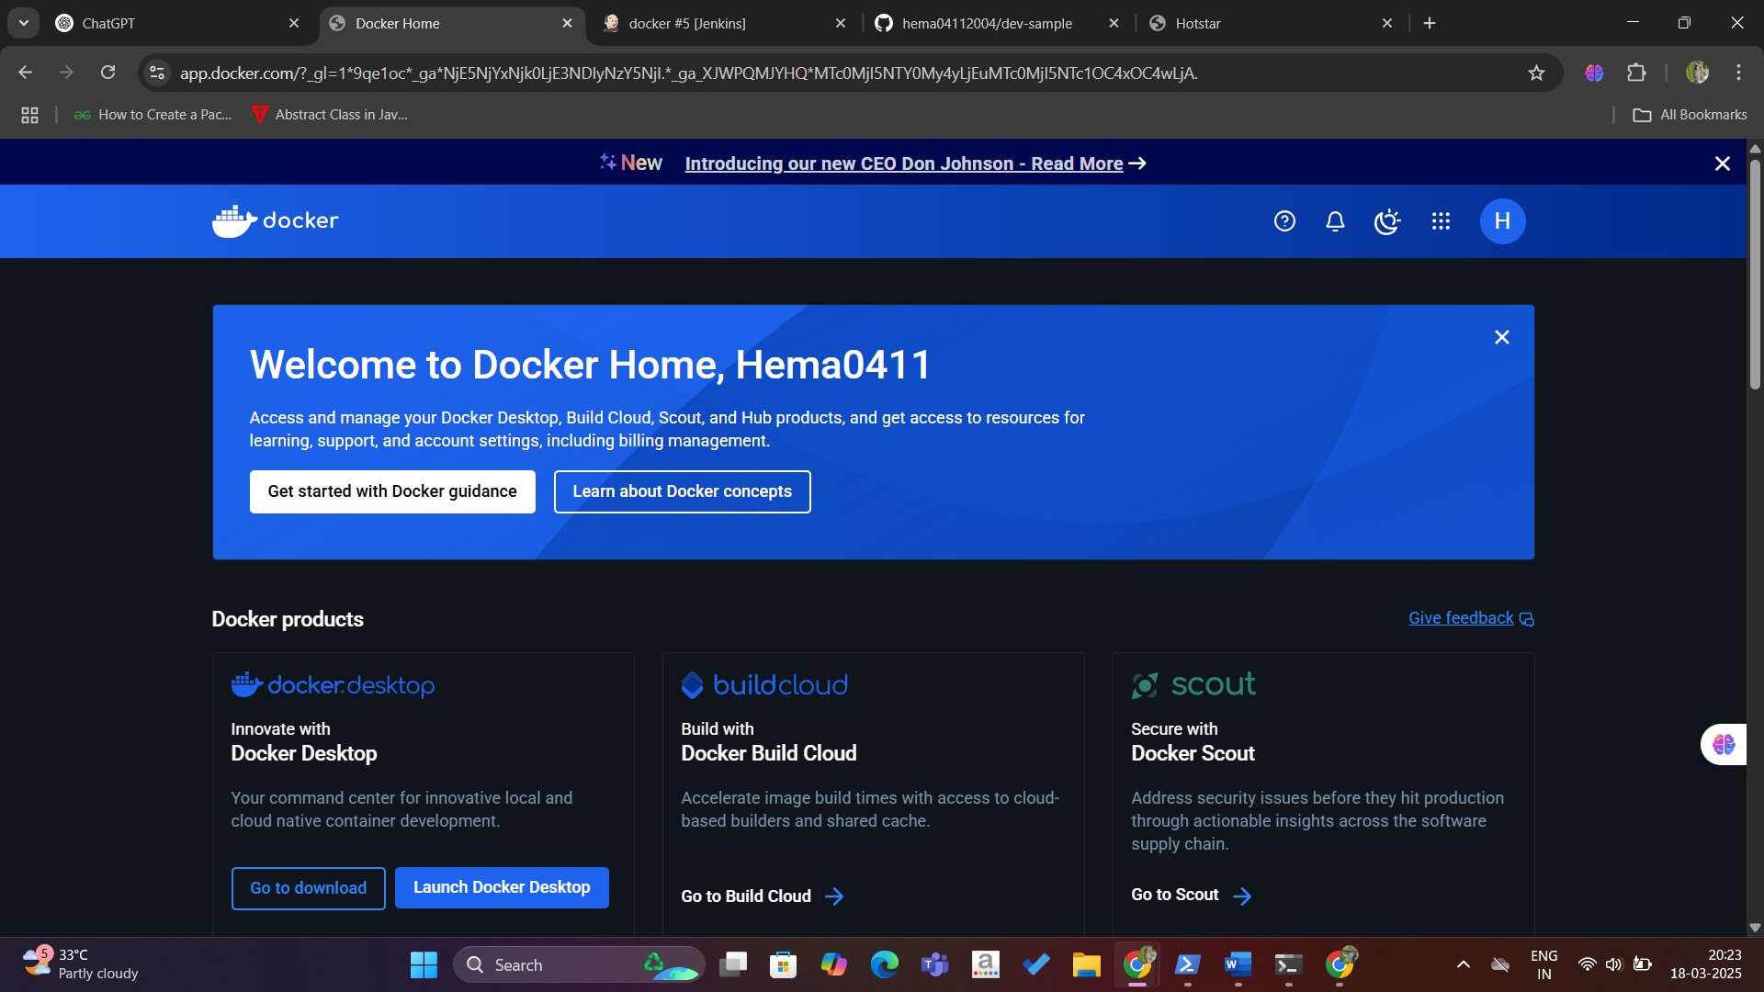

2.PIPELINE SCRIPT:
pipeline {
agent any
tools {
jdk 'jdk17'
nodejs 'node20'
}
stages {
stage('Clean Workspace') {
steps {
script {
echo "Cleaning workspace..."
deleteDir() // Deletes everything in the Jenkins workspace before starting
}
}
} script { echo "Cleaning workspace..."

deleteDir() // Deletes everything in the Jenkins workspace before starting

}

}

}

stage('Git Checkout') {

steps {

script {

git branch: 'main',

credentialsId: 'github_seccred3',

url: 'https://github.com/hemaveeramuthu/Devops.git'

}

}

}

stage('Install Node') {

steps {

script {

sh '''

if [ -f package.json ]; then

echo "package.json found. Running npm install..."

npm install

else

echo "ERROR: package.json is missing. Skipping npm install."

exit 1

fi

'''

}

}

}

stage('Docker Build & Push') {

steps {

script {

withDockerRegistry(credentialsId: 'docker3', toolName: 'docker') {

def imageName = "hemadharunika/docker"

def tag = "latest"

sh "docker build -t ${imageName} ."

sh "docker tag ${imageName} ${imageName}:${tag}"

sh "docker push ${imageName}:${tag}"

}

}

}

}

stage('Deploy Docker Container') {

steps {

script {

// Stop and remove the existing container if it's running

sh "docker stop jusjes_container || true"

sh "docker rm jusjes_container || true"

// Run the new container

sh "docker run -d --name jusjes_container -p 6001:6000 hemadharunika/docker:latest"

}

}

}

}

}

3. TOOLS CONFIG:
Java
Nodejs
Docker
4.Plugins:
Nodejs
Docker related(except build)
Eclipse
Pipeline
5.credentials:
Github&docker
For docker build &deploy
Sudo usemod -aG docker Jenkins
Sudo chmod 666 /var/run/docker.sock
Sudo systemctl restart Jenkins
Sudo systemctl status Jenkins

localhost:3001
